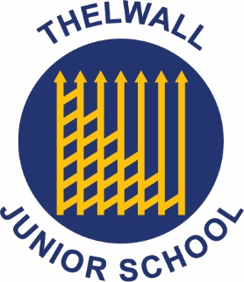
Maintenance Officer

Salary: Scale 5, Point 8-14 Hours: 30 Hours per week; 6x hours a day 7:00am – 10:00am & 3:00pm - 6:00pm (split shifts)
To start ASAP following relevant checks.
Accountable to: Headteacher / School Business Manager / Governors
Location: Thelwall Community Junior School
Thelwall New Road
Thelwall
Warrington
WA4 2HX

The Governing Body are seeking to appoint an enthusiastic and committed Maintenance Officer to undertake the efficient maintenance of the building and school site, including certain technical, IT and administrative duties to ensure their most effective use. The position is permanent (30 Hours a Week).
The candidate must be suitably qualified and have experience of contributing to the maintenance of a places of work. The right candidate will need to demonstrate that they are able to ensure that the whole school environment and services are maintained to a high and acceptable standard.
The successful candidate should be able to deliver high standards of work throughout the school, carry out portering duties, be able to demonstrate general maintenance skills and take responsibility for maintaining a secure and safe site. Candidates must be IT literate and must be able to use online systems effectively. Applicants must be highly motivated, proactive and take a pride in their work.

Application forms and other documents are available via the school website:
Thelwall Community Junior School - Vacancies (thelwalljuniorschool.org.uk)

Completed application forms should be returned to the school via email to: thelwall_junior_business@sch.warrington.gov.uk

Thelwall Community Junior School is committed to safeguarding and promoting the welfare of children and we expect all staff and volunteers to share this commitment to keeping children safe. Any offer of employment will be subject to statutory pre-employment checks including satisfactory references, online checks, Enhanced DBS and Barred List checks. Shortlisted candidates will be required to disclose any relevant criminal history prior to interview.

