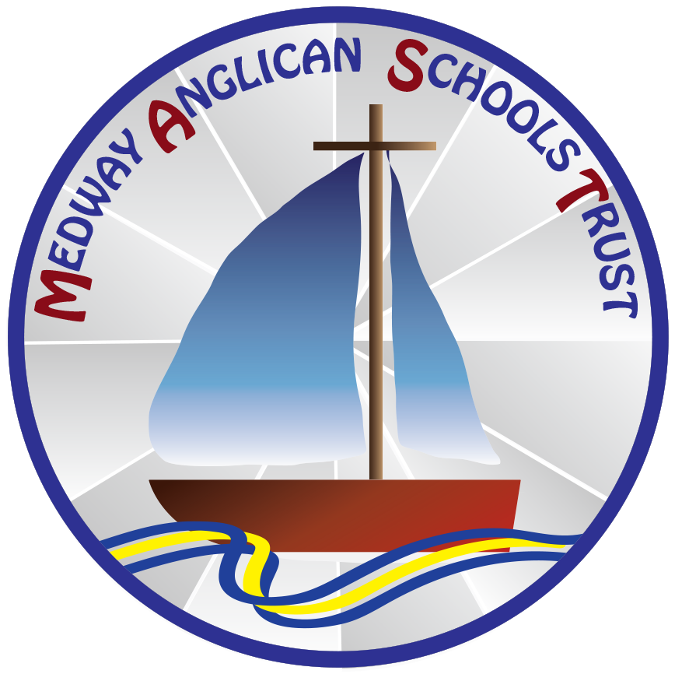

Chief Executive Officer

Recruitment Pack

November 2024

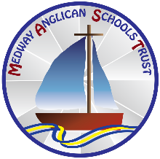**INTRODUCTION FROM GILL MOND Chair of Trust**

Dear Applicant,

Thank you for your interest in becoming our Chief Executive Officer at Medway Anglican Schools Trust, known as MAST.

This is an exciting time for us as a trust and we are seeking a new member of our executive team to lead operations across the trust and its academies. Our current CEO has served our community since the creation of the trust in September 2015 and is now retiring.

At MAST, we work closely together to ensure that our school communities feel supported to help them develop and improve. Through our practice of honesty, openness and transparency, we work collaboratively to provide good value in all that we do – while respecting and considering the unique context of each of our schools.

We are ambitious for our children, school teams and communities. This means we are committed to ensuring excellent teaching and learning. Our headteachers work closely together as a group to support and challenge each other and they are passionate about their own schools and individual contexts. We are an Anglican VA Trust and aim to deliver our vision, working in partnership with RDBE so that our children and communities flourish.

As a trust, we believe in working together to share excellent practice whilst ensuring each of our schools retains its commitment to its own community and surroundings. In this way our schools can ensure that the curriculum and wider opportunities and experiences engage and motivate our pupils/students.

Working at a trust with four very different primary phase schools you will need to be able to demonstrate an understanding of all aspects of the operations of a multi-academy trust and lead the trust growth strategy.

You will lead and manage the executive team and have oversight of the central team. The role will demand close working partnerships with all of our schools and stakeholders, whilst liaising closely with other executive team members and the trust board.

This is an excellent opportunity to join a good church trust and be able to shape our future.

If you would like to discuss aspects of the role further, then please do not hesitate to contact us for an informal conversation or a visit through our governance professional Natalie Hobbs, email [hobbn019@mastacademy.co.uk](mailto:hobbn019@mastacademy.co.uk)

Many thanks

Gill Mond

Chair of Medway Anglican Schools Trust

**Medway Anglican Schools Trust (MAST)**

***‘I came to give life – life in all its fullness’ John 10:10***

**CHIEF EXECUTIVE OFFICER**

*Full time (52 weeks), permanent, based at St Margaret’s CE Junior School, Orchard Street, Rainham, Kent ME8 9AE*

**Salary: L27 – L31 £ 94,332 - £104,040**

**Required:** Spring 2025

***_____________________________________________________________________***

Medway Anglican Schools Trust (MAST) is seeking to appoint a Chief Executive Officer to lead, manage and co-ordinate the operations of the trust, and its academies. The trust currently consists of four schools; two primary schools with nurseries, one small infant school and a three-form entry junior school, but growth plans should see expansion in the future. You will lead and manage the executive team (plus oversight of the central team). You will set the strategic direction of the trust with the directors and support the ongoing operational development of our schools. You will be accounting officer and responsible for ensuring compliance with statutory requirements.

**Why MAST?**

• We are a Trust whose Christian values are embedded in our work and relationships with our school communities. The entire MAST community is passionate about providing the best education for our children in our rich and diverse school communities so that they flourish.

• MAST embraces diversity and equal opportunity. We are committed to building a team that represents a variety of backgrounds, perspectives and skills.

• We value all members of staff alongside professional and supportive staff relationships. We are committed to providing career progression through continuing professional development

We offer:

* positive, friendly working environment
* Teachers’ Pension Scheme & Local Government Pension Scheme
* Travel expenses
* Flexible working
* wellbeing support services

**Why you?**

* You are an experienced education leader with evidence of systems leadership across more than one school, improving the quality of education, able to take responsibility for the trust’s operations and compliance with regulations.
* You have experience of working at a senior level within a Multi-Academy Trust and have a deep understanding of improving teaching and learning so that all pupils achieve well.
* You are committed to career progression for all and can provide evidence of how you have developed leadership at all levels and led impactful school improvement
* You have essential understanding of the Education & Skills Funding Agency regulatory framework for academies.  l
* You are highly organised and an effective communicator.
* You have commitment to partnership working across our schools and with external stakeholders.

.

Medway Anglican Schools Trust was formed in September 2015 and is a Church of England VA trust, built upon the importance of positive relationships amongst all involved. Our schools retain their own individuality, but the trust is always there to provide advice, guidance and support for each school. Our schools work well together and support one another in raising standards.

**Closing date for applications: Noon 6th January 2025**

Interviews to be held: week commencing 13th January 2025

If you are interested in applying for this position, to find out more and download an application form use this link [MAST Vacancies](https://medwaytrust.secure-primarysite.net/trust-vacancies/) and return it to Natalie Hobbs, governance professional by noon on 6th January 2025.

Due to safer recruitment requirements, CVs will not be accepted. Trust application forms must be completed.

References will be requested for all shortlisted applicants before interview.

In line with KCSIE 2024 guidance, as part of the shortlisting process, the Trust will conduct an online search on shortlisted candidates as part of our due diligence and to share any pertinent information found concerning a candidate's suitability to work with children with the chair of the interview panel to be discussed at the interview stage.

The Trust and its academies are committed to safeguarding and promoting the welfare of children and expects all staff to share this commitment. The post is subject to a successful Enhanced Disclosure and Barring Check. Pre-employment checks will be undertaken before an appointment is confirmed.

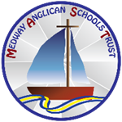**Medway Anglican Schools Trust**

**CEO Job Description**

**Salary Range L27-L31 £ 94,332 - £104,040**

1. **Job purpose**

As Medway Anglican Schools Trust (MAST) CEO you are responsible for the education of all children in our Trust’s academies. You will lead the Executive Team of the Trust and the Central Team, ensuring the Trust and all its schools continue to be successful over time and sustainable. You will provide high level strategic leadership and management across all aspects of the Trust’s activities. You will ensure that the Trust provides high quality education for all its pupils through the effective and efficient use of resources and people. As a system leader, the CEO represents the Trust with a wide range of stakeholders and partners and enables the Trust to fulfil its Christian and civic responsibilities. You are the Accounting Officer for the Trust, responsible for ensuring the Trust meets its statutory and legal requirements.

1. **Ethics and Professional Conduct**

As leader of our educational charity you are expected to demonstrate consistently high standards of principled and professional conduct. The CEO should always uphold and demonstrate The Principles of Public Life (The Nolan Principles). The CEO is responsible for upholding Diocesan and public trust in MAST, civic and system leadership, and should maintain high standards of ethics and behaviour. As leader of MAST, our academy communities and the profession, the CEO should serve in the best interests of the Trust’s pupils and communities, conducting themselves in a manner compatible with their influential position in society.

1. **CEO Core Responsibilities**

MAST is an education charity that runs our schools to give children a better future. We have a single legal and moral purpose: to advance education for the public benefit while maintaining our Christian ethos and delivering our vision. The MAST CEO has specific responsibilities as executive leader of the Trust.

There are six interlinked areas of the CEO’s core responsibilities. These are:

* Strategic leadership - Trust values and vision, culture and strategy
* Quality of Education
* Finance, sustainability and compliance
* People strategy
* Governance and accountability
* System leadership and civic responsibility

*Strategic leadership – Trust vision, values, culture, and strategy*

* Establish and sustain the Trust’s vision, values, culture, and strategic direction in partnership with the Trust Board
* Provide leadership that enables the Trust to achieve its strategic objectives and secure its future sustainability
* Create a safe, inclusive and positive culture across the Trust and its schools
* Develop operational objectives that are appropriate, deliverable and aligned to securing a sustainable future through the Trust’s strategic direction
* Enable the Trust’s organisational design and operational systems to meet its current and future requirements and manage change effectively

*Quality of Education*

* Tackle educational inequality, upholding and securing ambitious educational and behavioural standards for all pupils
* Promote further support for the most disadvantaged and those with additional and special educational needs and disabilities within a safe and secure environment
* Enable the Trust to establish and sustain a broad, rich and coherent curriculum entitlement for all pupils, supported by effective curricular leadership and delivered through high quality teaching in all its schools
* Ensure the Trust has high quality, expert teaching in all the Trust’s schools, built on an evidence-informed understanding of effective teaching and how pupils learn
* Ensure that priority areas for improvement are identified and addressed
* Enable the Trust and its schools to engage with appropriate evidence-based strategies for improvement and ensure their effective implementation and impact

*Finance, sustainability and compliance*

Provide operational leadership, reports and assurance to Board so that they are able to maintain effective oversight and meet their responsibilities:

* Ensure that sound financial management systems are in place, understood by all, adhered to and reviewed
* Prioritise and allocate financial resources appropriately, ensuring efficiency, effectiveness and probity in the use of public funds
* Ensure rigorous approaches to identifying, managing and mitigating risk
* Ensure the long-term sustainability of the Trust and its schools through effective financial and estates management
* Direct the Trust’s activities to achieve the most efficient, effective and sustainable provision of education to the highest quality, prioritising and making the most effective use of the resources available.
* Ensure the organisation complies with all statutory and legal requirements including safeguarding and health and safety
* Ensure that estate management is effective

*People strategy*

* Lead and effectively manage the activities and performance of the Trust’s executive and central team
* Enable a people strategy that identifies talent, supports and develops all staff and sustains a culture of staff well-being and high staff professionalism
* Ensure the Trust has high quality employment practices that promote equality, diversity and inclusion, including ethical practices of recruitment and retention of staff
* Ensure staff have access to high quality professional development, aligned to balance organisational and individual needs
* Ensure the Trust has a strong talent management and succession planning programmes across all areas of the organisation’s work

*Accountability and Governance*

* Promote a culture of accountability that is recognised and accepted as an essential element of improvement at all levels and across all aspects of the Trust’s work
* Understand the role of relevant regulatory bodies and ensure the Trust and its schools respond to their requirements
* Understand and welcome the role of effective Trust governance, upholding the obligation to give account and recognising that Trust Boards are ultimately responsible and accountable for the Trust’s work
* Develop and maintain effective relationships with the Trust Board recognising their key role in holding the CEO and executive team to account
* Maintain good communication with the Trust Board, including regular meetings with the Trust Chair
* Maintain a good relationship with local governance groups, attending meetings and providing updates as needed
* Ensure the Trust Board receives quality information in the level of detail needed to make informed decisions and fulfil its functions and legal obligations
* Ensure positive communications that promote the Trust and its work, and present the Trust effectively when dealing with the media

*System leadership and civic responsibility*

* Promote and enable ways in which the Trust’s schools and their local boards engage meaningfully with their communities and are responsive and accountable to them
* As CEO of an Anglican VA trust, maintain good relationships with the Rochester Diocesan Board of Education; working in partnership to enable our children to flourish, support the local church school communities and Diocese and deliver our vision through our values and Christian ethos
* In line with the Trust’s civic role, work with civic partners and stakeholders in the local area, region and/or nationally to contribute to the Public Good, ensuring the value of the child and coherent public service for children and families
* Foster and engage in the collective leadership of the sector building strong local systems to address disadvantage and improve the quality of education for all pupils
* Exert external influence on behalf of the Trust by active engagement with sector organisations, regulators, policy makers, local and national government, industry and other partners
* Give public assurance of high standards of probity

**SPECIAL FACTORS:**

Subject to the duration of the need, the special conditions given below apply:

(a) The nature of the work may involve the postholder carrying out work outside of normal working hours.

(b) The postholder may be required to attend, from time to time, training courses, conferences, seminars or other meetings as required by their own training needs and the needs of the service.

(c) Expenses will be paid in accordance with the Local Conditions of Service.

(d) This post is subject to an Enhanced DBS check regarding any previous criminal record.

This job description sets out the duties and responsibilities of the post at the time when it was drawn up. Such duties and responsibilities may vary from time to time without changing the general character of the duties or the level of responsibility entailed. Such variations are a common occurrence and cannot themselves justify a reconsideration of the grading of the post.

MAST and the academies which form part of our trust seek to promote the employment of disabled people and will make any adjustments considered reasonable to the above duties under the terms of the Equality Act 2010 to accommodate a suitable disabled candidate.

**Appendix A: Accounting Officer Responsibilities**

The Accounting Officer responsibilities are given the Academies Trust Handbook sections 1.31 – 1.38. The designated responsibilities are:

* Give assurance (to Parliament and the public) of high standards of probity in the management of public funds, particularly regularity, propriety and value for money
* Adhering to the Seven Principles of Public Life
* Having oversight of financial transactions (under Trustees’ control, measures to prevent losses or misuse, multi-person operation of accounts and records, accurate accounting records)
* Completing annual statement on regularity, propriety and compliance
* Taking personal responsibility for assuring compliance to the Board
* Advising on Board intent or action if incompatible with the articles, funding agreement or handbook
* Notify the ESFA if they consider the Board is in breach of the articles, funding agreement or handbook

**Appendix B: Working with Directors and Members**

CEOs work closely with their Trust Board, particularly the Chair. CEOs will recognise the responsibilities and statutory duties of Trustees and that the CEO operates under the oversight and direction of the Board of Trustees. MAST is an Anglican Church VA Trust with Rochester Diocese as a member and the CEO will engage with the Diocese through the diocesan strategic partnership and other activities to deliver our shared vision and enable our communities to flourish.

The Academy Trust Handbook indicates that Directors must comply with the Trust’s charitable objects, with company and charitable law and with their contractual obligations under the funding agreement. As an organisation the Trust has a range of obligations under current legislation and statutory guidance. This includes matters such as safeguarding, health and safety and estates management. The Academy Trust Handbook states that ensuring strong governance in these areas will be a key priority for the Board.

The Academy Trust Handbook indicates that Directors should focus on three core functions:

* ensuring clarity of vision, ethos and strategic direction
* holding executive leaders to account for the educational performance of the organisation and its pupils, and the performance management of staff
* overseeing and ensuring effective financial performance CEOs will recognise that in fulfilling these core functions Trust Boards are ultimately responsible for approving and monitoring certain aspects of a Trust’s work including the Trust’s vision and strategy.

|  |  |  |  |  |  |
| --- | --- | --- | --- | --- | --- |
| **Medway Anglican Schools Trust (MAST)** | | | | | |
| **Job Title:** | Chief Executive Officer | | | |
| **Grade:** |  | | | |
|  | | **Essential** | **Desirable** | **How assessed** | | |
| Qualifications  * + - * Hold a degree or equivalent qualification       * Successfully completed NPQ executive leader or equivalent       * Safer Recruitment Trained | | ****  ****  **** |  | App/Doc | | |
| Experience  * Working at a senior level within a multi-academy trust * Leading school improvement across more than one school * Leading and managing budgets. * Designing and implementing systems processes and controls. * Managing and working in a large organisation which operates across multiple sites. * Representation & engagement in the wider community and with a range of stakeholders * Evidence of strategic project management, demonstrating impact on outcomes * Experience of governance in an academy * Evidenced experience of raising standards * Experience of working/leading in different phases of education | | ****  ****  ****  ****  ****  ****  **** | ****  ****  **** | App/Ref/Int | | |
| Knowledge and Skills  * Good knowledge of the requirements of the Academy Trust Handbook * Excellent knowledge of teaching and learning strategies and their application * Secure knowledge of safeguarding processes and procedures * Good interpersonal skills * Good knowledge of HR management processes and practice * Able to analyse information and plan strategically to address short, medium, and long, term solutions * Able to research and assess different strategies to improve the quality of education * Ability to develop a positive, solutions focused culture * Good knowledge and understanding of the local context * Use information to strategically plan the allocation of finance resources, prioritising according to need * Knowledge of the responsibilities of accounting officer role * Knowledge of how the distinct nature of Anglican schools is driven through Christian ethos and theological roots shared vision * Able to form positive relationships with agencies and stakeholders beyond the Trust * Knowledge of managing health and safety requirements for schools and academies | | ****  ****  ****  ****  ****  ****  ****  ****  ****  ****  **** | ****  ****  **** | App/Ref/Int/Test | | |
| **General Circumstances**   * Maintains an up to date knowledge of education landscape and future changes * Uses strategic knowledge to set direction of travel so that pupil needs are prioritised * Understanding of diversity and its impact on experiences and how this can affect outcomes/perceptions | | ****  ****  **** |  | App/Ref/Int/Pre | | |
| **Factors not already covered** | |  |  |  | | |

**App = Application Form**

**Test = Test**

**Int = Interview**

**Pre = Presentation**

**Med = Medical Questionnaire**

**Doc = Documentary Evidence (E.g., Certificates)**