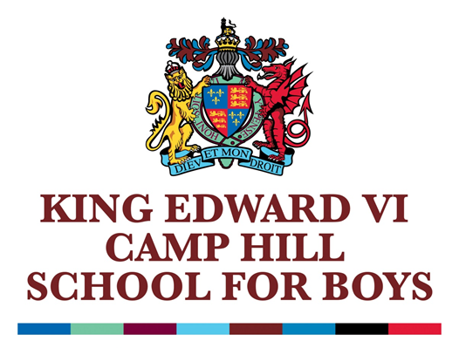

**KING EDWARD VI CAMP HILL SCHOOL FOR BOYS**

**Vicarage Road, Kings Heath, Birmingham, B14 7QJ**

**MATERNITY COVER RECEPTIONIST**

**Full time, Term Time Only, Plus 10 Days**

**SCP8 - £25,992FTE, £23,968.49 TTO pro rata,**

**36.5 hours per week**

**Required from September 2025**

We are seeking to appoint a well-organised, reliable and enthusiastic individual for this post. Further details of this post and an application form are available from Ms L May, PA to the Headmaster, on 0121 444 3188, email: [headspa@camphillboys.bham.sch.uk](mailto:enquiry@camphillboys.bham.sch.uk). They are also available from the school website [www.camphillboys.bham.sch.uk](http://www.camphillboys.bham.sch.uk).

Closing Date – **By 9:00am on Friday 20th June 2025.**

Interviews will take place shortly after.

*The Schools of King Edward VI in Birmingham is an educational charity supporting twelve schools and is committed to safeguarding and promoting the welfare of children and young people and expects all staff and volunteers to share this commitment. Applicants will be required to undergo child protection screening appropriate to the post, including checks with past employers and the Disclosure and Barring Service (DBS).*

*This post is covered by Part 7 of the Immigration Act (2016) and therefore the ability to speak fluent and spoken English is an essential requirement for this role.*

*CHARITY NUMBER: 529051*