

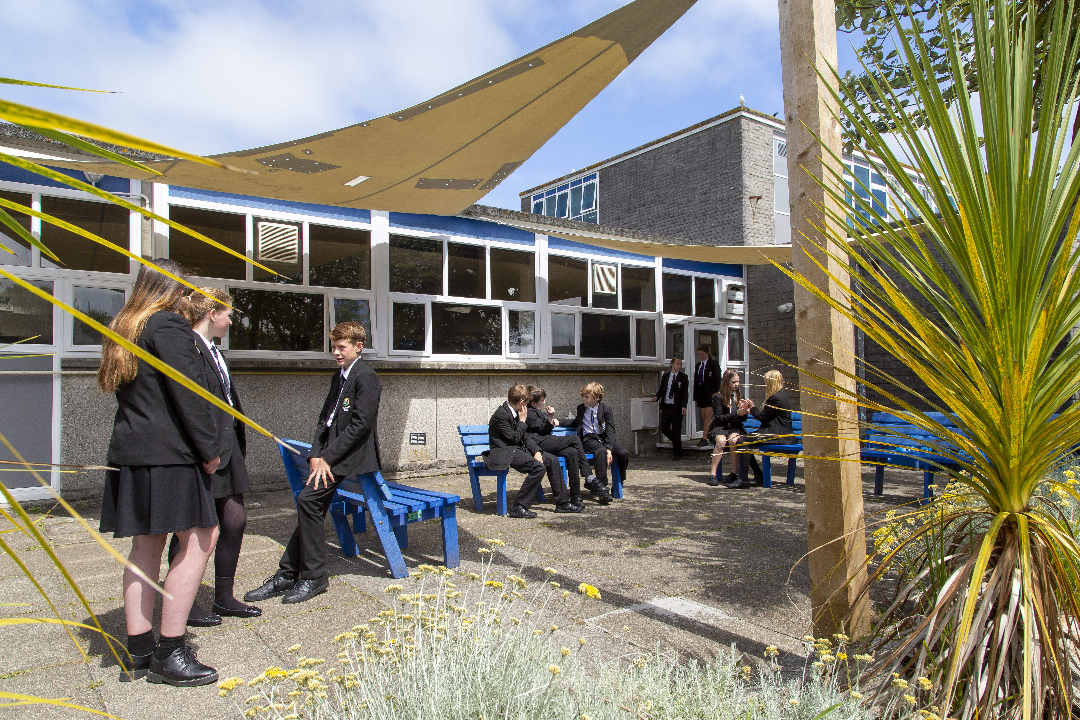

Maternity Cover Subject Lead of RSE
APPLICATION PACK

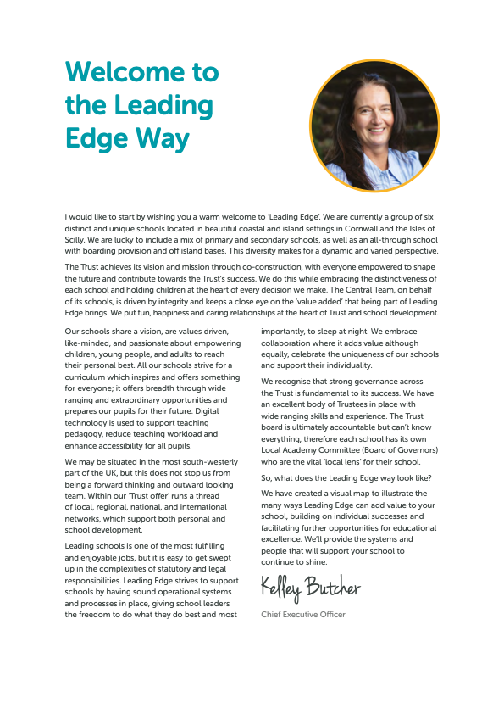
Principal – Mr S Royle BA Hons PGCE NPQH
Mounts Bay Academy
Boscathnoe Lane
Heamoor
Penzance
TR18 3JT
www.mountsbay.org

Salary scale: M1-UPS3 + TLR3 £2247.15
Contract Type: Fixed Term
Contract Term: Maternity cover start date November 2025.
Maternity Cover Subject Lead of RSE
We are seeking a talented, creative, and innovative Subject Lead of RSE to join our very successful Humanities team. Mounts Bay Academy is a caring and dynamic Academy where students are placed at the centre of everything we do. We provide a broad and balanced curriculum to all our students, who are set challenging academic and personal targets and given the inspiration to succeed.
Applications are welcome from colleagues who have a deep knowledge of PSHE and RSE. The successful candidate will also contribute to the development of strategic goals for the faculty and be able to project a vision within which students are well prepared for the world. We want you to show us that you understand how concepts, content and knowledge is organised and delivered; we want to know that you are up to date with what expert colleagues and specialist organisations are saying and it is important that you are passionate about sharing this with colleagues and students.
Is this post the right one for you? It is if:
- you are someone who can think critically about pedagogy and specialist-specific approaches.
- you are ambitious for students as well as yourself.
- you value and use research to extend your own repertoire to develop and coach others.
- it is your practice to use a wide range of pedagogical approaches because you can see their relevant in different contexts.
- you can articulate and justify the reasons why each might be used.
Specifically, we are interested in skilled practitioners who appreciate and understand the preconceptions and misconceptions students may have about a topic/area of study. Successful candidates will be able to show that they not only have a clear understanding of possible barriers to learning, but that they know how to select and use appropriate strategies to overcome these, especially for students with SEND and for those from disadvantaged backgrounds.
Mounts Bay Academy embraces the use of new technologies, providing 1-1 iPad devices for each child and an iPad Pro for each member of staff. We would welcome applicants who are innovative in their use of IT and can develop their use as a strategy to deliver outstanding lessons.
Application forms and information packs are available via our school website or upon request by telephoning the Academy.
For further information, please contact Malvina Jenkin,
Hr Manager at Mounts Bay Academy
(01736 352399 or email:mjenkin@mountsbayacademy.org

Closing date for applications:
Start: 27th Nov 2025
Interviews: TBC
Leading Edge Academies Partnership is committed to safeguarding and promoting the welfare of students and expects all staff to share this commitment

Please send your completed application form to Malvina Jenkin HR Manager at Mounts Bay Academy, Boscathnoe Lane, Heamoor, Penzance, TR18 3JT.
The successful candidate will be subject to reference checks with previous employers and an enhanced DBS disclosure check.

Welcome

Dear Applicant,

Thank you for expressing an interest in this post at Mounts Bay Academy, a member of the Multi Academy Trust called Leading Edge Academies Partnership (Leading Edge). I hope you find this information pack helpful and that in due course we shall receive an application from you.

Mounts Bay Academy is located in Penzance, West Cornwall with 950 students aged 11-16 years. This is a beautiful part of the world, enjoying a varied coastline surrounding rugged hills and moorland and it is a wonderful place to live and work.

Mounts Bay school converted to Academy status in 2011 and a year later was awarded an Outstanding grade in a full Ofsted Inspection. In November 2017 the Academy was inspected by Ofsted to review its safeguarding arrangements and the HMI visitors noted that the Academy had a fully inclusive culture and provided excellent support for vulnerable students. Since then, we were awarded a good grade in 2021 under the new Ofsted Framework introduced in 2019.

I have been the proud Principal of Mounts Bay since March 2024, and I am passionate about the Academy and the path that we need to follow. Whilst enjoying an enviable reputation in the local area, there is work to do in terms of outcomes, attendance and the quality of teaching and learning. Our priorities are explicit, and my style is very open and honest – there are no hidden agendas here!

We have recently introduced a new behaviour policy which is having very positive effects, and our teaching and learning policy has been stripped back to provide very clear expectations of staff and students. All strategies are supported by a comprehensive evidence-based programme of CPD, both internal, and through external bodies such the PTI, the Cornwall Research School, which we are delighted to lead, and the Challenge Partner network, where we are delighted to be the lead school in the Cornwall hub.

The Academy enjoys a range of impressive physical resources including a purpose-built science area, subject specific teaching areas in the Creative Arts as well as a lively and bouncing Music block. Sports facilities are strong, including a large sports hall, a 3G pitch and extensive outside field areas, all of which have significant community use. Plans are currently being made with Cornwall Council for an on-site ARB to provide further support to learners.

Mounts Bay Academy is an Apple Distinguished school, and each student and staff member is provided with a digital device to support their learning and work. We believe that students should be prepared for the world in which they will live when they leave the Academy and strive daily to ensure that we update our knowledge accordingly.

We are a learning community that aspires to success for all without exception, convinced that everyone can learn at the highest level, when presented with learning experiences that are as engaging as they are adventurous. We believe that all young people can achieve; it is our job to nurture the very best in each person by identifying their strengths and talents and removing any barriers to learning.

Mounts Bay is a caring and dynamic community where students are placed at the centre of everything that we do.

We provide a broad and balanced curriculum which is delivered by a team of skilled and dedicated staff, with the MBA way visible throughout the school, putting ‘Relationships, Respect and Responsibility’ at the centre of everything. Talent is celebrated, curiosity is nurtured, and every individual is given the chance to shine. We help to develop young people with a positive attitude to learning and life, ready to take on the challenges of our fast-changing world and to make a creative contribution to their community.

The successful candidate will be a brave, creative and visionary person, to join our staff to enable all to thrive in this ever-changing world. We are looking for a professional with a spirit of adventure who understands that high personal and academic standards and exciting learning can combine to change young people’s lives.

Mounts Bay Academy is committed to safeguarding and promoting the welfare of young people and we expect the candidate to share this commitment.

Since I joined the Academy, I have felt safe, I have been happy, I have felt challenged, and I have been genuinely welcomed into the Mounts Bay community. Is this not what all of us want from a school?

Please do get in touch if you would like to come and visit. I look forward to meeting you.

Yours sincerely

Simeon Royle
Principal


Job Description

Post Title: | Maternity Cover subject lead of RSE
Purpose: | To create, action and lead a holistic yearly action plan that transforms teaching and learning in your subject area to ensure that:  - All students have a high-quality learning experience because all learning programmes are designed to be conceptual, memorable, enjoyable and fully compatible with values-based education principles.  - All students have access to a range of cultural events and experiences that enhance their cultural capital and related studies.  - Outcomes are raised year on year for all groups.  - Achievement gaps rapidly narrow.
Reporting to: | Head of Humanities
Liaising with: | Principal/Vice Principals, teaching/support staff, LA representatives, external agencies and parents
Working time: | Within role
Salary/Grade: | MPS/UPS TLR3 £2247.15130 role commences Nov 2025.
Disclosure level: | Enhanced

MAIN (CORE) DUTIES
Main tasks | - The specific nature and balance of these responsibilities will vary according to the needs of the Academy and may be shared.
Class Teacher Responsibilities
• To carry out duties of an Academy teacher as set out in the current Academy Teachers’ Pay and Conditions Document.
• To carry out the duties of a general class teacher as detailed in the Academy’s class teacher job description, including some provision for cover of absent teachers.
• To be responsible for teaching across both key stages.
Internal Organisation, Management and Control
To contribute to:
- Maintaining and developing the ethos, values, and overall purposes of the Academy.
- Formulating the aims and objectives of the Academy and policies for their implementation.
- To contribute to planning improvement which will translate Academy aims and policies into actions.
- Implementing the Governing Body’s policies on equal opportunity issues for all staff and pupils in relation to sex, gender, race, disability, and special needs.
- The efficient organisation, management, and supervision of Academy routines.

Operational/Strategic Planning
- To development appropriate syllabuses, resources, schemes of work, marking policies and teaching strategies in the programme/subject.
- To contribute to the programme/subject’s development plan and its implementation.
- To plan and prepare courses and lessons.
- To contribute to the Whole Academy’s planning activities.
Curriculum Provision
To assist the Assistant Principal with Data, Standards and Progress, to ensure that the programme/subject provides a range of teaching that complements the Academy’s strategies and objectives.
Curriculum Development
To assist in the process of curriculum development and change to ensure the continued relevance to students’ needs, examining and awarding bodies and the Academy’s Mission and Strategic Objectives.
Staff Development
- To partake in the Academy’s staff development programme by participating in arrangements for further training and professional development.
- To continue personal development in the relevant areas including subject knowledge and teaching methods.
- To engage actively in the Continuous Career Development (CCD) process.
- To ensure the effective/efficient deployment of classroom support.
- To work as a member of a designated team and to contribute positively to effective working relations within the Academy.
Quality Assurance
- To help implement Academy quality procedures and to adhere to them.
- To contribute to the process of monitoring and evaluation of the Curriculum Area/Department in line with agreed Academy procedures, including evaluation against quality standards and performance criteria.
- To seek/implement modification and improvement where required.
- To review from time-to-time methods of teaching and programmes of work.
- To partake as may be required, in the review, development and management of activities relating to the curriculum, organisation and pastoral functions of the Academy.
Management Information
- To maintain appropriate records and provide relevant accurate and up-to-date information for MIS, registers, etc.
- To complete the relevant documentation to assist in the tracking of students.
- To track student progress and use information to inform teaching and learning.

Communications
- To communicate effectively with the parents of students as appropriate.
- Where appropriate, to communicate and co-operate with persons or bodies outside the Academy.
- To follow agreed policies for communications in the Academy.

Marketing and Liaison
- To take part in marketing and liaison activities such as Open Evenings, Parents’ Information Evenings, Progress Review Days and liaison events with partner schools.
- To contribute to the development of effective subject links with external agencies.

Management of Resources
- To contribute to the process of ordering and allocation of equipment and materials, whilst being conscious of efficiency savings.
- To assist the Head of Department to identify resource needs and contribute to the efficient/effective use of physical resources.
- To co-operate with other staff to ensure a sharing and effective use of resources to the benefit of the Academy, Department and students.

Pastoral System
- To be a Form Tutor to an assigned group of students.
- To promote the general progress and well-being of individual students and of the Tutor Group as a whole.
- To liaise with a Pastoral Leader to ensure the implementation of the Academy’s Pastoral System.
- To register the students in their Tutor Group, accompany them to assemblies, encourage their full attendance at all lessons and their participation in other aspects of Academy life.
- To evaluate and monitor the progress of students and keep up-to-date student records as may be required.
- To contribute to the preparation of Action Plans and Progress Files and other reports.
- To alert the appropriate staff to problems experienced by students and to make recommendations as to how these may be resolved.
- To communicate as appropriate with parents of the students and with persons or bodies outside the Academy concerned with the welfare of individual students, after consultation with the appropriate staff.
- To apply the Behaviour Management System so that effective learning can take place.

Teaching
- To teach students according to their educational needs, including the setting and marking of work to be carried out by the student in the Academy and elsewhere.
- To assess, record and report on the attendance, progress, development and attainment of students and to keep such records as are required.
- To provide, or contribute to, oral and written assessments, reports and references relating to individual students and groups of students.
- To ensure that ICT, Literacy and Numeracy are reflected in the teaching and learning experience of students.
- To undertake a designated programme of teaching.
- To ensure a high quality-learning experience for students that meets internal and external quality standards.
- To prepare and update subject materials.
- To use a variety of delivery methods that will stimulate learning appropriate to students’ needs and demands of the syllabus.
- To maintain discipline in accordance with the Academy’s procedures, and to encourage good practice with regard to punctuality, behaviour, standards of work and homework.
- To undertake assessment of students as requested by external examination bodies, Departmental and Academy procedures.
- To mark, grade and give written/verbal and diagnostic feedback as required.

Other Specific Duties
- To remain and adhere to the Trust’s Safeguarding Policy and child protection procedures.
- To play a full part in the life of the Academy community, to support its distinctive mission and ethos and to encourage staff and students to follow this example.
- To actively promote the Academy’s corporate policies.
- Be responsible for your own continuing self-development, undertaking training as appropriate.
- To be aware and adhere to applicable rules, regulations, legislation and procedures eg the Trust Equality and Diversity Policy, Staff Code of Conduct, national legislation and GDPR Data Protection Regulations.
- To comply with the Academy’s Health and Safety Policy and undertake Risk Assessments as appropriate.

As a restorative organisation we:
- Apply the principles of mutual respect and responsibility in all our internal and external relationships.
- Actively work to prevent, address and repair harm.
- Engage in continuous learning to further develop our communication and problem-solving skills.

Whilst every effort has been made to explain the main duties and responsibilities of the post, each individual task undertaken may not be identified.

Person Specification

Essential | Desirable | Demonstrated By
A commitment to safeguarding children and young people and an awareness of current national legislation relating to safeguarding and child protection. |  | Application Form / Interview
Graduate with QTS. | Further professional study at a higher level. | Application Form / Interview
Ability to teach PSHE and RSE to KS3 and KS4 | Experience of leading PSHE/RSE. | Application Form / Interview
A CPD portfolio with evidence of recent, relevant course participation and all academic qualifications. | Additional information. For example, students’ work or newspaper cuttings. | Interview
Recent experience of project management relating to Academy improvement. | Leadership of an innovative project with evidence of raised standards. | Application Form / Interview
Evidence of personal impact on the ethos of your school/ Academy or community. | Evidence of personal impact in education projects of county or national importance. | Application Form / Interview
An interest in making a contribution to the profile of the Associate Research School (EEF). |  | Application Form / Interview
A ‘can do’ positive attitude that seeks solutions to problems. | Evidence of creativity and a willingness to take risks and learn from mistakes. | Application Form / Interview
A willingness to role model good practice and act as a lead learner in the organisation. | Evidence of giving inset to others or doing research for school improvement. | Application Form / Interview
An interest in new approaches to learning. | A vision of how learning could be transformed in the Academy. | Application Form / Interview
A background in ICT for learning or admin. | Evidence of a qualification in ICT. | Application Form / Interview

