Shipston High School
___________________________
High achieving - Student-centred

Teacher of Maths

Candidate Information Brief

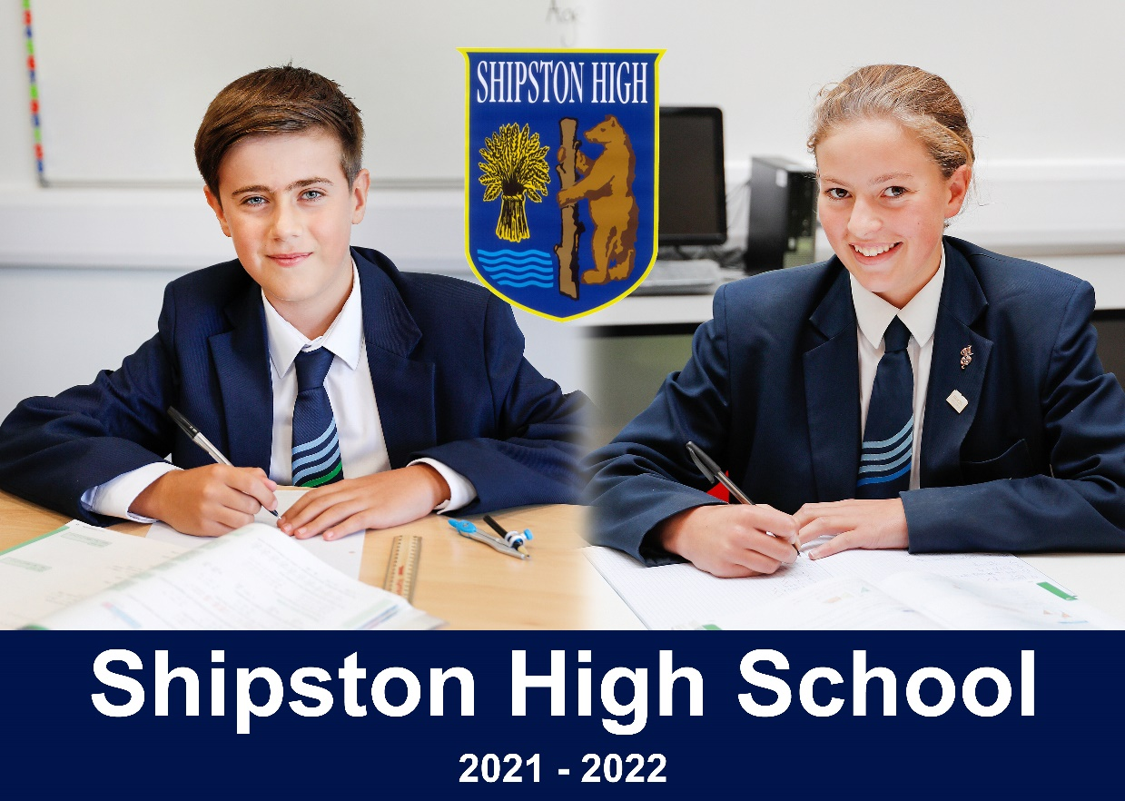

Darlingscote Road
Shipston on Stour
CV36 4DY

01608 661833 www.shipstonhigh.co.uk

October 2021
Dear Candidate,

Post of Teacher of Maths at Shipston High School

Thank you for your interest in this post. Shipston High School is a fantastic place to work, and I very much hope that you will wish to apply for this exciting job opportunity. The post of Teacher of Maths is a part time temporary position for spring and summer terms 2022. The post will be to teach students of all ages and abilities up to GCSE level.

Shipston High School has a unique school atmosphere, arising from our high expectations and our student-centred ethos. It is an ethos in which our teachers are able to focus on the wellbeing and academic progress of our young people. As a result, both students and teachers flourish. This post offers the successful candidate an exceptional opportunity for career development and will be of interest to both experienced and newly qualified teachers.

In our search for an outstanding practitioner we are seeking a teacher with a commitment to academic excellence and high standards. The successful applicant will have a good knowledge and understanding of the teaching of Maths to both Key Stage 3 and Key Stage 4 and will be able to demonstrate excellent pedagogy.

The mathematics department is highly successful. At GCSE in 2021, 76 % gained 9 to 4 grades, with over 25 % securing the top 9 to 7 grades. Students make excellent progress in the department. The department is at the forefront of implementing recent curriculum and assessment changes; they are an effective unit. The successful candidate will be joining a strong and supportive team, and will be able to work with an outstanding head of department to lead and develop provision.

This is a hugely exciting time for the school. At this point of significant national change in education, we are highly ambitious for our students and we recognise that our staff are essential to their success. Examination results have shown an impressive rise in the last few years and, as a result, the school is regularly oversubscribed.

Our students are our best advertisement. They are motivated, hardworking and well behaved. In March 2018, Ofsted noted that ‘pupils are a credit’ to the school, describing their conduct as ‘commendable’ and ‘unfailingly polite’.

For an informal, confidential discussion about the post or to arrange a visit please contact the Headteacher’s Secretary on 01608 661833 or at apunt@shipstonhigh.co.uk. Visits to the school are encouraged, and you will be most welcome. I wish you all the best with your application and very much look forward to hearing from you.

Yours sincerely,

Gavin Saunders

Headteacher

INFORMATION ABOUT APPLYING FOR THE POST

Please complete an application form and forward it by post or e-mail to Headteacher’s Secretary at apunt@shipstonhigh.co.uk

In your application please indicate (no more than 2 sides of A4) how you feel your experience to date has prepared you for this post and what strengths you feel you could offer the school. Please include specific examples of where your work has enhanced pupil progress.

Applications are welcome from both experienced and newly qualified teachers.

The closing date for applications is 9.00 a.m. on Friday 15th October 2021 with interviews planned for shortly afterwards.

INFORMATION ABOUT THE MATHS DEPARTMENT

Mathematics and numeracy have a high priority in the school which is reflected in the time allocated to them on the timetable. This is to ensure that our students have a vital foundation for future learning and are able to access the next steps in their education and careers.

The department itself consists of a lively, enterprising and supportive team. Currently there are five specialist teachers of mathematics in the school. One colleague also leads numeracy across the curriculum.

The department’s accommodation is excellent. The team utilise specialist classrooms in a contemporary teaching block, opened in September 2015. The rooms are equipped with the latest interactive technology and have access to further computers. The department is well-resourced and there are strong links between mathematics and other subjects.

The department is always keen to try new resources and pedagogical ideas, constantly striving to improve the quality of curriculum and learning experience the pupils at Shipston High receive. The department often welcomes visitors from other institutions who are keen to learn about our success. The department shares ideas and resources regularly and understands the importance of team planning.

Academically, the department has a strong track record of examination success. The department has been increasingly successful in raising standards in mathematics by reviewing its own classroom practice and by accessing good practice from elsewhere. The department’s results in the external exams of 2019 and the externally verified centre assessed grades of 2020 and 2021 were exceptional, demonstrating the energy, commitment and expertise of the team. 76% of pupils gained at least a grade 4 in 2021; progress was exceptional.

Mathematics is a core department, and important to the school. The current team are strong practitioners of impressive commitment. Pupils take their learning seriously. This vacancy is a unique career opportunity for the right candidate.

JOB DESCRIPTION

Title: TEACHER OF MATHS

Responsible to: Headteacher

Grade: Main Scale / Upper Scale

The Role
To teach Maths students in Key Stage 3 and Key Stage 4 up to GCSE level.

Key responsibilities
- Demonstrate highly effective subject teaching that motivates, inspires and improves student attainment
- Secure academic outcomes in line with the targets set through the school’s target setting policy
- Monitor, evaluate and continually improve the quality of your planning, teaching and assessment
- Analyse the performance data of your students and respond to the outcomes of assessment to ensure appropriate planning, teaching and interventions are in place to keep all students on track to achieve their targets
- Follow all areas of subject and school policy accurately and appropriately
- Create an orderly subject environment in which the school’s culture and ethos is upheld

Other
- Be a Form Tutor (where allocated)
- Contribute to the school’s extracurricular programme
- Undertake other various responsibilities as directed by the Head of Maths

Annual review
This job description will be reviewed annually. This is not a comprehensive statement of procedures and tasks but sets out the main expectations of the school in relation to the professional responsibilities and duties of the postholder.

PERSON SPECIFICATION

Title: TEACHER OF MATHS

The following will be assessed from applications, interviews and references:

Qualification criteria
- Qualified to at least degree level or professional equivalent
- Qualified to teach and work in the U.K.

Experience
- Evidence of raising attainment in the subject
- Evidence of improved practice following feedback
- Teaching in the secondary age sector

Behaviours

Teaching
- Up to date with latest pedagogy, curriculum developments and assessment requirements
- Excellent classroom teacher with a genuine passion and a belief in the potential of every student
- Effective behaviour management, with clear boundaries, praise, rewards and sanctions
- Good planning, organisational and communication skills
- Resilience, motivation and commitment to driving up standards of achievement for all students
- Commitment to regular ongoing professional development to improve practice
- A role model to students, parents and other staff
- Alignment to the Shipston High School ethos and vision
- Commitment to the safeguarding and welfare of all students

Other
- An excellent health and attendance record
- A satisfactory enhanced Disclosure and Barring Service check

INFORMATION ABOUT THE SCHOOL

Shipston High School is a non-selective 11-16 mixed High School with a very special ethos and character. Our students are high achieving and increasingly successful. The school itself is located on an attractive green-field site on the outskirts of Shipston-on-Stour in South Warwickshire. Our buildings are spacious and offer a wealth of specialist and general accommodation. Significant development of the site saw a first phase of new classrooms open in 2015, with a further teaching and reception block compled in the summer of 2018.

Visitors frequently remark on the distinctive ethos of Shipston High School. In particular, they praise the obvious energy and enthusiasm of staff and students, the excellent relations, and the happy and mutually respectful atmosphere. They also express admiration for the unusual confidence and maturity of our students and the way they rise to the challenge of taking on increasing levels of responsibility.

Some recent highlights
- The school has year on year been improving its examination results. In our most recent (2021) results over 75 % of students achieved standard passes in both Maths and English. Our increasing proportion of extremely able students has led to a rising proportion of GCSE passes at the very top grades of 7, 8 and 9; 25 % of the cohort in Maths.
- In our 2018 Ofsted inspection the school was judged to be good overall with our students seen as ‘a credit’ to the school.
- The school has achieved positive progress 8 outcomes in the majority of years this measure has been active.
- Owing to its continuing success the school has become increasingly popular and is now regularly oversubscribed. Numbers on roll are rising. We currently have nearly 600 students in the school but plan to expand over the forthcoming few years.
- The school became a new Academy on 1st September 2012 and has developed an imaginative and ambitious project to redevelop the entire school in phases. The first phase, a new £1.6M state-of-the-art teaching block, opened in September 2015, with the second £2.25M building opened in the summer of 2018.

Teaching and Learning

We put learning at the heart of everything we do. Staff have high expectations of all students, whatever their backgrounds or abilities, and we expect students to make the most of the many opportunities the school provides. Class sizes are kept as small as possible so that we cater more effectively for every student’s needs. We believe firmly in the importance of homework and independent study as important tools to help our students become successful, self-motivated learners.

Resources for Learning
The range and quality of our facilities ensure that teaching and learning is varied, interesting and successful. ICT facilities throughout the school have been increased and upgraded significantly during recent years.

All classrooms are equipped with audio visual technology; our students are learning in high quality, well-equipped subject environments.

The teaching was most enthusiastic and drew interested and involved responses from the students. The oral responses were particularly impressive. How well (the teachers) know their classes!

Visiting Governor

The School Curriculum
All National Curriculum subjects are taught through both Key Stages 3 and 4. Students are initially grouped by ability in most subjects at Key Stage 3. At Key Stage 4 all students follow a “core” curriculum and then choose from a wide range of options. The curriculum is robust, and fulfills national accountability measures whilst enabling a personalised programme for our learners.

Pastoral Care and Guidance
All students are expected to meet the very high standards of behaviour required of them. There is a very experienced pastoral team based on a House system that looks after the needs of all our students. We also rely on the support of parents to maintain our high standards.

We place a strong emphasis on establishing a caring community that encourages growth and confidence in all our students. Each student is assigned to a form and a form tutor whose purpose is to enable youngsters to obtain the best out of all aspects of the school life. The positive relationships that exist with our partner primary schools ensures that we have detailed information about students as they transfer at 11 years old.

During Years 10 and 11 students are encouraged to take on leadership roles by applying to become school prefects. They take on responsible duties and are expected to use their own initiative in helping with the day-to-day running of the school. Senior prefects are appointed annually.

Celebrating Achievement
Our school is founded on the belief that all students have talents and can achieve. We make it our mission to bring out the talents of our individual students and to celebrate their endeavours and successes at all levels. The school takes a proactive stance with regard to rewarding students for good behaviour, achievement, motivation and service to the school and wider community. Our system of rewards is designed to encourage positive attitudes above and beyond normal working expectations. Some examples of the many ways that we reward achievement include:
- Individual praise
- The award of merit points
- Letters, postcards and certificates sent home
- Celebration in House and whole school assemblies
- Inclusion on our “Success Board”
- Special, end of term “Celebration Assemblies”
- Letter of commendation from the Headteacher
- The “Shipston Award / Pixl Edge” scheme
- An award at our annual Awards Evening when students receive public recognition for their efforts and achievements

Extra curricular Activities
A wide range of opportunities exist for the students to be involved in sporting, dramatic, computing and musical activities. Our student participation rate is exceptionally high. We regularly compete on the sports field with neighbouring schools and youngsters are involved both locally and with county teams. We have staged many dramatic productions of varying types, along with regular music concerts. Opportunities also exist for students to take part in a wide range of educational visits to places in this country and abroad.

From the first telephone conversation to your school we were met with the utmost courtesy and attention and the boys who showed us round are to be particularly commended. They were truly ambassadors to your school and their knowledge, interest and enthusiasm for the school was clearly obvious to see. The comment from our son afterwards was that Shipston High School was his number one choice.

Prospective parent visiting the school

Communication with Parents
We are keen to see parents involved in helping their youngsters to learn. Much of this contact is achieved informally through parents coming into the school or by telephone. On a more formal level, regular consultation sessions take place including termly reports home. We also have a very active “Friends of Shipston High” Association.

Post 16 Destinations
On completion of their GCSEs the majority of our students leave school to follow a wide range of AS/A level and other post 16 courses at local sixth form centres and colleges. Many then go on to university and higher education in order to enter a wide range of professions and careers.

SHIPSTON HIGH SCHOOL’S SAFE RECRUITMENT PROCEDURE

Shipston High School is committed to safeguarding and promoting the welfare of children and young people and expects all staff and volunteers to share this commitment.

Disclosure
Shipston High School requires all employees to undertake an enhanced DBS check. You are required, before appointment, to disclose any unspent conviction, cautions, reprimands or warnings under the Rehabilitation of Offenders Act 1974 (Exceptions) Order 1975.

Non-disclosure may lead to termination of employment. However, disclosure of a criminal background will not necessarily debar you from employment – this will depend upon the nature of the offence(s) and when they occurred.

Shortlisting
Only those candidates meeting the right criteria will be taken forward for interview.

Interview
- Shortlisted candidates will be subject to an in-depth interview process including a lesson observation
- Candidates will be asked to address any discrepancies, anomalies or gaps in their application form

Reference checking
References from the previous and current employer will be taken up for shortlisted candidates, and where necessary employers may be contacted to gather further information.

Probation
All new staff will be subject to a probation period of three months (which may, in certain circumstances, be extended by up to a further three months). The probation period is a trial period to enable the assessment of an employee’s suitability for the job for which they have been employed. It provides the school with the opportunity to monitor and review the performance of new staff in relation to various areas, but also in terms of their commitment to safeguarding and relationships with students.

