BEVERLEY GRAMMAR SCHOOL

Teacher of Mathematics
Recruitment Information Pack

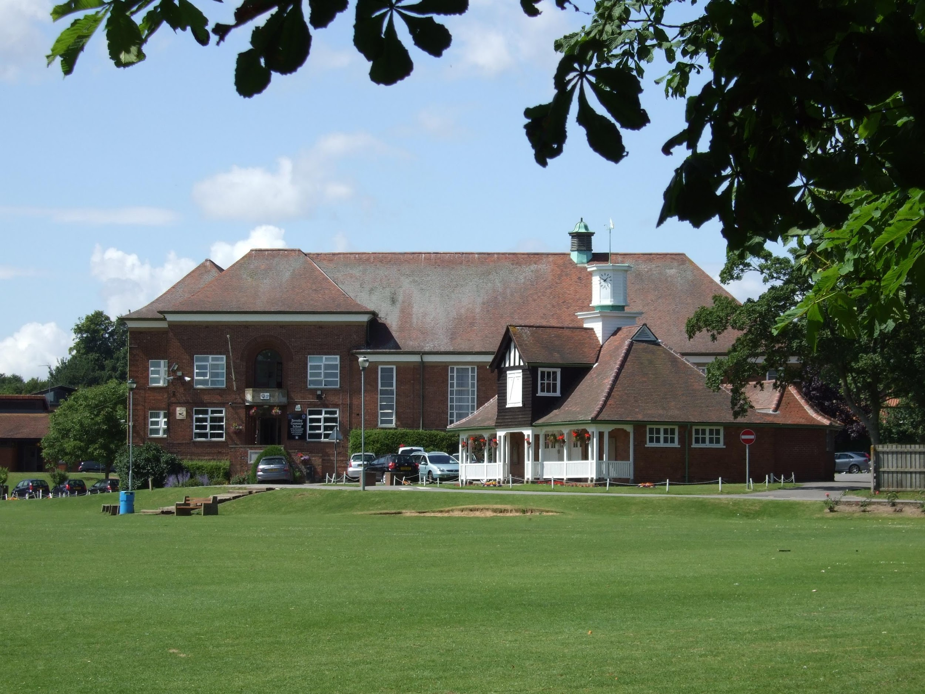

Beverley Grammar School
Queensgate
Beverley
East Yorkshire
HU17 8NF

BEVERLEY GRAMMAR SCHOOL

Teacher of Mathematics
Recruitment Information Pack

Contents

Letter from Gavin Chappell, Headteacher ............................................................................. 3

Beverley Grammar School Mission Statement…………………………………………….. 4

Application Process …………………………………………………………………… 5

Vacancy Advert ………………………………………………………………………….. 6

Department Information …………………………………………………………………… 7

Job Description ………………………………………………………………………. 8/9

Person Specification ………………………………………………………………………… 10

BEVERLEY GRAMMAR SCHOOL
Founded 700AD

Queensgate | Beverley | HU17 8NF
Headteacher Tel: 01482 881531| Fax: 01482 881564
Gavin Chappell email:office@beverleygrammar.co.uk
web:www.beverleygrammar.co.uk

November 2022

Dear Applicant

Thank you for taking an interest in the post of Teacher of Mathematics here at Beverley Grammar School. Your ability to inspire our students and your love of Maths teaching is incredibly important to us. This post represents a rare opportunity to join the Maths department of one of the area’s outstanding schools.

At Beverley Grammar we are proud of our unique ethos, underpinned by our core values of confidence, ambition, resilience and empathy. Though traditional in many respects we are also a forward-looking school, embracing modern methodologies where they are founded on secure, evidence-based practice.

We are an all-boys’ comprehensive school sharing a joint sixth form with our partner school; Beverley High School for girls. School results at GCSE and A level are an undoubted strength but these are underpinned by excellent pastoral support and care, as well as a commitment to develop our students as reflective, empathetic and tolerant citizens.

Our Maths department is composed of a dedicated team of teachers, who collaborate in all aspects of the mathematics curriculum. We are seeking an enthusiastic, committed and determined practitioner to support the Head of Department in realizing her vision.

The attached documents include a Job Description, Person Specification, details about the Maths Department as it currently stands, and a school application form. Please outline in your supporting letter, of no more than 2 sides of A4, how your experience and qualities will match the details given.

If you are enthused by these challenges, I look forward to hearing from you by the closing date of 29 November, 10 a.m. Interviews will take place at a date to be confirmed and selected candidates will be informed by e-mail. Further details will be provided once shortlisting has taken place.

Yours faithfully
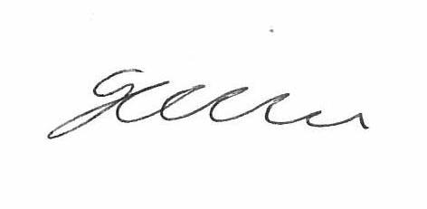
Gavin Chappell
Headteacher
Encs

BEVERLEY GRAMMAR SCHOOL

Mission statement

Our aims, devised by staff and students of BGS, are for students to

- Have the ambition and confidence to achieve their dreams
- Act with self-awareness and tolerance
- Have the independence and resilience to overcome barriers

In order to achieve these aims we will strive to

- Set high expectations and standards in all areas of school life
- Provide a consistent, respectful and highly supportive environment
- Create opportunities for students to become leaders
- Value the achievements and contributions of all students
- Make students experience at BGS memorable

BEVERLEY GRAMMAR SCHOOL

THE APPLICATION PROCESS

Completed applications should be:-

Posted to Mrs C. Hoyle,
Beverley Grammar School,
Queensgate,
Beverley,
HU17 8NF.

Emailed to apply@beverleygrammar.co.uk

Short-listed candidates will be contacted by email with details of the interview process. If you have not heard from us within 2 weeks of the closing date please assume your application has been unsuccessful.

Queries

If you have any queries on any aspect of the application process or need additional information, please contact Mrs C. Hoyle in the first instance on 01482 881531.

THE CLOSING DATE FOR APPLICATIONS IS:

29 November 2022 (10.00 am)
Interview Date - w/c 5 December 2022

Beverley Grammar School
Queensgate
Beverley
East Riding of Yorkshire
HU17 8NF
Headteacher: Gavin Chappell
Tel: 01482 881531

A Teacher of Mathematics is required for Easter 2023

Closing Date: 29 November 2022 (10.00 am)
Interview Date w/c 5 December 2022
Salary: MPS / UPS
Contract type: Full time, Permanent

We are seeking to appoint an impressive Mathematics specialist, with the ability to enthuse and inspire students, to join our excellent department. You will be an engaging classroom practitioner with a passion for the subject, who can demonstrate the commitment and determination to raise standards across all levels and abilities.

Applications from NQTs and experienced teachers are welcome. We have an excellent programme of CPD to help you reach your full potential.

Application forms and further details are available at www.beverleygrammar.co.uk Completed forms should be posted to Mrs C. Hoyle, or emailed to apply@beverleygrammar.co.uk

Beverley Grammar School is committed to safeguarding and promoting the welfare of children, young people and vulnerable adults. Clearance from the Disclosure and Barring Service is required prior to appointment.

BEVERLEY GRAMMAR SCHOOL
THE MATHEMATICS DEPARTMENT

The Mathematics department is a hard-working, dynamic group of teachers, who have a passion for teaching mathematics. It is made up of seven mathematics specialists, with the timetable being shared equitably between all members of the department. We have our own staff area and work as a very close-knit team, sharing ideas and supporting each other. We are looking for someone who is eager to join our enthusiastic team.

Years 7 to 9 are taught in three setted groups, split into two half year groups. The lower groups have between 10 and 15 students in each group, with the other sets consisting of approximately 30 students. In Years 10 and 11 we have block timetabling and this allows us to have 6 GCSE groups from a five-form entry; sets 1 to 3 have between 25-30 students and study the AQA Higher Linear Syllabus. Sets 4 to 6 consist of between 15-25 students and study the AQA Foundation Linear course. Students in set 1 also study the Further Mathematics Level 2 GCSE during year 10 and 11 which extends and supports their Mathematics GCSE. We also provide Entry Level Certificate qualifications to the very few students who find the GCSE inaccessible.

At A Level, we join with our sister school, Beverley High School and therefore the teaching is shared across both schools. At AS and A2 level, we offer Mathematics and Further Mathematics. The uptake at A Level is good, with approximately 60 students studying post 16 maths in total. We run two Mathematics groups and one Further Mathematics group per year. A Level Mathematics is a popular course; we have an excellent success rate with students studying mathematics or related subjects at Oxbridge and Russell Group universities.

We are a founding member of the KS5 Network group for the region and regularly work with the Advanced Mathematics Support Network in helping to develop A level Mathematics and Further Mathematics teaching across the region. Our Sixth Form Mathematics Enrichment programme provides support for STEP, UKCAT, BMAT and other similar entrance examinations for university.

The mathematics department prides itself on providing a rich and broad curriculum for its students. This includes cross-curricular activities: Cipher Challenge, the UKMT Team and Individual Challenges. Our students achieve some of the highest awards in the UKMT events, regularly our top students are selected for the follow-on rounds including being invited to attend Summer Schools hosted by Cambridge University and consideration in the preliminary rounds for the British Olympiad Team.

We teach in a building which is attached to the Sixth Form Centre. This consists of six Maths classrooms and a Maths staffroom. The department is equipped with interactive whiteboards in each room, and a range of Mathematics software is available to all staff. Each student has access to the relevant resources for their course online, and we support their learning at home with use of the MyMaths website.

As a department we constantly strive to ensure that we develop each child’s potential to the fullest, and we are committed to doing so through delivery of consistently high quality lessons, which are carefully differentiated to meet the needs of all students. Our team carefully monitor pupil progress, and use timely intervention and support where needed. This is frequently done in conjunction with our Learning Support department, with whom we have an excellent relationship.

This department is one that is highly motivated, and constantly seeking to develop our ideas and practices.
BEVERLEY GRAMMAR SCHOOL

TEACHING AND LEARNING CLASS TEACHER - JOB DESCRIPTION
Job title | Teaching and Learning Class teacher
Responsible to | Head of Department / Link SLT Manager / Headteacher
TLR | None
Duties: The duties outlined in this job description are in addition to those covered by the latest School Teachers' Pay and Conditions Document. It may be modified by the Headteacher, with your agreement, to reflect or anticipate changes in the job, commensurate with the salary and job title.
Key responsibilities
(a) Summary of post.
- Maintain a secure knowledge and understanding of your specialist subject and wider curriculum developments.
- Provide teaching and learning to students across the National Curriculum Levels range.
- Lesson preparation, classroom delivery, marking, assessing, reporting to parents according to school policy.
- Planning and preparation of courses and lessons for groups of students assigned to you, taking into consideration the educational needs of students within those groups.
- Using teaching methods, which engage students and stimulate their intellectual curiosity.
- Liasing with SENDCO to provide appropriate learning for all students, addressing the needs of gifted and talented students and providing tutorial support to students.
- Attend appropriate staff, student review, and departmental meetings.
(b) Planning, Procedures and Development
- To plan and prepare courses, schemes of work and individual lessons appropriate to the needs, interests, experience and existing knowledge of the pupils in one's class.
- Setting and supervising work by pupils: to teach classes, sets, groups or individual pupils, and to set tasks to be undertaken both at school and elsewhere as appropriate to school policy.
- Marking and recording: to mark and assess pupils' work and to record student development, progress and attainment, both at school and elsewhere.
- Discipline and relationships: to maintain good order, discipline and respect for others among pupils; to promote understanding of the school's rules and values; to safeguard health and safety; and to develop relationships with and between pupils conducive to optimum learning.
- Communication with parents: to build and maintain co-operative relationships with parents, and to communicate with them on pupils' learning and progress, drawing attention to special skills and talents as well as to problems or difficulties.
- The Classroom: to maintain an attractive and stimulating classroom environment, and to contribute to displays in the school as a whole.
- Overall policy and review: to take part in whole-school reviews of policy and aims, and in revising school guidelines.
- Reports: to provide or contribute to oral and written assessments, reports and references, both at school and elsewhere, relating to the development and learning of individual pupils and groups of pupils.
- Review: to evaluate and review one's own teaching methods, materials and schemes of work, and to make changes as appropriate (in line with Performance Management).
(c) Liaison, co-operation and Pastoral
- The teacher will work in liaison, contact and co-operation with: other members of staff, parents, governors, the local community, and advisory services.
- The teacher will work in liaison with organisations and networks relevant to the teacher's specialism or subject.
- Professional development: to keep up-to-date with current educational thinking and practice, both by study and by attendance at courses, workshops and meetings, and take part in appraisals and reviews of one's work arranged by the school.
- To maintain and undergo regular observations and participating in regular in-service training as part of continuing professional development (CPD).
- Liaising with other professionals, such as learning mentors, careers advisers, educational psychologists and education welfare officers as appropriate.
- Undertake pastoral duties, such as taking on the role of form tutor, and supporting pupils on an individual basis through academic or personal difficulties.
(d) Student Progress
- Organise and manage consistent procedures to monitor: student progress, attainment, teaching and learning, lesson plans, starters, plenaries, marking.
- Support departmental assessments both for external and internal exams.
- Support departmental procedures in encouraging positive student feedback procedures and assess and act upon the comments.
- Support the department in helping to assess students’ work and returning it promptly to students
- Encourage students to work to their potential.
- Maintain confidentiality and establish positive, mutually respectful relationships with students.
- Encourage positive pupil behaviour in the classroom and on the school premises and apply appropriate and effective measures in cases of misbehaviour.

Date approved | November 22 | Teacher signature
Date reviewed l | By agreement

Line manager |  | Headteacher | Gavin Chappell

The job description is current as at the date shown above. In consultation with the postholder it is liable to variation by the Headteacher to reflect or anticipate changes, in, or to, the post and the organisation. The job description gives an overview of the main responsibilities of the role. The daily job will also involve any other duties and responsibilities, express or implied, which arise from the nature and character of the post.

PERSON SPECIFICATION
Teacher of Mathematics
Key: Ess : Essential, Des : Desirable, A : Application, I : Interview, R : Reference
C : Certificate
 | Ess | Des | A | I | R | C
- Knowledge/Qualifications
Graduate with Qualified Teacher Status or QTLS | * |  |  |  |  | *
- Teaching and Learning
An ability to implement classroom strategies which motivate students to high standards of achievement | * |  |  | * | *
An ability to develop good working relationships with students and staff |  | * | * | * | *
An exceptional classroom practitioner | * |  | * | * | *
Excellent communication skills, oral and written | * |  | * | * | *
Confidence and competence in the use of Information and Communications Technology and knowledge of how ICT can be used to enhance students’ learning | * |  | * | *
An ability to be flexible | * |  | * | *
Ability to articulate the characteristics of effective teaching and learning | * |  |  | *
Understand how to ensure effective student learning through challenging, high quality and exciting teaching | * |  |  | *
Experience of effective monitoring and evaluation of teaching and learning | * |  | * | * | *
Good behaviour management strategies | * |  | * | * | *
Understanding the notion of accountability and Quality Assurance |  | * | * | *
Understanding of the principles and concepts of equality and fairness and a commitment to inclusive education for all | * |  | * | *
Enthusiastic and hard-working and able to contribute to whole-school projects | * |  | * | * | *
C. Skills
Thorough working knowledge of the Curriculum and recent initiatives | * |  | * | *
Knowledge of OFSTED requirements | * |  | * | *
Excellent administrative and communication skills | * |  | * | * | *
Excellent time management and organisational skills | * |  | * | * | *
Ability to manage resources effectively | * |  |  | *
Understanding of self-evaluation |  | * |  | *

