**KS3/KS4 Maths Teacher Required: Part time Outer London Main Pay Range/ Upper Pay Range plus pro rata SEN Allowance. 2 days per week.**

As our school roll expands, we have an exciting opportunity to join The Windmill School. We are seeking an enthusiastic and committed kS3/4 Maths subject specialist teacher.

We are especially keen to welcome to our organisation qualified teachers who have excellent maths curriculum knowledge from mainstream schools. We provide a programme of specialist autism training for all new members of staff, in addition to our ongoing CPD programme. We are looking for teachers who:

* Have QTS status who believe, inspire and achieve.
* Have maths curriculum knowledge from KS3 / KS4.
* Will enjoy developing positive relationships with young people, providing a model of excellence in terms of teaching & learning and role modelling.
* Will have an enthusiasm for new evidence-based approaches including the implementation of your ideas.
* Are reflective practitioners with a “can do” approach to teaching and with a passion to raise standards.
* Can support all students to believe they have the potential to thrive academically socially and emotionally.
* Are ambitious, professional and are committed to further personal development and committed to working as part of a dynamic team of professionals both in and out of the classroom.

The Windmill School is part of Barnet Special Education Trust, which is an organisation where all staff feel happy, valued and supported. We can offer the ideal candidate the following:

* Excellent CPD opportunities and the opportunity to work collaboratively alongside outstanding autism practitioners.
* Small class sizes and excellent staff: student ratio.
* A state-of-the-art new building designed especially for autistic learners.
* Outer London Pay Scale plus SEN Allowance
* Access to an Employee Assistance Programme which covers wellbeing, financial and legal support

Further information about this role can be found in the Job Description/Person Specification attachment.

To apply for this position please complete an application form (attachment) and return it to [vacancies@bsentrust.org](mailto:vacancies@bsentrust.org) by midday on Friday 10th January 2024.

If you are still unsure about applying for this role, we welcome visits to the school or we can arrange an informal chat with you about what the position will entail. Please call 020 3062 3600 to arrange an appointment.

*Barnet Special Education Trust are fully committed to safeguarding and promoting the welfare of children and expect all staff and volunteers to share this commitment. All posts are subject to an enhanced DBS check due to working with children, young people, and vulnerable adults. To be successful in your application you will be subject to a rigorous safer recruitment process including online searches for shortlisted candidates in accordance with KCSIE recommendations. Employees of the Trust must always adhere to a strict code of conduct regarding your behaviour. Barnet Special Education Trust is an equal opportunities employer.*

**Job Description**

**Post Held**: Maths Teacher MPR/UPR plus SEN allowance. Outer London pay range

**Employment Duties:**

The current School Teachers’ Pay and Conditions document describes duties which are required to be undertaken by teachers in the course of their employment. In addition, certain duties are reasonably required to be exercised and completed in a satisfactory manner. It is the contractual duty of the post holder to ensure that his/her professional duties are discharged effectively

**Exercise of general professional duties**

All teachers will be expected to carry out the professional duties of a teacher as outlined in the School Teachers’ Pay and Conditions Document 2023, or any subsequent legislation

**Purpose of Job:**

To teach maths to autistic learners and to carry out such other associated duties as are assigned by the Headteacher. To act within the statutory framework set out in the Teachers Standards (2012).

**Special Responsibility:**

* To develop a clear understanding of the needs of pupils that arises from autism and be able to apply distinctive teaching approaches to engage and support them (training and CPD will be provided).

**Reports to**: Headteacher

**Teaching and Learning**

* To implement school policies and schemes of work according to the individual needs of students, having high expectations and setting outcomes as part of the annual review cycle of the Educational Health and Care Plan (EHCP)
* To implement the curriculum in accordance with the school’s philosophy and policies
* Contributing to the whole school ethos by taking a leading role in creating an autism specific environment.
* To organise personalised learning activities and experiences which are differentiated to meet the individual needs and levels of achievement and motivation of each pupil.
* To ensure teaching programmes are supported by clear aims and objectives with appropriate links to recognised specialist approaches used within school underpinned by SCERTS and using principles of Intensive Interaction rooted in social relational models of child development (Training and CPD will be provided)
* Promoting the inclusion of all students within the classroom using a working knowledge of how to personalise learning.
* Assessing work and providing feedback to students and parents in line with school policy and practice.
* Contributing to the preparation and development of programmes of study, schemes of work, teaching materials, teaching programmes, methods of teaching and assessment and pastoral arrangements throughout the school, including school trips, assemblies, performances and special events
* To be responsible for planning, tracking, evaluating, assessing and reporting the teaching and learning of pupils, including; completing assessment systems including Evidence for Learning.
* Generating and updating Personal Snapshots and individual learning plans on a termly basis and preparing advice in accordance with the schools practices and policies.
* To lead on specific areas of teaching and learning within school as designated by Headteacher.
* To be responsible for safeguarding the health and welfare of pupils using appropriate risk assessments and incident /accident recording and reporting as required by the school
* To ensure in all teaching situations the collaborative nature of working between non-teaching staff, support services and parents.
* To maintain an inclusive and orderly learning environment through the effective management of resources, lesson planning and positive behaviour support.

**Other Activities**

* To safeguard every student’s health, safety and well-being in line with school policies, particularly those relating to child protection, equal opportunities, racial equality, health, safety and security, confidentiality, behaviour and data protection, reporting concerns to the designated person
* To promote the celebration of diversity and difference
* Communicate and co-operate with other agencies to support the educational, development, progress and well-being of individual students, participating in meetings arranged for any purposes described above, keeping records and making reports on the personal and social needs of students
* To communicate and consult with parents of students
* To participate in staff meetings as requested by the Head Teacher
* To supervise students throughout the school during play or unstructured free time or break or lunch requested by the Head Teacher.

**Training and Development**

* Participate in training and development activities in school or at other providers in order to improve professional skills and knowledge
* To participate in appraisal reviews in line with school policy
* Review and evaluate teaching methods and schemes of work

This job description is subject to amendment from time to time within the terms of the conditions of employment, as the needs of the school may require - but only to an extent consistent with those conditions of employment following consultation by all parties.

The agreed Grievance Procedure may be invoked in any dispute arising from this job description, or subsequent amendment, in which case teachers are advised to consult their professional association.

**Values and Ethos:**

**‘Celebrating Uniqueness’**

The Windmill School (TWS) will enable its pupils to access a full but relevant and meaningful curriculum that will allow them to achieve their potential in the least restrictive environment, informed by the latest approaches in the field of autism and education.

Our aim is to develop academic potential and prevent regression. Throughout planning, expectations will be high but realistic and based on thorough assessment of individual needs that arise out of the analysis of the individual’s sensory sensitivities, strengths and special interests. Personalised pathways of learning that build on this type of analysis will develop pupils’ self-esteem.

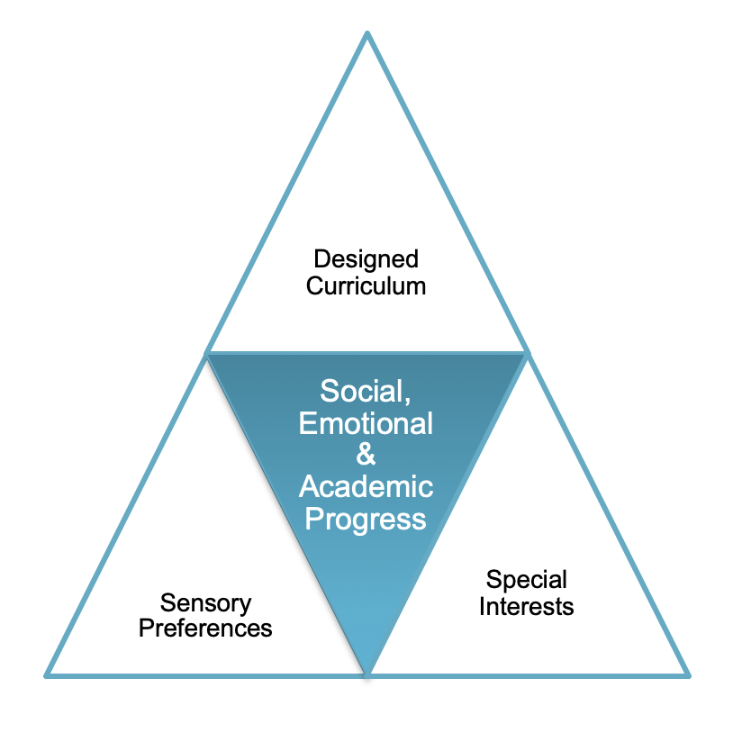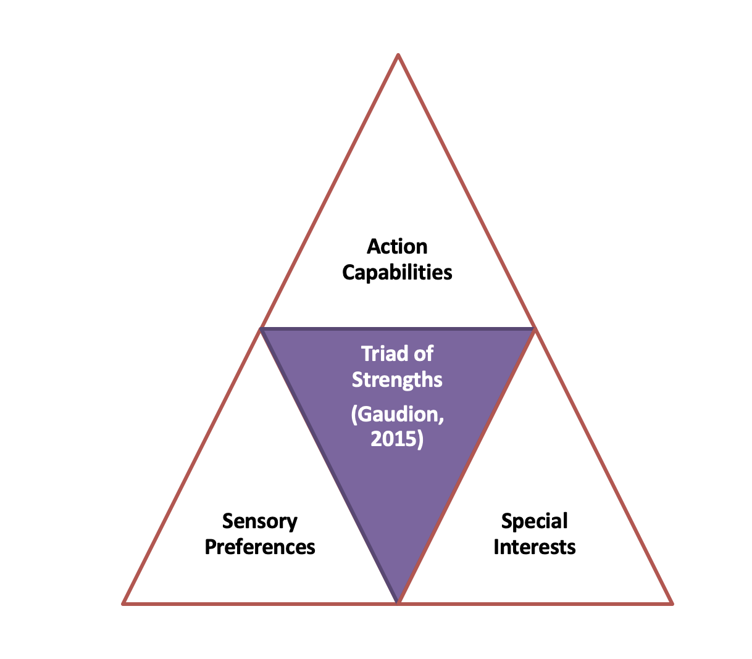Personalised programmes are designed on a model described as a triad of strengths rather than one of impairment.

The Windmill School will develop and conduct applied research to identify the best ways to directly improve the outcomes of its pupils and their families, and to ensure their wellbeing throughout their schooling and beyond by committing to the following within all provision planning:

* Autistic pupils need specialist, evidence-informed approaches in quality-first teaching practice to remove barriers and allow them to learn effectively inside and outside the classroom.
* Educating autistic pupils benefits from a whole-child approach, recognising that attention to pupils’ mental health and emotional well-being is just as important as their autism.
* Innovative and individualised methods of adapting the curriculum, utilising pupils’ strengths and interests, are essential for ensuring that it is accessible, effective and motivating for pupils.
* Close working relationships with parents, recognising their key role, expertise and joint decision making, as well as their need for support, is essential for ensuring that learning continues outside the school.
* Autistic pupils who are engaged in their learning, and who are active participants in decisions about their learning, are more likely to be confident learners.

**Person Specification**

|  |  |  |
| --- | --- | --- |
|  | Essential | Desirable |
| Qualifications | Qualified Teacher Status | Evidence of continuous INSET and commitment to further professional development |
| Experience | Delivering maths to students at secondary age range for our students in KS3 & 4  Working in partnership with parents. | Successful multi-agency collaboration.  Experience of teaching maths to neurodiverse learners. |
| Knowledge and understanding | Working knowledge and understanding of the National Curriculum and Secondary Syllabus for Entry Level and GCSE qualifications in maths.  The statutory requirements of legislation concerning Safeguarding, Equal Opportunities, Health & Safety, Prevent, SEN (EHCP & Annual Reviews)  The positive links necessary within school and with all its stakeholders; | The theory and practice and pedagogy suitable for teaching autistic pupils that includes all teaching and learning approaches and approaches to understanding emotional regulation  SCERTS framework (training will be provided)  B –Squared/ Evisense  Evidence for Learning |
| Skills | Promote the school’s aims positively, and use effective strategies to monitor motivation and morale;  Develop good personal relationships within a team & effective management of Teaching Assistants.  Establish and develop close relationships with parents, governor, Trustees and the community;  Communicate effectively (both orally and in writing) to a variety of audiences;  Create a positive, happy and purposeful learning environment.  Ability to manage time effectively to ensure the submission of reports on time.  Competent IT user | Develop strategies for creating community links. |
| Personal characteristics | Empathetic  Committed  Enthusiastic  Organised  Patient  Resourceful  Sociable  Resilient |  |