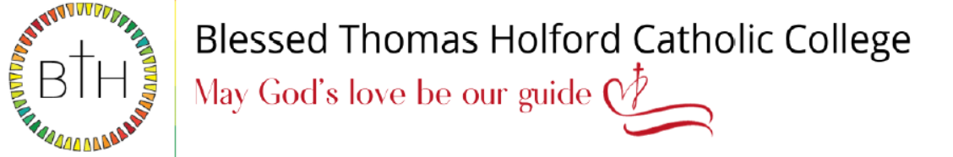

Teacher of Maths
Required for September 2024
Salary: MPR/UPR

We are an 11-18 Catholic School with 1,600 pupils on roll, including 220 in the Sixth Form. GCSE and A level results have been consistently excellent over several years and we are determined to make ourselves an exceptional educational provider. Our school is highly popular with parents/carers, and we are oversubscribed every year.

We are looking to appoint an enthusiastic and committed teacher of Maths, with the opportunity to teach KS5 for the right candidate.

This is an exciting opportunity for a highly motivated and ambitious person to develop their career in a forward-thinking school with high standards of achievement and care.

We offer:
- A supportive and committed school family
- A school with a desire to continuously improve
- Highly motivated and talented staff with a strong team ethic
- Ambitious and hardworking pupils

To Apply:
The job description and application forms are available on the school’s website: https://www.bthcc.org.uk/vacancies

All applications should be made using the CES application form

Completed application forms should be sent to: recruitment@bthcc.org

Closing date for applications is: 9.00 am on Monday 15th January 2024

Our school is committed to safeguarding and promoting the welfare of children and young people and we expect all staff and volunteers to share this commitment. An enhanced Disclosure and Barring Service (DBS) disclosure will be sought, along with other relevant pre-employment checks for the successful applicant.

