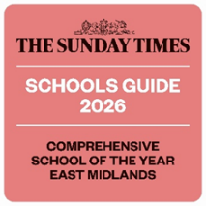 |   St Mary’s Catholic High School
Information Pack for Teacher of Maths from September 2026

St Mary’s Catholic High School has been serving the Catholic community in North East Derbyshire for 160 years. We are a geographically diverse community, who are united by the messages of Christ in the Gospel and the teachings of the Catholic Church.

It is our mission to ensure that each and every one of our pupils has the opportunity to fulfil their God-given potential, allowing them to ‘Live, Love and Learn in the Light of Christ’. We are committed to realising this through the provision of a highly ambitious but inclusive education rooted in academic excellence, holistic care, and religious formation.

Our broad and enriching curriculum sits alongside quality first teaching, outstanding pastoral support, and a comprehensive personal development programme to ensure our pupils go out into the world as knowledgeable, skilled, and confident citizens equipped with the capability and desire to contribute to the betterment of society.

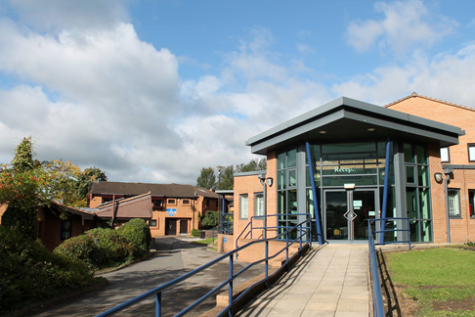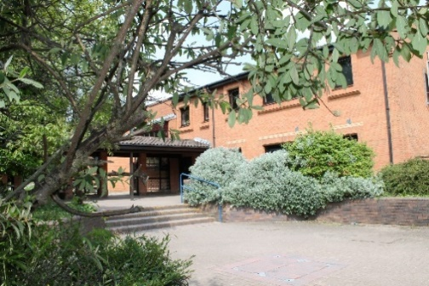

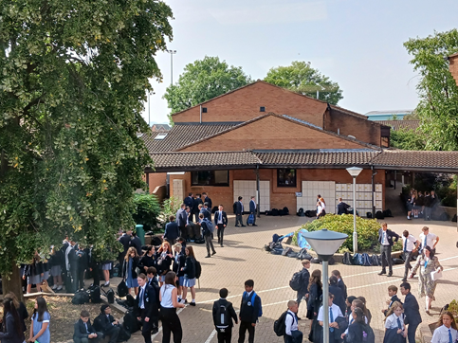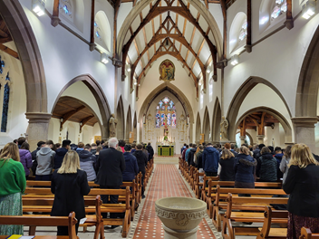

“Live, Love and Learn in the Light of Christ”

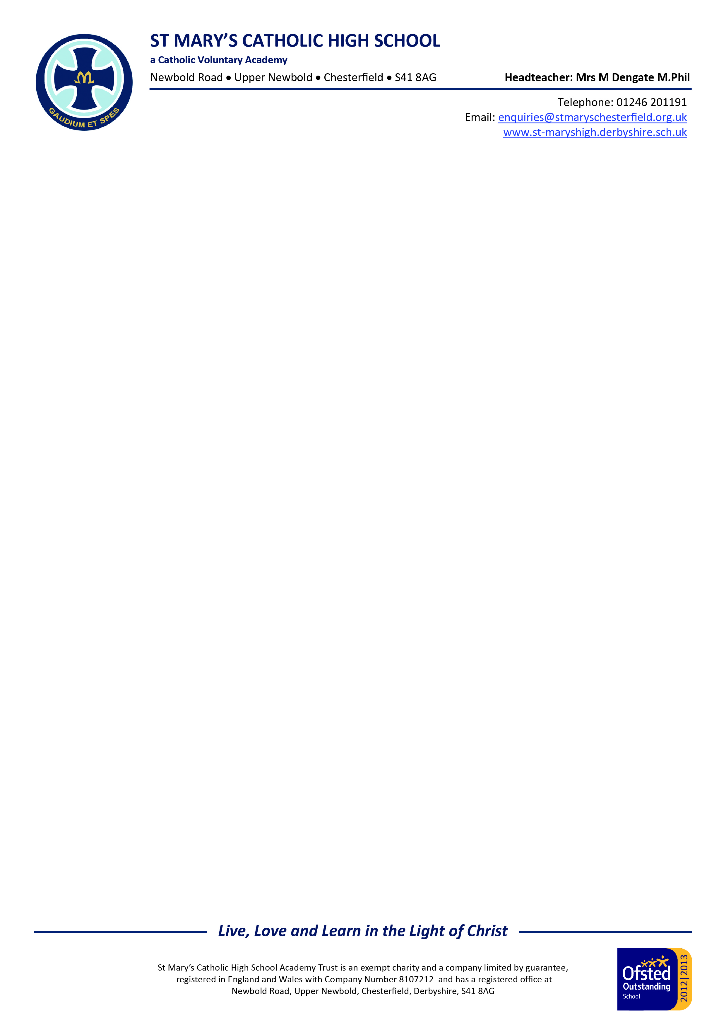

Dear Applicant
Teacher of Maths
Thank you for your enquiry regarding the above vacancy.
I am extremely proud to be Headteacher of St Mary’s Catholic High School. I believe that we are an excellent school and Ofsted judged us to be Outstanding in all areas when they visited us in June 2024, as did the Catholic Schools Inspectorate when they visited in March 2025. St Mary’s has also been named East Midlands School of the Year 2026, by The Sunday Times.
St Mary’s is an 11-18 Catholic Voluntary Academy serving North East Derbyshire. We are a thriving, highly successful and over-subscribed school with a long and well-established reputation and 160 years of history. Indeed, our record of academic achievements is outstanding, with examination results consistently well above the national average.
Many people talk about the outstanding results achieved by St Mary’s, and I am tremendously proud of the examination successes our young people achieve. However, my understanding of education is rooted in laying the foundations needed for life. I believe that school must enable children to build their spiritual life as well as their intellectual and moral capacity. Our priorities are therefore: academic excellence, holistic education and religious formation, with the support for the disadvantaged and vulnerable at the heart of the school.
Through the commitment of all members of the school community and the talents of my outstanding teaching colleagues, we therefore aim to tap into our pupils’ sense of awe, wonder and curiosity and so contribute to their spiritual growth.
I sincerely believe that St Mary’s is a place where faith, hope and love are fostered because the school is part of such a broad and supportive community of families and parishes, who share our belief that teaching is not just about communicating content but about forming young people.
We aim to cultivate a deeply supportive culture in which professional development and well-being are championed and prioritised. Our staff are highly valued, and we firmly believe they are the key to our continued success.
You are very welcome to visit our school prior to application – please contact my PA, Mrs Gilding, to make arrangements. If you pay us a visit you will be met with courtesy and politeness from students and staff alike.
All staff employed by the school are subject to disclosure of enhanced criminal records. Applicants must be aware that any issues raised by this process may mean that the offer of employment is withdrawn. Evidence of identity and the right to live and work in the UK will also be scrutinised along with confirmation of the home address, professional status, and references before any offer of employment becomes permanent.
The closing date is 10.00 am on 26 February 2026 and I look forward to receiving your application, which should be returned to my PA, Mrs Rachel Gilding.
Yours faithfully
Mrs M Dengate
Headteacher



APPOINTMENT PROCEDURE
Our appointment procedure will be based on the following:

• Shortlisting based upon skills and experience
• References and safeguarding checks prior to, during and after the interview process
• Lesson observation
- Professional discussion
• Formal interview panel

Applicants must complete the school’s Catholic Education Service application form and supporting documents (available from the school website or the Headteacher’s PA). We do not accept CVs and references will be sought prior to interview.

Closing date: 10.00 am on 26 February 2026

Application forms should be returned to rgilding@stmaryschesterfield.org.uk or posted to Mrs Gilding at the school’s address.

FURTHER INFORMATION FOR APPLICANTS

St Mary’s has a rigorous child protection policy. The successful candidate will receive formal induction to the school, which will include child protection and safeguarding issues. All staff at the school are DBS (Disclosure Barring Service) checked.

The successful candidate will need to provide the following documents at interview:

- Proof of identity:

One proof of Photo ID:
Passport
or
Photo Driving Licence

- Two utility bills with your name and address

- Evidence of Right to Work in UK:
Passport or birth certificate

- Qualifications:

Original certificates
or
Proof of qualification (not photocopies)

EQUALITY STATEMENT
We will comply with the requirements of the Equality Act (2010) and are committed to ensuring that throughout our recruitment and selection processes no applicant is disadvantaged or discriminated against because of the protected characteristics of age, disability, gender, gender re-assignment, marriage or civil partnership, pregnancy or maternity, race, religion or belief and sexual orientation.

SAFEGUARDING
St Mary’s Catholic High School is fully committed to safeguarding and protecting the welfare of its students. All offers of employment are provisional until such time as the school has undertaken appropriate safeguarding checks and is satisfied that successful candidates are suitable to work with children. All members of staff and volunteers are expected to familiarise themselves with the school’s child protection and safeguarding guidance and procedures and act accordingly.

TEACHING, LEARNING AND THE CURRICULUM
An ambitious, academic, and knowledge-rich curriculum that prepares students for the next stages of their lives is central to our provision. Our three-year Key Stage 3 enables pupils to study as broad a programme as possible for as long as possible, and we offer a full suite of traditional GCSE and A level subjects, alongside a range of vocational qualifications, to ensure that our curriculum meets the needs and aspirations of our students. Our curriculum is driven and underpinned by the knowledge and expertise of our highly capable staff.

Our teachers are proud to be champions of scholarship: we hold the very highest aspirations for the pupils in our care, and we cultivate and instil the positive academic behaviours that will enable students to become life-long lovers of learning.

At St Mary’s, we recognise that good and outstanding teaching takes many forms. The pursuit of excellence in Teaching and Learning is at the heart of our provision, and we celebrate the wide variety of teaching styles and pedagogical approaches that our staff take in ensuring outstanding pupil progress. We believe that pedagogical diversity is an asset and we are committed to maintaining and celebrating this through our approaches to professional development.

PROFESSIONAL DEVELOPMENT
St Mary’s prides itself on the way in which it welcomes and supports new staff. Each new member of staff is allocated a mentor who, alongside the line manager and other colleagues, can provide support and guidance, ensuring a smooth transition. A programme of weekly induction sessions provides the opportunity to meet key members of staff and to be introduced to school policies and procedures. Bespoke ongoing professional development is a priority, and all staff are able to access high-quality, carefully tailored training and development opportunities, including the observation of teaching and the sharing of practice. New staff are also warmly invited to join in a range of staff social activities and clubs.

A comprehensive programme of support is also in place for ECTs, and each ECT receives the guidance of an induction tutor, a departmental mentor, and a ‘buddy’, in the form of a recently qualified teacher. Training is highly personalised and a weekly programme of CPD offers a wealth of opportunity for professional development. Regular one to one meetings support an ECT through the induction process. New staff are supported at all times by the Head of Professional Development.

MISSION AND ETHOS
At St Mary’s, we are a community inspired by the belief that we are all God’s creation and as such we should ‘live, love and learn in the light of Christ’. We are an inclusive and welcoming school where students receive high-quality teaching in an environment underpinned by Gospel values such as compassion, care, and justice. The school’s mission is centred on the principle that as teachers, we are helping both ourselves, and our students, to become the people that God intended us to be. It is vital, we believe, that student progress and wellbeing is considered at all levels. By taking this holistic view, we believe that we are enabling our students to get the very best out of every opportunity provided here. Throughout the academic years we offer religious retreats and trips which enable our pupils to engage with their spirituality and to further embed their own key beliefs. The prayer and liturgical life of the school is important too, and as such, we follow the liturgical calendar of the Catholic Church and celebrate Mass at key points throughout the year.

STAFF WELLBEING
Staff wellbeing is important to the Headteacher and is of the utmost concern when key decisions are taken regarding the life of the school. The Headteacher operates an open-door policy and at all times staff are able to meet with their senior link colleague to discuss any concerns or issues they might have. Throughout the year, opportunities are given to develop and support the wellbeing of staff, and each department will offer their own wellbeing opportunities.

PASTORAL CARE
St Mary’s strives to be a Catholic community in which the principles of care and respect are valued, with emphasis on the development of the young person through academic achievement, holistic personal development, and religious formation. We aim to give every pupil the most appropriate opportunities to learn and develop to become the best that they can be. We take our ethos from Gospel values and work to draw out the potential in every young person.

The most important influences on a child’s values, attitudes and standards are those of family, home and community. We aim therefore, to work in close partnership with parents and carers to encourage all our pupils to have good manners, be kind and develop a sense of responsibility, self-discipline, respect for themselves, for others and for their environment. We recognise that education is a collaborative and cooperative enterprise and that although we emphasise our role in meeting individual needs, those needs must be met within the shared community life of the school and within an atmosphere which is positive, supportive, and conducive to learning.

It goes without saying that every member of staff has a role to play in Pastoral Care in St Mary’s. Every teacher is expected to be interested in a child’s overall development and should be trying to encourage good social and moral habits as well as academic potential. Good relationships between staff and pupils are extremely important. The key to any successful Pastoral System and to the success of the school are the qualities, abilities and commitment shown by the Form Tutor. With such a large pupil population the form teacher is the “lynchpin” of the Pastoral System in St Mary’s. The Form Tutor is supported by the Head of Year, the Head of Key Stage, and the Leadership Group.

Key Pastoral Staff
Designated Safeguarding Lead Miss H McKay
Deputy Designated Safeguarding Lead Mrs M Bowerman
Deputy Headteacher (Behaviour & Attitudes) Mr A Breedon
Assistant Headteacher (i/c Sixth Form) Mr P Maydom
Head of Key Stage 3 Mr J Slater
Head of Key Stage 4 Miss E Drury
PSHE & Careers Lead Dr E Dando
Director of Inclusion & SENDCO Mr C Atkinson

Heads of Year
Year 7 Mrs C Thurlow
Year 8 Mr H Strachan (Acting)
Year 9 Mr R Hancock
Year 10 Miss C Egan
Year 11 Mrs D Shaw
Year 12 Mr A Peach
Year 13 Mr M Bigg

Wellbeing Team
Counsellor Ms N Pledger
Family Resource Worker & Early Help Co-ordinator Mrs M Bowerman
Pupil Welfare & Early Help Support Worker Mrs R Torinsci-Furness
First Aid Lead Miss F Gibson

PUPIL BEHAVIOUR, SUPPORT AND DISCIPLINE
At St Mary's, positive behaviour is recognised and rewarded at every opportunity; everyone is encouraged to achieve, and success is celebrated at all levels. The value of service and giving back is promoted by all to help our young people understand that our core duty throughout life is to do our best for one another; and in doing this we may open our young people's minds to the inner meaning and coherence in life and all creation.

A high standard of behaviour and courtesy is demanded of pupils both inside and outside school.

Our pastoral system at St Mary's provides the framework to ensure behaviour and welfare policies are applied fairly, appropriately, and consistently across the school. Our behaviour and welfare policies underpin all aspects of school life, and our Catholic ethos is imbued through robust and rigorous procedures to reward, support and guide pupils. Our approach is underpinned and executed by the Gospel values of compassion, tolerance and forgiveness. Our behaviour policy provides the firm foundation to support the delivery of a first-class education for all.

It is the Headteacher's responsibility working with the Leadership Group and Heads of Key Stage to make judgements and interpret the behaviour policy on the day-to-day issues which the school faces in meeting our Mission Statement to ‘Live, Love and Learn in the Light of Christ.’ It is for all staff to play their part in making sure that the attitudes to learning and standards of discipline, behaviour and appearance, are of the highest order.

St Mary's Catholic High School believes that achieving success is a shared responsibility between the pupil, parents/carers, and staff and as such, parents/carers are asked to sign the home-school agreement. School will notify and involve parents/carers when a pupil is being successful, as well as when things go wrong. Parents/carers are asked to alert school to anything that may affect their own child’s behaviour or that of other pupils. Teachers will try to provide learning opportunities that are interesting and challenging and which match the ability of our pupils. All staff are expected to model the behaviour and attitudes they expect from pupils, listen to pupils when they have a problem, and follow school processes and procedures to offer the relevant support.

GCSE (Or Equivalent) – Key Stage 4 Results
 | 2023 | 2024 | 2025
Progress 8 | 0.37 | 0.5 | N/A
Attainment 8 | 57.80 | 56.6 | 59.64
Basics (9-4 English & Maths)  (9-5 English & Maths) | 83.0  67.5 | 83.4  63.2 | 85.9  73.7
% Entering the English Baccalaureate | 45% | 39% | 53%
Destinations - students staying in education or employment after KS4 | 100% | 96.59% | 100%
% grades 9-7 | 42.5 | 33.2 | 38.9
Number of Students in Year 11 | 206 | 205 | 205
Girl / Boy ratio | 48/52 | 52/48 | 52/48

Post 16 – Key Stage 5 Results (A level)
 | 2023 | 2024 | 2025
Value Added | N/A | 0.17 | 0.08 (TBC)
Average points per entry | 36.63 | 38.4 | 38.84
Average grade per A Level entry | B- | B | B
2+ A*AB in facilitating subjects | 23.5% | 27.8% | 25%
Achieving A* - E grades % | 99.4% | 100% | 100%
Achieving A* - B grades % | 55.3% | 64.4% | 63.3%
Number of students at the end of Y13 | 165 | 149 | 163
Girl / Boy ratio | 58%/42% | 66%/34% | 51%/49%

INFORMATION ABOUT THE MATHS DEPARTMENT

The Mathematics Department is led by Mr Kieren O’Sullivan and currently comprises thirteen specialist Mathematicians, supplemented by specialised support staff who also contribute some maths teaching. We are a hardworking, inclusive, and committed team that has high expectations of both ourselves and our pupils.

In Year 7, pupils are currently taught in sets across two broad ability bands which are then refined into vertical sets from Year 8 to Year 11. We also have 4 A-Level Mathematics groups in each year and 1 Further Mathematics group in each year, with around 190 students studying A-Level Maths or Further Maths across the 6th form. The majority of staff in the department teach at least one group of A-Level Mathematics. A variety of teaching styles are used to encourage students to work both independently and in small groups. We encourage all pupils to use a variety of methods in their work, allowing their mathematical creativity to shine through. Staff are encouraged to use and develop a wide variety of resources, with collaborative planning central to our department. Technology is used effectively within the department, and we are constantly improving and innovating our teaching to allow our students to make outstanding progress.

Our students are actively encouraged to seek help outside of class, and we believe our success is based upon our department being open, approachable, and supportive. We pride ourselves on the support that we offer our students, both inside and outside of the classroom. Students partake and compete in a wide variety of enrichment opportunities, allowing them to be supported, stretched and challenged outside of the classroom. All staff within the department contribute to these enrichment opportunities.

We look forward to welcoming you into our department!

GCSE MATHEMATICS
 | 9 | 8 | 7 | 6 | 5 | 4 | 3 | 2 | 1 |  | U | % 9-4 | No entered
2023 | 21 | 23 | 28 | 39 | 41 | 25 | 16 | 6 | 5 |  | 1 | 86 | 205
2024 | 13 | 24 | 28 | 29 | 43 | 44 | 15 | 2 | 3 |  | 0 | 90 | 201
2025 | 18 | 31 | 37 | 34 | 44 | 18 | 15 | 4 | 3 |  | 0 | 89.2 | 204
LEVEL 2 CERTICATE IN FURTHER MATHEMATICS
 | 9 | 8 | 7 | 6 | 5 | 4 | 3 | 2 | 1 | U | % 9-5 | No entered
2023 | 7 | 11 | 10 | 8 | 0 | 1 | 0 | 0 | 0 | 2 | 92.3 | 39
2024 | 2 | 4 | 9 | 7 | 10 | 4 | 0 | 0 | 0 | 17 | 60 | 53
2025 | 10 | 4 | 11 | 12 | 3 | 0 | 0 | 0 | 0 | 1 | 97.5 | 41
A Level MATHEMATICS
 | A* | A | B | C | D | E | U | No entered
2023 | 11 | 16 | 6 | 19 | 4 | 3 | 0 | 59
2024 | 21 | 15 | 11 | 3 | 2 | 1 | 0 | 53
2025 | 17 | 21 | 12 | 5 | 5 | 1 | 0 | 61
A Level FURTHER MATHEMATICS
 | A* | A | B | C | D | E | U | No entered
2023 | 2 | 3 | 2 | 0 | 1 | 0 | 0 | 8
2024 | 2 | 5 | 6 | 0 | 1 | 0 | 0 | 14
2025 | 6 | 1 | 7 | 4 | 0 | 0 | 0 | 18



St Mary’s Catholic High School

Job Description & Person Specification

Teacher of Maths

Safeguarding
St Mary’s Catholic High School is fully committed to safeguarding and promoting the welfare of its students. All members of staff will be vetted according to established procedures. All members of staff will familiarise themselves with the school’s child protection and safeguarding guidance and procedures and act accordingly.
Position: General Classroom teacher (QTS)
Purpose of the Post:
To carry out the professional duties of a teacher, as defined in the professional standards for QTS
To whom the Post Holder reports:
The Head of Department, Members of the Leadership Group, the Headteacher
Generic responsibilities:
- To promote and emphasise the distinctive Christian/Catholic ethos of our school.
- To carry out the duties of a general classroom teacher as set out in a separate job description.
- Where appropriate - to be a form tutor (as set out in a separate job description).
- To carry out a share of supervisory duties and cover duties in accordance with published lists and rosters.
- To abide by the generic terms and conditions as set out in the contract of employment and conditions of service.
- To have high expectations of all pupils and be committed to raising their educational achievement and progress.
- To demonstrate and promote positive values, attitudes, behaviour and appearance which we expect from our pupils.
- To contribute to, and share responsibility in, the corporate and faith life of the school.
- To treat pupils consistently, with respect and consideration.
- To comply with the requirements of the Equality Act (2010) and the school’s commitment to ensure that no employee is disadvantaged or discriminated against because of the protected characteristics of age, disability, gender, gender re-assignment, marriage or civil partnership, pregnancy or maternity, race, religion or belief and sexual orientation.

Main Areas of Responsibility and Accountability:
- To be an inspiring subject teacher who can enthuse pupils and build positive relationships with them.
- To have outstanding subject knowledge and a passion for academic excellence.
- To have regard for, and support of, the distinctive ethos of our school.

- To teach effectively those classes defined by the Headteacher and Head of Department.
- To have consistently high expectations of all pupils and plan astutely to set aspirational targets and challenging tasks based upon systematic, accurate assessment of pupils’ prior knowledge and understanding.
- To generate high levels of enthusiasm and motivation as well as consistently promoting and modelling the positive attitudes, values and behaviours expected of pupils.
- To enable all pupils to make rapid and sustained progress.
- To have excellent subject and curriculum knowledge.
- To be able to plan astutely, inspire a keen interest in the subject and promote scholastic excellence, including high levels of literacy.
- To plan and teach engaging lessons.
- To use well-judged and imaginative teaching strategies that match pupil need and ensure activities support pupils in firmly embedding knowledge, skills and understanding.
- To be able to differentiate and intervene in a sharply focussed manner.
- To stretch and challenge pupils where appropriate and identify and support those falling behind.
- To closely meet pupil needs, leading to extremely high levels of resilience, confidence and independence.
- To make highly effective use of accurate and systematic assessment to plan astutely based upon a clear comprehension of pupils’ prior knowledge, skills and understanding.
- To ensure that marking and constructive feedback is high quality and frequent, ensuring that pupils understand how to improve their work and enable them to extend their learning.
- To have consistently high expectations and effectively employ a range of learning and behaviour management strategies to ensure that all pupils are highly focussed.
- To ensure that pupils demonstrate high levels of engagement and exceptional behaviour at all times.
- To set and mark homework in line with school policy.
- To provide constructive feedback to pupils on the quality of their work. This involves the regular marking of books in line with Departmental policy and recording assessment data.
- To know and understand the relevant Departmental Programmes of study.
- To participate fully in the appraisal process.
- To attend and contribute to parents’ evenings as required by the Headteacher.
- To participate in meetings as defined by the Headteacher.
- To know and understand your responsibilities under the SEN Code of Practice.
- To communicate with parents or agencies as appropriate
- To work effectively with any other adult assigned to the class.
- Involvement in and organisation of wider school activities, including extra-curricular activities.
- To be a form tutor.

Person Specification
Teacher of Maths

Personal and Interpersonal Qualities | Essential | Desirable
Be prepared to adopt and support the core values and ethos of St Mary’s Catholic High School, in order to play your part in providing high quality education and support to our students and other staff colleagues | ✓
Understand, promote and uphold policies for safeguarding children and young people | ✓
Maintaining absolute confidentiality and integrity; being trustworthy and honest | ✓
Excellent interpersonal and communication skills; a non – judgemental team player | ✓
Positive, ‘can do’ approach to tasks and workload | ✓
Calm and patient; emotionally resilient in challenging situations | ✓
Energetic, enthusiastic and good attendance and punctuality | ✓
Professional in attitude, conduct and appearance – a role model to young people | ✓
Planned and organised approach to workload | ✓
Excellent written and verbal communication skills | ✓
Good ICT skills | ✓
Thinking laterally and open to new ideas and approaches | ✓
Committed to professional training and development | ✓
Committed to equality and diversity | ✓

Qualifications, understanding & experience | Essential | Desirable
Appropriate First degree (2ii minimum pass). | ✓
Have achieved Qualified teacher status, prior to beginning employment. | ✓
A continued commitment to own professional development. | ✓
Ability to teach A Level Maths |  | ✓
Ability to teach Further Maths |  | ✓
Understanding of child-safeguarding issues and successful measures that promote and ensure the safe-guarding of children | ✓
Knowledge of current legislation, guidance and developments relating to the subject area. | ✓
Successful practice (including training practice) in accordance with the specified teaching standards 2012 (as identified below).
Involvement in and organisation of wider school activities, including extra-curricular activities. |  | ✓

How to find us:

St Mary’s Catholic High School

Newbold Road

Chesterfield

Derbyshire S41 8AG

Telephone number: 01246 201191

We are situated in North East Derbyshire close to Chesterfield town centre, a thriving and popular market town in the Derbyshire Peak District. We have good access to Sheffield, Derby and Nottingham via the M1.

BY CAR

Exit M1 Junction 29 or 30, following signs towards Chesterfield

If you wish to use your Sat Nav to find us, use postcode S41 8AG. Please park in the main car park (overflow parking available in the Bus Bay until 3.00 pm)

