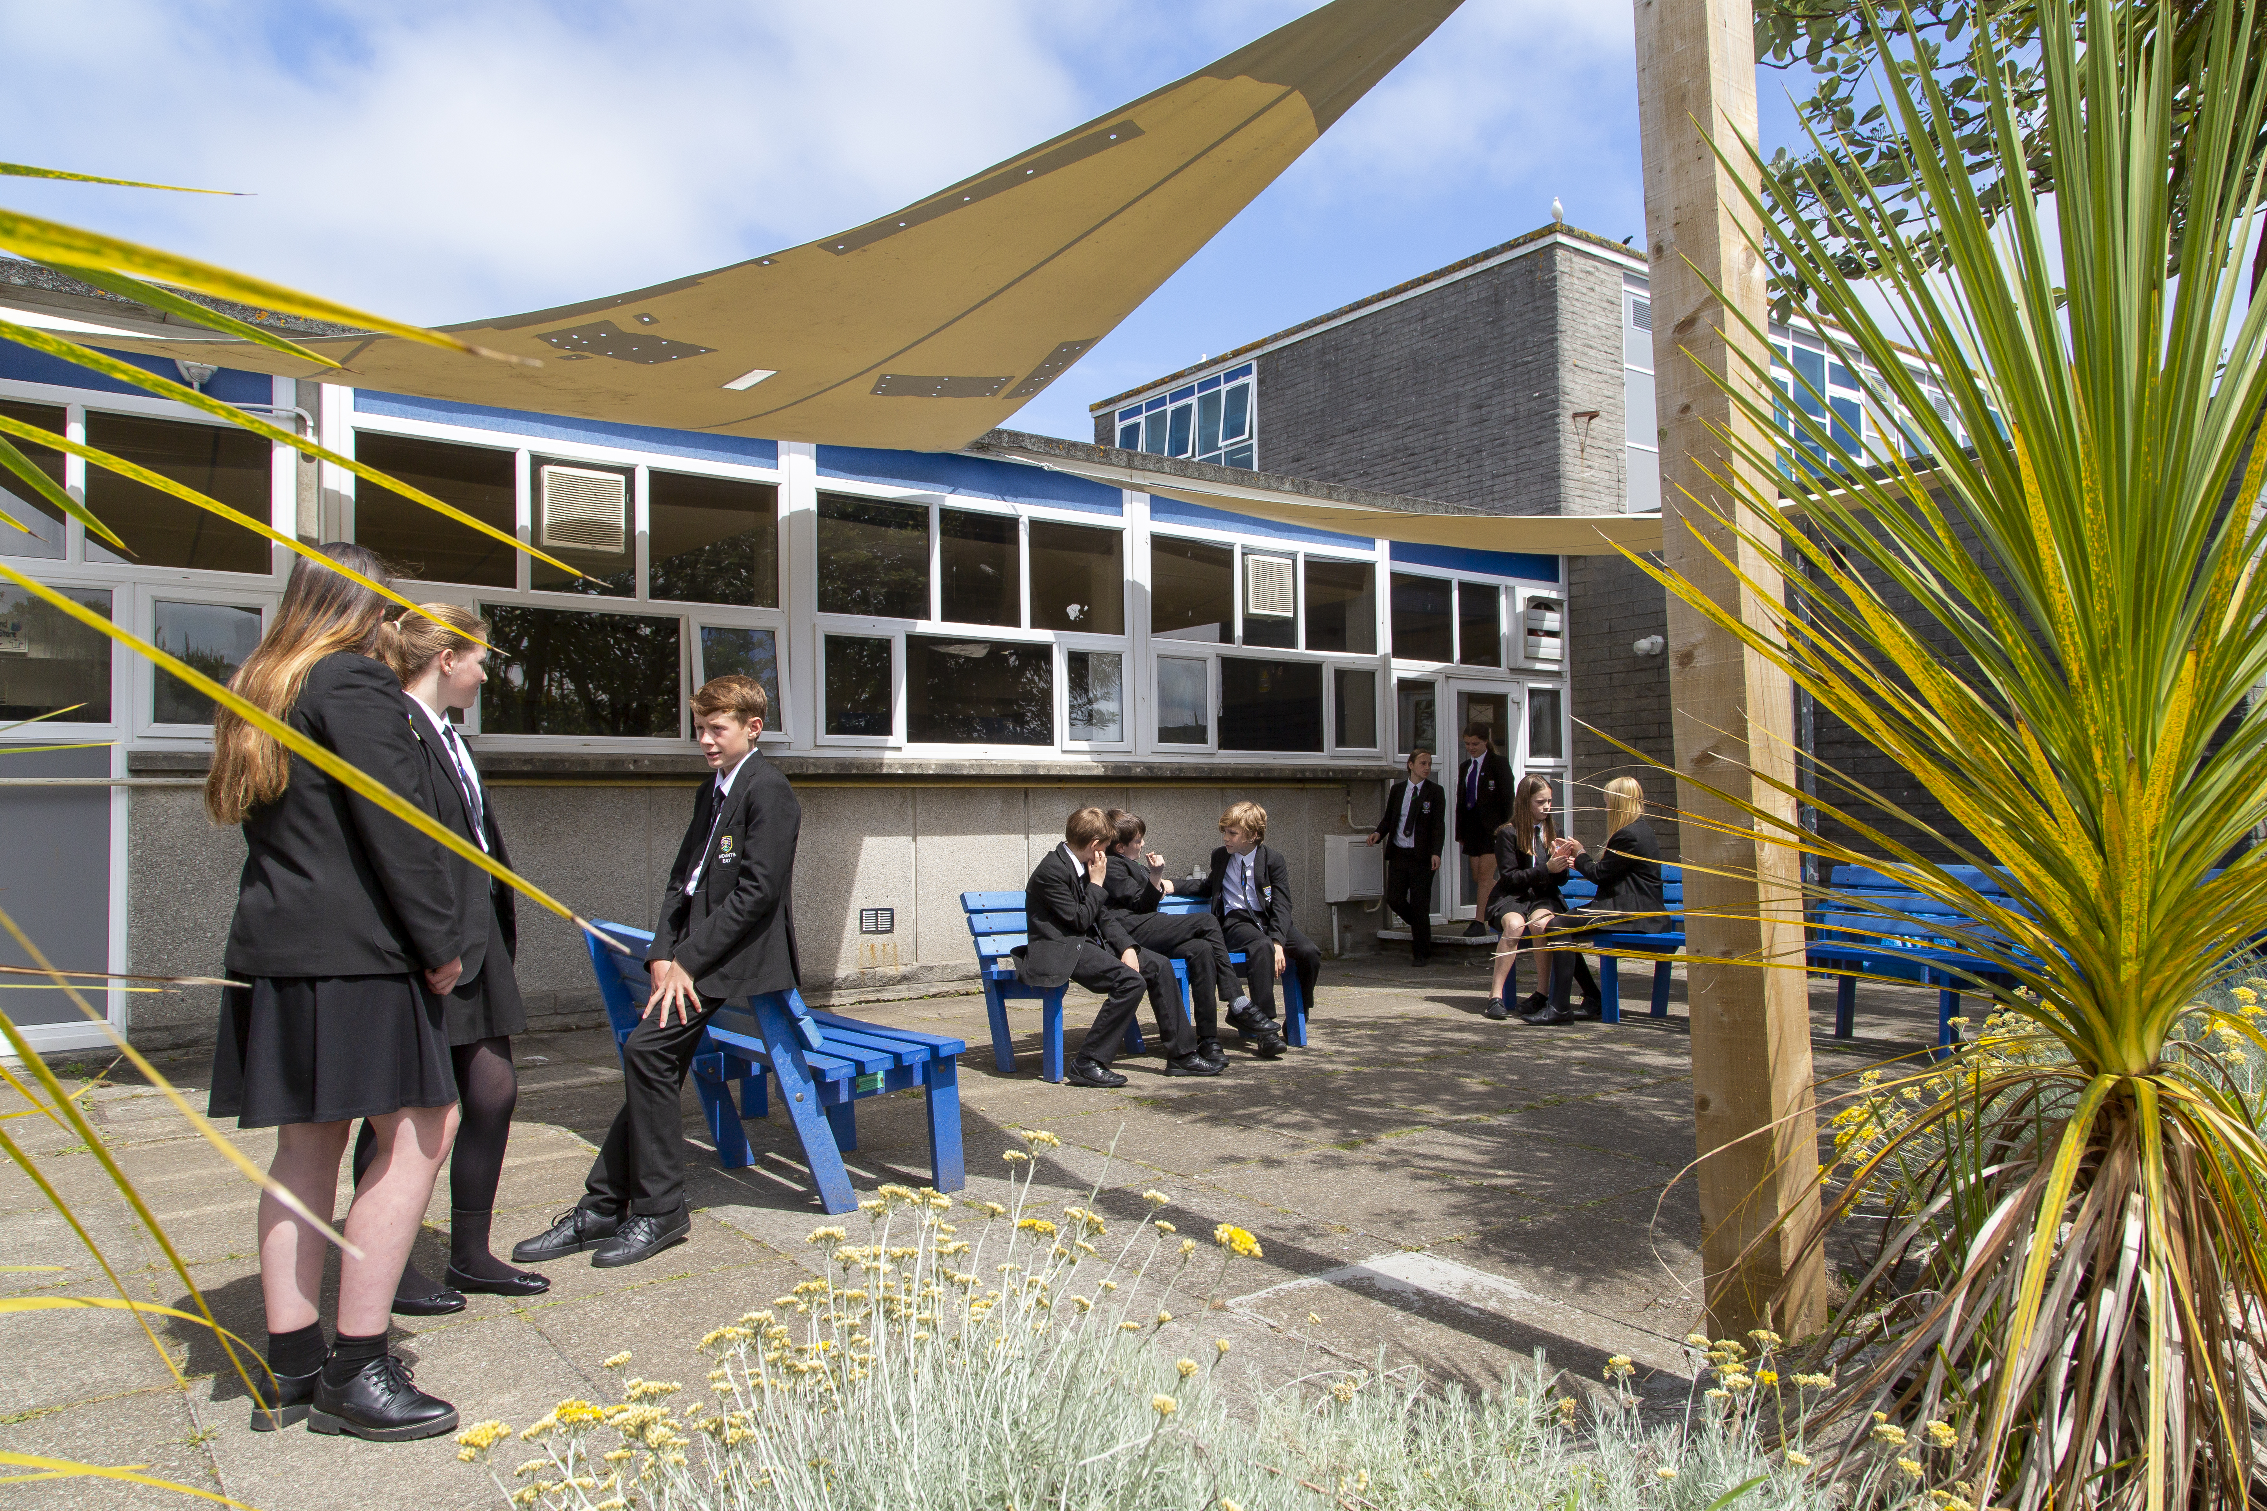

Media & Marketing
Co-ordinator

Job Description

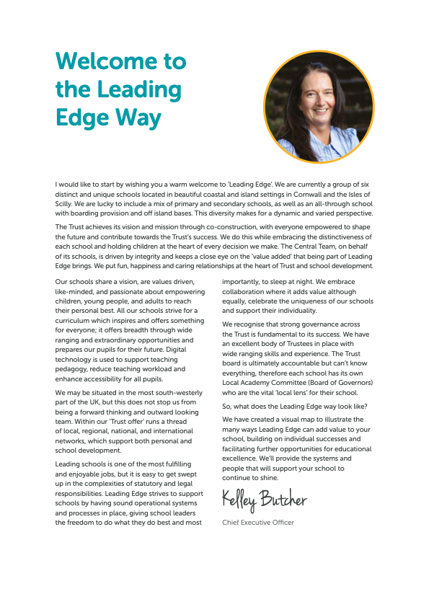
Principal – Mr S Royle BA (Hons) PGCE NPQH
Mounts Bay Academy
Boscathnoe Lane
Heamoor
Penzance
TR18 3JT
www.mountsbay.org

Contract Type: One year fixed term from Sept 1st 2025 44.6 weeks 15 hrs a week flexi.
Salary : F4
Applications by 31/08/2025
Interviews w/c 31/08/2025

Media & Marketing Co-ordinator
Mounts Bay Academy is seeking a dynamic and creative Media and Marketing Co-ordinator to showcase the outstanding work happening across our Academy to a wide audience.
In this role, you will manage the Academy’s social media presence and keep our website up to date and engaging. You will also contribute to whole-school design work, so a flair for creativity and the ability to work flexibly in a fast-paced environment are essential.
Our success relies heavily on a strong and positive reputation. Through our online platforms, newsletters, website, and public events, we communicate our values and achievements to all stakeholders. You will play a key role in ensuring these communications are consistent, professional, and impactful.
Additionally, you will support the development and maintenance of the Academy’s branding, ensuring that our visual identity is applied consistently and effectively across all materials.
This is a term-time position, plus two additional weeks to be worked flexibly throughout the academic year.
Any interested candidates are asked to apply . . . .
Informal pre-application visits to the Academy are welcomed.
Application forms and information pack are available via our school website or on request by telephoning the Academy.
For further information, please contact Malvina Jenkin HR Manager at Mounts Bay Academy 01736 352399 or email: mjenkin@mountsbayacademy.org
Closing date for applications:04/07/2025
Interviews W/C 07/07/2025
Start date: Sept 2025
.

MBA is committed to safeguarding and promoting the welfare of students and expects all staff to share this commitment

Please send your completed application form to Malvina Jenkin mjenkin@mountsbayacademy.org, Boscathnoe Lane, Heamoor, Penzance, TR18 3JT.
The successful candidate will be subject to reference checks with previous employers and an enhanced DBS disclosure check.

Welcome

Dear Applicant,

Thank you for expressing an interest in this post at Mounts Bay Academy, a member of the Multi Academy Trust called Leading Edge Academies Partnership (Leading Edge). I hope you find this information pack helpful and that in due course we shall receive an application from you.

Mounts Bay Academy is located in Penzance, West Cornwall with 950 students aged 11-16 years. This is a beautiful part of the world, enjoying a varied coastline surrounding rugged hills and moorland and it is a wonderful place to live and work.

Mounts Bay school converted to Academy status in 2011 and a year later was awarded an Outstanding grade in a full Ofsted Inspection. In November 2017 the Academy was inspected by Ofsted to review its safeguarding arrangements and the HMI visitors noted that the Academy had a fully inclusive culture and provided excellent support for vulnerable students. Since then, we were awarded a good grade in 2021 under the new Ofsted Framework introduced in 2019.

I have been the proud Principal of Mounts Bay since March 2024, and I am passionate about the Academy and the path that we need to follow. Whilst enjoying an enviable reputation in the local area, there is work to do in terms of outcomes, attendance and the quality of teaching and learning. Our priorities are explicit, and my style is very open and honest – there are no hidden agendas here!

We have recently introduced a new behaviour policy which is having very positive effects and our teaching and learning policy has been stripped back to provide very clear expectations of staff and students. All strategies are supported by a comprehensive evidence-based programme of CPD, both internal, and through external bodies such the PTI, the Cornwall Research School, which we are delighted to lead, and the Challenge Partner network, where we are delighted to be the lead school in the Cornwall hub.

The Academy enjoys a range of impressive physical resources including a purpose-built science area, subject specific teaching areas in the Creative Arts as well as a lively and bouncing Music block. Sports facilities are strong, including a large sports hall, a 3G pitch and extensive outside field areas, all of which have significant community use. Plans are currently being made with Cornwall Council for an on-site ARB to provide further support to learners.

Mounts Bay Academy is an Apple Distinguished school, and each student and staff member is provided with a digital device to support their learning and work. We believe that students should be prepared for the world in which they will live when they leave the Academy and strive daily to ensure that we update our knowledge accordingly.

We are a learning community that aspires to success for all without exception, convinced that everyone can learn at the highest level, when presented with learning experiences that are as engaging as they are adventurous. We believe that all young people can achieve; it is our job to nurture the very best in each person by identifying their strengths and talents and removing any barriers to learning.

Mounts Bay is a caring and dynamic community where students are placed at the centre of everything that we do.

We provide a broad and balanced curriculum which is delivered by a team of skilled and dedicated staff, with the MBA way visible throughout the school, putting ‘Relationships, Respect and Responsibility’ at the centre of everything. Talent is celebrated, curiosity is nurtured, and every individual is given the chance to shine. We help to develop young people with a positive attitude to learning and life, ready to take on the challenges of our fast-changing world and to make a creative contribution to their community.

The successful candidate will be a brave, creative and visionary person, to join our staff to enable all to thrive in this ever-changing world. We are looking for a professional with a spirit of adventure who understands that high personal and academic standards and exciting learning can combine to change young people’s lives.

Mounts Bay Academy is committed to safeguarding and promoting the welfare of young people and we expect the candidate to share this commitment.

Since I joined the Academy, I have felt safe, I have been happy, I have felt challenged, and I have been genuinely welcomed into the Mounts Bay community. Is this not what all of us want from a school?

Please do get in touch if you would like to come and visit. I look forward to meeting you.

Yours sincerely

Simeon Royle
Principal

Job Description

Post Title: | Media and Marketing Co-ordinator
Purpose: | - To have an oversight of the Academy’s publicity.  - To create and post content on the Academy’s social media channels.  - To maintain the list of students with publicity restrictions and reduced photo permissions and ensure awareness of this by amongst Academy staff.  - To develop and maintain a clear set of publicity guidelines for staff ensuring commonality of message and style.  - To populate and maintain the Academy website, working in conjunction with other staff in terms of updating content and layout and ensuring statutory compliance.  - To design and create documents as requested by the school by ensuring that the content provided by staff and students is presented clearly and effectively and in keeping with the house style or brand.  - To inform the SLT and other staff about the effectiveness of the current strands of publicity by keeping records of site visits, articles read and any other feedback.  All of the above need to be in keeping with Academy policy and direction  All of the above need to be compliant with the legislative framework concerning the publication of information.
Reporting to: | Principal, Vice Principals, Heads of Year.
Liaising with: | Internal: Principal, Senior Management Team, Staff, Pupils, Volunteers and Governors  External: Parents/carers, External Agencies, and members of the public.

MAIN (CORE) DUTIES

Main Duties and Responsibilities

Duties and responsibilities
- Responsible for school publicity through high quality press releases, advertisements, community publications, banners, weekly newsletters and promotional material for school.
- Responsible for the annual LHS leavers items including the yearbook . Liaise with staff, students and the prom committee to gather content for the yearbook in advance of the publication deadline, complying with GDPR to ensure all permissions are sought and granted, where necessary.
- Contribute to and organise key school events e.g., Open Evening and information evenings, being on site to ensure smooth running of events before, during and after. Oversee publicity of such events and facilitate communication with parents, students, school staff and staff.

Other Specific Duties
- To remain and adhere to the Trust’s Safeguarding Policy and child protection procedures.
- To play a full part in the life of the Academy community, to support its distinctive mission and ethos and to encourage staff and students to follow this example.
- To actively promote the Academy’s corporate policies.
- Be responsible for your own continuing self-development, undertaking training as appropriate.
- To be aware and adhere to applicable rules, regulations, legislation and procedures e.g. the Trust Equality and Diversity Policy, Staff Code of Conduct, national legislation and GDPR Data Protection Regulations.
- To comply with the Academy’s Health and Safety Policy and undertake Risk Assessments as appropriate.
- To be responsible for your own continuing self-development, undertaking training as appropriate.
- To take action to enable all students to have the best outcomes academically and socially.
- To manage own workload to allow an appropriate work-life balance.
- To maintain confidentiality of information acquired in the course of undertaking duties for the school.
As a restorative organisation we:
- Apply the principles of mutual respect and responsibility in all our internal and external relationships.
- Actively work to prevent, address and repair harm.
- Engage in continuous learning to further develop our communication and problem-solving skills.

Whilst every effort has been made to explain the main duties and responsibilities of the post, each individual task undertaken may not be identified and duties and responsibilities may change as directed by the Principal.

Requirements | Essential | Desirable | Demonstrated By
Qualifications and Training | GCSEs (or equivalent) in English and Maths (Grade C/4 or above). |  | Application Form /  Interview
Experience | Experience using social media platforms (Facebook, Instagram, Twitter/X, YouTube) in a professional or organisational context. | Proficiency in software such as Canva, Adobe Photoshop, InDesign, or similar design tools. | Application Form/  Interview
Skills | Strong written and verbal communication skills  Ability to use social media platforms appropriately and safely in a school context | • Photography and/or videography skills | Application Form / Interview
Knowledge | Good organisational and time management skills | Knowledge of safeguarding and data protection (GDPR | Application form
 |  | .

