GIFFORd PRIMARY  SCHOOL | “Teaching is consistently good with  many examples of outstanding practice." OFSTED  - Required for an immediate start  - Grade 5/6 (£22,751 - £26,222)  - 35 hours per week, term time only (39 weeks)  - Closing date: 9:00am on Friday 8th July 2022  - Interview date: W/C 11th July 2022
MEDICAL OFFICER
RECRUITMENT PACK June 2022

Welcome
PG. 2
Our Vision
PG. 3
Person Specification
PG. 4
Job Description
PG. 5/6/7
“Working in partnership to provide excellent and enjoyable education which enables all children to achieve their highest standards”
Mission Statement

Welcome

HeadTeachers message
Dear Applicant,

Thank you for showing an interest in the position of Medical officer at Gifford Primary School. Gifford Primary School is a popular four-form entry school with a Hearing Impaired Provision (HIP).

We are seeking to appoint a Medical officer to join our team. The Medical Officer has responsibility for the health and welfare of all students, with overall management and administration of the day to day medical room functions.

As a school, we pride ourselves on providing a learning environment and a rich variety of opportunities for our children so that every one of them may be helped to reach their full potential and make the most of their talents.

Please contact Mrs Fernandes on 020 8845 4661 or email HR@gifford.ealing.sch.uk. We look forward to hearing from you.

Yours faithfully,

Sarah Wilson

Sarah Wilson
Headteacher

Our Vision
Gifford Primary School shares a vision of learning today for a better tomorrow. | we are looking for a medical officer who has:  - High level of organisational skills and initiative  - The ability to manage own workload, work quickly and efficiently with a positive, can do attitude  - Be enthusiastic and have excellent communication and interpersonal skills  - Ability to work constructively as a team, understanding school roles and responsibilities and the post holder’s position within these.  - Be driven, motivated and most of all, is passionate about pupils health  We CAN OFFER:  - Inner London pay scales  - Pension contributions to the Pension Scheme  - Free on-site parking  - Ride to work scheme  - Childcare voucher scheme  - Ongoing extensive CPD programme  - A friendly and supportive team of staff  - Well-resourced facilities  - A professionally stimulating and collaborative working environment  - A commitment to professional development

Person Specification

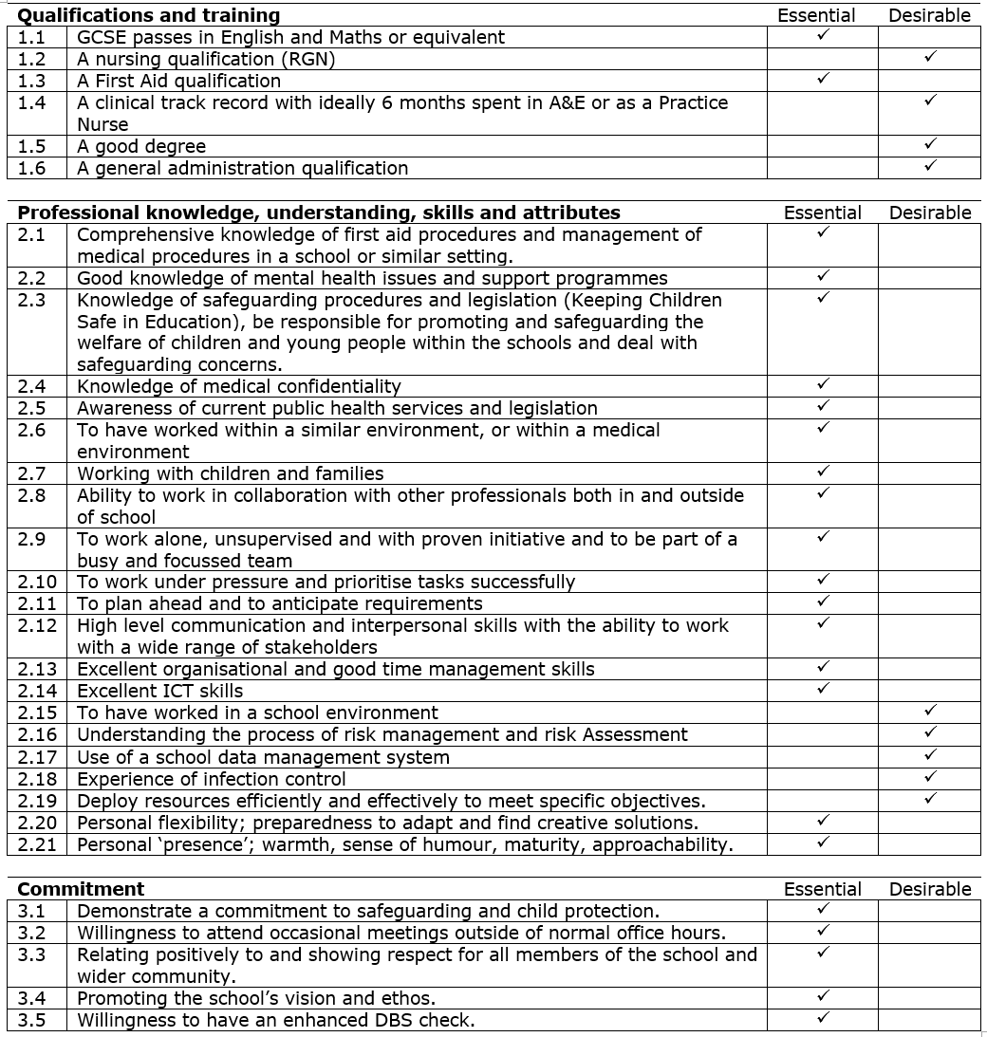

JOB DESCRIPTION

Purpose:
The Medical Officer has responsibility for the health and welfare of all students, with overall management and administration of the day to day medical room functions. The role will involve maintaining an active and regular point of contact for all students. The successful candidate will also be responsible for sign-posting students regarding mental and physical needs, co-ordinating and liaising with colleagues, Parents/Carers, Health Authorities, Social Services and other outside agencies. Good communication with parents and carers is a key part of the role as well as planning and delivering relevant and up to date First Aid staff training and producing and overseeing health risk assessments where needed.

Responsibilities:
To act as the School’s Lead First Aider and manage the School Welfare Rooms
Dealing with Students and liaising with others:
- To lead and manage the whole school First Aid and Welfare provision by acting as the primary lead for First Aid provision with school.
- To ensure that students who attend the Medical Room are assisted and ensure that the correct procedures are followed as per the First Aid Policy and Individual Care Plans.
- To ensure that a log of the support given to students is maintained in each case and details are logged on Medical Tracker/CPOMS/SIMS.
- To liaise with parents/carers, the School Nursing Team and other external agencies where necessary.
- To ensure that parents/carers are always informed of any serious injury.
- To liaise with parents and the LA School Nursing Team regarding school Immunisations and ensure that they are co-ordinated and undertaken in a timely manner.
- To signpost any student concerns to the Child Protection Team and/or Head of year including any non-accidental incident.
- To monitor medical room visits and report back to Head of Year/Pastoral Support if particular students’ visits become regular.
- To attend Student Induction Events for each new intake of students in order to meet and discuss medical needs with parents/carers.

Administration:
- To make contact with parents/carers of students who are offered an in-year place in order to discuss medical needs.
- To maintain records for any healthcare conditions that are declared to the school by ensuring that individual Health Care Plans, Risk Assessments and Action Plans are completed, filed correct and updated annually or when a student’s medical needs change.
- To manage on-site medications by ensuring that the relevant paperwork is completed and that any medication provided by parents/carers is in date, pharmacy labelled including the correct dosage instructions and is stored appropriately and logged on SIMS/CPOMS.
- To ensure that processes are in place to ensure that student medication is regularly checked and in date and to make contact with parents/carers to obtain a replacement.
- To ensure that all parents/carers are contacted annually to request any updated or additional information relating to their child’s medical needs.
- To hold an emergency stock of permitted medicines (e.g. spare Asthma Inhalers and Epi-Pens) for distribution to students in an emergency and to ensure that the school has individual parental consent for this.
- To create and maintain Student Profile Booklets for key staff/areas regarding students with life threatening medical needs (e.g. allergies, asthma, diabetes, etc.).
- To ensure posters are displayed in classrooms, staffrooms, welfare room and school office to reiterate the steps to take during an emergency.
- To oversee all administration procedures relating to medial administration within school.

Managing the Welfare Room:
- To be responsible for ensuring that the School First Aider Register is up to date, all qualifications are valid, and develop a programme of renewals for first aid qualifications for staff.
- To ensure that there is sufficient qualified staff to assist in the administration of emergency First Aid in compliance with published ratios in respect of student numbers.
- To develop and regularly review Medical Room processes.
- To ensure that regular briefings/training session are delivered to First Aiders.
- To be responsible for ensuring that all School First Aiders are given training in the Medical Room processes.
- To ensure that the Welfare Room is covered at all times and organise a cover rota.
- To be in attendance on the school site at all times during working hours, unless on a formal break, at which time cover should be arranged. During working hours to always have a walkie talkie and mobile phone on.
- To advise and train staff in emergency procedures (e.g. Epi-Pen training, asthma inhalers, diabetes care, epilepsy, allergies, head lice, etc) that they may be expected to carry out if a qualified person is not available.
- To maintain appropriate stock levels for the Welfare Room and process orders when necessary.
- To ensure that all First Aid Bags/Boxes and Defibrillators around the school site are maintained and kept fully stocked at all times with the appropriate documentation completed. To maintain a log of checks.
- To ensure class medical boxes are maintained/checked and children’s individual medication, packed and labelled in separate wallets for easy access in an emergency.
- To ensure that the Welfare Room Walkie Talkie and Mobile Phone are always charged.
- To share key information with staff, when necessary, on a regular basis.
- To ensure that a First Aid Bag, Defibrillator, Walkie Talkie and mobile phone are always taken to each emergency call out and to every fire evacuation.
- To liaise with third parties (such as paramedics) in emergency situations;
- To assist in organising and managing medical inspections as required.
- To ensure confidentiality of all medical information.
- To ensure up to date clinical and professional practice is maintained.
- To undertake any training commensurate with the post.
- Promote health and wellbeing to pupils and staff, working closely with the School Counsellor.

Reporting and Policies:
- To complete accident reports following incidents and report these to the School Business Manager and Health and Safety Officer.
- To carry out regular routine audits of the Welfare Room and to report the findings to the Assistant Head – these should be signed, countersigned and filed.
- To attend weekly meetings with the SLT line manager i/c of Welfare.
- To liaise with the SLT line manager to ensure policies and procedures relating to welfare/medical issues are up to date.
- To provide reports for the Governors and Designated Child Protection Officer as required.

School Trips:
- For day trips – ensure that the trip leader is provided with a First Aid bag, School Mobile phone and ensure its safe return to the Welfare Room.
- For residential trips/trips abroad – to ensure that trip leaders are given a First Aid bag, School Mobile phone and are made aware of any student medical needs and provided with any emergency backup medication that students may require.
- For whole school events (e.g. Sports Day) – ensure that whole school events are supplied with the appropriate First Aid Kits, Walkie Talkies, School Mobile Phone, whole school medical details, parent contact details and any emergency back-up medication that students may require.

Team working and Collaboration:
- Participate in any relevant meetings/professional development opportunities at the school, which relate to pastoral arrangements.
- Work as a team member and identify opportunities for working with colleagues and sharing the development of effective practice with them.

Fulfil Wider Professional responsibilities:
- Work collaboratively with others to develop effective professional relationships.
- Communicate effectively with parents/carers and co-operate with relevant external bodies.
- Make a positive contribution to the wider life and ethos of the school.

Other:
- To have professional regard for the ethos, policies and practices of the school and maintain high standards in your own attendance and punctuality.
- Be aware of and comply with policies and procedures relating to child protection, safeguarding, confidentiality and data protection, reporting all concerns to an appropriate person.
- To adhere to school policy on equality and diversity.
- To undertake similar duties, commensurate with the level of the post at the discretion of the Headteacher and SLT. These duties may include (not limited to):
- General Clerical/Administrative/Filing/Reception Support
- Administration Support for the School Absence Officer
- Collecting and distributing Lost Property
- Lunchtime Cover and /or temporary cover
- Supporting preparation for major School events
- Administration supporting the admissions process.

This job description is not your contract of employment or any part of it. It has been prepared only for the purpose of school organisation and may change either as your contract changes or as the organisation of the school is changed. Nothing will be changed without consultation.

