The Viridis Federation of Orchard, Southwold and Hoxton Garden Primary Schools Hackney, London

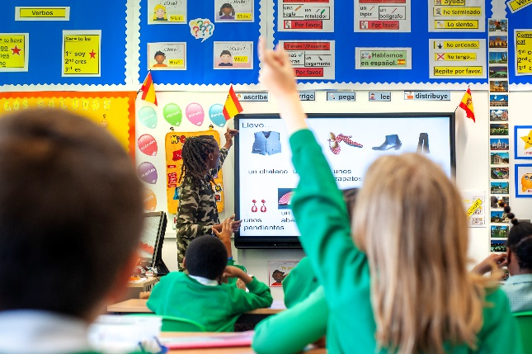

We are looking for a Modern Foreign Languages Teacher of Spanish (MPS / UPS)

We are a happy family of three schools working in partnership looking for an experienced full time Spanish Teacher. This position involves teaching Spanish lessons to all classes from Reception to Year 6, championing language provision for all pupils.

We are looking for a Spanish teacher who is:

- An excellent classroom practitioner with very high expectations of themselves and the children they teach
- Passionate about creating quality learning opportunities for children
- Organised and committed to raising the profile of Spanish across the school so that it impacts on all children regardless of ability or background
- Hard working, creative and keen to develop their own teaching

We offer:

- A happy and motivated team of friendly teachers to work with
- A large, well resourced classroom, great facilities and a generous budget
- An exciting, well organised environment in which to work
- A supportive and experienced administrative and management team
- A base on one school site with opportunities to work with two partner schools
- An established modern foreign languages offer to children

…….please download our application pack!
.
Visits are warmly welcomed. To arrange this, please call Ms Beverley Shore to 020 8806 5201. Alternatively, to request an application pack or to find out more about what we can offer visit our website:

https://viridis-schools.co.uk/

www.orchard.hackney.sch.uk | www.southwold.hackney.sch.uk | www.hoxtongarden.hackney.sch.uk
@OrchardPrimary  @primary_orchard | @ Southwold School  @Southwold School | @ Hoxton Garden Primary School  @HoxtonGardenSchool

Closing Date: 14 May 2021
Interview Date: 20 May 2021

Successful candidates will be asked to apply for an Enhanced Disclosure from the disclosure & barring service. Further information about the disclosure can be found at www.dbs.gov.uk and in the application pack.

All three schools are based in the London Borough of Hackney, close to central London with easy transport links

