MFL TEACHER APPLICATION PACK

Recruiting for: September 2021

Dear Applicant,

Thank you for your interest in the position of a MFL teacher at our schools. I hope that you will find this information pack helpful. If you would like to learn more about this post we would be delighted to answer any questions you may have and can offer tours of all three sites to meet children and staff.

We are seeking a dynamic Spanish teacher to join our existing teacher and work at Orchard School full time as a result of our current MFL leader retiring. Orchard Primary works in partnership with two other Hackney Schools, Southwold and Hoxton Garden. All three schools are in Hackney. With a joint pupil roll of over 1300 pupils we are a dynamic organisation with a passion for making a difference and not accepting excuses for low standards. Each school offers Spanish to all children from Reception to Year 6. We aim to give children a full and rich curriculum with Spanish as an essential ingredient to their education experience.

The successful candidate will lead the MFL provision at Orchard School. This will include delivering lessons, ensuring the representation of Spanish within classrooms, leading CPD for teachers and leading the language captains to ensure pupil voice is high profile. First and foremost we are looking for dynamic and confident teacher who has the energy and skill to make a difference as well as the flexibility to work in a large organisation. This post requires collaborative working with colleagues from each school and offers the opportunity to experience working on different school sites.
Contents
- Welcome!
- What are we looking for?
- What do we offer?
- How to apply
- Job description & person specification

We take our role in raising the aspirations of our children and meeting the ambitions of our staff very seriously. We can offer excellent facilities including reliable administrative support, a spacious dedicated classroom for lessons, a generous budget and opportunities to work jointly with a partner teacher in our organisation. If you are hardworking, reflective, put children first, have an expertise and passion for languages and are looking to further develop your skills as a teacher then we would love to hear from you.
Detmold Road London E5 9NL

Ivy Street
London N1 5JD
Holcroft Road London E9 7BB

Rachel Davie
Executive Headteacher

Spanish Teacher
.
We are looking to appoint a skilled and ambitious practitioner who wants to make a difference.

We are looking for a Spanish teacher who is:

- An excellent classroom practitioner with very high expectations of themselves and the children they teach
- Passionate about creating quality learning opportunities for children
- Organised and committed to raising the profile of Spanish across the school so that it impacts on all children regardless of ability or background
- Hard working, creative and keen to develop their own teaching

We offer:

- A happy and motivated team of friendly teachers to work with
- A large, well resourced classroom, great facilities and a generous budget
- An exciting, well organised environment in which to work
- A supportive and experienced administrative and management team
- A base on one school site with opportunities to work with two partner schools
- An established modern foreign languages offer to children

, sexual orientation

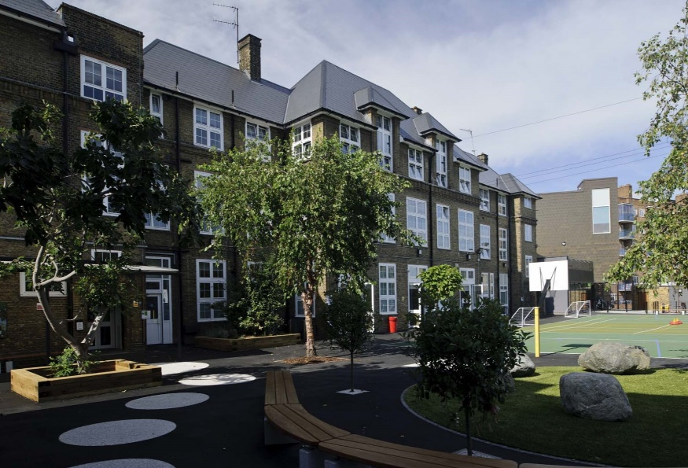
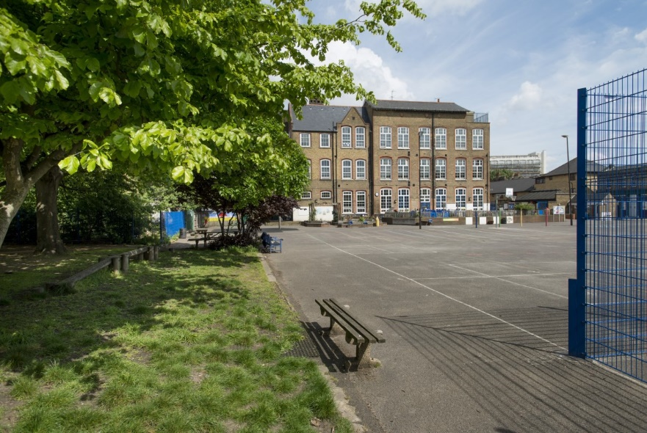
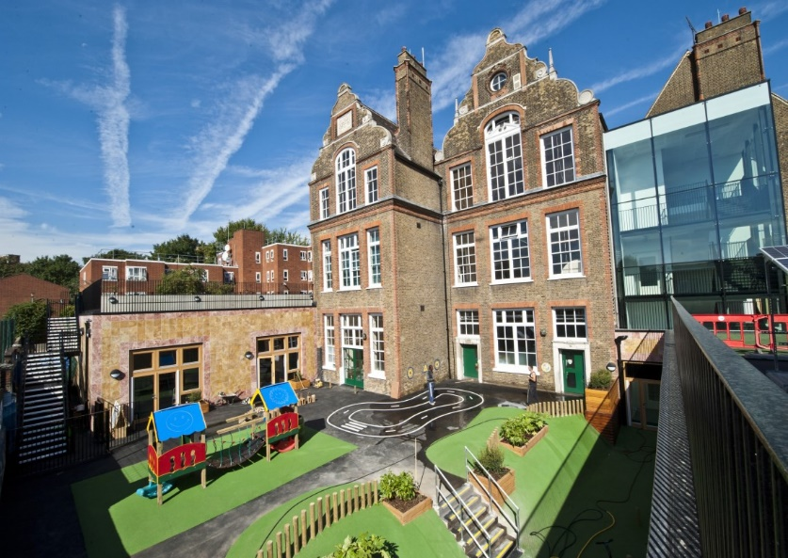

HOW TO APPLY
- Read the job description and person specification carefully.

- Complete the application form either electronically or print it off and hand write it.

- Ensure your supporting statement relates to the competencies outlined in the person specification.

- Email your competed application to Ms Beverley Shore at
recruitment@vs.hackney.sch.uk
or send by post:
Recruitment
c/o Southwold Primary School Detmold Road
London E5 9NL

- Please make sure that your application form indicates the name & address of the school where you have most recently taught and the age group that you currently working (if applicable).

Closing Date: 14 May 2021

Our schools are committed to safeguarding and promoting the welfare of children and young people and expects all staff and volunteers to share this commitment.

Successful candidates will be required to completed an enhanced DBS disclosure.

We welcome applications from all sections of the community, regardless of gender, race, religion, disability, sexual orientation or age.

Should you have any queries or would like to arrange to visit our schools please contact Ms Beverley Shore on: 0208 806 5201 or email her: recruitment@vs.hackney.sch.uk

We look forward to receiving your application!

MFL TEACHER JOB DESCRIPTION
Grade: MPS/UPS/LPS/ Full Time/Permanent

Main activities & responsibilities:
The current School Teachers’ Pay and Conditions document describes duties that are required to be undertaken by teachers in the course of their employment. In addition, certain particular duties are reasonably required to be exercised, and completed in a satisfactory manner. It is the contractual duty of the post holder to ensure that his/her professional duties are discharged effectively.

Essential Qualifications
- Educated to degree level
- Qualified teacher status

Experience
- Will have had some experience of teaching in a multicultural inner city environment, ideally in more than one year group.
- Will be able to demonstrate a strong history of excellent teaching in line with the teaching standards.

Particular Specific Responsibilities
- The post holder is responsible to their line manager for his/her duties, responsibilities and teaching tasks.
- The post holder will interact on a professional level with all colleagues establish and maintain good working relationships which will promote the development and effective delivery of the school curriculum and maximise children’s achievement.
- The post holder will be responsible for the supervision of the work of support staff and any pupils who may be on teaching practice or work placement.
- The post holder undertakes the teaching of the pupils across the school in Spanish and undertakes the associated pastoral and administrative duties in respect of those pupils as well as the general responsibilities in the school as agreed with the Headteacher.

Other Responsibilities
In addition, to undertake such duties of a similar nature as may be reasonably directed by the Headteacher from time to time. The duties and responsibilities of the post may vary from time to time according to the changing needs of the school.

Person Specification
- To be flexible and versatile in attending to the needs and requirements of children.
- Excellent organisational skills, ability to meet time-related deadlines and ability to prioritise.
- Ability to work under pressure and on own initiative.
- Ability to develop interpersonal relationships with children and staff.
- Identify underperformance in pupils and take appropriate action to rectify.
- Supervision of children in an assertive but fair and reasonable manner.
- To be able to praise, encourage and develop potential of children to raise attainment.
- Teaching all pupils across the school according to their educational needs and acknowledging that every lesson counts.
- Creating a well-ordered and secure environment that will ensure the educational well-being of individual children within the group.
- Making effective use of ICT to enhance learning and teaching.
- Undertaking careful planning and delivery of the curriculum.
- Ensuring careful and ongoing assessment of the pupils learning to inform further planning.
- Ensuring that the curriculum is differentiated to mean that tasks and activities are matched to the ability of the children and henceforth allowing them to make progress at the right pace and level.
- Completing all assessments and records as determined by school policy in a timely fashion.
- Working with school leaders to track the progress of individual children and intervene where pupils are not making progress.
- Working with school leaders to complete and teach individual pupil plans where pupils have specific needs, (IEPs).
- Ensuring that equal opportunities are implemented in the classroom and throughout the school.
- Developing and maintaining positive relationship with parents, which involve them actively in the classroom and in the learning process.
- Participating in planning and staff meetings.
- Contributing to the whole school ethos by taking a leading role in display particularly in own classroom and designated whole school areas as agreed with the Headteacher.
- Contributing towards the development of the school and implementation of whole school policies.
- Contributing and co-operating with other staff and professional agencies as appropriate to the needs of the children.
- Undertaking in-service training for further development as a teacher and delivering training to develop others.
- Ensuring the representation of Spanish teaching across the school through effective representation of languages within the school context.

