INFORMATION PACK
Altrincham Grammar School for girls
MIDDAY AND ADMINISTRATIVE ASSISTANT
28.75 hours (0.66 FTE) during Term Time only
Permanent, 5 days a week
Required as soon as possible

Overview of the Role
We are seeking a motivated person with good people skills to supervise students during breakfast club, rec (mid-morning break time) and lunchtime. The role includes some administrative work in the library and pastoral office between breakfast club and rec. The person appointed will work under the supervision of the Vice Principal and any designated supervisory staff.

The full job description and person specification are at the end of this pack.

Bright Futures Educational Trust

Bright Futures Educational Trust (The Trust) is a multi-academy trust (MAT) set up in 2011. The Trust is made up of a richly diverse group of schools in Greater Manchester and Blackpool. We are passionate about working together within and beyond the Trust to achieve our aspirational vision: the best for everyone, the best from everyone. We are an organisation that is underpinned by values of: community, integrity, and passion. In everything we do, we remember that we are accountable to the children, families, and communities that we serve.

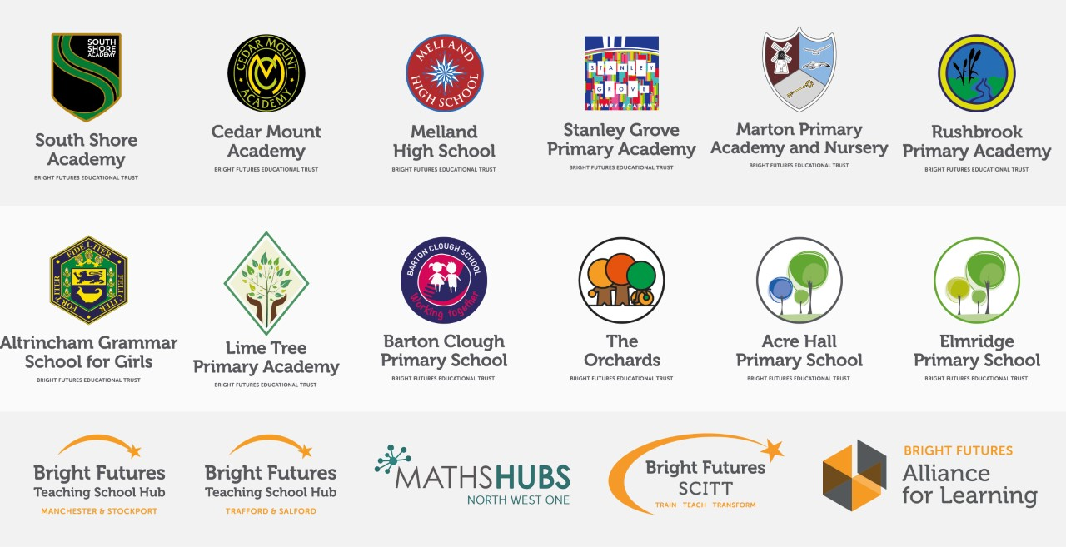

Our schools have their own identities and form one organisation and one employer, Bright Futures Educational Trust. Bright Futures’ Board of Trustees maintains strategic oversight of the Trust and delegates some of its responsibilities to the Executive Team, Principals, and local governing bodies. We place a high value on integrity and probity and take seriously our accountabilities for making the best use of public money. How decisions are made is described in our delegation framework. You can find out more about the Trustees and the Executive Team on our website: About Us

The central team comprises the Executive Team: John Stephens, CEO; Edward Vitalis, Chief Operating Officer; Gary Handforth, Director of Education; Lisa Fathers, Director of Development, Partnerships and Teaching School Hubs; Lynette Beckett, Director of HR & Strategy. The focus of these roles is to work with schools, providing high quality and timely guidance, leadership, challenge, and support. In addition to the Executive Team, we have central operations for Finance, HR, Educational Psychology, Marketing and Communications, and Digital Technologies. Please see our website brochure which explains our central operations: Working together for a Bright Future.

Bright Futures Development Network is another important outward facing component of our organisation made up of a number of hubs and networks at the heart the Trust. In January 2021, after significant national reforms to the teaching school policy Bright Futures was designated with two new large-scale Teaching School Hubs, which replace the Alliance for Learning Teaching School. This growth and expansion in our outward facing work brings about a significant increase in accountability and reach. The two Bright Futures Teaching School Hubs are designed to provide strong strategic regional leadership to build robust partnerships to support teachers and leaders in every phase and type of school, at each stage of their development. A crucial part of the hub remit is carefully ensuring structured collaboration. The Teaching School Hubs are at the forefront of providing high quality professional development, playing a significant role in the implementation and delivery of: The Early Career Framework, National Professional Qualifications (NPQ), Initial Teacher Training and Continuous Professional Development (CPD). The Hubs work directly with the Department for Education and national NPQ/ECT providers. In addition to this, the Hubs enhance the professional development needs of Bright Futures schools and academies. Within this outward facing area of Bright Futures Educational Trust, we have a commercial offer run through the Alliance for Learning which provides first-class school improvement services and CPD to over 700 schools, further complementing the work of our Teaching School Hubs. Our School-Centred Initial Teacher Training (SCITT) Bright Futures SCITT is also an integral part of the Teaching School Hubs, with over 10 years’ experience and judged Good by Ofsted, we offer Early Years, Primary and Secondary teacher training programmes. Within the Bright Futures Development Network, we are also proud to have a Maths Hub: NW1 Maths Hub offering a wide range of maths specific high-quality professional development opportunities and training/coaching to 500 schools.

Collaboration and strong relationships form one of the ‘commitments’ in our Strategy and all components of the Bright Futures’ family work closely together. Our Strategy was developed collaboratively and can be found on our website: Our Strategy

Altrincham Grammar School for Girls
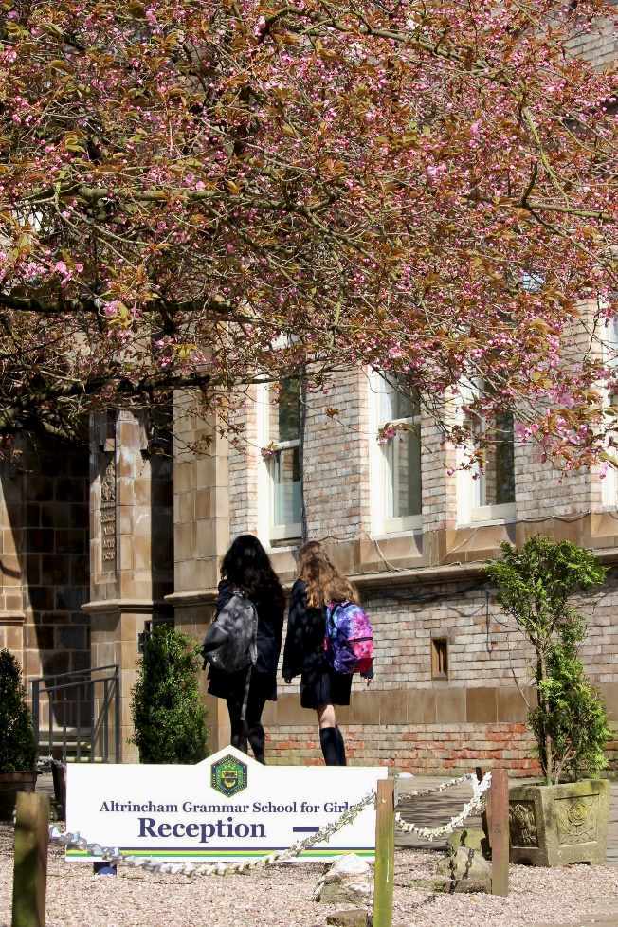
Altrincham Grammar School for Girls (AGGS) is a highly successful single sex 11 -18 academy in the South Trafford area. AGGS was in the first cohort of schools to be designated a national teaching school in 2011. AGGS is the lead school in ‘The Alliance for Learning’, which comprised schools of every type and phase, plus universities, throughout a wide geographical area. The impact of teaching school activities has been felt within the Trust and far beyond. We have a reputation for excellence regionally and nationally, of which we are very proud.

AGGS is committed to providing equal opportunity in recruitment and employment to all individuals. We will consider candidates without regard to race, ethnicity, gender, religion, sexual orientation and identity, national origin, age, military or veteran status, disability or any other legally protected status; and without discrimination based on socioeconomic, marital, parental or caregiving status, or any of the previously listed characteristics or statuses.

We value the diversity of our staff and reject any form of harassment, discrimination or victimisation. The Bright Futures Educational Trust vision is: ‘the best for everyone, the best from everyone’. To achieve this, we create and maintain a work environment and culture where people from different backgrounds, and with varying lifestyles, interests, opinions and responsibilities, treat each other with dignity and respect. It is a climate in which our staff feel safe and are inspired and motivated to be their best.

Our school is dedicated to sustaining and promoting diversity with respect to recruitment, promotion, training and general treatment during employment. We are actively seeking to extend the diversity of our staff. Furthermore, we welcome candidates who have not had previous experience of working in a grammar school.

We aim to ensure that our recruitment processes set up all candidates for success. At interview our aim is to provide a positive experience. We don’t want to catch anyone out, but rather to provide the opportunity for all candidates to be themselves and show us what they are capable of.

WHY WORK FOR US?

We offer a great opportunity to join an organisation which really lives its values. Our working environment is very inclusive and whilst you can expect to be challenged in your role, you will be supported through professional learning, treated fairly and with dignity and respect. Please see the Equality,
Diversity, an Inclusion statement on our website.

Terms and Conditions

Salary: NJC scale points 4 to 6 (Bright Futures scale 3). The full time equivalent pay is £19,264 rising to £20,043 per annum. The actual pay based on the below working pattern commencing £12,775.17 rising to £13,291.78 per annum actual pay. Pay progression is linked to performance.

Working weeks: This is a great opportunity for flexible working as the role will work 38 weeks during school term time.

Hours: 28.75 hours per week over 5 days. Hours of work are 7.45 am to 1.30 pm.

Holidays: You will be paid for the pro-rata equivalent of 25 days, plus 8 public holidays. This increases to 30 days plus 8 public holidays after 5 years’ service.

Pension: Local government pension scheme. Please take a look at the website: https://www.gmpf.org.uk/.

Other: We offer salary sacrifice schemes for purchasing bikes used for travel to work and technology for personal use, through monthly interest free salary deductions.
We also offer opportunities for professional development.

How to Apply
We can only accept completed application forms, rather than CVs. This is because the regulatory guidelines of
Keeping Children Safe in Education (2021), require us to check various details of job applicants and an identical
application format for each candidate enables us to do this. We use a process that does not identify personal
characteristics to the shortlisting panel. This is part of our commitment to equalities and diversity.
NO AGENCIES PLEASE.

Our application form is available online, along with the disclosure of criminal background form. The portal link is Midday and Administrative Assistant Application Form. Alternatively, you can click Apply Now on this role via the current vacancies page of our website. Please upload the forms by midday, Wednesday 28 September 2022.

The selection process may be conducted virtually, so candidates will need access to a device with a camera and a microphone to participate. However, we will confirm this following the closing date. Interviews will take place during the week commencing 3 October 2022. You will be notified after the closing date whether you have been shortlisted.

Keeping Children Safe in Education
Bright Futures Educational Trust is committed to safeguarding and promoting the welfare of children and young people and we expect all staff and volunteers to share this commitment. This post is exempt from the Rehabilitation of Offenders Act 1974; pre-employment checks will be carried out and references will be sought for shortlisted candidates and successful candidates will be subject to an enhanced DBS check and other relevant checks with statutory bodies.

Data Privacy
You can read the details of how we use the personal data that you provide us with in our Job Applicants’ privacy notice on our website: Applicant Privacy Notice

JOB DESCRIPTION
Midday and Administrative Assistant

The main aspects of this role involve the supervision of students during breakfast club, rec (mid-morning break time) and lunchtime. The role also includes some administrative work in the library and pastoral office between breakfast club and rec.

Responsibilities include the following
Laying out of tables and chairs in the dining room
Supervising the rec and lunch queue.
Monitoring the behaviour of students during breakfast club, rec and lunch break and taking appropriate action to ensure good discipline and compliance with school rules and the code of conduct.
Reporting to the Vice Principal or other appropriate staff information about any incidents, misbehaviour, accidents or potential threats to safety and welfare.
Supervising students in the library and carrying out administrative tasks, in liaison with the librarian.
Supporting the Pastoral Assistant with morning registration processes, including:
  - Checking the whereabouts of students that have not signed in at Reception.
  - Completing registers on SIMS for anti -bullying/wellbeing ambassadors and school council
  - Inputting marks to SIMS from students that have signed in late at Reception
  - Assisting with queries from students in the morning
Any other responsibilities reasonably requested by the Principal or Vice Principal.

School-wide Responsibilities
- Being aware of and acting upon relevant school policies and in particular those associated with child protection/safeguarding children, and health and safety issues.
- Being responsible for maintaining a clean and tidy environment.
- Attending relevant meetings as required.
- Acting as a role model for the students in school.
- Acting as an ambassador for school and ensuring that the school’s high standards are promoted at all times.

PERSON SPECIFICATION

 | Essential | Desirable | How tested
Relevant experience |  | Experience of working  with children.  Experience of administrative work.  Experience of working in a school. | Application form
Qualifications |  | GCSEs (or equivalent) with grade C/5 or above in English and maths. | Application form
Knowledge, skills, abilities | Ability to obtain the respect of children.  Ability to show initiative when required.  Fitness sufficient to set out tables, walk around the school site and monitor queues.  Ability to work as part of a team.  Alertness and awareness to anticipate potential hazards/difficult situations.  Tact and reasonableness in ensuring compliance with school rules. | Use of IT, including software such as the Microsoft Office suite. | Application form  Interview  Task
Safeguarding | Commitment to demonstrating a responsibility for safeguarding and promoting the welfare of young people. |  | Application form  Interview

Bright Futures Educational Trust is committed to safeguarding and promoting the welfare of children and young people and expects all staff and volunteers to share this commitment. Any successful applicant will be required to undertake an Enhanced Disclosure by the Criminal Records Bureau. The post is exempt from the Rehabilitation of Offenders Act 1974.

