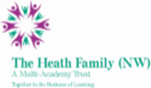
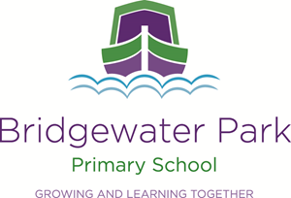

Bridgewater Park Primary School
“Growing and Learning Together”

Midday Assistant - Permanent

Salary: £9.50 per hour

Hours 5 hours per week (1 hour Monday to Friday 12:00-1:00)
Start: September 2022

Bridgewater Park School is a delightful Primary school nestled in the heart of Castlefields, Runcorn. We offer an exciting and enriched curriculum and all learning is engaging and fun to ensure that all our children will achieve their full potential and become life-long learners. Bridgewater Park is part of the Heath Family (NW) Multi Academy Trust which operates 9 schools across Merseyside and Cheshire.

We are looking to secure additional caring and efficient Midday Assistants to work at our school to be responsible for assisting pupils both inside whilst eating and supervising pupils outside at play over the lunchtime period.

Caring, friendly and efficient candidates will have the ability to work alongside other Midday Assistants and Teaching Assistants, have a smart, professional appearance and a friendly outgoing manner.

The Heath Family (NW) is committed to safeguarding and promoting the safety and welfare of children and young people and expects all staff and volunteers to share this commitment. This post is subject to an Enhanced DBS check and pre-employment checks.

An application pack is available from Cathy Brown, Office Manager. If you would like more information, or would like to arrange an informal conversation/ visit to the school please contact the school on 01928 563838.

Completed application forms and supporting letters should be emailed to head.bridgewaterpark@halton.gov.uk or delivered to the school.

Closing date for applications: 13th June 2022 at noon

Interviews: 21st June 2022

