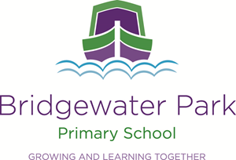

Bridgewater Park Primary School
Part of The Heath Family (NW)

Post Title: Midday Assistant

Accountable to: Principal

Line Manager: Principal

Person Specification

Personal Attributes
Communication & Influence
Conveys basic messages using a variety of media. Appears confident when communicating with others.

Team working
Shows an interest in others, taking time and effort to get to know people and a willingness to help others. Does not work in isolation, sharing information and keepings others up to date. Takes time out to listen, explain and provide constructive feedback.

Organisational Awareness
Understands how own job contributes to the schools activities. Stays up to date with developments in school and discusses with colleagues their activities to gain a broad understanding.

Adaptability
Understands the need for, and the effects of, change and is able to adjust style and way of working taking others into account. Learns from experience.

Professional Values and Practice
Demonstrates high expectations for all pupils.
Ability to build and maintain successful relationships with pupils, treat them consistently, with respect and consideration and demonstrate concern for them development as learners.
Ability to improve your own practice through observations, evaluation and discussion with colleagues.

Experience & Knowledge
Experience of working with and or caring for children (within a specified age range).

Awareness and basic understanding of school curriculum (within a specified age range).
Basic knowledge of First Aid.
Basic awareness of inclusion, especially within a school setting.

Qualification & Training
Willingness to participate in relevant training and development opportunities.

