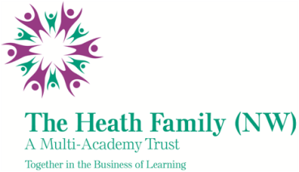

Palace Fields Primary School
Badger Close, Palace Fields , Runcorn, WA7 2QW
Part of The Heath Family Trust (NW)

NOR: 171

(Executive Principal: Paul Holloway)

Tel No: 01928 716521
Email: head@palacefieldsschool.co.uk
Website: www.palacefieldsprimary.org.uk

Required: ASAP

Fixed term Midday/Reading Assistant
(Until 31st July 2023)
Grade: HBC3-4
Gross salary range £5796 - £5912 per year/term-time only: £10.66 - £10.87 per hour.
Hours of Work: 12.5 hours per week to be completed as:-

Midday assistant
6 hours 15 minutes per week – 11:55am – 1:10pm

Reading assistant
6 hours 15 minutes per week (1 hour 15 minutes per day – times to be mutually agreed)

We are a medium sized school situated in the Palace Fields area of Runcorn. We are a highly motivated staff team committed to giving our children the best life chances and are passionate about fulfilling our shared aim of providing excellent learning opportunities; enabling all children to achieve success and become active citizens.
We are looking for enthusiastic people to work with our children at lunchtimes and hear our children read during the school day.

Previous MDA/reading assistant experience is not necessary, but applicants must have some experience of working with or caring for children.

You will also be expected to undertake any necessary training to support you within this role, i.e. safeguarding, first aid, in-school training around hearing children read etc.

Please contact Miss Genna Hitchin, Head of School, if you would like to know more about this post. Visits to the school are most welcome.

The school is committed to safeguarding and promoting the welfare of children and young people and expects all staff and volunteers to share this commitment.

Applicants should note that the successful candidate will be required to apply for an enhanced disclosure from the Criminal Records Bureau. Further information regarding the disclosure scheme can be found at www.disclosure.gov.uk

Application forms are available from Mrs Libby Connor, Palace Fields Primary School, Palace Fields, Runcorn, WA7 2QW (email: LConnor@pfp.theheathfamily.org.uk or pop into the school office)

Closing date for receipt of applications: Tuesday 27th September 2022

Interviews are currently scheduled to take place on Thursday 29th September 2022

The Governing Body is committed to safeguarding and promoting the welfare of students and the post is subject to a satisfactory Disclosure and Barring Service (DBS) check (formerly Criminal Records Bureau). Further information about DBS checks can be found at www.gov.uk/crb-criminal-records-bureau-check.

