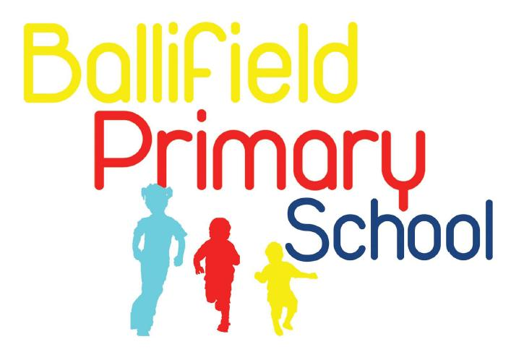
Handsworth Grange Road
Sheffield
S13 9HH

Tel/Fax: (0114) 269 7557 www.ballifield.co.uk

Headteacher: R Binns, BA Hons, NPQH

Advert – Midday Supervisor

Ballifield Primary School are looking for an enthusiastic part-time Midday Supervisor to join our team. This is a permanent position, starting date to be confirmed.

Hours are 6 hours, 15 minutes per week (11.50am – 13.05pm Monday to Friday) for 40 weeks per year. Salary: Grade 1 SCP 2 (£23656 pro rata)

Closing date: 18th July 2025 but we welcome application forms at any time up to this date.

You will join a friendly team of Midday Supervisors and will be responsible for supervising children during the lunchtime period, attending to their welfare and domestic needs.
You should have good communication skills both written and verbal, experience of working with children across the whole school and be willing to work as a team player and use your own initiative.

How to apply

For more information or to request a recruitment pack including full job description, please email recruitment@ballifield.sheffield.sch.uk or phone the school office on 0114 2697557.

If you have any questions regarding this role please contact Rachael Binns (Headteacher) on 0114 2697557.

Completed application forms can be returned by email to recruitment@ballifield.sheffield.sch.uk by the closing date.

Ballifield Primary is committed to safeguarding and promoting the welfare and safety of all our children. We expect all our staff and volunteers to share this commitment. This post is exempt from the Rehabilitation of Offenders Act (ROA) 1974. All shortlisted candidates will be asked to disclose any cautions or convictions prior to interview. The amendments to the ROA 1974 (Exceptions Order 1975, (amended 2013 and 2020)) provide that when applying for certain jobs and activities, certain spent convictions and cautions are ‘protected’, so do not need to be disclosed to employers, and if they are disclosed, employers cannot take them into account. Guidance and criteria on the filtering of these cautions and convictions can be found on the Ministry of Justice website:

https://www.gov.uk/government/publications/dbs-filtering-guidance/dbs-filtering-guide.

In addition, an online search will also be conducted for all shortlisted candidates prior to interview. If appointed, the successful candidate will be required to complete various vetting checks, including an enhanced DBS criminal records check, a Children’s Barred List check and a prohibition from teaching check. Please note that it is a criminal offence to apply for this post if you have been placed on the Children’s Barred List. Before applying, candidates are asked to read the school’s safeguarding policy which can be found through this link https://ballifield.co.uk/wp-content/uploads/2024/09/Child-Protection-and-Safeguarding-Policy-September-2024.pdf and the recruitment of ex-offenders policy, which we will send with the application pack.

We value our diverse workforce and aim to work together to make the most of our differences. We welcome applications from everyone. Under the Disability Confident employer scheme, disabled applicants who meet the essential criteria of this job are guaranteed an interview.

