

Gladstone Road Primary School

Midday Supervisory Assistant
Recruitment Information Pack



Contents

About the School 3
Application Process 5
Job Description and Person Specification 6
Applying for a job with North Yorkshire Council 8

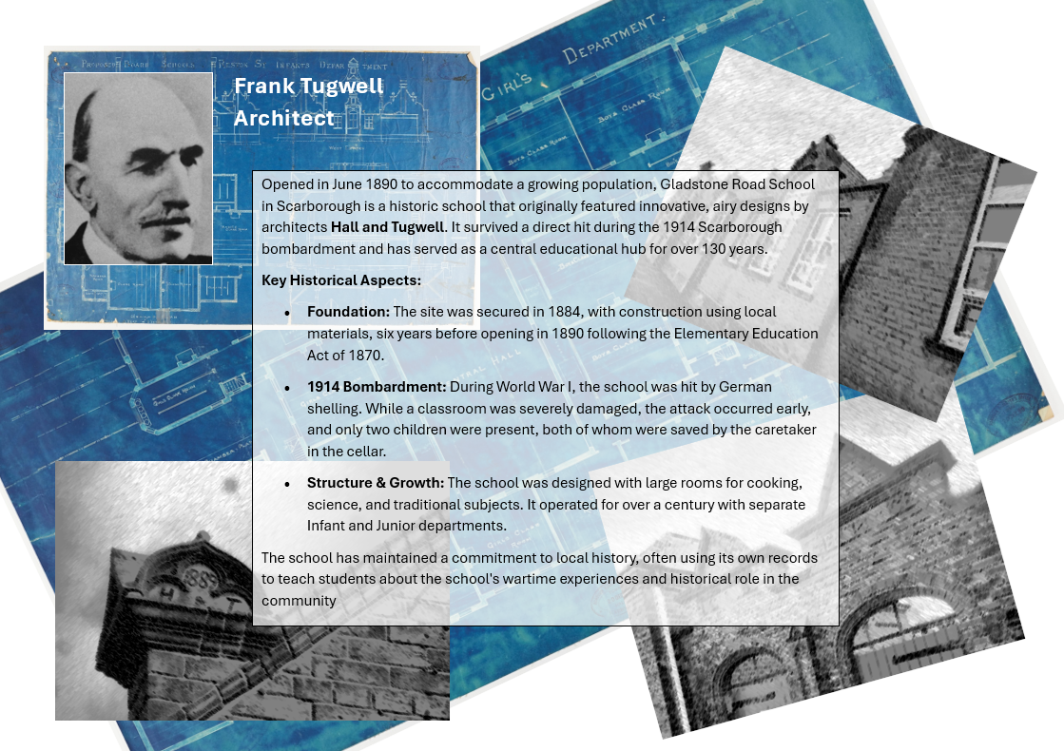

Gladstone Road Primary School

I am delighted you are interested in joining our team here at Gladstone Road Primary School. You will be joining a highly ambitious, aspirational group of professionals who are raising standards and significantly improving the life chances of the children of Scarborough and the Yorkshire Coast.

Our motto ‘Learning to Succeed’ is at the heart of everything we do. We live the values necessary for children to contribute positively to the world they will inherit and lead one day. Our children feel valued and accepted as individuals. Our aim is that they will be able to function in the wider community in which they have respect for themselves, others, and their environment.

We are fortunate to have a school environment that mixes the traditional school feel along with making sure we have a tailored and creative curriculum that allows us to give our children the opportunities that they deserve.

Staff morale is high, and we have a commitment to recognise individual potential and to provide support, CPD and training for colleagues joining our school at all levels; you will never feel unsupported or alone in our school.

As a school we are secure and share resources, teaching, curriculum ideas and partnerships with other schools to maximise the benefits to our children, staff and the community.

Our very creative staff have a love of teaching and we are looking for a future member of our team who can develop a sense of awe and wonder in children. The children at Gladstone Road are delightful, happy, confident and energetic. They are passionate about their learning, be it in the traditional classroom or through other areas of the curriculum such as dance, art, PE and music. We are looking for someone who can embrace all aspects of the curriculum as well as literacy and numeracy.

We are really proud of our school and the progress we are making. Please take the time to come and visit is – we’d love to show you around.

All posts at Gladstone Road Primary involve at all times, a view to further the mission, values and strategic aims of the school; accepting responsibility for the implementation of school policy, procedures and other guidance, as set out in the Staff Handbook and elsewhere; working positively, flexibly and co-operatively both with colleagues and as appropriate with those outside school; and the setting of high standards.

All roles involve responsibilities and expectations as set out in the appropriate national standards and in the school's role specifications and documentation.

All members of staff are expected to promote and safeguard the welfare of students in accordance with the Safeguarding Children in Education Act, including maintaining clear professional boundaries in all relationships; to promote an anti-racist, multi-cultural approach; in line with school policy. Additional duties may be asked of members of staff by the Head teacher as occasion requires.

The generic role specifications below are offered in good faith as a guide to professional practice in the expectation that staff will seek to approach them in a professional manner. All role specifications are subject to revision in the light of changing circumstances.

Good luck with your application!

Garry Johnson (Headteacher)






Application Process

Please apply online via NYC jobs

The closing date for all applications is 9am, Friday 25th September

Interviews will be held on Tuesday 29th September

Application forms must be completed in full – CV’s are not accepted

Please contact us if you need an application form in a different format.

An email will be sent to shortlisted candidates with details of the interview process / support if unsuccessful in your application.

Queries / Visits
Please contact Chloe Bullen on 01609 536 964 or via chloe.bullen@northyorks.gov.uk
Chloe has been engaged to support us with recruiting to this exciting opportunity.

When applying please take into account the following:

Employment History
In line with KCSIE requirements, please complete your full employment history to ensure any gaps in your education and career history are accounted for.

Suitable References
When completing your application, please provide two employment referees. Generally, this should be your current and most recent Headteacher or line manager. Please note if your former Headteacher or line manager has since left, please use an alternative current senior staff member as they need to be in post at your former location to be able to confirm your details in full.

Unfortunately, we cannot accept personal references or personal email addresses.

Please get in touch for any queries if you are unsure.

Supporting Information
The supporting information section of your application should clearly evidence your ability to meet the requirements we have outlined in the job description & person specification. This will be used to shortlist applicants for this role and therefore it is imperative that you provide evidence as requested.

Job Description
Post title: | Midday Supervisory Assistant (MSA)
Grade: | AB
Responsible to: | Senior MSA or Office Manager
Staff managed: | None
Directorate: | Children and Young People's Service
School name: | Gladstone Road
Job family: | C&S - Care & Support
Date of issue: | August 2023
Safeguarding Statement
- Required to work indoors and outdoors when supervising the children and young people to ensure their safety.
- Enhanced DBS Clearance required

Job Purpose: | To work as part of a team monitoring pupil behaviour during the midday break to ensure a caring and safe environment.
Operational Issues: | - Supervise the playground area, playing fields, cloakrooms and classrooms etc during the lunchtime break.  - Assist with the removal of food and equipment once pupils have eaten their lunch.  - Deal with minor first aid incidents; follow appropriate procedures for recording and reporting.  - Assist in the implementation of appropriate behaviour management strategies as required  - Observe a child or young person’s behaviour, understand its context, and notice any unexpected changes and report any inappropriate behaviour to the correct member of staff.  - Resolve minor disputes between pupils  - Assist in the supervision of other activities during the midday break, including setting out and storing equipment
Communications: | - Establish rapport and respectful, trusting relationships with children, young people and those caring for them.  - Report any concerns about pupil welfare to the appropriate member of staff in a confidential manner.  - Communicate effectively with all staff, pupils, families and carers.  - Provide support and encouragement to children and young people.
Safeguarding | - To be committed to safeguarding and promote the welfare of children, young people and adults, raising concerns as appropriate.  - Be aware of and comply with policies and procedures relating to child protection, confidentiality, health, safety and security.  - Be aware of own (and others’) professional boundaries.  - Be responsible for promoting and safeguarding the welfare of children and young people that you are responsible for and come into contact with
Systems and information: | - Participate in the school’s performance management scheme.  - Participate in training and other learning activities and performance development as required.  - Attend staff meetings and training days by agreement with the Headteacher.

Person Specification:
Essential | Desirable
Knowledge and Experience  - Awareness of health and hygiene issues  - Experience appropriate to working with children  - Behaviour management | - Good written and verbal communication skills.
Occupational Skills
- Judgemental skills
- Demonstrable interpersonal skills.
- Ability to work successfully in a team
- Confidentiality
- Initiative
Behaviours
- link
Qualifications | - Appropriate first aid training or willingness to undertake training
Other Requirements  - Enhanced DBS Clearance  - To be committed to the school’s policies and ethos.  - To be committed to Continual Professional Development.  - Motivation to work with children and young people.  - Ability to form and maintain appropriate relationships and personal boundaries with children and young people.  - Emotional resilience in working with challenging behaviours; and attitudes to use authority and maintaining discipline.  - To assist in ensuring that NYC’s equalities policies are considered within the school’s working practices in terms of both employment and service delivery. | - Creativity

We are committed to meeting the needs of our diverse community and aim to have a workforce reflecting this diversity. We are also committed to safeguarding and promoting the welfare of children, young people and adults. We have a robust child protection policy and all staff will receive training relevant to their role at induction and throughout employment at the school. We expect all staff and volunteers to share this commitment.
Please note this post is in regulated activity and exempt from the rehabilitation of Offenders Act 1974 and subject to satisfactory references and an enhanced DBS criminal records and barred list check for work with children. An online search may be undertaken as part of the recruitment process on information available in the public domain. Candidates should disclose anything that may be relevant in line with Keeping Children Safe in Education.
APPLYING FOR A JOB WITH NORTH YORKSHIRE COUNCIL
IMPORTANT ADVICE ON COMPLETING THIS APPLICATION

Your application form plays an important part in your selection. Please ensure you address all the essential requirements listed in the specifications. The following advice should help you to complete the application form as effectively as possible.
Data Protection
The information that you state on this application form will be used by the school and the Council to consider you for a job vacancy. To find out about how we use your personal data for the purposes of recruitment please see our Privacy Notice at www.northyorks.gov.uk/working-us.

Rehabilitation of Offenders
The post you are applying for requires you to have an enhanced Disclosure and Barring Service criminal records check for work with children, with a barred list check if you work in regulated activity. This check for disclosure of criminal history will include spent convictions, pending prosecutions / current court proceeding and police enquiries.

Should you be shortlisted, you will be asked to disclose full details of your criminal history prior to your interview. This includes any information deemed relevant as part of Keeping Children Safe in Education which may arise in an online search undertaken on shortlisted candidates. This information may be discussed with you at your interview in order to assess job related risks, but we emphasise that your application will be considered on merit and ability and you will not be discriminated against unfairly. Failure to disclose this information will result in any offer of employment being withdrawn.

Please also see the policy statement on the Recruitment of Ex-offenders below.

Information in Support of your Application
Every post advertised is supported by a full person specification. The specification lists all the essential skills, experience and qualifications which are necessary for the job and the criteria against which you will be assessed, both through your application form and at interview.

As part of the application process, you may have been asked to demonstrate within this application form how you meet some or all of the criteria or key competencies outlined in the person specification. Rather than simply repeating your career history, look at the skills and experience required by the job and provide evidence that you possess them by giving specific and detailed examples which include a focus on outcomes and on your own contribution to the scenario. Try to use different and varied examples wherever possible.

When completing these sections, do not forget the skills and experience you have gained outside full-time work. Outlining your previous work experience or other responsibilities may help you to uncover skills which you have taken for granted and which are clear signs of your ability to do the job.

Canvassing
You must not try to influence an elected Council Member, any council employee or a member of the school governing body, to act in your favour, as this will disqualify you. If you are related to a Councillor, a Council employee or a governor you must indicate this in the relevant section of the application form.

Policy Statement on the Recruitment of Ex-offenders (Source www.gov.uk)
- As an organisation assessing applicants’ suitability for positions which are included in the Rehabilitation of Offenders Act 1974 (Exceptions) Order using criminal record checks processed through the Disclosure and Barring Service (DBS), this school complies fully with the DBS code of practice and undertakes to treat all applicants for positions fairly.

- This school undertakes not to discriminate unfairly against any subject of a criminal record check on the basis of a conviction or other information revealed.

- This school can only ask an individual to provide details of convictions and cautions that it is legally entitled to know about. Where a DBS certificate can legally be requested (where the position is one that is included in the Rehabilitation of Offenders Act 1974 (Exceptions) order 1975 as amended, and where appropriate Policy Act Regulations as amended) this school can only ask an individual about convictions and cautions that are not protected.

- This school is committed to the fair treatment of its staff and potential staff, regardless of race, gender, religion, sexual orientation, responsibilities for dependents, age, physical/mental disability or offending background.

- This school has this written policy on the recruitment of ex-offenders, which is made available to all DBS applicants at the start of the recruitment process.

- This school actively promotes equality of opportunity for all with the right mix of talent, skills and potential and welcome applications from a wide range of candidates, including those with criminal records. Candidates are selected for interview based on their skills, qualifications and experience and criminal record information is only requested from short-listed candidates.

- A disclosure is only requested from the DBS after a thorough risk assessment has indicated that one is both proportionate and relevant to the position concerned. For those positions where a criminal record check is identified as necessary, all application forms, job adverts and recruitment briefs will contain a statement that a DBS certificate will be requested in the event of the individual being offered the position.

- This school ensures that all those who are involved in the recruitment process have been suitably trained to identify and assess the relevance and circumstances of offences.

- This school also ensures that they have received appropriate guidance and training in the relevant legislation relating to the employment of ex-offenders, e.g. the Rehabilitation of Offenders Act 1974.

- At interview, or in a separate discussion, this school ensures that an open and measured discussion takes place on the subject of any offences or other matter that might be relevant to the position. Failure to reveal information that is directly relevant to the position sought could lead to withdrawal of an offer of employment.

- This school makes every subject of a criminal record check submitted to DBS aware of the existence of the code of practice and makes a copy available on request.

- This school undertakes to discuss any matter revealed on a DBS certificate with the individual seeking the position before withdrawing a conditional offer of employment.

