

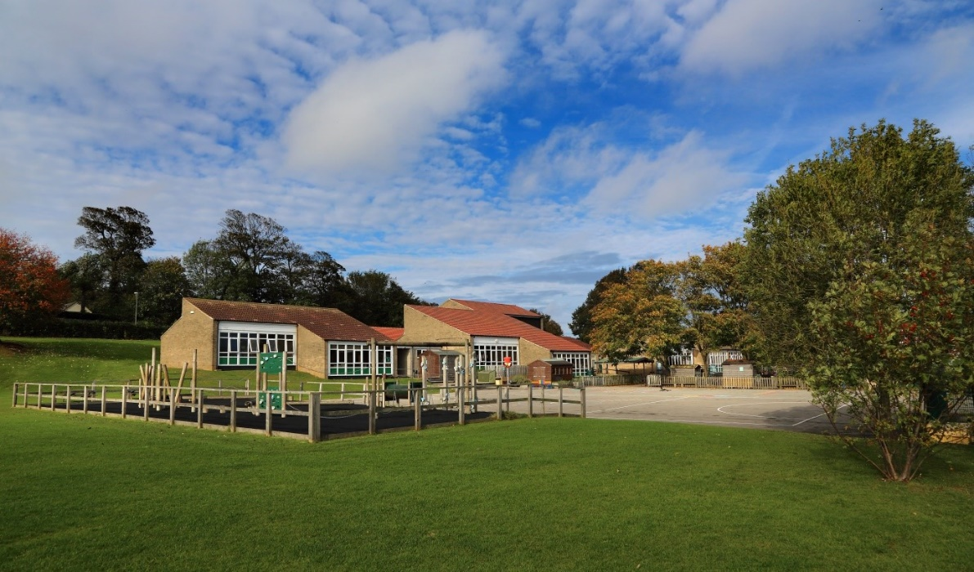

**Midday Supervisory Assistant**

**Airy Hill Primary School**

**Recruitment Information Pack**

Waterstead Lane  
Whitby  
North Yorkshire  
YO21 1PZ

[www.airyhill.n-yorks.sch.uk](http://www.airyhill.n-yorks.sch.uk)

## Contents

Welcome from the Headteacher 3

Airy Hill Values 4

YEAT vision and values 5

YEAT Schools 6

Application process 9

Job Description and Person Specification 10

Applying for a job with North Yorkshire Council 12

**Welcome from the Headteacher**

Dear Applicant,

May I take this opportunity to thank you for expressing an interest in applying for a position at Airy Hill Primary School.

Our school is at an exciting phase of development. You will be joining an extremely friendly and supportive team, who are driven to ensure that our pupils achieve the highest possible standards. As a school, we all work together so every child succeeds. The ability to collaborate and be open to personal and professional development is essential. If you are ambitious in your career, self-motivated and want to be the best that you can be, we would encourage you to apply.

We are incredibly proud of our pupils and we encourage you to visit our nurturing and rights-respecting school to see the Airy Aims and Vision in action.

During the application/selection process if you require special arrangements at any of the recruitment stages, please do not hesitate to contact the school.

Please ensure that your read all of the instructions for applying very carefully and complete the application form in full. Please do not attach any supplementary documents, as the application form is the only document we consider.

If this fantastic opportunity excites you, I look forward to your application. Please do not hesitate to contact me for further information.

**Sam Butters,**

**Headteacher**

**Airy Hill Primary School is committed to safeguarding and promoting the welfare of children and young people and expects all staff and volunteers to share this commitment. As such the successful candidate will be required to undergo an enhanced DBS check.**

**Vision and Aims**

**Vision**

Working together so every child succeeds.

Broad and exciting learning opportunities to achieve the best we can.

A rights respecting, nurturing and positive learning community.

**Values**

Educates the whole child through a world class curriculum.

Emphasises the rights of everyone and the importance of community.

Works in partnership with parents, carers and all stakeholders, including the local community.

Nurtures all children and actively cares for their wellbeing and social and emotional development.

A curriculum that educates pupils about the wider world and different cultures.

**Aims**

We are resilient and tackle challenges.

We are polite and kind.

We are proud of our heritage.

We are confident and try new things.

We are happy and friendly.

We are artistic.

We respect the rights of others.

We represent the school at sports.

**Yorkshire Endeavour Academy Trust**

**Our Vision and Values**

## Vision

* **Ethical** action for a world class education.
* **Nurturing** relationships at the heart of our communities.
* **Brave** leadership in a changing landscape.

## Values

* Providing world-class education to all children through an ambitious curriculum.
* Encouraging curiosity and a lifelong love of learning.
* Wrapping around our community through an inclusive nurturing approach.
* Taking pride in local heritage whilst preparing our children to be global citizens.
* Collaborating with partners in education and universal services to support each child’s unique journey.
* Highlighting and sharing excellent educational practice for the benefit of all.
* Growing and developing people in all roles to be their very best.

**Schools in Yorkshire Endeavour Academy Trust**

**Airy Hill Primary School**

Pupils succeed and flourish at our school. They achieve well across the whole curriculum. Our children love the outdoor spaces at school and they say learning at Airy Hill is fun. We are a nurturing, rights-respecting and pupil centred school. Our school vision runs deeply through the life of Airy Hill and is easily identified by anyone visiting us. We ensure our pupils have broad and exciting learning experiences and this is reflected in the way our pupils talk about school. Children learn about their local heritage as well as aspects of culture from around the globe – they value and celebrate the differences in each other. We work together so every child succeeds.

For more information about Airy Hill, please visit our [website.](https://airyhill.n-yorks.sch.uk/)

**Castleton Community Primary School**

Castleton currently has 53 pupils on roll across two classes: Acorns (EYFS/KS1) and Oaks (KS2). Outdoor learning is a key feature of our provision and children have regular opportunities to participate in a range of outdoor activities. Hidden behind our historic building are extensive grounds, which include tiered gardens featuring a pond, greenhouse, adventure play area, stage, quiet zone, forest school site and an outdoor classroom. Our children are also interested in music and the arts. Our parents are very keen to be involved in the life of the school and we have an active PTFA.

For more information about Castleton, please visit our [website.](https://www.castletonprimaryschool.co.uk/)

**Glaisdale Primary School**

Glaisdale school currently has 34 pupils on roll across two classes: Explorers (EYFS/KS1) and Adventurers (KS2). We have a relatively new staff team who have worked hard in recent months to develop our curriculum, sports offer, school council and EYFS provision.

Our children love the great outdoors and our rural location provides lots of opportunities for sport and adventurous activities. We would love our new teacher in charge to share this passion, taking the lead on improving our sports and PE provision in order to achieve local, regional and national recognition.

Staff have developed excellent relationships with our parents and 100% of those completing a recent survey said they would recommend Glaisdale to other parents.

For more information about Glaisdale, please visit our [website.](https://www.glaisdaleprimaryschool.co.uk/)

**Lealholm Primary School**

Lealholm is a very welcoming school with a friendly atmosphere. The small pupil numbers encourage a family feel, where pupils from Reception to Year 6 happily learn, play, eat and celebrate together. All pupils can identify trusted adults within school, including those in non-teaching roles, to whom they could turn to if they had any worries. Positive attitudes and kind behaviour are celebrated and awarded in weekly assemblies.

Pupils have access to a wide range of activities, as well as taking on leadership responsibilities, including being on the school council and being reading buddy. Opportunities to work collaboratively with pupils from other schools within the Trust are actively planned into the school year. This provides pupils from our small village community with useful opportunities to develop confidence and build relationships with their peers beyond Lealholm, in preparation for their eventual transition to secondary school in the nearest town, almost 10 miles away.

For more information about Lealholm, please visit our [website.](https://www.lealholm.n-yorks.sch.uk/)

**Oakridge Community Primary School**

Oakridge Community Primary School is situated in a most beautiful part of the country: the village of Hinderwell located between the North Yorkshire Moors and the North Sea coast.

We are a designated Community Primary School, including a nursery and cater for children between the ages of 3 and 11. The children are organised into two classes: Dolphin Class for KS2 pupils and Seahorse Class for EYFS and KS1 pupils.

We provide a rich and exciting curriculum in a safe and caring environment, where children flourish and have the opportunity to build positive relationships, make reputable choices and be inspired to become innovative life-long learners.

We recognise that parents and carers are an integral part of our family of schools, and we strive to work with them to make positive contributions to our local communities.

For more information about Oakridge, please visit our [website.](https://oakridge.n-yorks.sch.uk/)

**West Cliff Primary School**

West Cliff Primary School is a warm and friendly community school that provides education from children aged 2-11. It currently has around 200 children on roll, divided into 8 classes (one for each year group). We also have the Rockpool, which is our Targeted Mainstream Provision for children with high level social, emotional and mental health needs. The school mainly takes children from the west side and the centre of Whitby but is accessible from all parts of the town.

We pride ourselves on providing a warm and welcoming environment for children and adults alike, and we strive to provide the very best standard of education possible for our children. The six principles of nurture run through our school.

We are a Beach School as we believe that the beach is a fantastic resource that can be used, both to learn and have fun on. We are located a short walk from the beach and you can even see the sea from our upper-floor classrooms!

For more information about West Cliff, please visit our [website](https://www.west-cliff.n-yorks.sch.uk/).

**Application Process**

The closing date for all applications is **11:59pm Thursday 1st May 2025**

Interviews will be held shortly thereafter.

An email will be sent to candidates with the outcome of the shortlisting process.

**Application Process**

Please apply online via NYC Jobs

An email will be sent to candidates with details of the shortlisting process.

We do not accept CV’s.

**Queries / School Visits**

Informal chats with our Headteacher, Sam Butters, are welcomed. For queries or to arrange a call or school visit with the Headteacher / Head of Department, please contact **Chloe Bullen at** [**Chloe.Bullen@northyorks.gov.uk**](mailto:Chloe.Bullen@northyorks.gov.uk) **or on 01609 536 964**

We actively welcome you to contact us to chat through the role and talk informally about the school/post and how working here will make a real difference to the children and young people on the coast.

**Job Description**

|  |  |
| --- | --- |
| **Post title:** | Midday Supervisory Assistant (MSA) |
| **Grade:** | AB |
| **Responsible to:** | Senior MSA or Office Manager |
| **Staff managed:** | None |
| **Directorate:** | Children and Young People's Service |
| **School name:** |  |
| **Job family:** | C&S - Care & Support |
| **Date of issue:** | August 2023 |

|  |
| --- |
| Safeguarding Statement |
| * Required to work indoors and outdoors when supervising the children and young people to ensure their safety. * Enhanced DBS Clearance required |

|  |  |
| --- | --- |
| Operational Issues: | * Supervise the playground area, playing fields, cloakrooms and classrooms etc during the lunchtime break. * Assist with the removal of food and equipment once pupils have eaten their lunch. * Deal with minor first aid incidents; follow appropriate procedures for recording and reporting. * Assist in the implementation of appropriate behaviour management strategies as required. * Observe a child or young person’s behaviour, understand its context, and notice any unexpected changes and report any inappropriate behaviour to the correct member of staff. * Resolve minor disputes between pupils. * Assist in the supervision of other activities during the midday break, including setting out and storing equipment. |
| Communications: | * Establish rapport and respectful, trusting relationships with children, young people and those caring for them. * Report any concerns about pupil welfare to the appropriate member of staff in a confidential manner. * Communicate effectively with all staff, pupils, families and carers. * Provide support and encouragement to children and young people. |
| Safeguarding | * To be committed to safeguarding and promote the welfare of children, young people and adults, raising concerns as appropriate. * Be aware of and comply with policies and procedures relating to child protection, confidentiality, health, safety and security. * Be aware of own (and others’) professional boundaries. * Be responsible for promoting and safeguarding the welfare of children and young people that you are responsible for and come into contact with. |
| Systems and information: | * Participate in the school’s performance management scheme. * Participate in training and other learning activities and performance development as required. * Attend staff meetings and training days by agreement with the Headteacher. |

|  |  |
| --- | --- |
| Person Specification: |  |
| Essential | **Desirable** |
| Knowledge and Experience   * Awareness of health and hygiene issues * Experience appropriate to working with children | * Behaviour management * Good written and verbal communication skills |
| Occupational Skills   * Judgemental skills * Demonstrable interpersonal skills * Ability to work successfully in a team * Confidentiality * Initiative |  |
| Behaviours   * [link](https://www.northyorks.gov.uk/your-council/our-role-structure-and-objectives#accordion-content-0-0) |  |
| Qualifications | * Appropriate first aid training or willingness to undertake training |
| Other Requirements   * Enhanced DBS Clearance * To be committed to the school’s policies and ethos * To be committed to Continual Professional Development * Motivation to work with children and young people * Ability to form and maintain appropriate relationships and personal boundaries with children and young people * Emotional resilience in working with challenging behaviours; and attitudes to use authority and maintaining discipline * To assist in ensuring that equalities policies are considered within the school’s working practices in terms of both employment and service delivery | * Creativity |

**APPLYING FOR A JOB WITH NORTH YORKSHIRE COUNCIL**

**IMPORTANT ADVICE ON COMPLETING THIS APPLICATION**

Your application form plays an important part in your selection. Please ensure you address all the essential requirements listed in the specifications. The following advice should help you to complete the application form as effectively as possible.

**Data Protection**

The information that you state on this application form will be used by the school and the Council to consider you for a job vacancy. To find out about how we use your personal data for the purposes of recruitment please see our Privacy Notice at [www.northyorks.gov.uk/working-us](http://www.northyorks.gov.uk/working-us).

**Rehabilitation of Offenders**

The post you are applying for requires you to have an enhanced Disclosure and Barring Service criminal records check for work with children, with a barred list check if you work in regulated activity. This check for disclosure of criminal history will include spent convictions, pending prosecutions / current court proceeding and police enquiries.

Should you be shortlisted, you will be asked to disclose full details of your criminal history prior to your interview. This includes any information deemed relevant as part of Keeping Children Safe in Education which may arise in an online search undertaken on shortlisted candidates. This information may be discussed with you at your interview in order to assess job related risks, but we emphasise that your application will be considered on merit and ability and you will not be discriminated against unfairly. Failure to disclose this information will result in any offer of employment being withdrawn.

Please also see the policy statement on the Recruitment of Ex-offenders below.

**Information in Support of your Application**

Every post advertised is supported by a full person specification. The specification lists all the essential skills, experience and qualifications which are necessary for the job and the criteria against which you will be assessed, both through your application form and at interview.

As part of the application process, you may have been asked to demonstrate within this application form how you meet some or all of the criteria or key competencies outlined in the person specification. Rather than simply repeating your career history, look at the skills and experience required by the job and provide evidence that you possess them by giving **specific and detailed examples** which include a focus on outcomes and on your own contribution to the scenario. Try to use different and varied examples wherever possible.

When completing these sections, do not forget the skills and experience you have gained outside full-time work. Outlining your previous work experience or other responsibilities may help you to uncover skills which you have taken for granted and which are clear signs of your ability to do the job.

**Canvassing**

You must not try to influence an elected Council Member, any council employee or a member of the school governing body, to act in your favour, as this will disqualify you. If you are related to a Councillor, a Council employee or a governor you must indicate this in the relevant section of the application form.

**Policy Statement on the Recruitment of Ex-offenders (Source** [**www.gov.uk**](https://www.gov.uk/government/publications/dbs-sample-policy-on-the-recruitment-of-ex-offenders/sample-policy-on-the-recruitment-of-ex-offenders)**)**

1. As an organisation assessing applicants’ suitability for positions which are included in the Rehabilitation of Offenders Act 1974 (Exceptions) Order using criminal record checks processed through the Disclosure and Barring Service (DBS), this school complies fully with the DBS [code of practice](https://www.gov.uk/government/publications/dbs-code-of-practice) and undertakes to treat all applicants for positions fairly.
2. This school undertakes not to discriminate unfairly against any subject of a criminal record check on the basis of a conviction or other information revealed.
3. This school can only ask an individual to provide details of convictions and cautions that it is legally entitled to know about. Where a DBS certificate can legally be requested (where the position is one that is included in the Rehabilitation of Offenders Act 1974 (Exceptions) order 1975 as amended, and where appropriate Policy Act Regulations as amended) this school can only ask an individual about convictions and cautions that are not protected.
4. This school is committed to the fair treatment of its staff and potential staff, regardless of race, gender, religion, sexual orientation, responsibilities for dependents, age, physical/mental disability or offending background.
5. This school has this written policy on the recruitment of ex-offenders, which is made available to all DBS applicants at the start of the recruitment process.
6. This school actively promotes equality of opportunity for all with the right mix of talent, skills and potential and welcome applications from a wide range of candidates, including those with criminal records. Candidates are selected for interview based on their skills, qualifications and experience and criminal record information is only requested from short-listed candidates.
7. A disclosure is only requested from the DBS after a thorough risk assessment has indicated that one is both proportionate and relevant to the position concerned. For those positions where a criminal record check is identified as necessary, all application forms, job adverts and recruitment briefs will contain a statement that a DBS certificate will be requested in the event of the individual being offered the position.
8. This school ensures that all those who are involved in the recruitment process have been suitably trained to identify and assess the relevance and circumstances of offences.
9. This school also ensures that they have received appropriate guidance and training in the relevant legislation relating to the employment of ex-offenders, e.g. the Rehabilitation of Offenders Act 1974.
10. At interview, or in a separate discussion, this school ensures that an open and measured discussion takes place on the subject of any offences or other matter that might be relevant to the position. Failure to reveal information that is directly relevant to the position sought could lead to withdrawal of an offer of employment.
11. This school makes every subject of a criminal record check submitted to DBS aware of the existence of the [code of practice](https://www.gov.uk/government/publications/dbs-code-of-practice) and makes a copy available on request.

This school undertakes to discuss any matter revealed on a DBS certificate with the individual seeking the position before withdrawing a conditional offer.