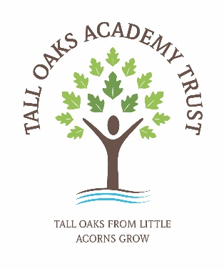

**JOB ADVERT  
Midday Supervisory Assistant**

Tall Oaks Academy is recruiting Midday Supervisory Assistants at both Mercer’s Wood Academy and Castle Wood Academy.

**Mercers Wood Academy x Two Positions**

8.75 hours per week – 11.45 to 1.30pm, Monday to Friday during Term Time (38 weeks) Salary: Grade 2 - £4,817 (FTE £24,413)

**Castle Wood Academy x One Position**

11.25 hours per week – 11.15 to 1.30pm, Monday to Friday during Term Time (38 weeks) Salary: Grade 2 - £6,194 (FTE £24,413)

**Job overview:**

We are seeking to appoint an enthusiastic and flexible Mid-day Supervisory Assistant. This is an exciting opportunity to join a vibrant and outstanding team of professionals all dedicated to providing the very best for all our children. Lunchtime duties include helping to promote good eating habits whilst supervising the children in the dining area, caring for their health, safety and welfare both in the dining area and on the playground.  You will be able to use your own initiative and be flexible and well organised. We are looking for someone who enjoys working with young children and can build positive relationships with them. You will be able to manage, organise and take part in positive play activities with our children.

**The right candidate will have:**

* An interest in working to support children as part of a team.
* Be willing to complete Basic Food Hygiene and Safety Certificate prior to taking up the post.
* A good level of proactivity and enthusiasm.
* Positive communication skills.
* A willingness to use technology to support their role.
* A good understanding of healthy eating and good dining habits.
* A commitment to the happiness, well-being, self-esteem and progress of everyone at the school.

*Tall Oaks Academy Trust is committed to safeguarding and promoting the welfare of children and young people and expects all staff and volunteers to share this commitment. Safer recruitment practice and pre-employment checks will be undertaken before any appointment is confirmed. This post is subject to an enhanced Disclosure and Barring Service (DBS) check.*

**How to apply**

Interested candidates can download the Recruitment pack, including job descriptions, person specifications and application forms at www.talloaksacademy.co.uk. This includes information about Tall Oaks Academy Trust, what we offer and how we can support you as well as a how-to guide on completing the application form.

|  |  |
| --- | --- |
| **Closing Date for Applications:** | **19th September 2025** |
| **Shortlisting Date:** | **23rd September 2025** |
| **Interview Date:** | **1st October 2025** |

Completed application forms should be emailed to recruitment@talloaksacademy.co.uk (please note: CVs will not be accepted as additional information or a replacement for any part of the application provided and only Tall Oaks Academy Trust application forms will be accepted).

Receipt of applications and unsuccessful applications will only be confirmed by email.

*References will be requested prior to interview and an Enhanced DBS check and Right to Work in the UK evidence will be required for successful applicants.*