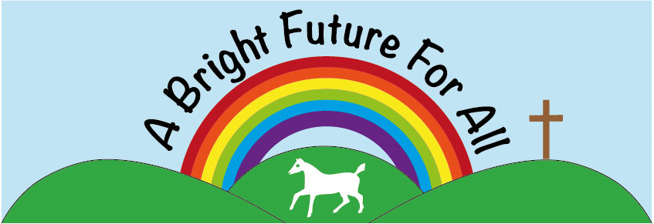


Broad Town CE Primary School Headteacher: Miss Bridget Long Broad Town www.broadtown.wilts.sch.uk Swindon admin@broadtown.wilts.sch.uk SN4 7RE Tel: 01793 731395

Job Specification
Post Title: Mixed Reception & Year 1 Class Teacher
Salary: MPS
Responsible to: Headteacher

Purpose of the Role
To provide high-quality teaching and learning for a mixed Reception and Year 1 class, delivering the Early Years Foundation Stage (EYFS) Framework and Key Stage 1 National Curriculum within a nurturing Christian environment.
The postholder will actively support the Christian vision and values of our Church of England school, ensuring that all children are known, valued and enabled to flourish academically, socially, emotionally and spiritually.

Key Responsibilities

1. Teaching & Learning
- Plan and deliver engaging, creative and differentiated lessons for a mixed-age Reception and Year 1 class.
- Deliver the EYFS Framework and Key Stage 1 National Curriculum effectively.
- Provide high-quality systematic synthetic phonics teaching.
- Create a stimulating, language-rich indoor and outdoor learning environment.
- Embed opportunities for spiritual development, reflection and awe and wonder within the curriculum.
- Maintain high expectations for behaviour, rooted in the school’s Christian values.
- Adapt provision to meet the needs of all learners, including SEND, EAL and disadvantaged pupils.

2. Christian Distinctiveness & Ethos
- Actively promote and uphold the school’s Christian vision and values in daily practice.
- Foster an inclusive environment where all faiths and worldviews are respected.
- Model positive relationships built on dignity, compassion and respect.
- Contribute to the school’s distinctiveness as a Church of England school

3. Assessment & Pupil Progress
- Monitor and assess pupil progress in line with school policy.
- Complete statutory EYFS assessment requirements (including EYFS Profile).
- Use assessment effectively to inform planning and interventions.
- Provide clear and constructive feedback to pupils and parents.
- Undertake the Y1 Phonics Screening assessment

4. Pastoral Care & Safeguarding
- Promote children’s wellbeing, independence and personal development.
- Create a safe, nurturing and inclusive classroom environment.
- Safeguard and promote the welfare of children in accordance with statutory guidance and school policy.

5. Professional Responsibilities
- Work collaboratively with colleagues, teaching assistants, governors and the wider parish community.
- Build strong partnerships with parents and carers.
- Engage in professional development and reflective practice.
- Contribute positively to the wider life of the school.

Essential Criteria

Qualifications
- Qualified Teacher Status (QTS).

Experience
- Experience teaching in EYFS and/or Key Stage 1.
- Experience of planning for mixed-ability learners.
- Experience using assessment to inform next steps in learning.

Knowledge & Understanding
- Secure understanding of the EYFS Framework and Key Stage 1 curriculum.
- Understanding of child development in the early years.
- Knowledge of effective early reading and phonics strategies.
- Understanding of safeguarding responsibilities.
- Understanding of the role and expectations of a Church of England school.

Skills & Personal Qualities
- Commitment to supporting the Christian ethos of the school (applicants do not need to be practising Christians).
- Ability to nurture children’s spiritual, moral, social and cultural development.
- Warm, reflective and compassionate approach.
- High expectations for achievement and behaviour.
- Strong organisational and communication skills.
- Ability to work collaboratively as part of a team.

