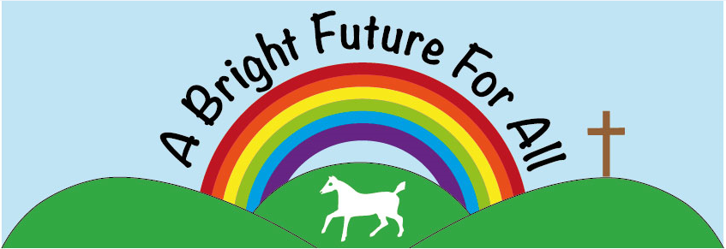


Broad Town CE Primary School Headteacher: Miss Bridget Long Broad Town www.broadtown.wilts.sch.uk Swindon admin@broadtown.wilts.sch.uk SN4 7RE Tel: 01793 731395

Job Specification
Post Title: Mixed Reception & Year 1 Class Teacher
Salary: MPS
Responsible to: Headteacher

Purpose of the Role
To provide high-quality teaching and learning for a mixed Reception and Year 1 class, delivering the Early Years Foundation Stage (EYFS) Framework and Key Stage 1 National Curriculum within a nurturing environment.
The postholder will ensure that all children are known, valued and enabled to flourish academically, socially, emotionally and spiritually.

Key Responsibilities

1. Teaching & Learning
- Plan and deliver engaging, creative and differentiated lessons for a mixed-age Reception and Year 1 class.
- Deliver the EYFS Framework and Key Stage 1 National Curriculum effectively.
- Provide high-quality systematic synthetic phonics teaching.
- Create a stimulating, language-rich indoor and outdoor learning environment.
- Embed opportunities for spiritual development, reflection and awe and wonder within the curriculum.
- Maintain high expectations for behaviour, rooted in the school’s values.
- Adapt provision to meet the needs of all learners, including SEND and disadvantaged pupils.

2. School Ethos
- Actively promote and uphold the school’s vision and values in daily practice.
- Foster an inclusive environment where all faiths and worldviews are respected.
- Model positive relationships built on dignity, compassion and respect.

3. Assessment & Pupil Progress
- Monitor and assess pupil progress in line with school policy.
- Complete statutory EYFS assessment requirements (including EYFS Profile).
- Use assessment effectively to inform planning and interventions.
- Provide clear and constructive feedback to pupils and parents.
- Undertake the Y1 Phonics Screening assessment

4. Pastoral Care & Safeguarding
- Promote children’s wellbeing, independence and personal development.
- Create a safe, nurturing and inclusive classroom environment.
- Safeguard and promote the welfare of children in accordance with statutory guidance and school policy.

5. Professional Responsibilities
- Work collaboratively with colleagues, teaching assistants, governors and the wider parish community.
- Build strong partnerships with parents and carers.
- Engage in professional development and reflective practice.
- Contribute positively to the wider life of the school.

Essential Criteria

Qualifications
- Qualified Teacher Status (QTS).

Experience
- Experience teaching in EYFS and/or Key Stage 1.
- Experience of planning for mixed-ability learners.
- Experience using assessment to inform next steps in learning.

Knowledge & Understanding
- Secure understanding of the EYFS Framework and Key Stage 1 curriculum.
- Understanding of child development in the early years.
- Knowledge of effective early reading and phonics strategies.
- Understanding of safeguarding responsibilities.
- Understanding of the role and expectations of a Church of England school.

Skills & Personal Qualities
- Ability to nurture children’s spiritual, moral, social and cultural development.
- Warm, reflective and compassionate approach.
- High expectations for achievement and behaviour.
- Strong organisational and communication skills.
- Ability to work collaboratively as part of a team.

