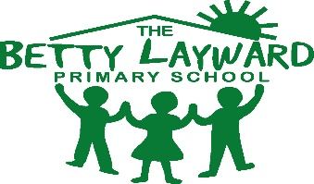

Music Teacher and Subject Leader Required from Spring Term 2025 three day a week permanent position (flexible on which days)

Salary: Main Scale or Upper Pay Scale or Unqualified Teacher Scale as appropriate (inner London)

Music is at the heart of our school and we would like to appoint a music teacher to take the school to even greater heights. If you would like to be part of a highly effective staff team and continue to keep music at the forefront of our supportive lovey school, we would like to hear from you.

We would like to appoint an outstanding music teacher who:
• Is passionate about music and the difference it can make for our children;
• Has excellent music skills and can play an instrument to a high standard;
• Has a proven track record of improving learning and progress;
• Have excellent knowledge of the music curriculum;
• Works effectively with teachers, parents and external agencies;

We can offer:
• A caring ethos where every child matters;
• A school where music is more than just a subject;
• Children whose behaviour and attitudes to music (and learning generally) are exemplary;
• Excellent take up of peripatetic instrumental music teaching;
• A friendly and collaborative staff team;
• A supportive wider school community;
• Commitment to your further professional development including mentoring and support

If you would like to discuss the details of the vacancy further with Jessica Bailey, the Head teacher, you are warmly welcomed to do so, preferably by visiting the school. Please arrange through the school office. Application packs can be downloaded from this advert and are returnable to the school office. Please use the correct application form, which is attached and return your application to admin@bettylayward.hackney.sch.uk.
For relevant information relating to this position, please contact us via email on or telephone 02072497111.

Closing Date and Shortlisting: Monday 2nd December 2024 at 12 noon

Interviews will be taking place on: Thursday 5th December 2024

Betty Layward Primary School is committed to safeguarding children and promoting the welfare of children and expects all staff and volunteers to share this commitment. We ensure that all our recruitment and selection practices reflect this. All successful candidates will be subject to an enhanced Disclosure and Barring service check along with other relevant employment checks

