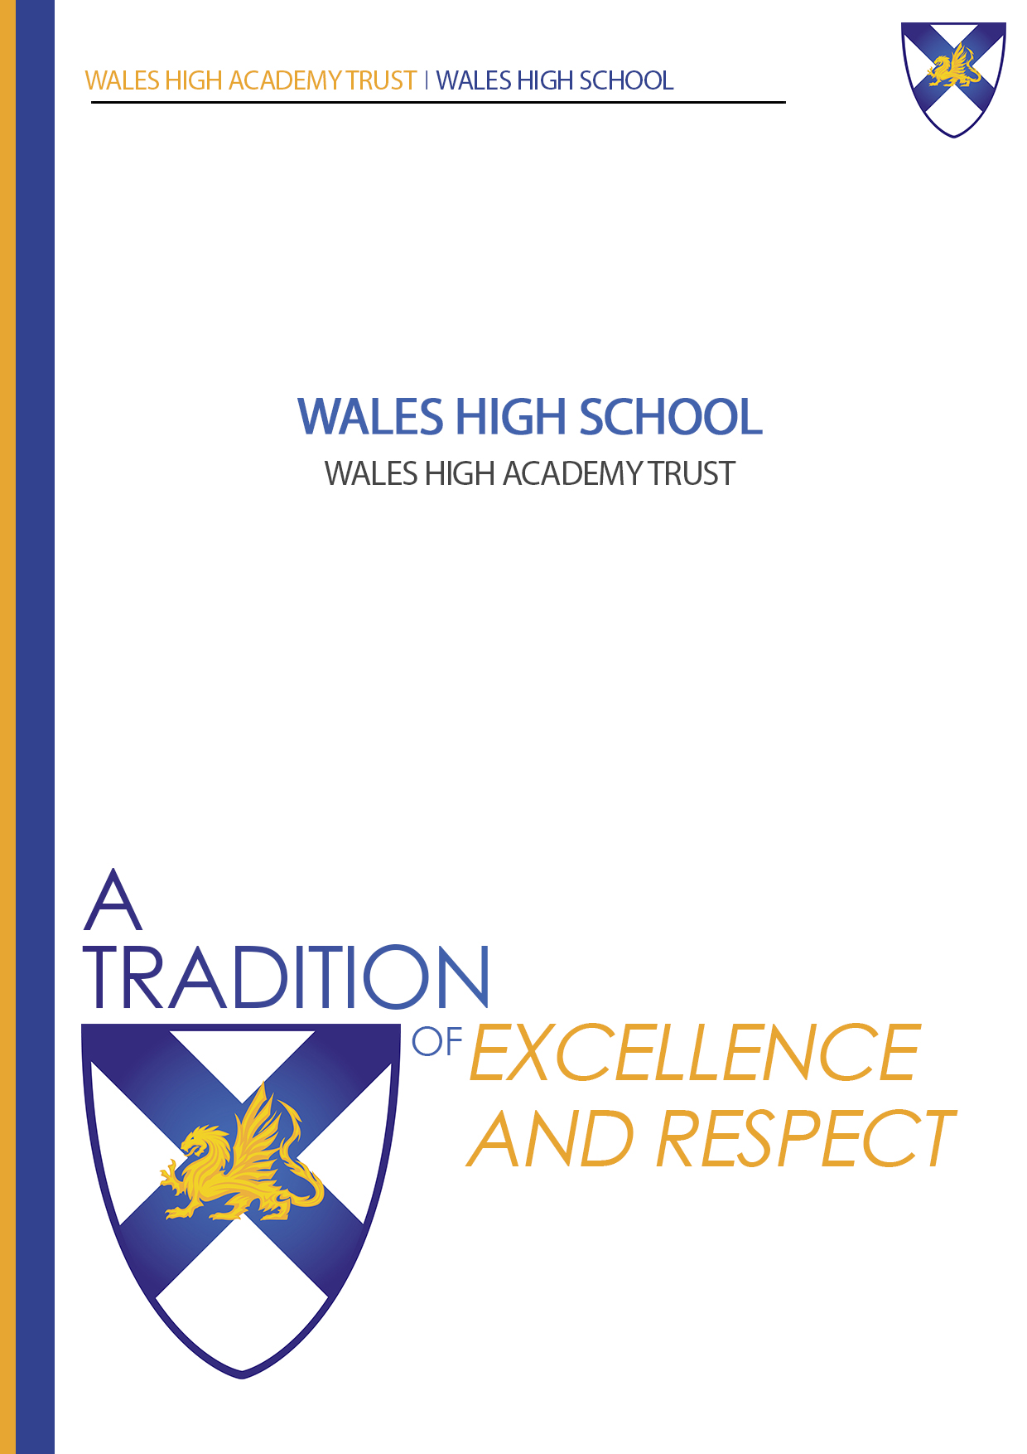
Teacher of Religious Education

INFORMATION PACK

Details of the post of
Teacher of Religious Education

Are you interested in joining a school and department:

- That is committed to excellent teaching and learning
- That demands high standards from students and staff
- That is extremely popular and over-subscribed
- Which is forward thinking, innovative and creative
- That is at the heart of its community and enjoys excellent links with parents
- That believes well-motivated and highly skilled staff are key to a school’s success
- Where students feel safe and happy.

If so, then please consider applying for this challenging and rewarding post.

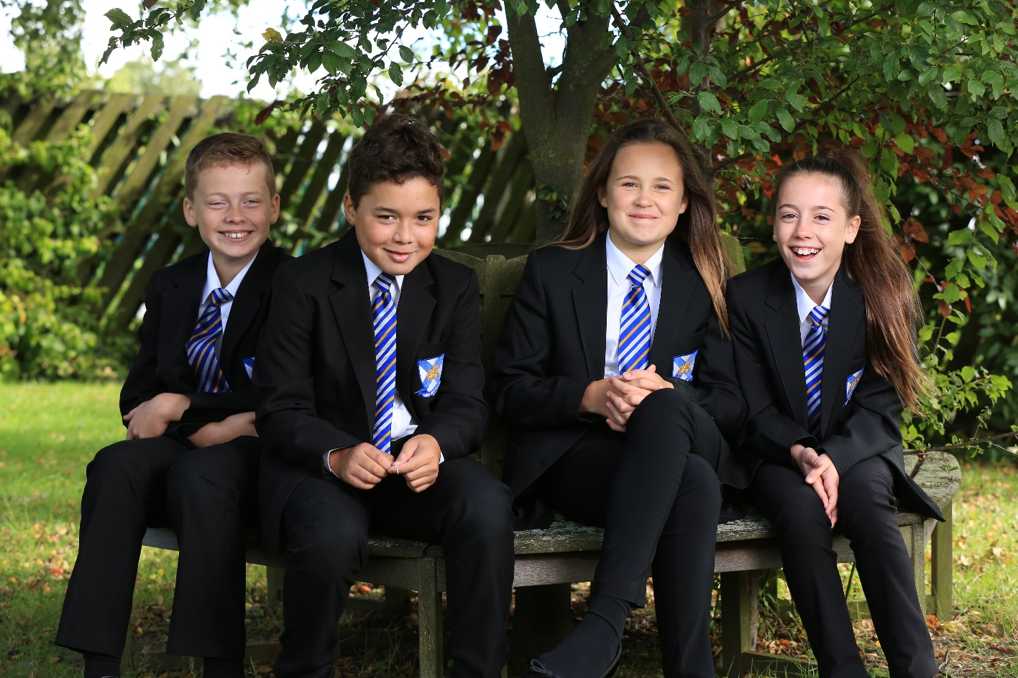

Message from the Headteacher

Wales High School is a happy, popular and highly successful school which provides an excellent education for over 1,800 children and young people and I am immensely proud to be the headteacher of this vibrant learning community.

Our aim is for all of our students to achieve their potential and to prepare them to thrive in a rapidly changing world. Pupils are valued as individuals and we are passionately committed to their achievement, personal growth and excellence in everything we do. We have a hugely talented and committed staff team, with a range of well qualified and dedicated professionals to make sure that our curriculum, guidance, care and support meets the different needs of every young person, and we pride ourselves on having high expectations which ensures that our students are well organised, caring and supportive of each other and also personally ambitious.

We are at an exciting point in our SEND development, having a growing number of SEND students attending Wales. In 2020 we built a new integrated resource, which over the next 4 years will support 25 students in a successful career at Wales. Our strong tradition of success is built on a firm foundation of pastoral care, and we ensure a climate for learning which is well ordered, safe, calm and focused on achievement and success.

All of our students are expected and encouraged to become independent learners and to develop their leadership skills, so they can fully participate in our rich extra-curricular programme. Across the school, teachers and students work in a collaborative and orderly atmosphere of mutual respect and trust. This gives the students a sense of belonging and a pride in our school and in themselves. Above all, we are committed to working together as a team.

We believe that by working together we can ensure opportunity and success for everyone. Every young person has unlimited potential, together we can make sure that this potential is realised and fulfilled.

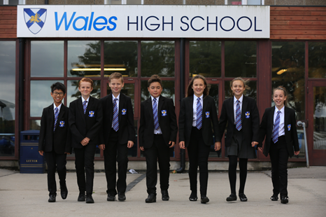
We pride ourselves on very close, open and positive relationships with parents and carers and expect them to be fully involved in supporting the learning of their son or daughter.

We are very active in our local and wider community, and have developed very close links with our Business and Enterprise partners.

I have pleasure in inviting you to visit the school to judge for yourself what makes this such a special community in which to learn.

Mr. G. Di'Iasio
Headteacher

WALES HIGH SCHOOL
Storth Lane, Kiveton Park, Sheffield S26 5QQ
Tel: 01909 775711

Headteacher: G. Di’Iasio, B.Ed. (Hons)
11-18 Mixed Comprehensive
1833 on roll (Sixth Form 234)

We welcome applications for the following full-time, permanent post
with effect from 1st January 2022.

NEWLY / RECENTLY QUALIFIED TEACHER OF RELIGIOUS EDUCATION

We are seeking a newly qualified, motivated and enthusiastic
teacher of Religious Education to join this innovative and exciting department.
The successful candidate will be energetic and inspiring.
It would be essential for applicants to have the ability or potential
to teach Religious Education across all Key Stages.

Further details and a Wales High School application form can be found online,
via the school’s website www.waleshigh.com.
PLEASE NOTE we operate Safer Recruitment and we do not accept CVs -
all applicants must complete our application form in full.
Applications can be posted to the school or e-mailed to vacancies@waleshigh.com

Deadline for applications is: 8:00 am on Wednesday 20th October 2021
Interviews have been scheduled for: Friday 22nd October 2021

If you would like to discuss the role or would like to arrange a visit to the Religious Education department, please contact Mrs Sian Roberts-Commons on
01909 771291 or by email on src@waleshigh.com

Mrs Sian Roberts-Commons
Head of Department of Religious Education

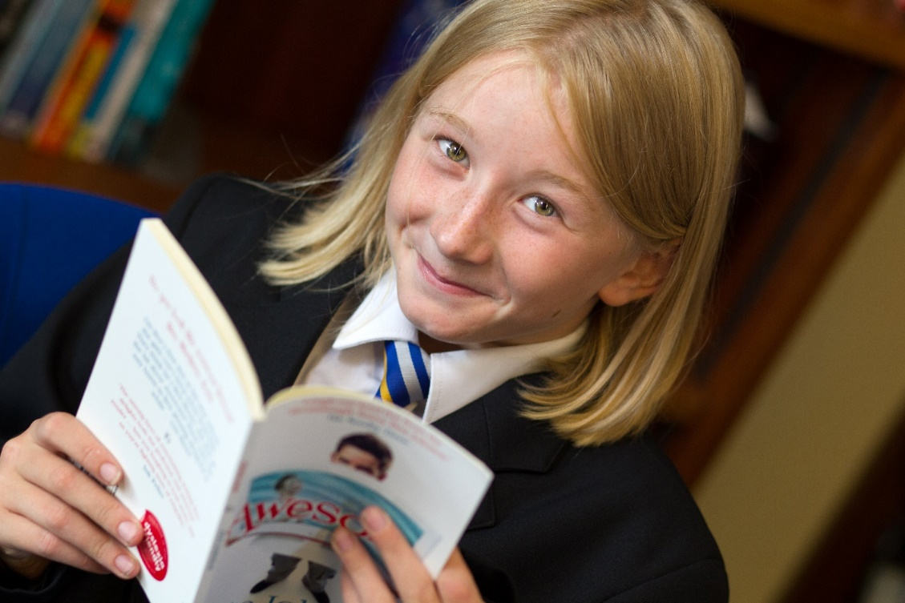

Wales High School is committed to safeguarding
and promoting the welfare of children, young people and vulnerable adults.
Successful candidates will be required to apply for a disclosure of criminal records check at an enhanced level. Further information about the Disclosure Scheme can be found at www.gov.uk/disclosure-barring-service-check.

Teacher of Religious Education
~ Job Description ~

Responsible to: Head of Religious Education

Hours: 32.5 hours per week (52 weeks p.a.)

Main Purpose

To teach Religious Education as directed by the Head of Department.

Duties and Responsibilities

To plan, prepare and deliver stimulating and imaginative lessons to classes of different age groups and abilities - incorporating differentiation, as appropriate.

To develop appropriate Schemes of Work.

To mark, check and assess students’ work and provide feedback.

To routinely track and monitor students’ progress in accordance with school procedures and Assessment Points.

To prepare students for qualifications / examinations.

To manage pupil behaviour within lessons and the wider school premises.

To attend staff and department meetings, as appropriate.

To manage and co-ordinate extra-curricular interventions and activities.

To liaise with parents and carers, as appropriate.

To maintain up-to-date subject knowledge and keep up with changes in the National Curriculum.

To engage in continuous professional development, including INSET opportunities.

Teacher of Religious Education

~ Person Specification ~

Essential | Desirable
- QTS and suitable experiences or qualifications as a teacher of Religious Education.  - Proven IT skills.  - Managerial / leadership skills.  - To like children and have high expectations of them, with good standards of discipline.  - To be efficient, well organised and able to work to deadlines.  - To have shown a strong interest and success in dealing with young people and their pastoral welfare.  - To demonstrate effective communication skills - written and verbal.  - To have a strong public presence.  - To be able to deal with pupils, parents, staff and the wider community.  - To have a ‘whole school’ perspective.  - To be reliable, have the ability to work hard and give freely of your time.  - People focused with a friendly, yet professional, and respectful approach - which demonstrates support and mutual respect.  - Flexibility and willingness to work unsociable hours occasionally. | - To have a good honours degree in Religious Education or related subject.  - Experience of teaching Religious Education.  - To have participated in extra-curricular activities.  - Experience of being a form tutor.  - To have a good sense of humour.  - To have taught the full ability range in a mixed comprehensive school.  - To have experience of working in more than one school.  - Smart appearance / dress.

The Religious Education Department

Religious Studies is a very popular subject at both GCSE and A Level. Numbers in recent years have remained high, with approximately 25 A Level students currently studying with us on our new A Level Religious Education course. In addition to this, we usually have approximately 90 students studying RE across Year 10 and 11. The Department is keen to continue to expand on these numbers in the future.

There are 3 classrooms in the department. All enjoy the benefit of an interactive whiteboard and teacher PC. One room has been recently converted to incorporate a suite of computers for departmental use. Staff are also fortunate to have an office with internet access and work space. The Department is well equipped with a variety of resources for each key stage and a wide range of audio visual resources to support learning.

There are currently 2 full time RE teachers and 2 part time RE teachers. With the Department there is a wealth of knowledge and experience. The Department is friendly and welcoming and staff support one another in order to ensure the best outcomes for students. The teachers are committed to improving attainment and enhancing the learning experience of all of its pupils. The Department pride themselves on the level of support offered to students, this includes, extra classes, revision sessions, essay technique sessions to support KS5 students and homework clubs. A full programme of activities and visits is also available; including a visit for Year 10 pupils to London to visit places of worship. The Department would love to develop learning activities outside the classroom and would welcome new and innovative ideas.

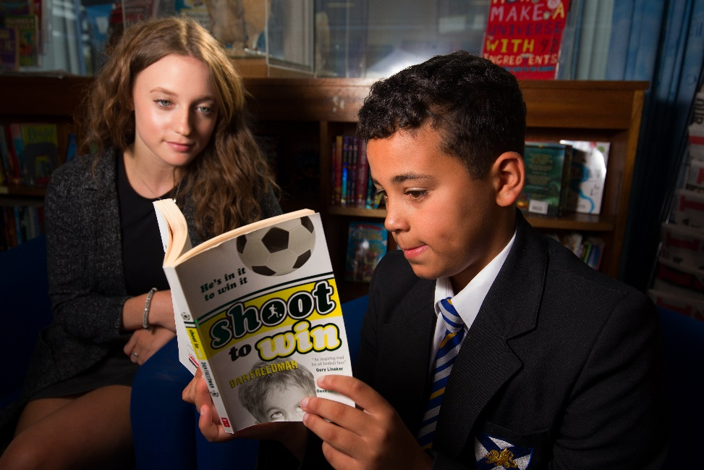
The teachers in the RE department work extremely well together as a cohesive team and mutual support and collaboration are central to their ethos. All share a passion for RE which they are keen to impart to students of all ages.

The Governors are seeking to appoint an inspirational and talented RE teacher for this post. The ability to teach GCSE RE is vital and experience at A Level would be an advantage.

Enthusiasm and commitment are pre-requisites as is a willingness to play an active role in the wider life of the school. In return, the RE Department can offer challenges and rewards in equal measure – and the opportunity to work in a happy and well respected school.

Mrs Sian Roberts-Commons
Head of Religious Education

Wales High School – Stake Holder Comments

Parents/Guardians:

- ‘My daughter enjoys coming to this school’
- ‘Fantastic - child extremely happy. He loves the school.’
- ‘Wales high is a fantastic school: nurturing and caring’
- ‘When your son walks into school saying he is worried about scraping through a particular subject and walks out with a 9 in it! Priceless!’
- ‘What an amazing teacher. Thank you’
- ‘Very supportive teachers and approachable’

Students:

- ‘I'm happy with everything - love the school’
- ‘This is a lovely school to be at and it makes me feel grown up. So glad I came to this school’
- ‘Teachers care and help me’
- ‘Thank you so much for being the best teacher ever and making exams less stressful’
- ‘Proud of myself’
- ‘Over the moon with my results - the hard work has finally paid off’

Wales High School – Ofsted

During the last two inspections of Wales High School, Ofsted were impressed with “the schools drive to provide strong pastoral care and ensure a climate for learning which is well ordered, safe, calm and focused on achievement is a reality at this ‘good school.’” They also commented that “the leadership team has maintained the good quality of education in the school…Together with governors, you are resolutely committed to the school’s further improvement. You are not complacent about any of the school’s successes and strengths.”

We are proud of all our staff, pupils, parents, governors and community who have made this possible.

Among the points highlighted by the Inspectors in the School's recent short inspection they say:

- ‘the leadership team has maintained the good quality of education in the school since the last inspection’
- ‘leaders have worked with persistence and diligence to maintain and improve levels of attendance and persistent absence, which are better than the national averages’
- ‘there is evidence of very effective teaching’
- ‘a significant number of middle leaders are now nationally recognised as leaders in their subject areas, and they provide support to other schools’
- ‘acted decisively in responding to the needs of your pupils, such as training 18 staff as mental health first aiders’
- ‘pupils told us that the school is a tolerant place, and that they feel safe there. They told us that bullying is rare, but that if it happens, the school deals with it’.

Wales High School
Founded 1970
Wales High School Academy Trust
Storth Lane, Kiveton Park, SHEFFIELD, S26 5QQ

Tel: 01909 771291
Email: vacancies@waleshigh.com

