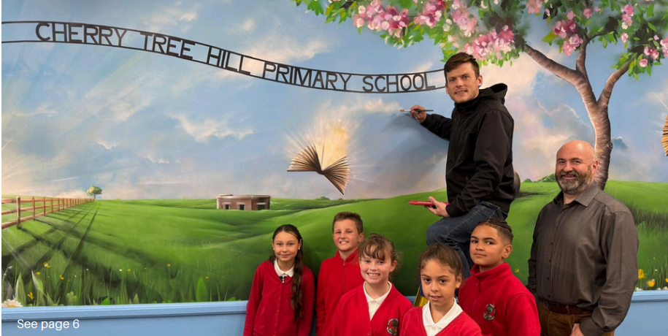

Job Application Pack

Cherry Tree Hill Primary School

Early Years Teaching Assistant
22.2 hours per week (Part Time)
Contract Type: Part Time, Term Time only, Fixed Term (5th January 2026 – 24th July 2025)
Salary: Grade E (Point 10-14)

Closing Date: Tuesday 25th November 2025 (9am)
Interview Date: Wednesday 3rd December 2025



Welcome letter from Paul Appleton, Head Teacher of Cherry Tree Hill Primary

Dear Candidate,
Thank you for showing an interest in the role of EYFS Teaching Assistant at our school. An exciting opportunity has arisen for a strong candidate to make a difference to our pupils at Cherry Tree Hill in Derby. We are looking for a candidate who will strengthen the team, who has good communication skills and will have our children’s best interests at heart.

Our school is a large primary, set in spacious grounds two miles from Derby City Centre. Visitors to our school comment positively on our facilities and the stimulating environment. They describe our atmosphere as respectful and nurturing, and you know what? It is!

Being the Headteacher of Cherry Tree Hill Primary School continues to give me great pleasure. I am fully committed to the community of Cherry Tree Hill Primary School and strive to ensure that the school serves our local children and their families well. I am proud to welcome you to our school and I look forward to welcoming you to our community.

Our school is part of the Odyssey Collaborative Trust. Our Trust is committed to supporting and delivering education of the highest quality across the trust. Here at Odyssey, we share one vision; ‘Our Children Thrive - Our Colleagues Thrive - Our community Thrives.’

This is a tremendous opportunity to make a difference and to be part of a dynamic and innovative staff team.

We look forward to receiving your application and working with you on your own professional journey to excellence.

Best regards,
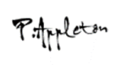
Mr Paul Appleton
Headteacher
Cherry Tree Hill Primary School




About the school

At Cherry Tree Hill, we endeavour to create a happy, secure, relaxed atmosphere whilst, at the same time, insist on high standards of both work and behaviour. Together we strive for the fulfilment of every child’s potential. Children are encouraged to be independent and self-reliant. They are taught to have respect for property, themselves and each other.

Parents are seen as important partners in their child’s learning, and are actively encouraged to get involved in the life of the school. Parents are always made welcome in school, and staff endeavour to find time to listen to their concerns.

We develop positive learning relationships with our children and recognise the importance of this. We are proud of our children, staff and school.

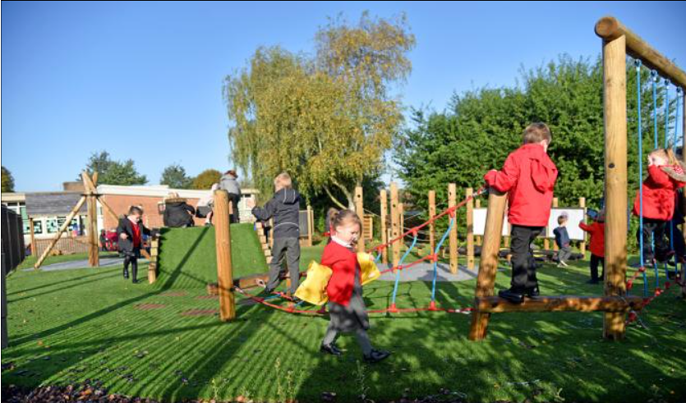

Job Description – EYFS Teaching Assistant
Application Details
We are looking for an enthusiastic EYFS Teaching Assistant to join our team here at Cherry Tree Hill Primary School. We need ambitious and driven candidates with a passion for helping children learn effectively. Everyone who visits our school comments on the calm atmosphere, the enthusiasm our children have for learning and the great sense of team amongst staff and children alike.

At Cherry Tree Hill we value every individual and put our children at the heart of everything we do. If you think this sounds like you then come and visit us to see for yourself. Visits are positively encouraged. Please contact Holly Hassall (details below) to arrange a convenient date. Please phone or email to arrange a mutually convenient appointment. Find out if we’re right for you! Contact Holly Hassall on 01332 673520 or email h.hassall@cherrytreehill.odysseyct.org.uk .

Odyssey Collaborative Trust is committed to safeguarding and promoting the welfare of children. We follow safer recruitment procedures and will require an enhanced DBS clearance and references from current and past employers. Further details of this post, the school and the Trust are included in this pack and details of how to apply can be found below.

How to Apply
Should you wish to apply for the post, please complete and return an application form along with a covering letter addressed to Cherry Tree Hill Primary School which clearly demonstrates your suitability for this role. Applications can be submitted via email to h.hassall@cherrytreehill.odysseyct.org.uk , or by post, for the attention of Holly Hassall, to the following address: Cherry Tree Hill Primary School, Lime Grove, Chaddesden, Derby, DE21 6WL.

Wherever possible, please provide work email addresses for your referees.

Closing Date
Please ensure your application form arrives by 9am Tuesday 25th November 2025
Interviews for the role will be held Wednesday 3rd December 2025
Our privacy notice can be found at https://www.odysseyct.org.uk/gdpr/

Cherry Tree Hill is committed to safeguarding and promoting the welfare of children and young people, and expects all staff and volunteers to share this commitment. As this post is regulated activity, successful appointments are subject to an enhanced Disclosure and Barring Service check and relevant recruitment checks that comply with guidance in the most recent version of Keeping Children Safe in Education.
We are committed to equality of opportunity in employment and services
Cherry Tree Hill is part of the Odyssey Collaborative Trust

All members of staff will receive training in line with our Safeguarding and Child Protection Policy.

Equal Opportunities
Odyssey Collaborative Trust welcomes applications from everyone and values diversity in our workplace. A commitment to promoting diversity and developing a workplace environment where all staff are treated with dignity and respect is central to our recruitment process.

JOB PURPOSE
To work with teachers to support teaching and learning in all aspects of the curriculum, with specific responsibility for pupils with additional needs as delegated by the class teacher or Headteacher.

ACCOUNTABILITIES
• Delivering interactions and activities based on teachers planning
• Preparation of materials and equipment
• Assessment of needs – supporting assessment of pupils’ learning through quality first interactions
• Supporting the class teacher to report on achievement
• Short term cover supervision of classes where appropriate
• Supporting allocated SEND pupils with teaching and learning
• Liaise with parents, external professionals/agencies
• Contribute to school improvement priorities alongside class teachers Accountable to the Headteacher.

KNOWLEDGE
Key duties:
• To promote and actively support the values of the school
• Provide learning activities for individuals and groups of pupils under the professional direction and supervision of a qualified teacher, differentiating and adapting learning programmes to suit the needs of allocated pupils
• Assess, record and report on development, progress and attainment as agreed with the teacher
• Monitor and record pupil responses and learning achievements, drawing any problems which cannot be resolved to the attention of the teacher
• Plan and evaluate specialist learning activities with the teacher, writing reports and records as required
• Select and adapt appropriate resources/methods to facilitate agreed learning activities
• Support pupils in social and emotional well-being, reporting problems to the teacher as appropriate
• Prepare and present displays
• Be involved in planning, organising and implementing individual development plans for pupils (such as Individual educational plans), including attendance at, and contribution to, reviews
• Work with pupils not working to the normal timetable
• Share information about pupils with other staff, parents/carers, internal and external agencies, as appropriate
• Support the work of volunteers and other teaching assistants in the classroom
• Meeting the national occupational standards (NOS) in Supporting Teaching and Learning level 3 and NVQ level 3 or equivalent relevant qualification
• Knowledge and compliance with policies and procedures relevant to child protection and health and safety
• Demonstrate a good working knowledge of the current KS2 national curriculum
• Deliver intervention strategies/programmes for specific pupils
• SEND code of conduct knowledge

ADDITIONAL SKILLS AND DEMANDS
Under supervision and direction of qualified teachers contribute to:
• Delivery of activities for an individual, group or class
• Assessment of need for individuals or groups
• Gather, collate, analyse information to contribute towards reviews of attainment and progress
• Form and maintain appropriate professional relationships with pupils, teachers, support staff, parents/carers, governors, external professionals and agencies
• Know when to maintain confidence concerning sensitive information
• Work on a one-to-one basis with specific SEND pupils, or with a small group delivering intervention programmes
• Able to respond to many circumstances but know when to call for assistance or refer to more senior staff
• Maybe required to administer medication in accordance with an agreed plan under direction of healthcare practitioner, following appropriate training
• Work indoors in classroom or other venues in school, or outside during all seasons
• Accompany pupils and teachers on educational journeys, day trips that may require being outdoors all day
• Ability to adapt to changing circumstances and make judgements to solve minor day to day challenges/problems
• Positive work-related pressure to achieve expected results will always apply
• Maintain professionalism at all times
• Need to have positive motivational skills to engage pupils in a favorable educational atmosphere and environment
• Operate within the school’s Behaviour policy with positive reinforcements, rewards and sanctions

RESPONSIBILITIES
• Responsible for health, safety, welfare and educational achievement of assigned pupils, groups, class during school sessions
• Common courtesy to all pupils and adults in course of normal duties
• Will contribute to assessment of pupil needs in conjunction with other professionals and parents/carers and share in delivering appropriate programmes
• Some day-to-day support of other teaching assistants and volunteers in the classroom
• Responsible for supervision and safe use of equipment and materials including classroom, PE/games both inside and outside and careful use of school premises by pupils in your care

These above-mentioned duties are neither exclusive nor exhaustive, the post-holder maybe required to carry out other duties as required by the Trust.
As this job is designated as a ‘regulated activity’ an enhanced DBS with Barred list check is essential.

Person Specification
Post Title: EYFS Teaching Assistant
Hours: 22.2 hours
Salary: Grade E (Point 10-14)

Person Specification EYFS Teaching Assistant | Essential | Desirable
Experience
Experience of working with young people | X
Previous Classroom Assistant experience | X
Experience of working with young people with Special Educational Needs | X
Qualifications
Qualification in Early Years Foundation Stage | X
GCSE (or equivalent) in English and Maths | X
NVQ Level 2 Qualification or equivalent | X
Evidence of Professional Development |  | X
Skills and Abilities
The ability to communicate effectively – both verbally and in writing and to use language and other communication skills that students can understand and relate to | X
The ability to respond calmly and constructively when dealing with students with Special Educational Needs | X
Ability to manage time effectively | X
The ability to seek advice and assistance to meet students needs | X
Willingness too maintain confidentiality on all school matters | X
A willingness to engage in professional development opportunities | X
Ability to provide engaging 1:1 support | X
Ability to demonstrate active listening skills |  | X
General and Specific Knowledge
To understand Special Educational Needs | X
The ability to learn and use a range of strategies to deal with classroom and individual behavior | X
An understanding of and commitment to equality of opportunity in day to day working practices | X
The ability to work as part of a team | X
Awareness of Literacy Development | X
Experience of using Information Technology to support students in the classroom |  | X
Safeguarding
A commitment to safeguarding and promoting the welfare of children, young people and vulnerable adults | X
Upholding school policies and procedures in relation to safeguarding and/or child protection | X

