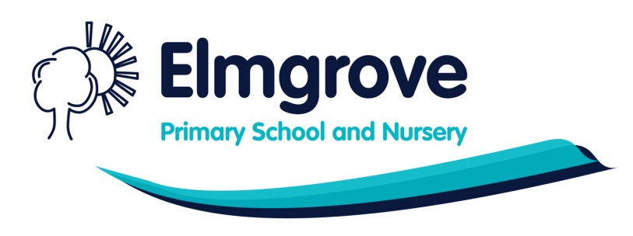

Kenmore Avenue, Harrow, HA3 8LU

Nursery Nurse (Foundation Stage Team) – Permanent Role
Salary range Nursery Nurse G3 Point 9: £25,668
Full Time – 8.30-3.30pm (inc. 30 min break)
Would you like to work in a caring, happy and successful school where children come first? If so, we are looking to appoint an additional colleague to Elmgrove to start as soon as possible.
The successful applicant must:
- Have experience of working with young children
- Be emotionally intelligent, caring and flexible
- Have excellent interpersonal skills and be able to fit in with our happy hard-working team
- Have a diploma in pre-school practice, NVQ Level 3 or equivalent
- Have a good standard in literacy and numeracy skills – (GCSE Maths & English Grade C is essential)
- Have First Aid Qualifications or be willing to undertake Paediatric First Aid training
- Previous experience working in a school or pre-school setting is essential
- Have successful experience working with children with a diagnosis of ASD, ADHD or social and emotional challenges
- Have good positive behaviour management strategies
- Have a strong desire to develop and learn for themselves
- Committed to developing children’s learning
This is a great opportunity to work in a well-resourced school with dedicated professionals who enjoy providing high quality provision for all our children.
At Elmgrove we pride ourselves on our kind, caring environment and all staff are valued members of the team with the simple mission of inspiring and nurturing lifelong learners in a quality learning environment for all.
Elmgrove Primary School and Nursery is committed to safeguarding and promoting the welfare of children and expects all staff and volunteers to share this commitment. Appointment is subject to an enhanced Disclosure and Barring Service (DBS) check. In accordance with Keeping Children Safe in Education, we will carry out an online search as part of the due diligence on shortlisted candidates.
Completed applications should be emailed to applications@elmgrove.harrow.sch.uk
Closing date: 1st July 2024
Interviews: w.c 5th July 2024
Previous applicants need not apply
An Equal Opportunities Employer

