





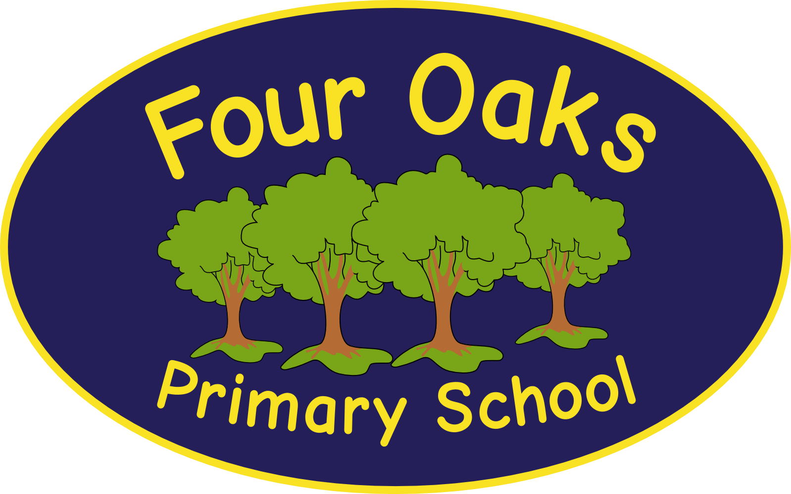

Headteacher: Mrs S Robinson B.A.(Ed) M.Ed. NPQH

39 Davy Street
Liverpool L5 1XP
Telephone: (0151) 263 4038
Fax: (0151) 260 7257
Email: office@fouroaksprimary.com
Website: www.fouroaksprimary.co.uk

June 2025
Nursery Room Leader
Full-time, term time only 35 hours per week. Fixed term in the first instance.
1st September 2025 to 31st August 2026
Level 3 minimum. Pro rata salary Grade 5 to 9 (£24,790 - 26,409)
Starting salary is dependent on experience.

Four Oaks is an inclusive primary school, with high aspirations for all. We have happy, extremely well behaved children and supportive, dedicated staff and governors, catering for pupils from 1 to 11 years old.

Our school has received a prestigious SCALA architects’ award. It is a modern build with beautiful, well equipped classrooms and state of the art facilities including an interactive 4D classroom. It is surrounded by landscaped grounds with many facilities for the children. Visitors to our school always comment on the happy, enthusiastic children who demonstrate exemplary behaviour.

In May 2025 an EYFS Ofsted Inspection graded us as Good in all areas and Good Overall. The Governors wish to appoint a Nursery Room Leader to join our team. The role will include working with our EYFS team which includes 2-year old nursery, pre-school Nursery and Reception. You will be predominantly working in our Little Acorns 2 year old room. You must have consistently strong feedback on your teaching and where possible, please give examples in your letter of application. You will be joining an EYFS team who work well together and who are dedicated to providing the very best education to our children. The post is fixed term for one year in the first instance to work with the team to embed actions identified by school and Ofsted to develop and cement outstanding practice.

You will:
• Have a sound knowledge of EYFS;
• Have excellent interpersonal and leadership skills;
• Be a dynamic practitioner with high expectations and a proven track record of relevant experience;
• Have excellent organisation and communication skills;
• Be enthusiastic and creative;
• Have commitment to further professional development;
• Have a commitment to support the inclusive ethos of the school.

We are able to offer a supportive team, happy children, CPD opportunities, dedicated wellbeing package of support and we are easily accessible with good transport links and we have a large safe car park.

Closing date: Sunday 29th June 2025
Please apply via the link below.

Top of Form
Nursery Room Leader

Please address any queries regarding the application process or to arrange a visit to the school to office@fouroaksprimary.com

Four Oaks Primary School is committed to safeguarding the welfare of young people and expects all staff and volunteers to share this commitment. All appointments are subject to enhanced DBS checks and excellent references.

