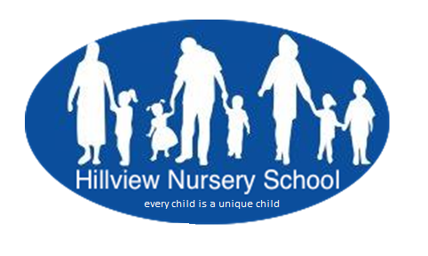
Hillview Nursery School
2 Grange Road
Harrow HA@ 0LW
02084224692
www.hillviewnurseryschool.co.uk

Would you like to work in an inspirational and successful nursery school? If so, then Hillview Nursery School is for you.

Hillview Nursery School is the only maintained nursery school in Harrow and has a very strong history of providing early education, care and support to children and their families in a most inclusive environment through the close partnership of the co-located Hillview Children’s Centre Hub, local schools and other agencies
We offer 90 places to two, three and four-year-olds, and an additionally resourced nursery provision for 12 children with special need.

We are seeking to appoint a creative and energetic Nursery Teacher (QTS) who:
- Has passion and enthusiasm for the early years
- Is excited about teaching and learning
- Has an excellent understanding of how young children learn and develop (within a sound pedagogical framework)
- Demonstrates a deep commitment to inclusion
- Has skills to lead and work as part of a team
- Is keen to continue professional development
- Is wholeheartedly committed to working with families and the wider community
- Is fully committed to safeguarding

Salary Scale: M1 to UPS3 (outer London)
Closing date for application: Friday 19th March 2021
Start date: September 2021
Interviews: Depending on the length of school closures, we may need to arrange alternative options in place of normal interviews, such as telephone or video-conference interviews with the possibility of onsite interviews in special cases.
We want to reassure applicants that effective measures have been implemented to ensure their health and well-being on school premises. Candidates will be kept informed of developments via email.

Please return your completed form directly to Hillview Nursery School or e-mail to: jackie.halpin@harrow.gov.uk

We are committed to safeguarding and promoting the welfare of children and their families and expect all staff and volunteers to share this commitment. Offers of employment are subject to a satisfactory enhanced DBS disclosure and other employment checks.
Hillview Nursery School is committed to safeguarding and promoting the welfare of children, and expects all staff and volunteers to share this commitment.

