Normand Croft Community School
Candidate Information Pack:

Early Years
Nursery Teacher
Normand Croft
Community School
Candidate Information Pack:
Primary Teacher (with ot without Leadership TLR)

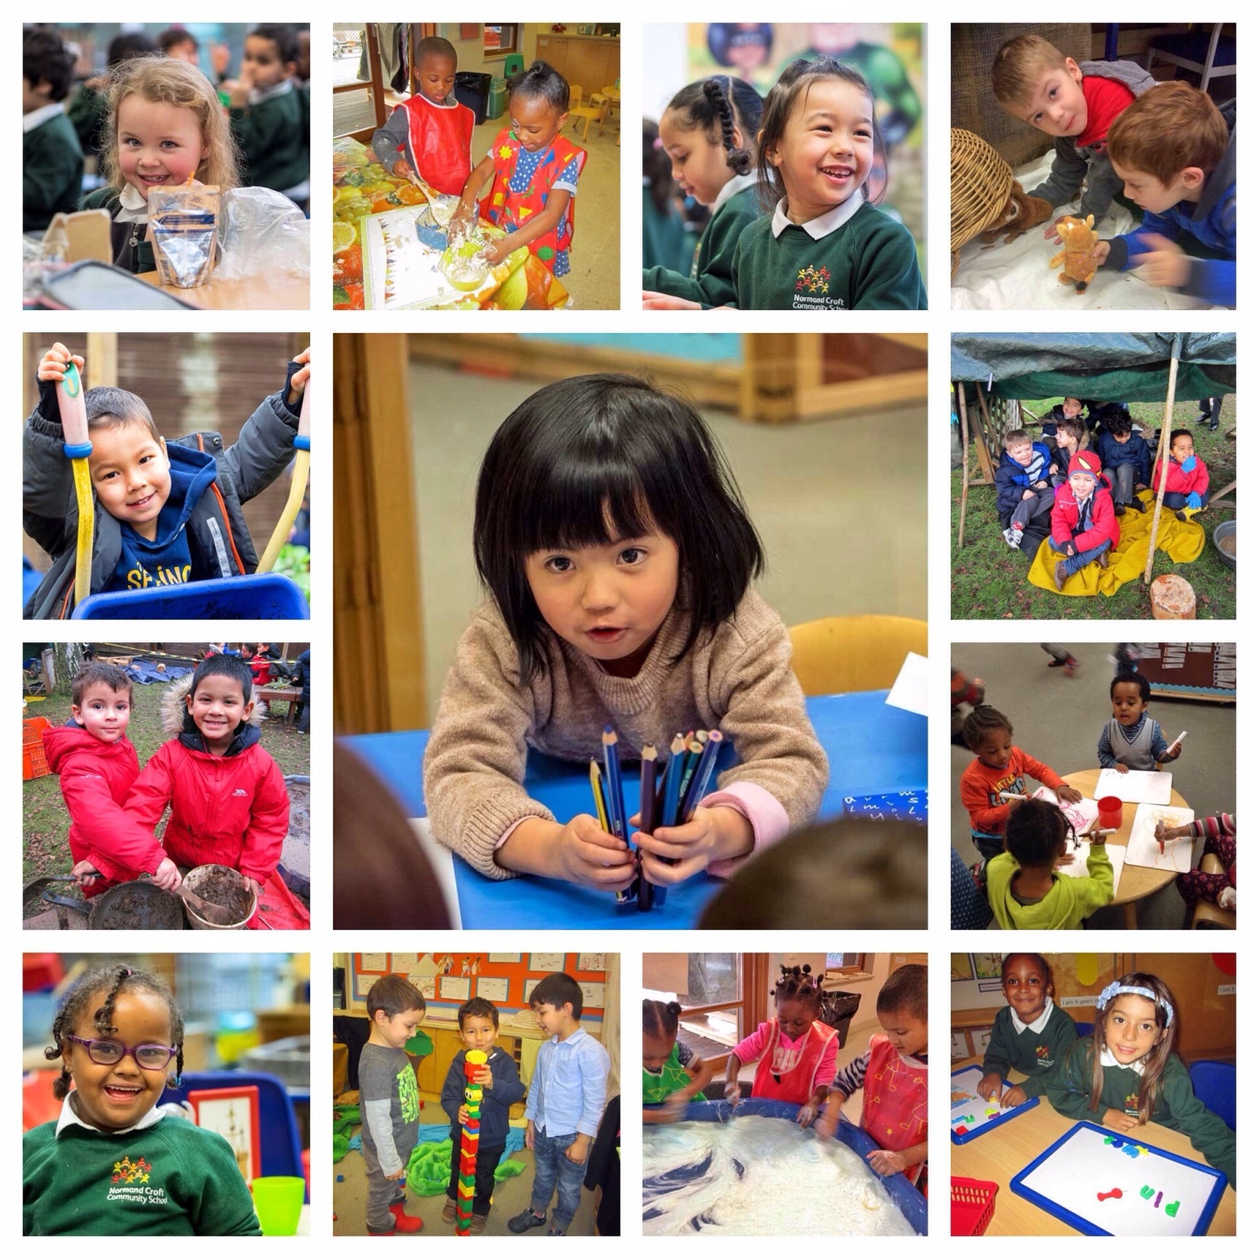
Welcome to Normand Croft
Dear candidate,
To join Normand Croft is to join an international family of learners. We are passionate about children’s education and determined to go that extra mile to ensure that the children in our care have the very best opportunities to grow, learn and achieve.
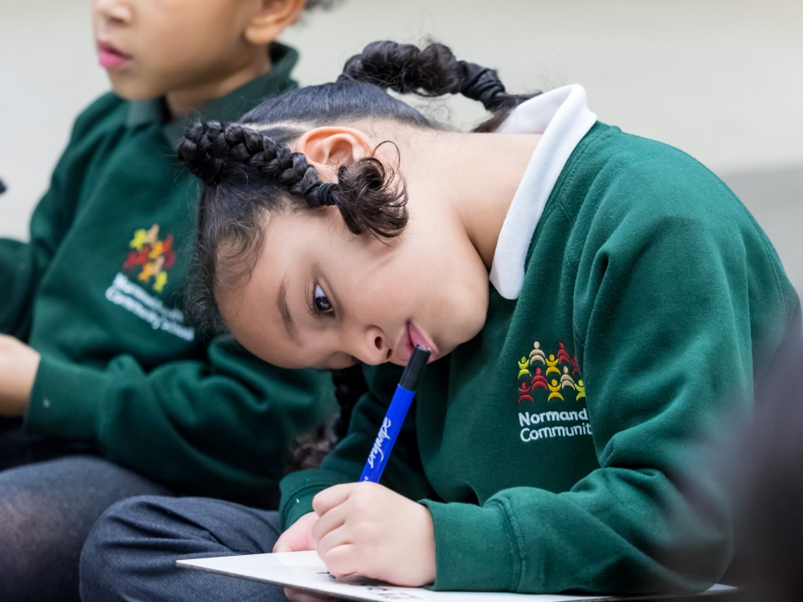
We think deeply about what we do, we strive to give the children the most challenging and most exciting curriculum possible, and we treat each other with kindness and respect.

Our school is built on a foundation of shared values - excellence, responsibility & respect, determination, independence, unity and trust. They inform every aspect of school life.

As we continue on our journey to excellence we are looking for an enthusiastic and skilled Nursery Teacher who will lead our Nursery team to create a wonderful learning environment for children.

To help you decide if this is the school for you here are a few things that we do at Normand Croft:
- We encourage collaborative partnerships and provide shared teaching opportunities with experienced colleagues.
- We believe in coaching, and will work with you to identify ‘small-step/ high leverage’ improvements to your practice.
- We believe in teaching the whole child, but also in developing your potential. Through demonstrating energy, resilience, enthusiasm and commitment you will find we offer a springboard to career development both in school and beyond.

We would love you to visit and see the school in action, or call to talk things through. Normand Croft is on an exciting journey, and we are looking for people to join us who have a belief that more of the same is just not ambitious enough.

With best wishes

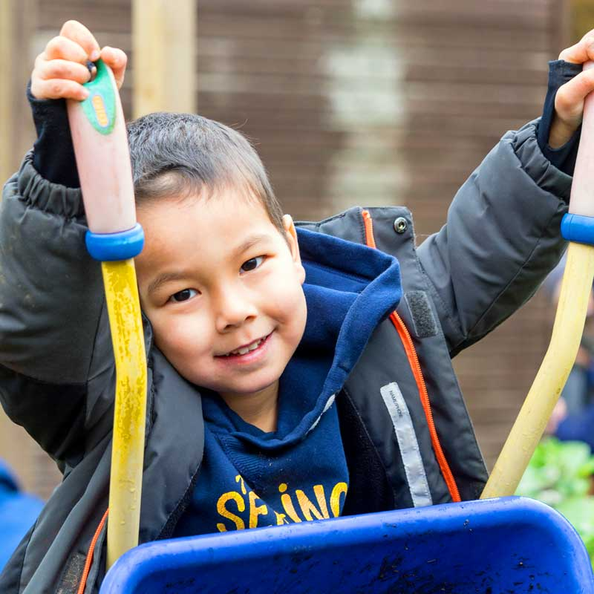
About Normand Croft
Our Values and Vision
Normand Croft is a 2-11 community primary school in West Kensington, London. We have up to 8 children in who are under 3 and up to 30 3-4 year olds in any one session (am or pm) in our Nursery. Children come with a wide variety of starting points and backgrounds to create a rich and diverse multi-cultural community of learners.
We all work hard to make a real impact on these children’s lives and learning. We have a strong sense of purpose, which comes from serving children, who despite often living in socially disadvantaged and at times, challenging environments, all have huge potential.
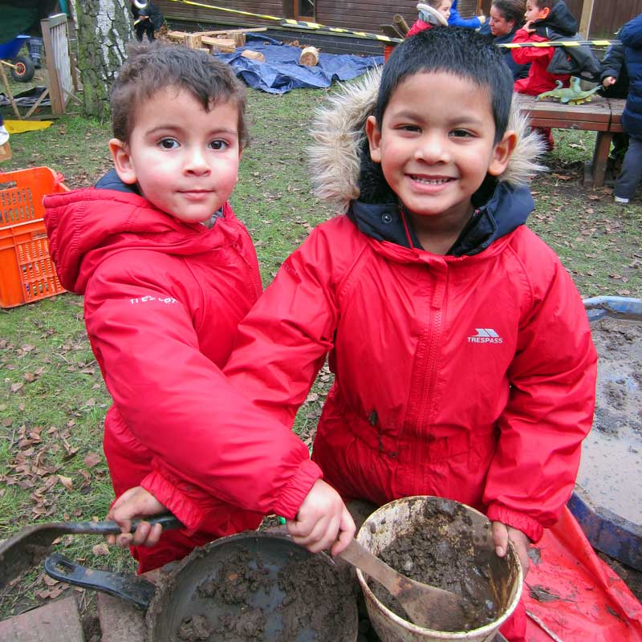
Our shared values guide everything that we do. We work to create a safe and happy ‘family’ atmosphere where every child has the chance to find their voice, be supported and be given a rich range of opportunities and experiences that will inspire them to enjoy school and make rapid progress.
We believe in a child-centred focus on learning and this is captured in our vision statement which defines our common ground as a school community as:
We put children at the heart of everything we do achieving
their safety, happiness and progress as learners underpins
every aspect of our work
We set high standards with high expectations of, and aspirations for, ourselves and all children
We support and challenge every child ensuring high quality teaching helps to overcome barriers to learning, and through building (and re-building) children’s self-belief enable them to achieve their potential
We value individuals ensuring that every child receives an education that is
tailored to their needs, and where enjoyment and achievement walk hand-in-hand
We enable children to shine giving them the opportunities, responsibility
and trust needed to learn for themselves, and explore/use their talents
We build bridges between children, parents, families and communities and work in partnership with others for the benefit of children
We celebrate core values such as excellence, responsibility, respect, determination, independence, unity and trust as expressions of our school ethos
Together we are re building a values-based learning ethos fit for the 21st Century.
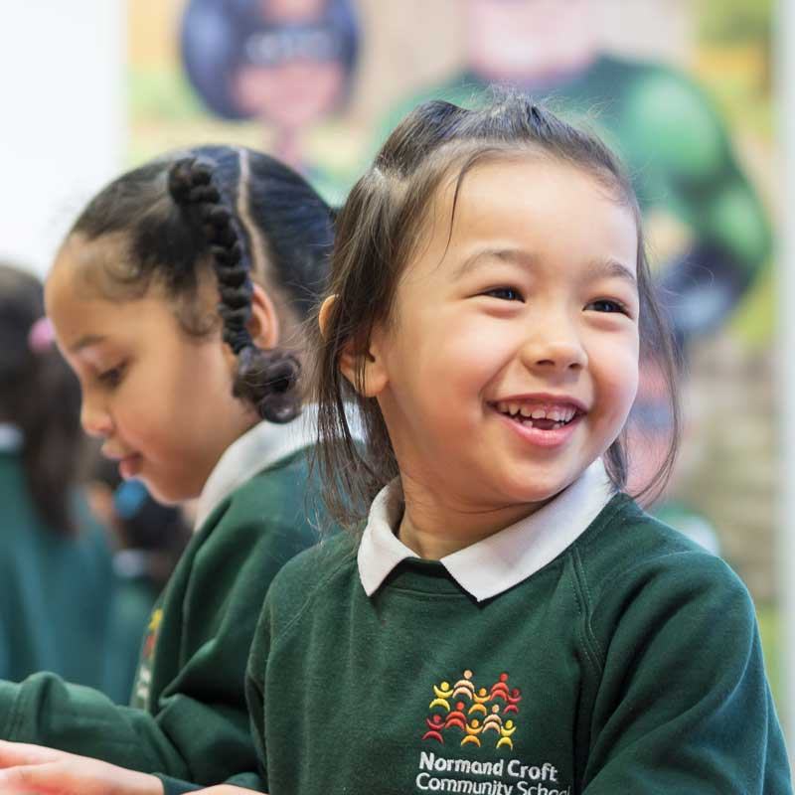
Important Features of Normand Croft
Our school is a rich learning environment for both children and staff. It is a special place, with a number of innovative features:
- Professional development is central to our school. Each member of staff collaborates with colleagues from across the school to improve their practice and develop new ways of supporting children.
- English language is at the heart of everything we do, with children given the chance to develop a love of books, of stories and early writing skills every day.
- Support & nurture. Our class sizes and adult ratios mean that more time can be spent on really understanding the needs of each child. All children are supported and none fall through the cracks.
- Best practice. The way we teach and the way children learn does not happen by accident. We make sure our teachers keep up to date with the latest developments in teaching and learning and we are very proud of the fact that our bespoke approach to teaching and learning has evolved over time to meet the specific needs of our children. Importantly, it is an approach based on best practice drawn from the work of colleagues, academics and schools all over the world.
- Growth Mindset. We believe in a 'Growth Mindset'. Inspired by the work of Carol Dweck, and her colleagues, we work to instil in children, teachers and hopefully parents/carers the belief that the brain is like a muscle. It grows, develops and indeed becomes more intelligent when mistakes are made and then corrected through feedback. We believe that intelligence and abilities can be significantly developed through practice; that an individual's end point is not pre-determined and that there is limitless potential for growth.
- Microcosm. We believe that our school should be a microcosm of the best of the world around us. Our approach to teaching helps us to achieve this by actively developing children's social and relationship skills and promoting a positive learning environment where children feel safe, valued and respected.
Job profile
Title: Early Years Teacher for Nursery
Salary: M1 – M6 £34,502 - £44,756 per annum (MPS Inner London)
Start Date: 01.09.2023
Contract: Subject to enhanced DBS check
This application is your chance to join a professional learning community where teachers have the chance to grow and develop through working in partnership, and in close collaboration with, experienced practitioners in school.
At Normand Croft, Early Years Teachers have a chance to develop their skills both through adult-led activities (with a focus on communication & language development) and through modelling language skills as a play partner during child-initiated play.
General:

- have experience of working with children aged 2 to 4 years old and in the delivery of high quality childcare and education
- have responsibility (with EY teachers and other EYES) for developing, planning and delivering a curriculum based on the revised EYFS framework and Birth to 5 matters
- work cooperatively with parents and other professionals to ensure that the needs of all children are met
- have a high expectation of every child whatever their background or starting point
- establish a positive relationship with children
- assess, evaluate, monitor and support each child’s progress
- record and report on their development, progress and achievement in line with school policy
- work as part of a team to establish a safe, supportive and stimulating Early Years learning environment where displays and resources are used to help children learn effectively

You will undertake all duties in accordance with the local authority’s and school’s policies and guidance; Health & Safety advice; and the Children’s Act.
The following description of accountabilities and tasks should be viewed in conjunction with the aforementioned document.

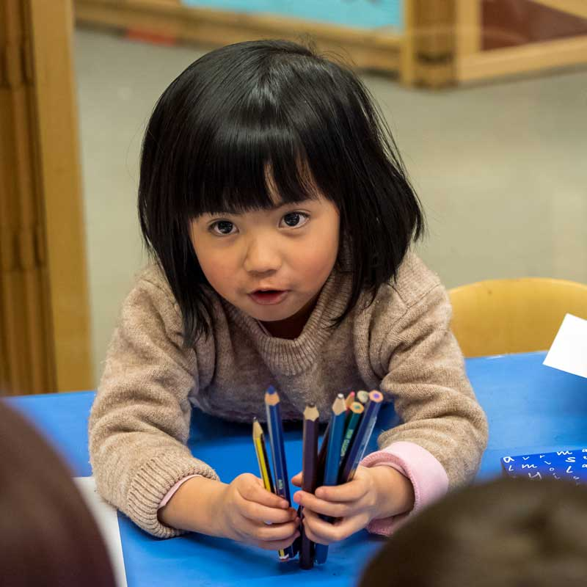
Supporting Children

- establish positive relationships with children
- act as a role model and setting high expectations
- promote the inclusion of all children
- encourage children to interact co-operatively with others
- engage all children in activities
- be responsible for the day-to-day physical care needs of children
- promote independence and employ strategies to recognise and reward achievement of self-reliance
- provide feedback to children in relation to their progress and achievement
- within the team help to organise and manage an appropriate, healthy, safe and stimulating learning environment
- have high expectations for all children’s achievement and be highly responsive to children’s interests to promote high levels of engagement
- monitor and evaluate children’s responses to learning activities
- provide objective and accurate feedback and reports as required on children’s achievement, progress and other matters, ensuring the availability of appropriate evidence
- record progress and achievement in activities systematically and providing evidence of range and level of progress and attainment in line with school policy
- work within an established Promoting Positive Behaviour policy to anticipate and manage behaviour constructively, promoting self-control, resilience and independence
- support parents in supporting their children’s learning and provide parents with constructive feedback on children’s progress / achievement
- contribute to reports for each child as required and in line with school policy
- assist children to carry out personal care and hygiene tasks including intimate care

Supporting learning
- provide an excellent model of standard English
- link children’s knowledge to earlier learning and develop ways to encourage it further
- challenge and inspire children to deepen their knowledge and understanding of the world
- motivate children through sharing an enthusiasm for learning, creativity and imagination
- celebrate and value achievement through displaying children’s work in designated areas of the school, and contribute to whole school projects and displays
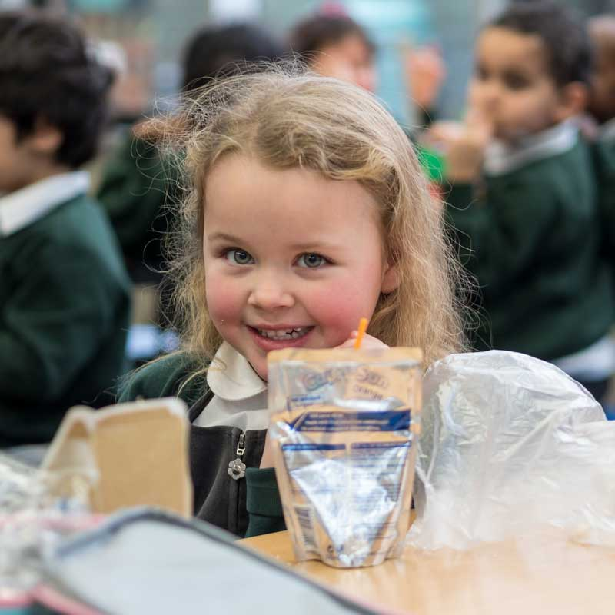
- deliver learning activities to children within agreed system of supervision, adjusting activities according to the child’s responses/needs
- deliver local and national learning strategies e.g. literacy, numeracy, early years and make effective use of opportunities provided by other learning activities to support the development of pupils’ skills
- use ICT effectively to support learning activities and develop children’s competence and independence in its use

Supporting the School:
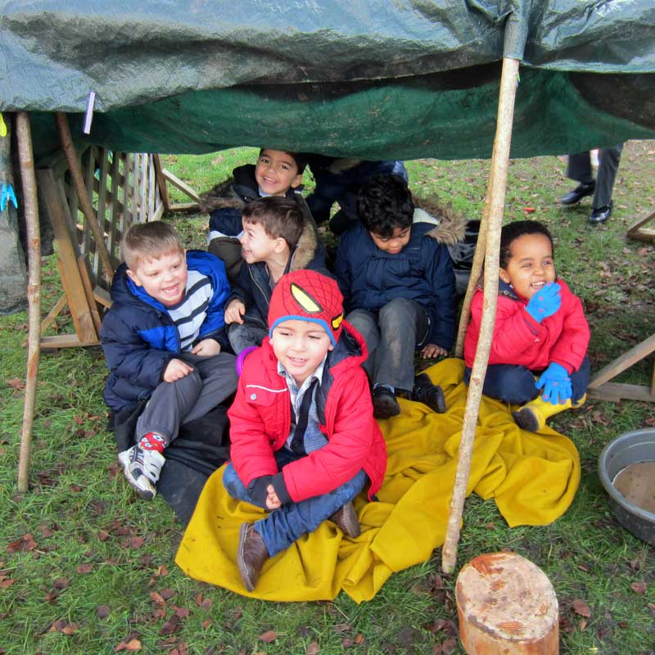
- work closely with other members of the teaching and Early Years Educator team to plan, co-ordinate and facilitate all children’s work
- foster supportive relationships with parents/carers and communicate and consult with them as required
- provide formal and informal feedback to parents/carers on their child’s progress on a regular basis
- participate in the school’s in-house training programme and engage in external professional development / training opportunities
- stay up-to-date with changes and developments in relation to pedagogy and practice
- work with colleagues on issues of curriculum development to achieve the early learning outcomes
- participate in staff meetings
- assist in the development and implementation of policies and practices that reflect the school’s commitment to high achievement and effective teaching and learning
- contribute to the creation of a climate which encourages positive attitudes towards teaching and children’s learning
- contribute to the school’s process of self-evaluation and to the development of the School Improvement Plan

Accountability

- to the Head Teacher, for effectively fulfilling of the roles, responsibilities and actions outlined above and, discharging any other duties, as required by the Head Teacher, that are consistent with the level of responsibility of the post.
- this job description is not a comprehensive statement of procedures and tasks, but sets out the main expectations of the school in relation to the post holder’s professional responsibilities and duties.

Elements of this job description, and changes to it, may be negotiated at the request of either the Head Teacher or the incumbent of the post.

Person Specification

Qualifications

- qualified primary teacher QTS
- teaching experience in an EYFS setting – Nursery or Reception
- paediatric first aid certificate (desirable)

Knowledge

- excellent working knowledge or EYFS revised framework and Birth to 5 Matters
- an understanding of excellent communication and language, early reading and early mathematics strategies
- knowledge of different effective teaching and learning strategies
- early Curriculum, characteristics of effective learning and the Early Learning Goals

Experience

- two years minimum experience in a UK based Early Years setting (desirable)
- experience of supporting children of all abilities to make excellent progress
- ability to deliver age-appropriate learning and teaching activities
- excellent knowledge of appropriate U5s behaviour management techniques
- good literacy skills and the ability to communicate effectively in written form
- ability to lead a team and manage the day-to-day running of the nursery
- knowledge of observation and recording practices in an EY context and using that knowledge to inform planning and evaluate children’s progress
Professional practice

- high standards in everything
- willingness to approach work flexibly in response to the changing needs of the setting
- a growth mindset – always willing to have a go and take on new challenges
- good communication, planning and organisational skills
- commitment to improving standards
- acts as a role model to children and the community
- a warm, confident manner
- can remain calm under pressure
- effective oral and written communication skills

