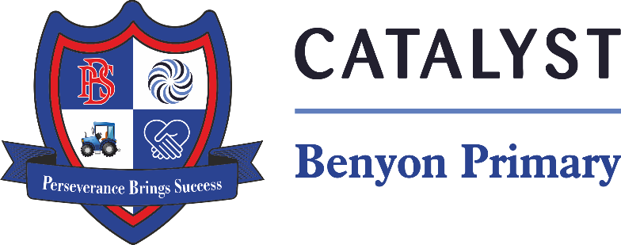

Tyssen Place, South Ockendon, Essex RM15 6PG
Telephone: 01708 853200 E-mail: admin.bps@catrust.org.uk

Start Date – 1st September 2025
Working Hours – EYFS 8am – 4pm 37 weeks per year ( unpaid 30minute lunch)
Salary: Catalyst Pay Scale Band TLW/A – Point TLW – 4 - £23,596 - £24,868 (FTE)
Closing Date – 26th July 2025
Interview Date – On application
Qualifications required: NNEB or Level 3 qualification (NVQ, CACHE)

We are looking to appoint an experienced LSA in the nursery setting who is enthusiastic, reliable and flexible. The right candidate will be passionate about Early Years learning and teaching, with a warm and caring nature, committed to working with children and always putting their needs first. Some of your responsibilities will include:
• ensuring the children are cared for in a happy, safe, stimulating environment
• acting as key worker for specified children
• working in partnership with the parents and carers
• delivering targeted interventions to accelerate pupil progress
• working as part of the Early Years team, contributing to planning and assessment.
In return we offer:
- a committed team who genuinely want the best for our pupils
- excellent professional development opportunities
- strong, collaborative partnerships with other local schools
- an employee assistance programme
- You will also be added to our "Catalyst Employee Perks" platform where you will be able to access a range of discounts from regular supermarkets, numerous retailers, family days out, restaurants and more.

Our school motto is ‘Perseverance Brings Success’; with your help we will achieve the success of which we are capable.

To apply please go to www.benyonprimaryschool.org.uk or www.essexschoolsjobs.co.uk. Informal visits are warmly welcomed or for an informal, confidential discussion please contact Samantha Oxley, Headteacher on 01708 853200

Benyon Primary School is part of Catalyst Academies Trust, an innovative, charitable organisation, whose mission is to widen access to outstanding educational provision by supporting and empowering teachers and leaders in other schools to develop remarkable teaching and achievement outcomes.

Catalyst Academies Trust and Benyon Primary School are committed to safeguarding and protecting the welfare of children and expect staff and volunteers to share this commitment. We follow safer recruitment practices, and all appointments are subject to satisfactory references, pre-employment health check and a successful enhanced DBS.

