Shape a Legacy. Build a New Vision. Join Us at Thomas Ashton School.

The Trustees are looking to recruit to the post of
KS2 Nurture Class Teacher & Nurture Lead
MPS/UPS/UQS
Plus TLR2a (or equivalent) and SEN Allowance
Full Time
Commencing April 2026

New Bridge Multi-Academy Trust is a vibrant, aspirational and inclusive multi-academy trust of eight special schools and two specialist post-16 provisions across Oldham, Tameside and Rochdale. As part of the wider New Bridge Group there are also two post-19 provisions. Our settings support a wide spectrum of needs from age 4-19 and beyond. The Trust is proud to be national leaders in Special Education and has a culture of creating outstanding opportunities for all.
Thomas Ashton School is on the brink of an exciting new chapter, and we are looking for a practitioner with deep compassion, resilience and vision to help shape it. This is your opportunity to be part of the design, launch and leadership of a brand‑new Nurture provision in Tameside, part of a long-term legacy programme that will change lives for years to come.
This work will be tough. Our children have complex needs, significant SEMH challenges and often histories of trauma.
But the relationships you build…
The trust you earn…
The breakthroughs you witness…
They will be some of the most rewarding experiences of your career.
At the heart of everything we do is unconditional positive regard the belief that every child deserves consistency, dignity, safety and an adult who will stay with them, even on the hardest days.

A Vision Coming to Life
Below are real concept visuals of the new Nurture environment you’ll help shape and lead.
A calming, connection focused Nurture Zone
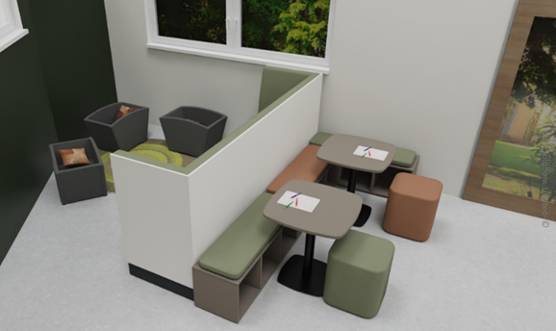
A thoughtful, therapeutic layout
Every element from zoning to seating to sensory flow is designed around emotional regulation and readiness to learn.
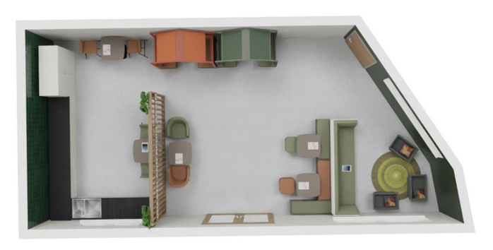
Spaces that encourage relationships, reflection and regulation
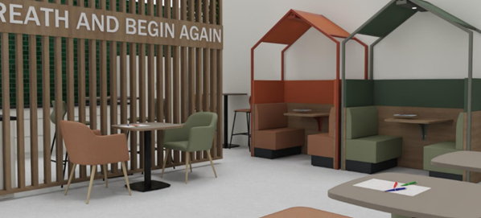

Why This Is a Unique Opportunity?
As our KS2 Nurture Teacher with leadership responsibility for Nurture across both sites (KS2 & 3), you will:
- Shape and refine our new nurture spaces and ethos
- Design trauma‑informed pathways and interventions
- Coach, guide and model nurture practice for colleagues
- Influence strategy across an expanding SEMH school
- Build environments where children feel safe, valued and believed in

This is not simply joining a school it is helping create the next chapter of a specialist SEMH provision within the highly respected New Bridge MAT.
What We’re Looking For
We are seeking someone who:
- Believes deeply in the power of relationships
- Leads with warmth, consistency and unconditional positive regard
- Understands child development, attachment and SEMH
- Can stay calm while supporting pupils through dysregulation
- Wants to help shape a new provision at its very beginning
- Has the resilience to persevere and the heart to connect

We can offer you
- A supportive and values-led culture
- Generous pension scheme
- High quality continuing professional development (CPD) through our dedicated Everyone Learning Team
- Hospital Saturday Fund (HSF), with access to HSF Assist and Perk Box
- Trust TOIL Scheme for all staff
- The opportunity to be part of our thriving team, who are committed to creating meaningful futures for both our students and staff
A Tough Role. A Transformative Reward. A Legacy to Build.
This is an emotionally demanding role, but it is also one of the most meaningful, purpose driven opportunities in education today.
You will see growth others thought impossible, help children rewrite their stories, and be part of something much bigger than a job.

Visit Us, Feel the Vision
We warmly encourage candidates to visit, walk the spaces, and feel the ethos for themselves.
For visits or further information, please contact: David Butterworth, Headteacher - David.butterworth@newbridgegroup.org
New Bridge MAT is committed to safeguarding and promoting the welfare of children and applicants must have a commitment to safeguarding young people. This post is subject to a satisfactory enhanced disclosure from the Disclosure and Barring Service and references will be sought prior to interview.

This post will be subject to a number of pre-employment checks including an enhanced DBS check, satisfactory references and proof of right to work in the UK in accordance with the Asylum and Immigration Act 1996. It will be exempt from the provisions of the Rehabilitation of Offenders Act 1974. DBS Code of Practice which can be viewed here.

For shortlisted candidates, an online search will be carried out as part of our due diligence in line with Keeping Children Safe in Education 2025.

We strive to create a fair and inclusive workplace that is as diverse as the communities we serve. We positively welcome applications from all candidates regardless of age, disability, gender reassignment, marriage and civil partnership, pregnancy and maternity, race, religion or belief, sex and sexual orientation.

Salary: Teacher or Unqualified Teachers’ Pay Scale + TLR2a
Allowance: SEN allowance - £2,539 per annum
Hours of work: 1.0 FTE
Based: Thomas Ashton School (Lower) Lumb Lane, Audenshaw, M34 5SF
Status: Permanent
Commencing: April 2026
Closing Date: Monday 23rd February 2026 (9.00am)
Shortlisting: Monday 23rd February 2026
Interviews: Thursday 26th February 2026
For visits or further information: David Butterworth, Headteacher David.butterworth@newbridgegroup.org
Completed application forms via email to: recruitment@newbridgegroup.org

