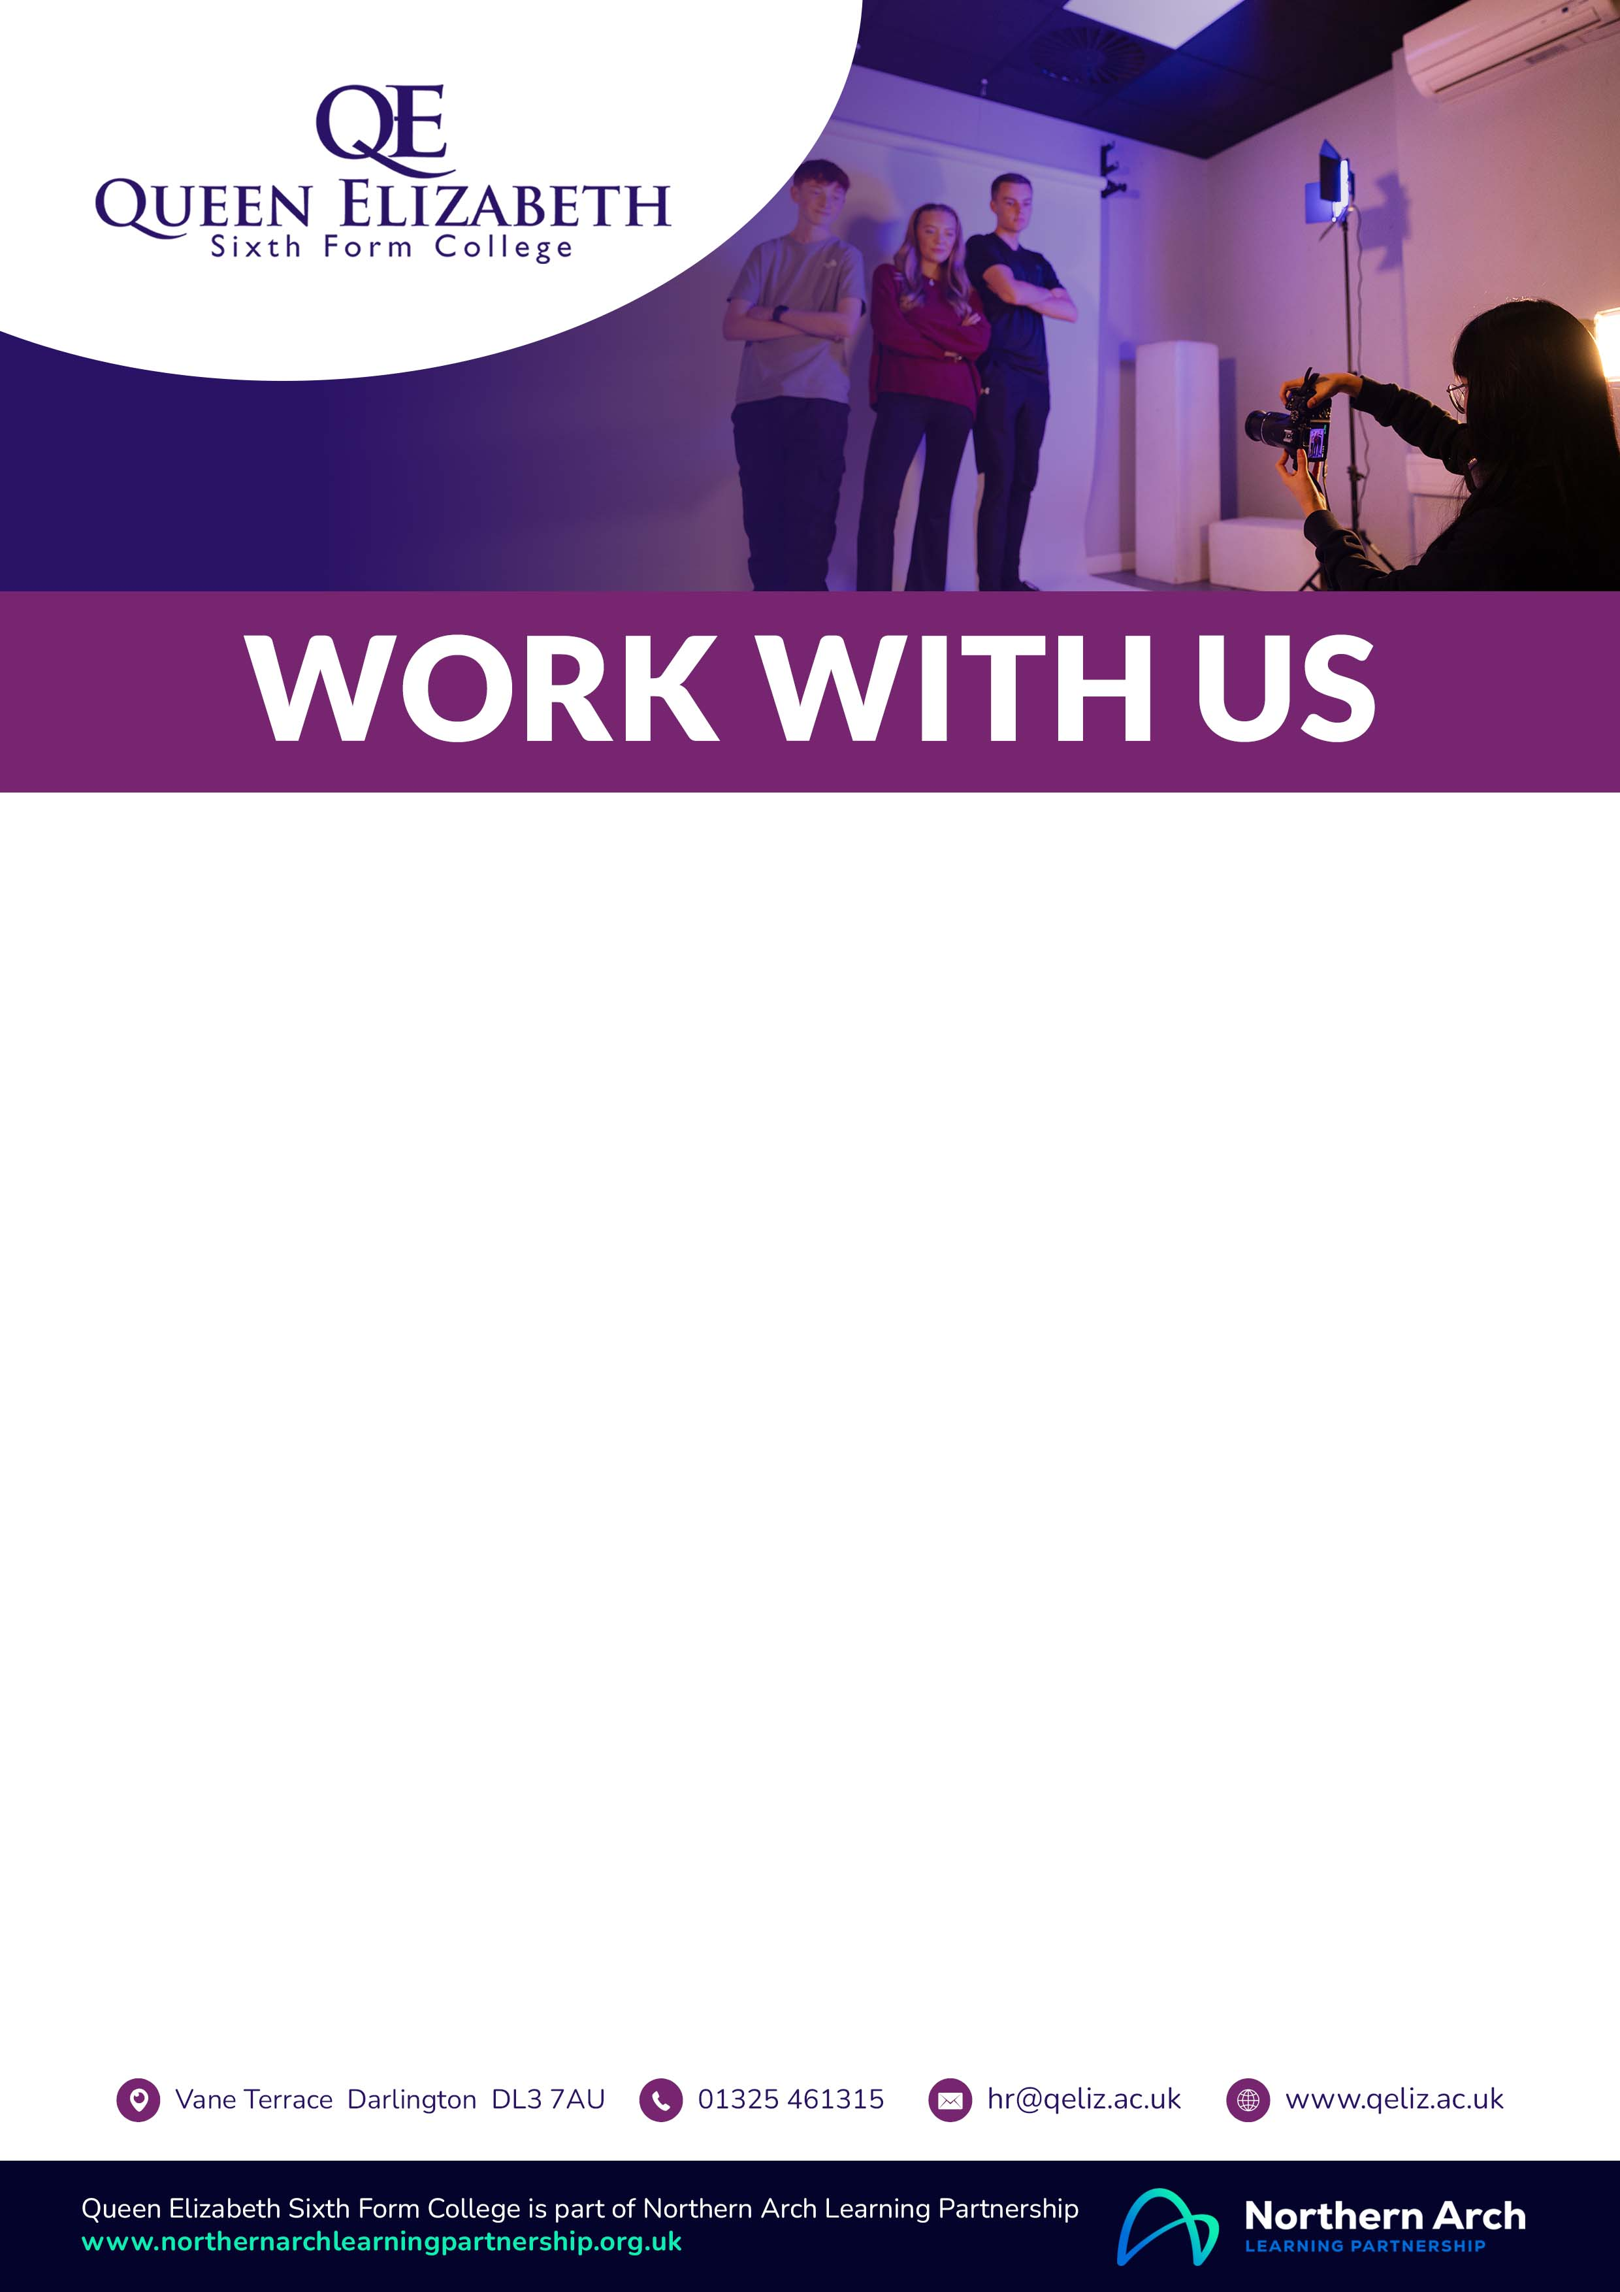

OFFICE MANAGER AND

PERSONAL ASSISTANT TO THE PRINCIPAL

**Permanent, Full Time**

**SFCA Support Staff Pay Scale Pts.20-24, £36,283 – £40,462 per annum**

Queen Elizabeth Sixth Form College’s popularity and success are built upon our commitment to provide our students with the best possible learning experience and the highest standards of support and guidance. We are proud of our dedicated staff and our vibrant student community, as evidenced by our recent Ofsted Inspection, which rated the College as “Outstanding” for Overall Effectiveness and in all other areas, with no recommendations for improvement.

We are seeking to appoint an inspirational and experienced Office Manager & PA to the Principal who will manage the combined Curriculum Resources and General Administration areas of the College. The ideal candidate will be an excellent communicator, highly organised with the ability to manage, adapt and work effectively with your team, students, members of staff, parents/carers and visitors to the College. There are currently 8 members of the Curriculum and Administration team.

The College is committed to safeguarding our students and an enhanced DBS check is required for all posts. The College will also make an online check on all shortlisted candidates. The College values diversity and actively promotes equality of opportunity. As a disability symbol employer, all disabled candidates who meet the minimum criteria for a post will be offered an interview.



**Closing Date:** Midday, Monday, 9 June 2025