**Candidate Information Pack**



Office Manager

**Contents**

|  |  |
| --- | --- |
| About the Trust | 4 |
| Benefits of being part of L.E.A.D. Academy Trust | 6 |
| How to apply | 7 |
| Job description and person specification | 8 |

2

****-**L.E.**-**A.D.**-**Academy Trust Lead • Empower • Achieve • Drive**

#### Welcome from the CEO

L.E.A.D. Academy Trust comprises primary and secondary academies across the East Midlands. Our mission is to be a pioneering, confident, high-performing Trust with national and international influence.

We are determined to bring about change and improvement to education standards in the East Midlands by appointing visionary leaders who believe in the Trust's vision and values and are committed to making a tangible difference to the lives of children and young people.

As a Trust, we pride ourselves on the support and advice we give to all our leadership staff, enabling them to be exceptional leaders and teachers who can inspire both pupils and staff.

This role represents an exciting opportunity to be part of something special; developing and supporting our Trust in improving educational outcomes while retaining the school's individual identity and specific needs of their children, young people and community.

If you are ambitious, determined, energetic and passionate about education and want to join us on our mission, then we look forward to receiving your application.

**Diana Owen CBE**

**Chief Executive Officer**

-L.E.-A.D-. Academy Trust **Lead • Empower • Achieve • Drive**

#### About the Trust

**Be part of an ambitious, high-performing Trust, committed to improving the lives of children and young people.**

L.E.A.D. Academy Trust comprises primary and secondary academies across Nottinghamshire, Derbyshire, Leicester, Lincoln and Sheffield. Established in 2011, our mission is to be a pioneering, confident, high­ performing Trust with national and international influence.

***"We are determined to bring about change and improvement to educational standards in the region by appointing visionary leaders who believe in the Trust's vision and values and are committed to making a tangible difference to the lives of children and young people."***

**Diana Owen, CBE - Chief Executive Officer**

#### Inspiring experience

Our Trust Executives have first-hand experience of working in education, so they know what it's like to be on the front line. We pride ourselves on the support and advice we give to all our staff, enabling them to be exceptional leaders and teachers who can inspire both pupils and staff. By choosing to work with us, you will be helping to improve educational outcomes for children, young people and the local community.

Within our Trust, all academies strive to achieve:

* The highest standards of behaviour and conduct
* Outstanding teaching and learning
* A fully inclusive approach where all children are equally important
* A climate of mutual respect between the children, staff and community
* A 'can-do' attitude - high aspirations for all involved with the school
* A wide range of enrichment opportunities for all to get involved in
* A celebration of all the cultures and faiths represented in the school



* An organisation in which there are no excuses for underachievement.

#### Supporting external trusts and schools

As well as our core offer to L.E.A.D. academies, we offer additional areas of support to external trusts, schools and organisations through L.E.A.D. IT Services and L.E.A.D. Teacher Training Hub.

-L.E.-A.D.-Academy Trust Lead • Empower • Achieve • Drive

L.E.A.D. Academy Trust comprises of:

**24**

## pri•mary

·········and•········

# 3

## secondary

academies

* across•·••··•·



geographical regi•ons

········· with ·········

**11,000**

## pupils

·········and•········

**1,500**

**members**

**of staff**

Edna G Olds Academy Huntingdon Academy St Ann's WellAcademy Sycamore Academy Warren Academy

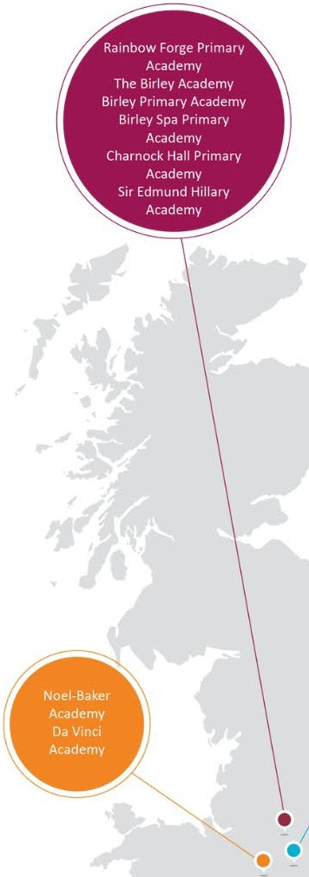Windmill L.E.A.D. Academy Hogarth Academy

Bishop Alexander L.E.A.D. Academy

Glapton Academy Jubilee L.E.A.D. Academy Radford Academy Cloudside Academy

•



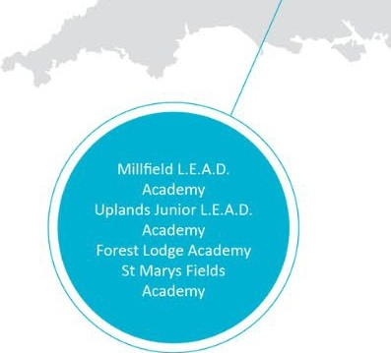

-LE.-AD-. Academy Trust **Lead** • **Empower** • **Achieve** • **Drive**

#### Benefits of being part of L.E.A.D. Academy Trust

We recognise that successful people place value on a range of benefits associated with their careers, including receiving professional recognition, commensurate financial reward, job satisfaction, opportunity to innovate and a balanced approach to work and personal time. We place value on these aspects too.

**Competitive salary**

All Trust roles* are subject to a minimum hourly rate, which is currently above the National Living Wage amount. All our support staff roles are subject to a competitive 6-point salary range, allowing for progression within the role.

**Pension scheme**

Automatic entry to the Local Government Average Salary (LGPS) pension scheme. Benefits include generous employer rate of contribution at minimum 17%, life cover, lower tax, survivor benefits and ill health cover.

**Enhanced annual leave**

Holiday allowance starts at 26 or 31 days, up to a maximum of 36 days. Term time only workers also benefit from the same annual leave entitlement paid as part of their usual monthly payroll. This varies on the role and amount of service, increasing after 5 and 10 years' service. Holiday is in addition to Bank or Public holidays.

**Employee assistance programme**

The Trust is committed to supporting staff wellbeing and partner with Health Assured to offer a comprehensive Employee Assistance Programme to all Trust employees and extends to dependent adults living the same household. This includes access to a 24/7 free phone helpline 365 days per year to access advice and support on emotional, financial, legal or other lifestyle matters.

**Continuing professional development (CPD}**

We provide excellent training and development opportunities within the Trust, including a full induction programme for all staff.

**And more!**

* Access to free Trust Occupational Health service, including physiotherapy
* Access to staff discounts and cashback for a huge range of products, including travel, shopping, insurance, motoring and utilities.
* Travel expenses for business travel at maximum HMRC mileage rate.
* Free eye tests for VDU users.
* Free seasonal flu jabs.

*"Everyone is valued, everyone is supported, and if you hold the same values that L.E.A.D.*

*has, then really consider coming to work with us."*

**Becky Hyder, Safeguarding Compliance**

**Lead**

*\*With theexception of*

*Apprenticeships*



**Job Title: Start Date:**

**Contract Type: Hours:**

**Working Weeks: Salary Range:**

**Cleaner**

**Monday 6th January 2025 Permanent**

**10 hours per week (3:30pm – 5:30pm) – Part time Term Time + 3 Days**

**NJC pay scale 2-7**

### How to apply

Please send a completed application form and covering letter explaining your interest in the role and how you meet the person specification to [sallyclarke@siredmundhillaryacademy.co.uk](mailto:sallyclarke@siredmundhillaryacademy.co.uk)

**CLOSING DATE**: Midday Friday 5th September

**INTERVIEWS**: We expect interviews to take place week commencing 15th September 2025**.**

Applications will be reviewed upon receipt, therefore shortlisted candidates may be contacted in advance of the closing date.

L.E.A.D. Academy Trust is committed to safeguarding and promoting the welfare of children and young people and we can expect all staff and volunteers to share this commitment. This post is subject to an enhanced DBS check.

**Job description**

**Key responsibilities and accountabilities**

7

**The Role available – Office Manager**

**Salary:** SCP 23 – 28 £34,433.71 - £39,152.02 (Term time only + 2 weeks – actual salary pro rata)

**Location:** Sir Edmund Hillary Academy, Kingsway, Kilton, Worksop, Nottinghamshire S81 0AN

**Closing date:** Midday Friday 5th September 2025

**Interview date:** Week commencing 15th September 2025

**We now have an exciting opportunity for an experienced, professional and motivated Office Manager. You will be responsible for setting up the systems and processes required to run an effective and efficient school office; ensuring that all parents, carers, colleagues and visitors experience the best possible customer service along with supporting the Head of School to ensure our pupils receive excellent teaching and learning.**

You will have previous experience running a busy and varied office environment, preferably within an educational setting however this is not essential. The Office Manager promotes the highest standards of business ethos within the administrative function of the school and ensures the most effective use of resources in support of the academy learning objectives. As a member of the school leadership team, makes a major contribution to the strategic direction of the school.

**The ideal candidate will have:**

* **Excellent communication skills**
* **Attention to detail and high standards in all aspects of their work**
* **flexibility and adaptability to learn new systems, processes and implement change under direction**
* **A resilient approach to challenging situations**
* **A positive, problem-solving approach to challenge**
* **A warm and approachable personality**
* **The ability to work really well both individually and as part of a team**
* **Proven leadership experience of administration and/or other teams In return, we can offer you:**
* **A happy, friendly, welcoming school on an improvement journey**
* **Amazing children who are happy, motivated and eager to learn**
* **Opportunities for professional development, coaching and mentoring**
* **A supportive, creative and enthusiastic staff team**
* **Generous benefits and employment opportunities The role will include:**

**Administrative**

* + Manage the full range of administrative support to the Headteacher and other leaders within the Academy
  + Line manager members of the administration team to ensure effective customer service and administration provision to parents and other Academy colleagues
  + Ensure all members of the administration team receive annual appraisals and performance management including assessing CPD for the team

8

* + Devise and maintain effective office administrative systems to deal with any relevant paperwork including organising, storage, document retrieval and other information in both paper and computer based systems
  + Attend meetings to take notes and document actions arising including supporting the Headteacher or senior leaders with any relevant preparation required
  + Be responsible for liaison with any other relevant departments both within the Academy and wider Trust for any administrative requirements or contractor management
  + Ensure any relevant processes or risks from an insurance provision are managed with direction from the Headteacher
  + Management of any financial procedures within the Academy as directed by the wider Trust business support teams
  + Support and manage the administrative team to ensure effective school messaging systems and where applicable any monies are collected and recorded appropriately e.g. dinner monies, trips and any other requirements
  + Manage the process for parents undertaking visits to the Academy ensuring all relevant safeguarding procedures are in place
  + Manage the admissions processes for the Academy including maintenance of waiting lists, allocation or spaces and other responsibilities in line with requirements
  + Maintain pupil records and be responsible for completion and submission of relevant forms and returns including to outside agencies
  + Ensure all visitors are greeted and supported effectively by the administrative team and that all relevant procedures are in place from a safeguarding perspective
  + Ensure all the administrative team are compliant with any relevant statutory or Academy processes in relation to pupil or staff data, equality and diversity requirements, health and safety procedures and safeguarding policies
  + Work with the Site Manager to ensure effective administrative support for any health and safety processes or contractor management
  + Support and help coordinate any Academy events as required

**Procurement & Resources**

* + Ensure value for money is always considered in Procurement.
  + Obtain quotes and approval as outlined in the Scheme of Delegation.
  + Maintain an Asset Register in line with Trust policy.
  + Be responsible for ordering resources ensuring best value in line with Trust procedures
  + Operate and manage resource allocation of IT equipment and other system to ensure these remain fit for purpose with the IT team
  + Assist with the marketing and promotion of the school as required

**HR**

* + Have knowledge of all of the Trust’s HR policies and follow procedures as outlined in relevant policies.
  + Manage the recruitment process writing Adverts, updating Job Descriptions and ensuring all recruitment checks are carried out prior to interview and references are received, gaining authorisation/liaising with the Trust where required.

9

**Payroll**

**Audit**

* Assist with the Headteacher shortlisting and support with the interview process as required. Send out offer letters and arrange for contracts to be raised.
* Ensure all pre-employment checks are carried out and personnel files are updated with the correct documentation.
* Ensure all new starters are thoroughly inducted in line with Trust procedures and probation policies are followed
* Record all DBS checks on a Single Central Record and ensure that it is fully compliant and is in line with Ofsted requirements. Keep up to date with safeguarding legislation.
* Complete Starter and Leaver forms and Variations to Contract letters or forms.
* Inform Payroll of any contract changes and pay increases.
* Enter any contract and salary changes on HCSS and SIMS.
* Monitor Staff Absence on the Management Information System.
* Carry out performance management on line managed staff
* Ensure all pension documentation for Teachers Pensions and LGPS is completed on time.
* Complete all HR paperwork for example, changes of contracts and salary changes and ensure the HR system is updated daily as required
* Review all overtime, unpaid leave, expenses claims before authorisation by the Headteacher.
* Ensure all staff changes are applied within the HR system at the time of change to ensure payroll is accurate
* Check draft and final Payroll reports using Staff Monthly Profile Listing.
* Prepare all documentation for both internal and annual audit processes.
* Act on any recommendations that result from the Audit and the Trust.

**Premises Management and Health and Safety**

* + Work with the Trust procurement team to prepare work specification for tender and to assist with the selection of contractors.
  + Work with the Trust’s Health & Safety Officer to formulate, implement and monitor the Academy’s Health and Safety policy.
  + Ensure a safe environment for the stakeholders of the Academy. Monitor statutory Health and Safety checks, Fire Risk Assessment and update the Business Continuity Plan.
  + Line management of Premises staff

**Marketing & Liaison**

* + Participate in the work of the Academy through attendance at meetings and participation in working parties.
  + Promote the Academy to different audiences and raise the profile within the local community.
  + Liaise with local businesses and other schools for fundraising, arranging vocational experience and joint projects.

10

**Management Information Systems and ICT**

* + In consultation with LEAD ICT that the Academy has a strategy for using technology aligned to the development plan.
  + Ensure that contingency plans are in place in the case of technology failure.
  + Ensure data collection systems providing information to stakeholders are streamlined to maximise efficiency of the data supplied.

### Person specification

The person specification listed below outlines the competences, knowledge and behaviour of candidates who would be suitable for this role. The two right-hand columns provide guidance as to whether these items are essential (E) or desirable (D) criteria.

**Office Manager Person Specification**

This job description lists the competencies expected of an experienced/fully trained post-holder. The two right hand columns provide guidance for the appointment of new staff. (E = Essential criteria, D + Desirable criteria)

**D**

**E**

|  |  |  |  |
| --- | --- | --- | --- |
| **Qualifications and Attainments** | * Studied to a minimum standard of GCSE (grade A* - C), or equivalent, in English and Maths * Relevant qualification at level 4 and above | E E |  |
| **Skills and knowledge** | * Excellent level of oral and written communication skills * Good level of use of ICT including Microsoft and other finance management or accountancy systems * Able to work to tight deadlines, managing and prioritising time effectively * Self-starter, with and ability to work independently & use own initiative to overcome obstacles * Good level of understanding of health & safety and site management * Knowledge of recruitment procedures and basic HR processes * Knowledge of/or ability to learn school’s policies and procedures | E E  E E  E E | D |
| **Experience** | * Proven ability in a school or business environment * Experience of managing budgets and budget monitoring * Experience of managing and developing staff * Project management experience | E E | D D |
| **Personal Attributes** | * Have an openness to learning and change | E |  |

11



**L.E.A.D. Academy Trust**

#### Lead• Empower• Achieve• Drive

L.E.A.D. Academy Trust 5a The Ropewalk

Nottingham NG15DU