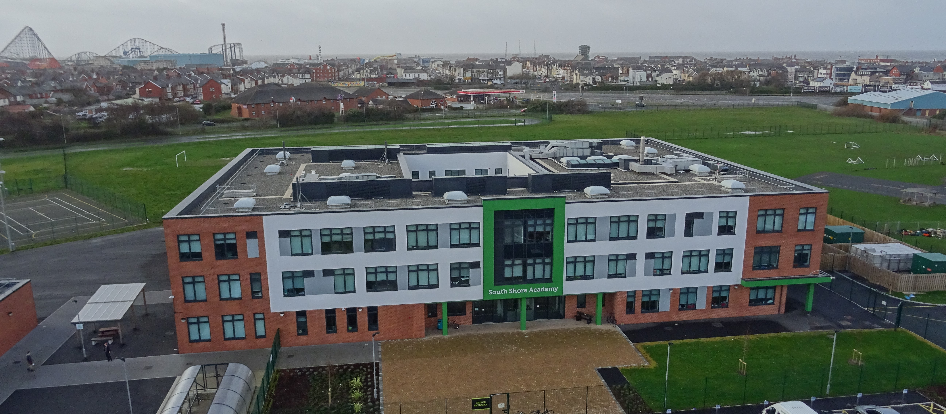

South Shore Academy
St Annes Road, Blackpool,
Lancashire
FY4 2AR
(01253) 336500

Contents of this pack
Bright Futures Educational Trust | Page 2
South Shore Academy | Pages 3 -6
Why work for us and terms and conditions of the post | Page 7
Further information and a tour of the school | Page 7
How to Apply | Page 7
South Shore Job Description | Pages 8-10
South Shore Person Specification | Pages 11-12

Bright Futures Educational Trust

Bright Futures Educational Trust (The Trust) is a multi-academy trust set up in 2011. The Trust is made up of a richly diverse group of schools in Greater Manchester and Blackpool. We are passionate about working together within and beyond the Trust to achieve our aspirational vision: the best for everyone, the best from everyone. We are an organisation that is underpinned by values of: community, integrity and passion. In everything we do, we remember that we are accountable to the children, families and communities that we serve.

Our schools have their own identities and form one organisation and one employer, Bright Futures Educational Trust. Bright Futures’ Board of Trustees maintains strategic oversight of the Trust and delegates some of its responsibilities to the Executive Team, Principals and local governing bodies. We place a high value on integrity and probity and take seriously our accountabilities for making the best use of public money. How decisions are made is described in our delegation framework. You can find out more about the Trustees and the Executive Team on our website: http://bfet.co.uk/about-us/.

The central team comprises the Executive Team: John Stephens, CEO; Edward Vitalis, Chief Operating Officer; Gary Handforth Director of Education; Lisa Fathers, Director of Teaching School and Partnerships and Lynette Beckett, Director of HR & Strategy. The focus of these roles is to work with schools, providing high quality and timely guidance, leadership, challenge and support. In addition to the executive team, we have central operations for finance, HR, educational psychology and Digital Technologies. Please see our website brochure which explains our central operations: Working together for a Bright Future.
Bright Futures Development Network is another important outward facing component of our organisation. Underneath this umbrella we have 5 network hubs. ‘The Alliance for Learning’ (AFL) which provides school improvement services and CPD to over 700 schools (http://allianceforlearning.co.uk/); a North West Maths’ hub providing mathematics training and coaching to 500 schools: a SCITT (School Centered Initial Teacher Training) which is the largest in the North West. After significant national reforms to the teaching school policy, Bright Futures was designated with two new large-scale Teaching School Hubs in 2021. The areas we serve are Manchester, Stockport, Salford and Trafford.

Collaboration and strong relationships form one of the ‘commitments’ in our Strategy and all components of the Bright Futures’ family work closely together. Our Strategy was developed collaboratively and can be found on our website: Our Strategy.

South Shore Academy

South Shore Academy was one of the first schools to join Bright Futures Blackpool cluster, and is working with the Trust to help every student and member of staff to succeed. Leaders from South Shore are involved in collaboration and support with other Bright Futures schools, and we also receive advice from other leaders within the Trust whose expertise helps us to fully meet the needs of all our pupils.

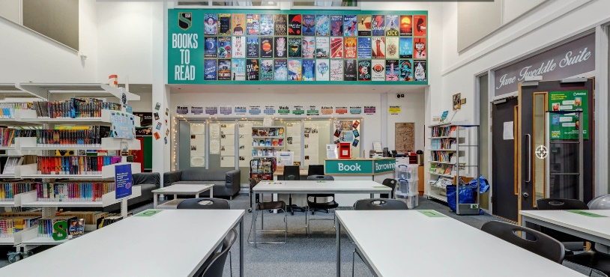

We are proud of the excellent relationships that exist between staff and students. Within our culturally diverse student body, tolerance, respect and understanding are cornerstones for the strong relationships which exist. Parents and governors work in partnership with the school, in order to ensure that the young people of our community enjoy the highest standard of education. The traditional values of courtesy, discipline and respect are important to us and we believe that upholding them will help us to achieve results for all at South Shore.

SOUTH SHORE ACADEMY– PUPIL INFORMATION

Type: Mainstream School
Phase: Secondary
Funding status: Public - Academy
Gender: Mixed
Religion: Mixed
Age Range: 11 - 16 years
No of students on roll: 755
PAN: 985
SEN Students: 25% typically
EAL Students: 10% typically
Address: South Shore Academy
St Annes Road, Blackpool
Lancashire. FY4 2AR

Telephone: +44 1253336500
http://www.southshoreacademy.co.uk

South Shore Academy is located in the south shore area of Blackpool with great links to the M55 motorway and also has good transport links.

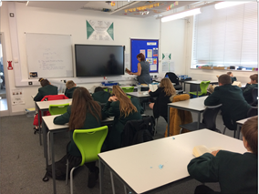

2021 GCSE results
English and Maths
G4-9 38.8%
G5-9 18.8%
G7-9 5.6%

There were some excellent results in: Computer Science G4-9 65.4% and Physics G4-9 100% Geography, History, Chemistry and Physics all show a strong improving trend. The school have also posted some excellent BTEC outcomes. There is much still to be done, but the school is enjoying a period of positive improvement, has a committed, friendly, and enthusiastic staff and a real drive to provide the very best for students.

South Shore Academy serves people who experience very high levels of socio-economic disadvantage. Numbers of children with special educational needs and/or disabilities are high. There is a high level of social care involvement with families and pupil mobility is also high. These indicators highlight the vulnerability of many families who have also been impacted badly by Covid 19. Equally, the students, families, and communities that we serve at South Shore are bright, ambitious, resilient, friendly, and kind. We owe it to them to maintain the highest expectations and to work positively and creatively to realise the Bright Futures vision: ‘the best for everyone, the best from everyone’. As Head of South Shore, the successful candidate will need to be uncompromising in their ambition for the people of Blackpool.

Blackpool Opportunity Area and Education Improvement Board
Blackpool was designated as one of the government’s ‘Opportunity Areas’ four years ago. The town has received significant additional resources from the DfE during that time and this has impacted positively on work at South Shore. The work of the OA has increased the scale and depth of collaboration between schools in Blackpool. The secondary sector works well together to take responsibility for all children and young people in Blackpool. Blackpool’s Research School, English Hub and Teaching School Hub each make a valuable contribution to the work of schools in the area. The MATs responsible for mainstream and special secondary schools in Blackpool work closely together. There is a secondary headteacher group and the MAT Chief Officers also meet regularly.

The local authority is very supportive of schools and has been a valuable partner, especially during the Covid pandemic. Through the Opportunity Area resources, South Shore has reduced permanent exclusions to zero and has a good programme of family support/early help in place. Through the Education Improvement Board – a collaborative structure focusing all partners on improvement – the town has developed an ambitious ten-year strategy for education.

Ofsted
South Shore was last inspected in September 2019 under the ‘new’ Education Inspection Framework. The school was judged to ‘require improvement’ but inspectors noted many significant improvements, not least in the improved consistency and quality of teaching, learning and the curriculum. The report can be accessed here:
Ofsted 2019.

Staff Information
Snr Leadership: In addition to the post of Head of School, South Shore has six other Leadership roles; two Deputy Head posts and four Assistant Head posts.
Teachers: The academy has 46 teaching posts and 20 of these role holders have a range of teaching and learning responsibilities (TLRs) such as team leader, deputy team leader (department heads/deputies), SENDCo, reading leader, heads of year and for leading careers, EAL and Duke of Edinburgh award.
Associate Staff: In addition, there are 46 associate staff posts e.g., pastoral leads, data, HR, IT, technicians, keyworkers, facilities, administrator posts
Staff engagement: A summary of the results of the Spring 2020 staff engagement survey is included below. Over the last few years, the new leadership team have made significant improvements in the culture at the academy. This is also seen in the voluntary turnover which in 2019/20 was 7.87% (lower than the national and the Trust’s average) and sickness absence in term two 2020/21 was 1.34%, again lower than the national and Trust’s average.
Governance: Accountability for the school rests ultimately with the Bright Futures Board of Trustees. However, the Board delegates some of its responsibilities to a local governing body (LGB) of staff, parents/carers, community, and co-opted representatives. The LGB is chaired by Jill Baker. Jill worked at the most senior levels in education and children’s service in local authorities and with DfE and bring significant experience and expertise to the role.
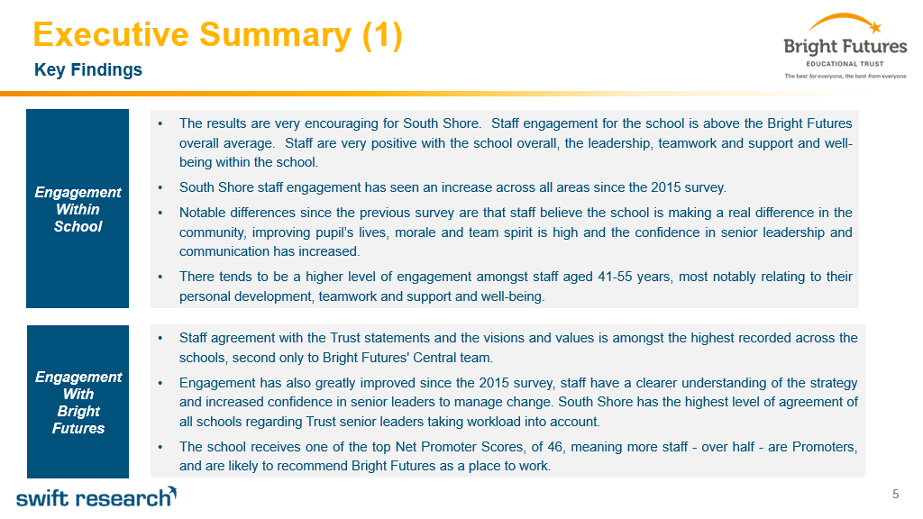

Why work for us?

We offer a great opportunity to join an organisation which really lives its values. Our working environment is very inclusive and whilst you can expect to be challenged in your role, you will be supported through professional learning, treated fairly and with dignity and respect. Please see the Equality, diversity and inclusion statement on our website: http://bfet.co.uk/vacancies/.

About the role The On-Site Appropriate Provision Manager is a new role at South Shore Academy and will be part of an experienced team of staff and is line managed by the Deputy Head of school. The post holder will be a role model for our students in the Bridge provision whilst ensuring their personal development, behaviour, progress, outcomes, and well-being are being met.

Terms and Conditions
Salary: NJC scale points 31 to 35 (Bright Futures scale Grade 8). The full time equivalent pay is £34,728.00 rising to £38,890.00 per annum. The actual pay based on the below working pattern commencing £29,737.55, per annum actual pay. Pay progression is linked to performance.

Working weeks: This is a great opportunity for flexible working as the role will work 38 weeks during school term time and an additional 1 week to be agreed. A total of 38 weeks.

Hours: 36.25 hours per week over 5 days. Flexible working will be considered, please discuss at interview if you wish this to be considered.
Holidays: You will be paid for the prorate equivalent of 25 days, plus 8 public holidays. This increases to 30 days plus 8 public holidays after 5 years’ service.

Pension: Local government pension scheme. Please look at the website: https://www.lppapensions.co.uk/members/schemes/local-government-scheme/

Other: We offer salary sacrifice schemes for purchasing bikes used for travel to work and technology for personal use, through monthly interest free salary deductions. We also offer opportunities for professional development.

Start Date: 4th January 2022

For a full explanation of our employment offer please see the booklet on our website:
Great-Place-booklet.pdf (bfet.co.uk)

How to Apply
We can only accept completed application forms, rather than CVs. This is because the regulatory guidelines of Keeping Children Safe in Education (2021), require us to check various details of job applicants and an identical application format for each candidate enables us to do this. We use a process that does not identify personal characteristics to the shortlisting panel. This is part of our commitment to equalities and diversity.

NO AGENCIES PLEASE.
Our application form is available online, along with the disclosure of criminal background form. The portal link is: https://bfet.jotform.com/213142121473947

Please complete the application by Monday 29th November 12.00
The selection will take place on insert date at South Shore Academy

Keeping Children Safe in Education
Bright Futures Educational Trust is committed to safeguarding and promoting the welfare of children and young people and we expect all staff and volunteers to share this commitment. This post is exempt from the Rehabilitation of Offenders Act 1974; pre-employment checks will be carried out and references will be sought for shortlisted candidates and successful candidates will be subject to an enhanced DBS check and other relevant checks with statutory bodies.
Data Privacy
You can the details of how we use the personal data that you provide us with in our Job Applicants’ privacy notice on our website: http://bfet.co.uk/wp-content/uploads/2018/07/BFET-Applicant-privacy-notice-002.pdf

JOB DESCRIPTION
On Site Appropriate Provision manager

Bright Futures Educational Trust is committed to safeguarding and promoting the welfare of children and young people and expects all staff and volunteers to share this commitment. Any successful applicant will be required to undertake an Enhanced Disclosure by the Criminal Records Bureau. The post is exempt from the Rehabilitation of Offenders Act 1974.

On-sITE APPROPRIATE PROVISION MANAGER
reports to DEPUTY HEAD

About BFET

Bright Futures Educational Trust (BFET) is a partnership of schools based in the North West. Our aim is to provide a quality education that opens real choices for every one of our pupils, raising aspirations and helping every child to achieve their ambitions, no matter their background. The Trust currently has twelve partner schools.

Bright Futures Educational Trust is establishing itself as a leader in educational excellence. The Trust’s vision of, the best for everyone, the best from everyone is evident in everything we do.

We inspire excellence and believe in nurturing the abilities of all within our schools and communities. Our values of Community, Integrity and Passion enable us to empower our young people to build purposeful lives and have the courage and confidence to make a positive contribution to society.

About the Role – Behaviour Manager

Grade 8 (scale points 31-35) Term time plus 5 days
Actual salary £29,737.55 p.a. 36.25 hours per week
Temporary 12 months

Main purpose of the job

The post holder will report to the Deputy Head of School and will be responsible for the management of the Academy’s on-site appropriate provision ‘The Bridge’. The Bridge provides emotional and educational support to some students whom are disaffected, underachieving and vulnerable, whose cognitive, social and/or emotional well-being prevents them from accessing the mainstream provision successfully. The post holder will be responsible for personal development, behaviour, progress, outcomes, and well-being for all students accessing The Bridge.
They will strive for excellence in all they do and be committed to providing first class provision for all our students. Excellent teamwork, high standards and a capacity to work hard will be at the core of their success. They will be flexible with the ability, determination and commitment to work collaboratively with the Head of School to continue the development of the Academy.

Organisation and Delivery of the On-Site Appropriate Provision ‘The Bridge’
- Ensure the delivery of an appropriate, comprehensive, high quality and cost-effective curriculum programme which meets the needs of all students, secures good outcomes for all students, and impacts on improving standards of attendance, behaviour, well-being and engagement.
- Develop, in liaison with the SEN, student welfare and attendance teams, a range of programmes to secure students’ emotional well-being and ensure students choose better behaviour choices. Ensuring students are fully supported and equipped to overcome any cognitive, social and/or emotional barriers in order to successfully engage in mainstream provision.
- Develop protocols and processes within The Bridge to support students’ entry and exit from mainstream provision.
- Work closely with a range of external agencies to secure personalised support programs for students with additional needs and challenges.
- Establish effective communication links between The Bridge and mainstream provision to ensure continuity of provision.
- Effectively deploy support staff working in The Bridge.
- Monitor all resources to ensure that they are maintained in a safe and usable state.Main Duties

- Be based in the On-site Appropriate Provision co-ordinating the activity of staff/students and liaising with parents.
- Take a leading role in ensuring procedures are followed in relation to the organisation and administration of the provision.
- Ensure that all attendance and registration procedures are followed.
- To implement and manage an effective BFL policy, which avoids stepped consequences.
- To ensure any consequence system, including detentions are carried out and managed consistently.
- To attend academy CPD and commitments at Middle Leader level.
- The person with responsibility for appropriate provision will co-ordinate regular review meetings, and parent’s evenings.
- Provide educational support to students engaged in a range of educational activities
- Maintain records in respect of all students in respect of targets, progress, rewards etc.
- Collect and distribute refreshments to students at break and lunchtime.
- Be a First Aider and deal with and report first aid incidents as and when required.
- Establish good relationships with students by presenting a positive personal image and responding appropriately to individual needs.
- Promote the inclusion and acceptance of all students.
- Encourage students to act independently as appropriate.
- Provide regular comprehensive updates to the Academy’s Leadership Team.
- To carry out escort duties as appropriate whenever required.
- To support students on integration placement in mainstream schools or colleges and on work experience placements.
- Be aware of, and comply with, child protection procedures, health and safety and security, confidentiality, and data protection, reporting any concerns to the relevant members of staff.
- Assist in maintaining high standards of health and safety at all times.
- Maintain good relationships with colleagues and work together as a team.
- Be aware of and support difference and ensure all students have equal access to opportunities to learn and develop.
- Participate in training, including relevant learning strategies and other learning activities and performance management where required.
- The On-site Appropriate Provision Manager must carry out his or her duties with full regard and commitment to the Trust’s Policies.
- To develop an appropriate and suitable appropriate curriculum focused on building skills, resilience, communication, and self-responsibility.

The person undertaking this role is expected to work within the policies, ethos and aims of the Academy and to carry out such other duties as may reasonably be assigned by the Head of School. The post holder will be expected to have an agreed working pattern to ensure that all relevant functions are fulfilled.

Expectations of all Academy Staff

- Work professionally and effectively as part of a specific and wider Academy staff team.
- Demonstrate optimistic personal behaviour, positive relationships and attitudes towards pupils and staff, and towards parents, carers, governors and members of the local community.
- At all times to be a positive, professional role model for all pupils.
- Treat all students with dignity, building relationships rooted in mutual respect, and always observing proper boundaries appropriate to staff’s professional position.
- Actively adhere to the Academy’s commitment to safeguarding of all pupils and the promotion of pupils’ well-being, in accordance with statutory provisions and academy policy.
- Carry out supervision duties as directed in the duty rota.
- Actively engage in the Academy’s performance management process.
- Actively engage in the CPD programmes to develop skills and improve practice.
- Be familiar with, and follow, all Academy policy and practice to ensure a consistent high standard approach to all aspects of the Academy.
- Play a full part in the life of the Academy, to support its distinctive mission and ethos.
- Act as an ambassador for the Academy at all times and positively promote its reputation within the community.
- Attend Academy events and activities as directed by the Head of School.

Whilst every effort has been made to explain the main duties and accountabilities of the post, each individual task undertaken may not be identified. Employees will be expected to comply with any reasonable request from the Head of School and / or Executive Principal to undertake work of a similar level that is not specified in this Job Description.

About the Person – On-site Appropriate provision manager

 | Essential
Qualifications,  Educational,  Training | Minimum of 5 grade C GCSE level or equivalent, including English and Maths.  Level 4 NVQ and above or substantial experience / training relevant to the role.  Mental Health First Aid or willingness to undertake
Relevant Experience | Relevant experience of working with students with challenging behaviours  Relevant experience of running successful individual and small group behaviour focused sessions.  Leadership or management experience  Proven track record of working with secondary aged students in an educational / pastoral setting
Knowledge Skills and Abilities | Strong behaviour management skills with an ability to diffuse difficult situations and find constructive ways forward with a focus on removing obstacles to learning.  The ability to plan lead and manage behaviour for learning support programmes for KS3 and KS4 students.  Ability to engage constructively with, and relate to, a wide range of young people with different social and cultural backgrounds.  Emotionally intelligent.  Excellent skills including the ability to prioritise and manage time effectively.  Excellent communication skills both verbal and written.  Adopts a problem solving approach to conflict.  Ability to analyse data and produce detailed reports.  Effective and efficient record keeping.  Ability to identify work priorities and manage own workload.  Ability to plan and work independently and without supervision.  Good IT skills.  Ability to work as part of a team.
Dispositions and Attitudes | Demonstrate a positive attitude and enthusiasm for the job.  Demonstrate a commitment to the aims and ethos of the Academy and the Trust.  Demonstrate tact and diplomacy in all interpersonal relationships with the students, their families and colleagues at work.  Demonstrate resilience and the ability to work calmly under pressure.

BFET is committed to safeguarding and promoting the welfare of children and young people and it is expected that all applicants will share this commitment. DBS checks will be carried out on all successful candidates

