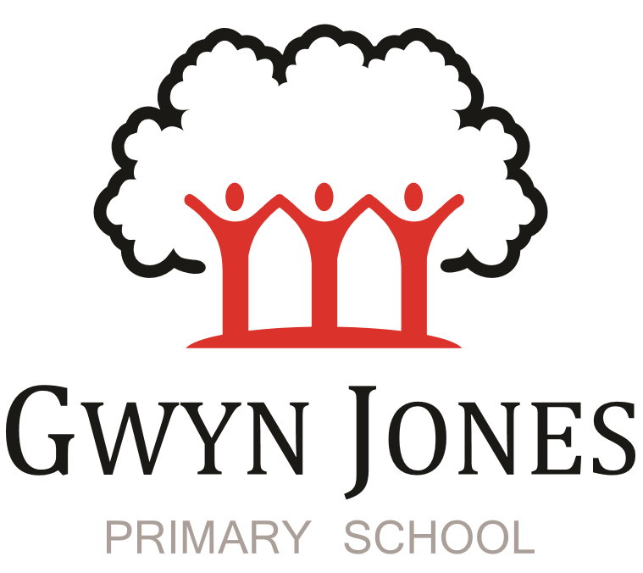



**Recruitment Pack**

|  |
| --- |
| **OPAL Play Leader**  Fixed term post – term-time only. 1 Year contract  11am -1.30pm each day. (Total 12.5 hours per week 45.6 weeks per year)  ***We are open to discussing a flexible working approach for the right candidate***  Grade: Scale 5 (Points 12 – 16)  Pro rata pay: £9527  September 2025 start |

 

Dear Applicant,

Thank you for your interest in this exciting opportunity to join Gwyn Jones Primary School as a member of team in the role of OPAL Play Leader to join our friendly and hardworking team. This exciting role will be fundamental in developing the school’s OPAL play provision at lunchtimes. In accordance with the UN Convention on the Rights of the Child, article 31 the role of Play Leader enables every child to engage in stimulating, child-led play opportunities, building their own worlds and directing their own actions. Please visit the OPAL website to find out more about the program prior to applying so you have a good understanding of OPAL: [Home - Outdoor Play And Learning](https://outdoorplayandlearning.org.uk/)

We are a two-form entry, culturally diverse school based in East London and we are very proud of our school. Visitors comment on the warmth of the school and the friendliness of both staff and pupils alike. Our dedicated staff team are incredibly hard working and are committed to creating a happy, secure and stimulating environment in which every child can achieve their potential and develop a life-long love of learning.

At Gwyn Jones Primary School we are a Rights Respecting School and we actively teach our children about the rights of the child. The Rights Respecting ethos permeates all parts of school life and into our school motto “Inspired and Empowered”. This motto epitomises the staff’s genuine commitment to provide a rich, creative and challenging curriculum which inspires children’s curiosity and empowers our pupils to have a voice and be knowledgeable, active global citizens. We strive to ensure that every child thrives academically whilst benefiting from excellent pastoral care that nurtures and develops emotional wellbeing.

We are looking for someone who has good communication skills and is flexible in their approach when supporting children and working alongside other colleagues. We know it is important to be positive, inspirational and a real team player.

The successful applicant will:

* Have a good understanding of the OPAL program.
* Lead, support and supervise the promotion of positive and creative play at lunchtime in line with OPAL practice and ethos (Outdoor Play and Learning).
* Lead on the setting up and organisation of equipment and resources for the children to use during playtime.
* Lead the play team (Midday Supervisors).
* Maintain, organise and carry out the replenishment of resources
* Purchase resources as required.
* Seek funding sources.
* Collect resources (e.g., by contacting supermarkets and businesses, visiting shops for offcut materials etc)
* Supervise pupils in designated areas of the school (including playground or external spaces) during the lunchtime break, including supervision of pupils indoors on wet lunchtimes.
* Attend relevant training as required.
* Support the school’s Behaviour Policy and ensure that it is implemented effectively.
* Support the ethos of play in school according to the school play policy and OPAL.
* Attend to the health, welfare and safety of the children during lunchtime adhering to the school Health and Safety policy and procedures at all times

Prospective candidates can arrange to visit the school if they wish to see the outdoor facilities or learn more about OPAL.

I hope this application pack and the information available generally on our website and on social media will give you a flavour of our School. I would be delighted to show you around our friendly and caring school. To arrange a visit please contact the school office on 02085567904 or email: [HR@gwynjones.waltham.sch.uk](mailto:HR@gwynjones.waltham.sch.uk)

I look forward to meeting with you

**Sian Boutalbi**

**Headteacher**

 

Dear Applicant,

Thank you for your interest in the position of OPAL Play Leader . Please visit the OPAL website to find out more about the program prior to applying so you have a good understanding of OPAL: [Home - Outdoor Play And Learning](https://outdoorplayandlearning.org.uk/)

Gwyn Jones is a successful and very popular school within the local area. We are fortunate in having an engaged and culturally diverse community, a hardworking and talented staff team and amazing pupils.

As Governors, we work alongside the Head and her dedicated team in our common belief in the fundamental importance of Primary Education as the foundation for developing a lifelong love of learning in our children. Our Governing Board is keen to develop its skills and knowledge of the school and its community and supports the drive within school for continuous improvement within a nurturing and supportive environment.

Our curriculum is rich, diverse and challenging and aims to provide a range of exciting and meaningful experiences which foster confidence and provide aspirations. Staff plan for children to be academically challenged, creatively inspired and supported in their personal development.

Gwyn Jones maintains strong links with other local schools within Waltham Forest. As a member of our staff team you would receive ongoing support and development in your role.

If the thought of this role in our school excites you, we look forward to receiving your application.

**Liz Jackson**

**Chair of Governors**

**Vision and Values**



At Gwyn Jones, we are committed to ensuring that every member of our school community is **inspired and empowered** each day.

We aim to inspire and empower our children by:

* Providing excellent teaching which nurtures our children’s innate curiosity, allowing them opportunities to take risks and to think for themselves.
* Supporting our children to have responsibility for their own learning; to have their own opinions and the skills to articulate them.
* Allowing all children access to a rich and broad curriculum which fully prepares them to be active, global citizens.
* Ensuring all children participate in a variety of trips and visitors in their local and wider community.
* Acting as role models who respect others and enjoy the rich diversity of our school family.
* Insisting that every child is known well, safe and nurtured to achieve their personal best.

We aim to inspire and empower our staff by:

* Providing a wide range of relevant and innovative professional learning in school which focuses on collaboration and sharing good practice, including lesson study, planning support, team teacher and action research.
* Forging strong links with external agencies to deliver professional development - teaching schools, higher education institutes etc.
* Giving developmental feedback with clear and specific actions for staff and leaders.
* Establishing coaching and mentoring relationships which encourage reflection.
* Identifying and nurturing leadership talent.

**Rights Respecting School**  

### **What is UNICEF's Rights Respecting Schools?**

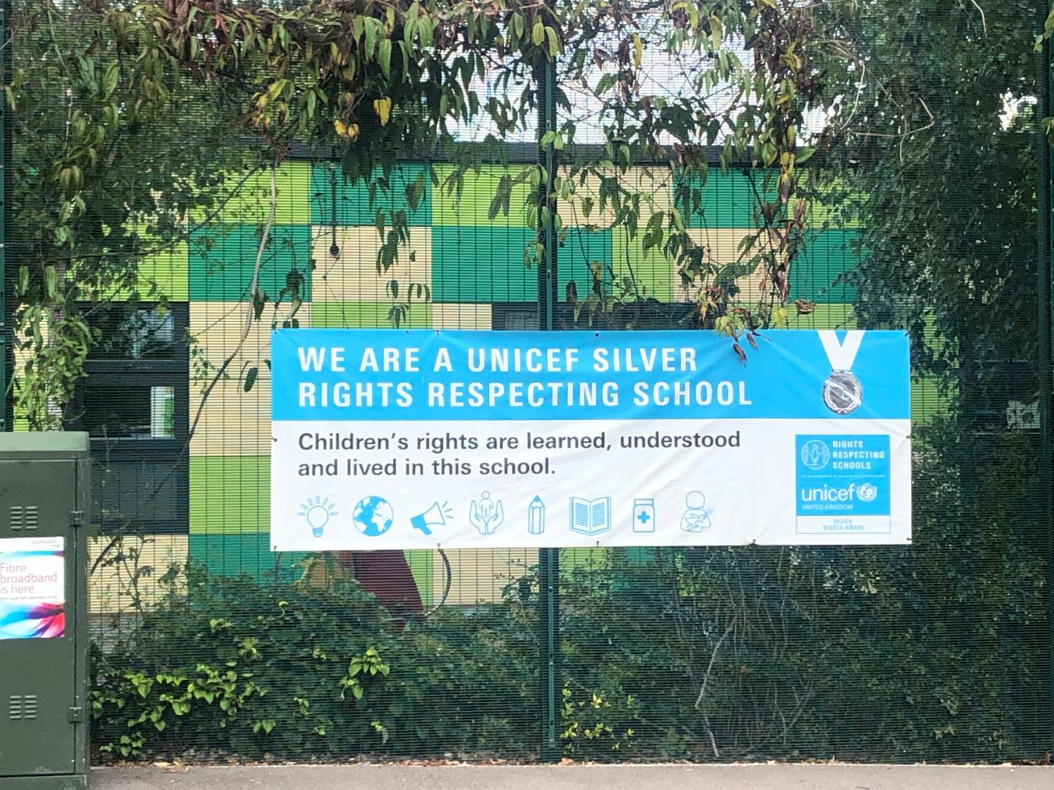

We are committed to placing the UN Convention on the Rights of the Child at the heart of our core values and ethos; believing children’s participation is integral to all aspects of school life. This results in empowered and self-confident children who can advocate for the rights of children everywhere.

This ethos further fosters a sense of community, respect and responsibility. It encourages the children to be active and informed citizens, who look to develop a positive future for all; campaigning and raising awareness.

The children’s experiences at Gwyn Jones Primary ensure the children know that they have the Rights of the Child and that these rights are inalienable. They also understand responsibilities they have as members of our local and global society.

**How to Apply**

Should you wish to apply for the post, please complete an application form and include a personal statement, which clearly demonstrates your suitability for this role. Please send your completed applications to [HR@gwynjones.waltham.sch.uk](mailto:HR@gwynjones.waltham.sch.uk)

**Closing Date**

Please ensure your application arrives by noon on the closing date of Friday 6th June 2025 at 9am.

**Shortlisting**

Shortlisting will take place on Monday 9th June 2025, if you have not heard from us by Wednesday 23rd April 2025 please assume that unfortunately, on this occasion, your application has not been successful.

**Interview**

Interviews will take place on Wednesday 11th June 2025.

**Safeguarding**

Applicants called for interview are kindly requested to contact their referees so that references are received ahead of the interview dates.

Gwyn Jones Primary School is committed to safeguarding and promoting the welfare of children and young people and expects all staff and volunteers to share this commitment. The school follows safer recruitment practices and the successful applicants will be required to apply for an Enhanced Disclosure and Barring Service check. A copy of our Safeguarding Policy is available to view on our website

**Location**

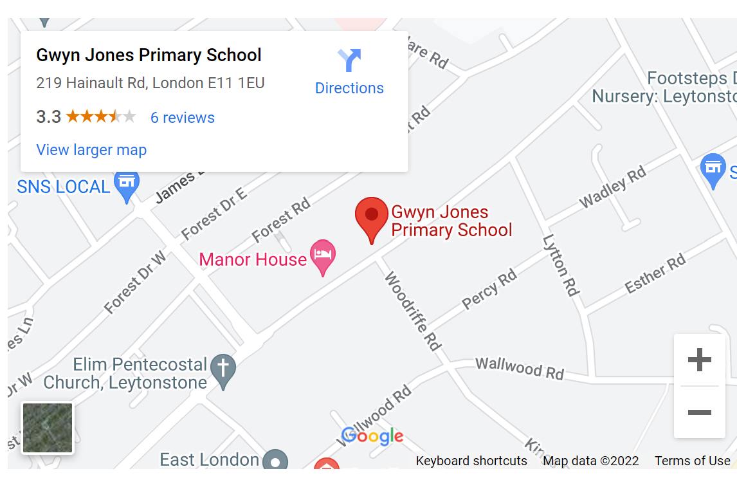

Job description and person specification

|  |  |
| --- | --- |
| **School Name:** | Gwyn Jones Primary School |
| **Job Title:** | Play Leader |
| **Scale and Points** | Scale 5 (Points 12 – 16) |
| **Reports To:** | Headteacher and Curricular Lead for play |
| **Role Summary:**  The play coordinator will support and facilitate meaningful and productive child-initiated play during the school day in accordance with the play policy.  The post holder will have a responsibility to promote and safeguard the safety and welfare of children in accordance with the schools’ safeguarding incorporating child protection policy; anti-bullying policy; behaviour policy; and in line with the school’s values and mission statement. | |
| **Ensure wellbeing of pupils**   * Ensure that all play team staff are completing their main duties to a high standard and that all staff are facilitating play development. * Ensure that you and your play team have read the play policy and are fully supportive of it. * Ensure the safety, welfare and general conduct through appropriate application of the school’s policies and procedures. * Establish safe and proper behaviour, by appropriate intervention or referral to senior staff, as appropriate. * Identify and report any unauthorised visitors on school premises. * Complete any relevant documentation required by the school in relation to incidents occurring during the lunchtime break period. * Participate in OPAL meetings, as required. * Ensure you and your play team are aware of children’s special medical conditions and the relevant precautions and treatments necessary. * Take any immediate action to attend to sickness or accidents by carrying out minor first aid and summoning relevant assistance. * Report any major accidents or bumped heads to the class teacher, headteacher and pastoral leader and record on medical tracker.   **Ensure a diverse range of playable resources are provided for, and are accessible to, all children**   * Ensure there are sufficient resources to promote each of the ‘play types’ as listed in the play policy. * Check the quality and condition of resources and repair or remove any resources that are not of a suitable condition. * Ensure resources are stored appropriately.   **Discuss resources with the children (school council) and use their views to create development plans**  Organise and carry out the replenishment of resources through:   * Securing funding from internal or external sources. * Purchasing resources as required. * Coordinating appeals within school and local communities for resources. Collecting resources from sources such as the Scrap project.   **Provide support and training for other school staff or pupils as required**   * Build play team members expertise and practice. * Organise and support pupil playground leaders with their role. * Facilitate peer led play opportunities. * Provide suggestions for playmaker activities and games.   **Ensure enriching play events or opportunities are created**   * Discuss and plan with pupils/staff and Rights Respecting Ambassadors. * Implement planned activities which promote play development. * Review activities to promote self-evaluation and play development. * Create opportunities for play to support the social and behavioural development of pupils.   **Ensure a rich and varied set of play opportunities is available to all children.**   * Outdoor Play and Learning (OPAL) e-Pack. * Provide engaging playwork interventions for pupils who find positive behaviour choices challenging.   **Review:**  The job description sets out the principle responsibilities for the post but does not describe each of the tasks that it may be necessary to carry out. The job description may be reviewed from time to time in consultation with the post-holder in order to address the changing circumstances of priorities within the school. | |
| **General Information:** | |
| Equality of Opportunity | * As a member school staff to take individual and collective professional responsibility for reinforcing and promoting a working environment free from discrimination, victimisation, harassment and bullying. * Ensure the development and progression of equality within the sphere of responsibility of this post and the fair and equal treatment of all colleagues, children, parents and visitors. |
| Confidentiality and Data Protection | * To treat all information acquired through employment, both formally and informally, in strict confidence. * To be aware of the school's responsibilities under the GDPR for the security, accuracy and relevance of personal data held on such systems and ensure that all processes comply with this. |
| To contribute as an effective and collaborative member of the School team | * Any other duties as reasonably required by any manager of the school. * Participating in the ongoing development, implementation and monitoring of the school plans. * Attend regular meetings as required and make a positive contribution during meetings. |
| Child Protection | * Being aware of and complying with policies and procedures relating to child protection reporting all concerns to an appropriate person. |

|  |
| --- |
| **Key Skills and Competencies:**  Essential:   * Prior experience of working with children in an educational or playwork setting is essential. * Relevant qualifications or experience of working with children.   Desirable:   * Playwork level 2 or above. |