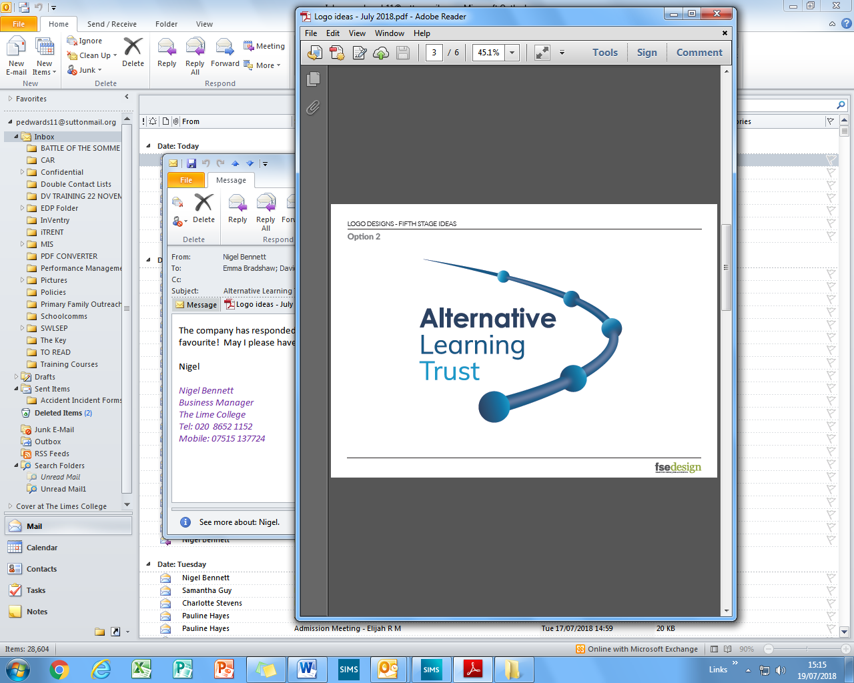

**JOB DESCRIPTION**

|  |  |  |
| --- | --- | --- |
| **Job title:** | Outreach Mentor | |
| **Post number:** | Limes 02.02 24/25 | |
| **Grade:** | NJC Scale 5 | |
| **Hours:** | 36 hours per week, term time only including five training days | |
| **Responsible to:** | Strategic Safeguarding Manager | |
| **Responsible for:** | --- | |
| **Job purpose:** | To support young people with complex and multiple needs to overcome barriers to attendance and engagement with school, by providing targeted and intensive intervention and child-centred support.  To play a proactive, significant role in promoting positive outcomes for young people at The Limes College, and their families, ensuring young people benefit from the school’s value and ethos of belonging, relationships, moving on and achieve, and are able to succeed at The Limes College and are supported to return to mainstream school and/or Post-16 provision.  To empower families to thrive by identifying the need for intervention from appropriate relevant agencies and signposting to external professional for intervention, ensuring wraparound care and support. | |
| **Key internal contacts:** | * Strategic Safeguarding Manager * Designated Safeguarding Leads * School Attendance Officer * Administrative Team | * Pastoral Team * Students * Teachers * Curriculum Support Assistants |
| **Key external contacts:** | * Parents/Carers * Social Workers * Borough School Attendance Service * Other Multi-Agency Professionals | |
| **Special consideration:** | * Hold a clear Enhanced DBS check * Required to have own transport to travel between schools and homes. * Hold a current and clean driving licence with the ability to drive the minibus and be willing to undertake MIDAS test. | |

|  |
| --- |
| **Specific duties**  **Outreach for students and their families**   * Maintain responsibility for a caseload of approximately 20 students on roll at The Limes College. * Ensure all students on caseloads are receiving weekly targeted intervention and regular supportive intervention, to include check-ins, tutor time visits and support during break times. * Record, monitor and evaluate all targeted and supportive interventions on CPOMS. * Develop and implement personalised support plans that include one-to-one mentoring, community-based outreach sessions and in-class support, to focus on promoting positive behaviour, engagement in learning and school attendance. * Empower students to overcome barriers to education by identifying and by addressing underlying issues such as behaviour, mental health and attendance. * Proactively address barriers to attendance and punctuality by working directly with students and their families and providing holistic support. * Collaborate with the School Attendance Officer and the local authority to ensure early interventions and participation in attendance meetings. * Conduct welfare checks, home visits and community-based sessions for hard-to-reach students or those at risk of disengagement from education, employment, or training (NEET). * Foster family involvement through conducting home visits and completing background information checks, signposting families to internal services and external agencies accordingly. * Support students in their transitions, whether returning to mainstream school, moving to an alternative provision or preparing for post-16 education. * Respond promptly and effectively to crises involving students, offering immediate intervention and ensuring appropriate referrals to safeguarding leads and external agencies. * Maintain up-to-date records on CPOMS and ensure safeguarding policies are adhered to. * Report any safeguarding and child protection concerns to them On-Duty Designated Safeguarding Lead.   **Supporting students to be successful in education**   * Implement behavioural strategies tailored to the individual students. * Support students to behave as expected and make positive choices and to support students at times of dysregulation. * Participate in re-entry meetings following exclusions to discuss behaviour, provide mentoring support and reinforce positive choices. * Act as an advocate for students in meetings with staff, parents and external agencies. * Ensure the student’s voice is captured and central to discussions around support and that their needs and preferences are considered in all decision-making processes. * Lead the Team Around the Child (TAC) meetings and participate in multi-agency meetings, ensuring that cohesive plans are in place for each student. * Regularly review and adapt support strategies as needed. * Record minutes from meetings on CPOMS and disseminate accordingly.   **Attendance**   * Work closely with students and families to understand the root causes of non-attendance and create action plans to overcome these challenges. * Monitor daily attendance, data and monitor progress. * Follow-up on lateness and non-attendance. * Provide tailored 1:1 or small group interventions that focus on mental health, self-esteem and anxiety, addressing the emotional barriers that may prevent students from attending school. * Identify the need for signposting and referral to external agencies for further support, monitoring and following up accordingly. * Build strong, trusting relationships with parents/carers to foster home-school collaboration. * Ensure parents are fully informed and kept updated and are involved in decision-making where appropriate.   **Duties for All**   * Liaise with parents/carers frequently to exchange information and share updates. * Be responsible for sharing information and data with external agencies and professionals in line with school policies and with a child-centred focus. * Attend and contribute towards external meetings led by Social Workers, such as Child Protection Conferences, Child In Need reviews, Child Looked After reviews and Professionals meetings, devising reports and completing assessments in advance as required. * Use SIMS and CPOMS to monitor and process student data and record minutes of meetings. * Attend daily briefings and team meetings, contributing positively and sharing ideas and information. * Be responsible for arranging supervision with Line Manager to troubleshoot any challenges with students on caseload. * Ensure own knowledge of relevant legislation, such as Keeping Children Safe In Education, is kept up to date, along with school policies relevant to the role. * Proactively commit to further development of own knowledge and expertise regarding issues and current trends affecting young people. * Undertake lunch duties, as published on rota. * To support and provide cover for the groups when team members are off short-term. * Ensuring The Limes College ethos is upheld in all aspects of daily work, embedding its core values of Belong, Relationships, Move On and Achieve.   **Trust**   * Promote the Trust’s core themes of working with vulnerable young people and helping them to flourish. * Promote the safeguarding and welfare of all children and young people in school. * Complying with the Trust’s policies and procedures (e.g. equal opportunities and health and safety); * Ensure high standards of behaviour and dress are maintained.   You may be required to carry out additional duties, as the Executive Principal may reasonably request, which are commensurate with the post. |

|  |
| --- |
| **Review:**  This job description will be reviewed regularly and may be subject to amendment and modification, following consultation with the post-holder. It is not a comprehensive statement of procedures and tasks; however, it sets out the main expectations of the College in relation to the post-holder’s professional responsibilities and duties.  I confirm that I understand and agree the duties of this job description.  Signature:  Print name:  Date:  ----------------------------------------------------------------------------------------------  Manager’s signature:  Print name:  Date: |

**PERSON SPECIFICATION**

**Outreach Mentor**

Please find below a list of points that you will need to respond to in your supporting statement. This should detail your experience and knowledge on each point. The information you provide in your statement will be assessed against the relevant items on points below.

|  |  |  |  |
| --- | --- | --- | --- |
|  | **Criteria** | **Essential** | **Desirable** |
| **Qualifications and Experience** | Minimum of English and Maths qualifications equivalent to GCSE grade A-C. | **🗸** |  |
| To have a Level 3 qualification relevant to the role. |  | **🗸** |
| Experience of working with hard to reach families with complex multiple needs. |  | **🗸** |
| Experience of multi-agency working across statutory and/or voluntary organisations. | **🗸** |  |
|  |  |  |  |
| **Skills and Abilities** | Ability to organise and lead small group work, as requested, where appropriate. | **🗸** |  |
| Able to monitor and evaluate progress through support plans, including regular reviews, in order that impact can be measured. | **🗸** |  |
| Ability to develop and maintain good relationships with children, caregivers, school staff and other agencies. | **🗸** |  |
| Have experience and appropriate training to deliver ELSA and other interventions. |  | **🗸** |
| Ability to work co-operatively and effectively as part of a team, sometimes without direct supervision; | **🗸** |  |
|  |  |  |  |
| **Knowledge** | To have good working knowledge of IT e.g. Word, Outlook, Excel and PowerPoint. | **🗸** |  |
| To understand assessments / reviews and professional boundaries. | **🗸** |  |
| Knowledge of the factors which put children and young people at risk of crime, poor attendance at school and social exclusion and what services might be involved. |  | **🗸** |
|  |  |  |  |
| **Special conditions** | Hold a current driving licence with own transport. | **🗸** |  |
| Willing to undertake an Enhanced DBS check | **🗸** |  |
| Willing to undertake training to drive the minibus. |  | **🗸** |