

# Job Description

**Title of Post:** Outreach Teacher

**Grade/ Pay Range:** MPS as appropriate plus SEN 1 allowance

**Reporting to:** Outreach Service Lead

The responsibilities of the post are to be performed in accordance with the provisions of the current School Teachers’ Pay and Conditions document and Teachers’ Standards / post threshold standards.

|  |
| --- |
| **Job Purpose** |
| * Manage a caseload of children requiring outreach input and record outcomes using the service's documentation systems * To provide expert guidance, support, and interventions to schools, Early Years settings, and families, specifically focused on children with autism in the Early Years and KS1. Provide 1:1 and group coaching or modelling of strategies in the classroom. * To supports the development of inclusive practice, strengthen transition processes, and delivers tailored outreach interventions to improve outcomes for children with autism and/or social communication needs, in mainstream education. * To plan, devise and deliver training to schools, Early Years settings, and families, specifically focused on children with autism in the Early Years and KS1. * To promote the aims and objectives of the school / Trust and maintain its philosophy of education. * To support the school / Trust in meeting targets identified in the Improvement Plan. |

**Main duties and responsibilities**

|  |
| --- |
| * To provide expert guidance, support, and interventions in managing a caring, supportive, purposeful and stimulating environment which is conducive to children’s learning. * To provide expert guidance, support, and interventions in planning and preparing lessons in order to deliver an appropriately adapted National Curriculum ensuring breadth and balance in all subjects. * To provide expert guidance, support, and interventions in identifying clear teaching objectives and learning outcomes, with appropriate challenge and high expectations. * To provide expert guidance, support, and interventions to maintain good order and discipline among the pupils, safeguarding their health and safety. * To provide expert guidance, support, and interventions in organising for and managing the needs of individual pupils ensuring adaptation of learning needs, reflecting all abilities and care needs. * To provide expert guidance, support, and interventions in planning opportunities to develop the social, emotional and cultural aspects of pupils’ learning. * To provide expert guidance, support, and interventions in maintaining a regular system of monitoring, assessment, record-keeping and reporting of children’s progress. * To provide expert guidance, support, and interventions in ensuring that individual therapies are delivered for those children who require these interventions. * To provide expert guidance, support, and interventions in the liaison with outside agencies when appropriate e.g. SALT, OT, Physiotherapist, School Nurse, Social Worker, EP. * To provide effective leadership of a team of teaching assistants, including performance management, as requested. * To participate in staff meetings as required. * To undertake supervisory duties and leadership of areas according to agreed areas identified on development planning. * Contribute to the development and co-ordination of a particular area of the curriculum / improvement plan as agreed with service lead, which may include:   + Writing of policies   + Writing a programme of work and corresponding recording document for an identified area / training.   + Arrange and lead any necessary working parties, disseminating relevant information.   + Monitor, check and develop resources for identified areas and ensure that these are fairly allocated and maintained.   + Identify staff and development needs relating to identified areas.   + Attend related NC courses and other relevant training / INSET and disseminate information. |
| * To support in the collection of and reporting of data and information as requested around KPI’s. * To ensure that trust policies are reflected in daily practice. * To communicate and consult with parents over all aspects of their children’s education – academic, social and emotional. * To continue professional development, maintaining a portfolio of training undertaken. * To meet with parents and appropriate agencies, to contribute positively to the education of the children concerned. * To support the Trust Team in promoting the ethos of the Trust and the service. * To promote the welfare of children and to support the trust and schools in safeguarding children though relevant policies and procedures. * To promote equality as an integral part of the role and to treat everyone with fairness and dignity. * To recognise health and safety is a responsibility of every employee, to take reasonable care   of self and others and to comply with the Health and Safety policy and any school specific procedures / rules that apply to this role. |

**Other Duties**

The duties and responsibilities in this job description are not exhaustive. The postholder may be required to undertake other duties that may be required from time to time within the general scope of the post. Any such duties should not substantially change the general character of the post. Duties and responsibilities outside of the general scope of this grade of post will be with the consent of the postholder.

An annual review of this job description and allocation of particular responsibilities will take place as part of the Performance Management Review.

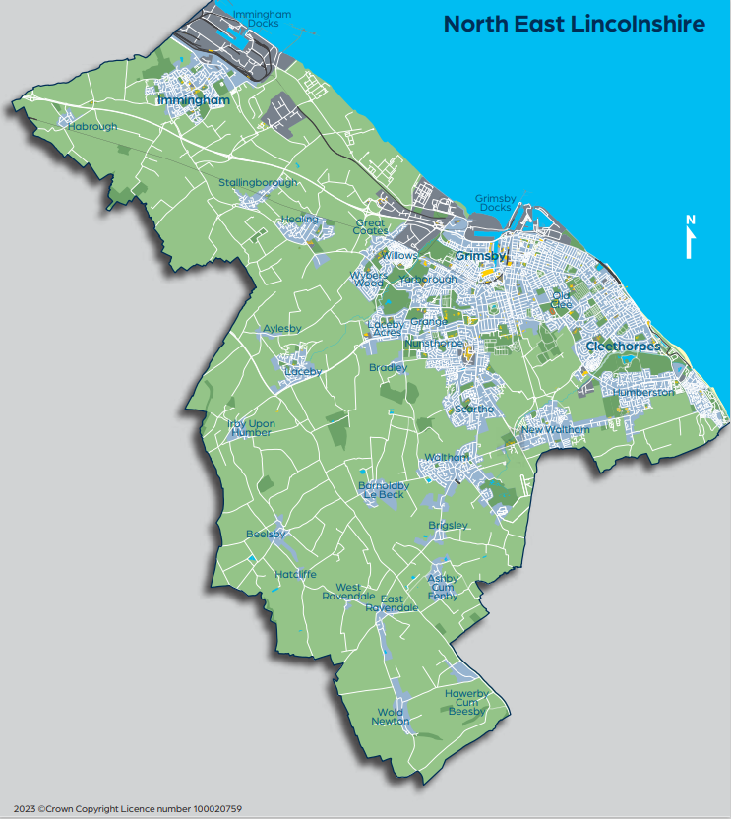

# PERSON SPECIFICATION

|  |  |  |
| --- | --- | --- |
| **KEY CRITERIA** | **ESSENTIAL DESIRABLE** | |
| **Qualifications and Experience** | Qualified teacher status  Evidence of effective teaching experience using innovative and creative teaching approaches | A qualification specific to SEN  Evidence of teaching children with ASD / complex learning needs including specific interventions |
| **Knowledge** (Knowledge, abilities, skills, experience) | A thorough up to date knowledge of the range of teaching, learning and behaviour management strategies and how to implement them effectively.  Knowledge of Early Years and KS 1 practices.  Knowledge around Autism / interventions / strategies / and related practices, such as trauma informed.  Experience of working closely with parents and other partners to support children’s learning and development.  A sound knowledge and understanding of child development and how experience contributes to learning.  Knowledge and understanding of how to monitor and record pupil progress effectively.  A working knowledge of the current Code | Thorough knowledge and understanding of the National Curriculum and assessment of children attaining within and below nationally expected levels  Expertise and ability to develop curriculum areas across a range of settings  Experience of coordinating the work of a team. |
|  | of Practice.  Good personal ICT skills and a willingness and enthusiasm to make use of new technologies to support learning and development.  Know the legal requirements, national policy and guidance on the safeguarding of children. |  |

|  |  |  |
| --- | --- | --- |
| **Skills and Abilities** | Ability to prepare and plan effectively.  Good organisational and record keeping skills.  Ability to work well under pressure.  Ability to develop good personal relationships within a team, making an effective contribution to team morale.  Ability to work alone and seek support as needed. |  |
| **Work-related Personal Requirements** | Emotional honesty. Working in a specialist environment is not for everyone and a natural affinity for our wonderful group of pupils is required.  Stamina, resilience and a very good sense of humour. | Clear aspirations for your own professional development and career advancement  A personal interest or skill area that you can deploy to the benefit of the Trust / outreach services and the pupils. |

**Examples of evidence that could be provided in support of the Personal Learning Journey:**

* Planning structures, examples of strategies and impact, management structures
* Progress data against key indicators, in line with KPI’s
* Communications with parents, carers, professionals
* Observation review feedback
* Team communications
* Departmental development against improvement planning

**(this list is not exhaustive and is to give examples only)**

**I confirm that I have received a copy of this job description and person specification:**

**Signed …………………………………………… Name ……………………………………………. Date ………………………………………………**