|  |  |
| --- | --- |
|  | |
| **Specialist Autism Advisor (Early Years and KS1) for NEL Outreach Service** | |
| **GRADE:** G6 Term time only  **REPORTS TO:** Outreach Service Lead | |
| **1** | **PURPOSE OF JOB:**  The Specialist Autism Advisor will provide expert guidance, support, and interventions to mainstream schools, Early Years settings, and families, specifically focused on children with autism in the Early Years and KS1. This role supports the development of inclusive practice, strengthens transition processes, and delivers tailored outreach interventions to improve outcomes for children with autism and/or social communication needs. |
| **2** | **MAIN RESPONSIBILITIES, TASKS AND DUTIES** |
| **2.1** | **Specialist Support and Advice**   * Work alongside the service lead and provide expert autism-specific advice to education settings (EY and KS1) via direct visits and work with children, practitioners and families * Develop and disseminate high-quality resources for use in classrooms and at home. * Support early identification of needs and advise on inclusive strategies and reasonable adjustments in line with the SEND Code of Practice. |
| **2.2** | **Early Years and Transition Support**   * Deliver bespoke support for children transitioning into, between, or out of Early Years and KS1 settings. * Collaborate with Early Years providers and primary schools to implement autism-friendly environments and routines. * Contribute to Early Support Plans and EHCP reviews where required. |
| **2.3** | **Parent/Carer Engagement**   * Offer practical advice and emotional support to parents and carers of children with autism. * Organise and deliver parent workshops or coffee mornings on relevant topics. |
| **2.4** | **Case Management**   * Respond to enquiries providing timely, evidence-informed guidance. * Manage a caseload of children requiring outreach input and record outcomes using the service's documentation systems. |
| **2.5** | **Staff Training and Development**   * Plan and deliver in-house autism training for school and EY setting staff. * Provide 1:1 and group coaching or modelling of strategies in the classroom. * Support settings to implement whole-school approaches for neurodiverse learners. |
| **2.6** | **Collaboration and Reporting**   * Maintain regular communication with the NEL SEND team, contributing to a collaborative and cohesive service offer. * Attend multi-agency planning meetings as required. * Maintain accurate records and contribute to service impact reports. |
| **3** | **OTHER DUTIES**  The duties and responsibilities in this job description are not exhaustive. The post holder may be required to undertake other duties that may be required from time to time within the general scope of the post. Any such duties should not substantially change the general character of the post. Duties and responsibilities outside of the general scope of this grade will be with the consent of the post holder. |

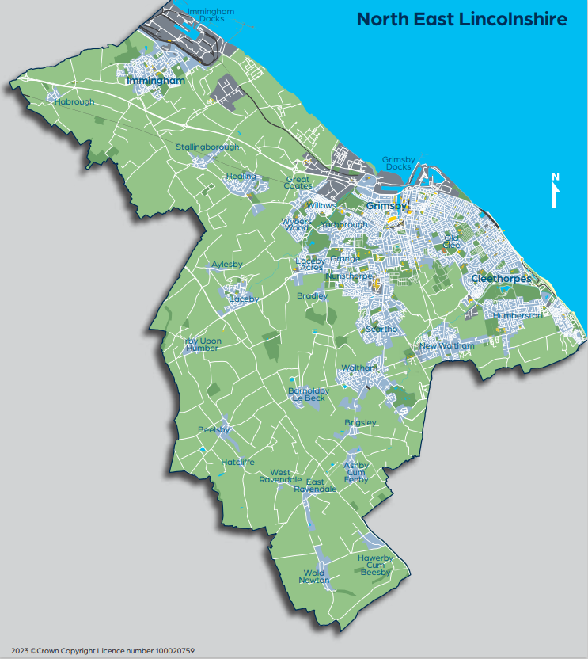

**PERSON SPECIFICATION**

|  |  |  |
| --- | --- | --- |
|  | ESSENTIAL | DESIRABLE |
| QUALIFICATIONS & TRAINING | * Current First Aid qualification * GCSE or equivalent in Maths, English or   equivalent level of competency.   * Education to NVQ3 in Education or Childcare | Additional SEN qualifications, e.g. NASENCo, Autism Education Trust TEACCH, PECS, or EarlyBird training certification |
| EXPERIENCE | * Significant classroom-based experience supporting children with autism in Early Years or KS1 * Experience supporting pupils with communication and interaction difficulties | * Experience of delivering outreach or advisory support * Experience of supporting children with an EHCP |
| KNOWLEDGE &  SKILLS | * Deep understanding of autism and developmental needs in young children * Ability to model effective autism strategies and create resources * Excellent interpersonal and communication skills * Ability to manage caseloads and maintain clear documentation * Excellent communication, organisational and ICT skills * The ability to handle sensitive and confidential information and issues appropriately * The ability to self-evaluate learning needs and actively seek CPD | * Familiarity with EHCP processes and local offer services * Knowledge of Early Years Foundation Stage (EYFS) curriculum * Use of assessment tools for SEND (e.g., Boxall, SCERTS) * Knowledge of NEL SEND processes and pathways |
| PERSONAL CHARACTERTISTICS | * Empathetic, professional, and reflective Strong organisational and time management skills * Ability to communicate effectively with parents/carers/outside agencies under agreed systems of supervision/direction. |  |
| SPECIAL REQUIREMENTS | * Full driving licence * Flexibility to travel across the local area (see map attached) |  |

We are committed to safeguarding and promoting the welfare children and young people and expect all staff share this commitment. All posts will be subject to an enhanced DBS disclosure, medical and reference checks. Applicants may be subject to a social media presence check.