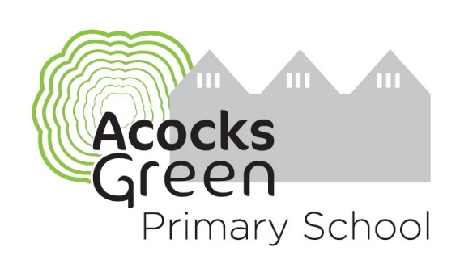
Join Our Team!

A very warm welcome to our wonderful school. We formed as a standalone academy in 2013 and have been proudly shaping our school since. We are keen to keep developing to be the very best that we can be. We are forward thinking and are a school built upon relationships.
Our motto is “Everyone is different, everyone is equal and everyone is welcome”. We are a school that celebrates and respects our differences, treating everyone as an individual whilst focusing on equality.
We place great emphasis on developing a strong partnership between home and school; it is through working together in an atmosphere of mutual respect and support that we can provide what is best for our children.
We are proud of our caring, happy and friendly school ethos and the achievement of our pupils. All the staff at Acocks Green Primary School are fully committed to building your child’s confidence and preparing them for a lifelong journey of discovery and learning. We have a diverse range of staff team with over 60 staff people with a wide range of skills expertise. We are always looking for others whose values match ours, to join our vibrant team. Could this be you?
Acocks Green Primary School was inspected in July 2024. We are really pleased with the outcomes;
Overall effectiveness | Good
The quality of education | Good
Behaviour and attitudes | Outstanding
Personal development | Outstanding
Leadership and management | Good
Early years provision | Outstanding

What Ofsted say about our school:

“The school motto of ‘everyone is different, everyone is equal, everyone is welcome’ shines through.”
“This is a school where everyone is included and valued.”
“Behaviour in class and around the school is excellent.”

At our school, we place a high priority on staff well-being. The list below shares some of the things that we offer staff but this is not exhaustive and it is continually added to:
- Staff have wellbeing day off, paid, for birthday or a special day for them to relax/doing something for their own wellbeing
- Free tea and coffee
- Free school lunch
- Free after school fitness sessions
- Staff have slightly more than minimum PPA, including TAs who have an hour a week
- Option to take PPA at home
- Remodelled marking and feedback policy to reflect the needs and the children’s learning but also balance what feedback is most helpful and how this is presented to the children in books or verbally
- Staff surveys to see how staff are feeling at various points of the year and feedback acted upon
- Staff meetings are relevant for staff CPD as development coaching. If we don’t need one, we don’t have one
- Staff Well-being policy, Mental Health policy, Smoking cessation policy, Alcohol and substance abuse policy
- New starter induction which includes wellness check ins
- Open door for anyone who wants to talk
- Thrive at Work accreditation

- Well-being award for Schools accreditation
- Senior Mental Health Leader
- Mental Health first aiders for adults, Mental Health first aiders for children
- Nurture mentor supports children who need more layers of support than class teachers can give them whilst in class. This is very flexible and with the needs of the child at the heart of the support
- Signposting for external support for anyone who feels they need some help with mental health, physical health, diet, alcohol, bereavement or stress (for those preferring to speak to someone separate to school)
- Our staff sickness and absence is very low. This has improved year on year as more well-being initiatives are incorporated into our daily life at school and become the norm. Staff want to come to work and everyone works hard to ensure that we look out for each other. Acocks Green Primary School feels a healthy place to work at for this reason.

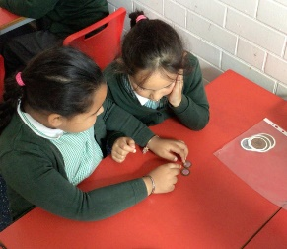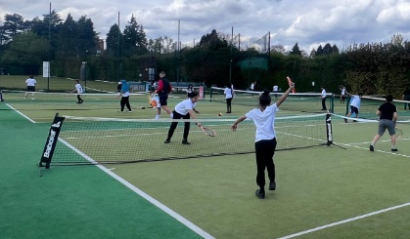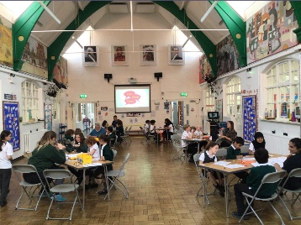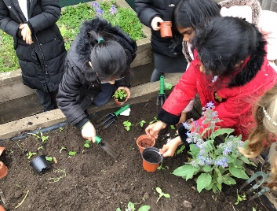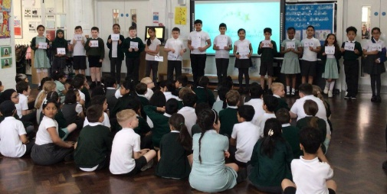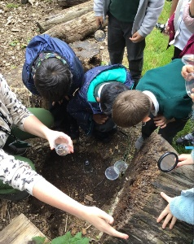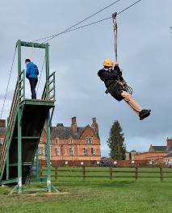

Why not take a look through our website which can be found at https://www.acocksgreen.bham.sch.uk/ and our newsletters, to see what we have been up to and what we can offer you at our wonderful school? This is a great opportunity for you to be able to grow professionally amongst our team of inspirational teachers and leaders.
We love to welcome those with shared vision and values. If you would like to join our incredible team, please contact the school office to arrange a walkaround (0121 706 2165 or email s.ward@acocksgreen.bham.sch.uk)
Mrs Ward, Headteacher

