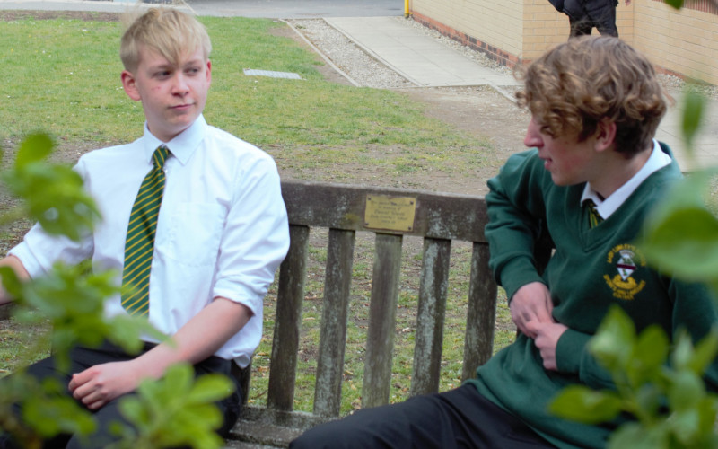

Part Time Caretaker (15 hours)
Closing Date: Monday 23rd May, 12 Noon
Recruitment Information Pack
Lady Lumley’s School
Swainsea Lane, Pickering, North Yorkshire
YO18 8NG

Contents

Welcome from the Headteacher 3-4
Our Visions and Values 4
Our schools 6-7
Application process and how to apply 8
Job Description/Person Specification 9-11

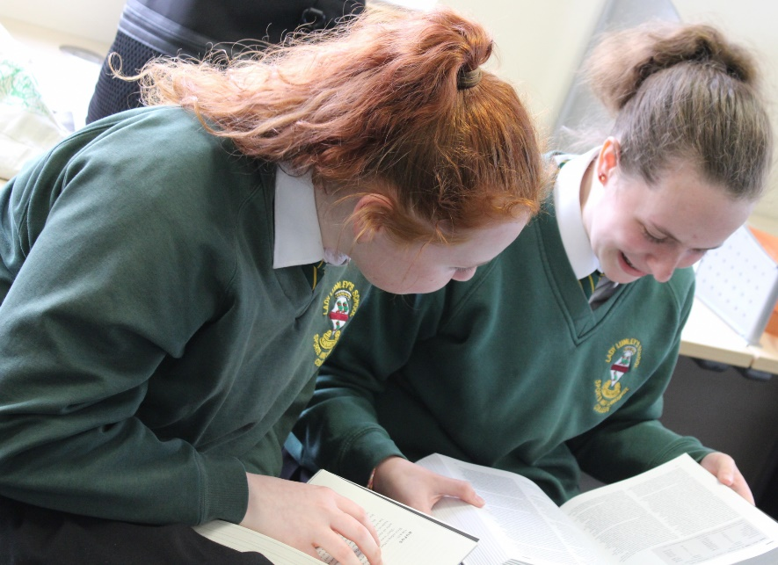

Dear Applicant

Thank you for taking an interest in joining our staff at Lady Lumley’s. I hope reading about our school gives you a sense of a driven community school, ambitious to do all we can to see staff and students thrive.
Lady Lumley’s school has a proud tradition and heritage of providing quality education. A trailblazer in the pursuit of education for all – welcoming the children of farming families and girls long before this was a requirement. Building on those foundations, Lady Lumley’s is a truly comprehensive school of 900 students drawing from the town of Pickering, surrounding villages and rurality as well as from Scarborough and all points in between.
‘Being our best’ signals Lady Lumley’s commitment to school improvement. We are ambitious for all our students and staff and strive to improve teaching and learning through constant evaluation and positivity. Our curriculum offer is broad and balanced, giving students a clear progression route through the school that builds the fundamental knowledge and understanding to allow them to specialise for Key Stage 4 then again at Key Stage 5. Lady Lumley’s curriculum gives all students the best chance of being successful at GCSE, A Level and Vocational Provision, ensuring our above national average outcomes open doors for life chances.

Our staff are integrated into thorough well-constructed CPD that looks to build strength in the classroom as well as modelling the pursuit of improvement. Ensuring all our strategic planning is built of evidential educational research is fundamental to ensuring we are investing staff time where it will reap rewards. A love of learning is a necessary mindset to thrive at Lady Lumley’s.

Lady Lumley’s is equally ambitious for our students to experience an enriched learning journey with a diverse offer of experiences. From trips abroad to Bordeaux, Saint Émillion and Dune de Pyla in France and Weiz in Austria our students also visit Belgium and France in Year 10 for the GCSE Battlefields Experience and Krakow and Auschwitz in Year 11, 12 and 13 for Religious Education. There are numerous theatre and music trips and visits taking in everything from Opera to Pantomime. The excellent sporting facilities are always fully booked with traditional team sports running alongside rock climbing and table tennis. Our Duke of Edinburgh scheme is ever popular and Lady Lumley’s students show leadership in this testing qualification right through to the Gold Award. With regular orienteering, canoeing and mountain biking our students also contribute hundreds of hours to volunteering and raise thousands of pounds for charity. Nurturing the growth of students through Enriching their experience enables Lady Lumley’s to prepare students to thrive locally or to move on to different cultures and experiences.

We value our pastoral staff and system as the cement that holds the school together. There are very high expectations of students conduct and a transparent and fair policy for rewards and consequences. All our students are supported through school with dedicated tutors and a Pastoral Officer with additional expertise available from the Pastoral Team and SLT. There are weekly ‘Life’ lessons to educate students with powerful knowledge to enable them to keep themselves safe and to have well placed confidence outside of school. Our staff and students deserve to feel safe and valued throughout their time at Lady Lumley’s.

Lady Lumley’s benefits from the knowledge and experience of Coast and Vale Trust as we are a unique school with a shared Trust vision. Through leadership development, collaboration and investment Lady Lumley’s is enabled to maintain its identity whilst belonging to a larger family of schools.

If you have read this and are committed to joining a school that is driven by ambition to be better, values a comprehensive community school and thrives on being part of a team, then we look forward to meeting you.

Yours sincerely

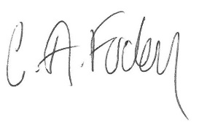
Clair Foden
Headteacher

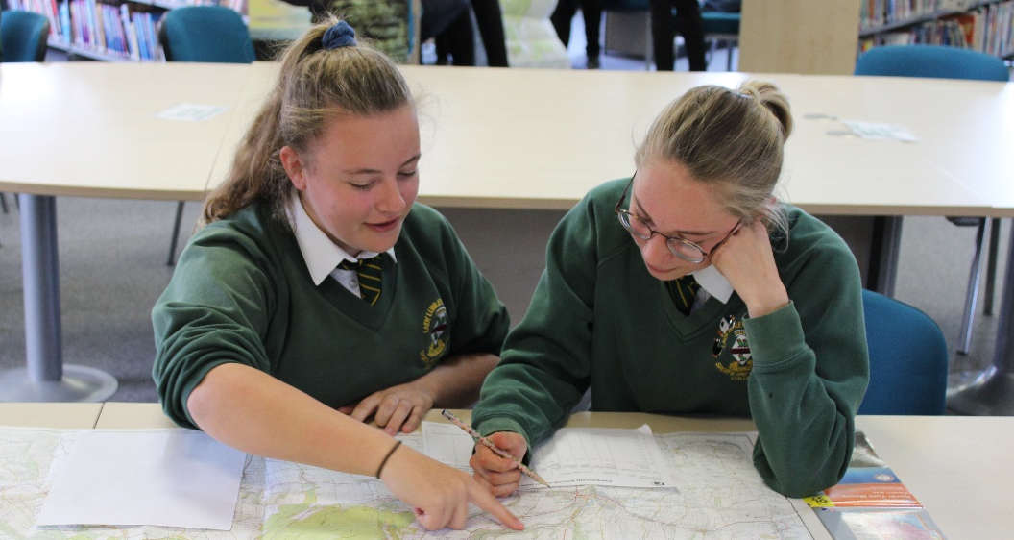

Visions and Values

Lady Lumley’s School is driven by the vision of ‘Being our best’. All staff and all students are asked to commit to our core values:

Learning
Lady Lumley’s core purpose is supporting our students and staff to make progress and continually adapt and develop to become lifelong learners.

Leading
Students and staff have regular opportunities to lead within and outside of the classroom to improve themselves and the community.

Ambition
We are relentlessly positive about improving and seeing all mistakes as ways to learn and improve and exceed our potential.

Progress
The journey through Lady Lumley’s for staff and students is a journey of improvement. Through striving to be our best we will face some setbacks but will build progress over time.

Our schools

Newby and Scalby Primary School

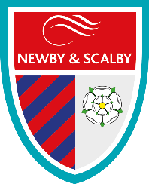
We are one of the schools of choice in our community and we are within commutable distance of Whitby, Teeside, York and surrounding areas. Ofsted in 2018 judged us to be ‘good’ in all areas and as a school we are very much outward facing both in terms of teaching and learning and in constantly thinking about how we can improve.
Since our “good” Ofsted, we continue to build on our successes and we are a family and a team, where everyone is given the challenge and support to be the best they can possible be in a safe, welcoming and positive environment. Children and staff will work and play together developing skills so that we all become ambitious and reflective lifelong learners as well as being respectful and respected members of the community.
To learn more about us please visit us at:
Newby and Scalby Primary School - Home (coastandvale.academy)

Friarage Primary School
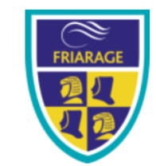
We are proud to serve the communities around the Castle Ward area of Scarborough as ‘Together we can’ make a real difference to the life chances of children and young people in Scarborough.

Children and staff will work and play together developing skills so that we all become ambitious and reflective lifelong learners as well as being respectful and respected members of the community.
We are committed to Restorative Practice Principles to nurture respect for all in our school community.

To learn more about us please visit us at: Friarage Community Primary School - Home (coastandvale.academy)

Scalby School
Scalby School is a successful and popular 11-16 community school and in recent years we have become the school of choice in our local community. We were judged ‘good’ by Ofsted in 2019 and in 2019 we celebrated sustained results. Our provisional P8 score has placed us in the top 20% of schools nationally. We are proud of our broad and balanced GCSE based curriculum.
To learn more about us please visit us at: Scalby School - Home (coastandvale.academy)

Lady Lumley’s School

Lady Lumley’s School (11-18) in Pickering is on a transformational journey. We are a school that is popular with parents and is easily accessible across North Yorkshire, East Riding and Wolds and Vale. The communities we serve around the Pickering, Ryedale and wider Coastal area deserve and need our school to play a leading role in terms of teaching, learning, progress and outcomes.

In April 2020 we welcomed our new Headteacher Clair Foden who joined us at the same time we joined our Trust - Coast and Vale Learning Trust. Lady Lumley’s is on an ambitious journey of school improvement.

To learn more about us please visit us at Lady Lumley's School - Home (coastandvale.academy)

Useful Links
Lady Lumley's School - Home (coastandvale.academy)
Welcome to Pickering. Gateway to the North York Moors, Yorkshire

Scarborough University Technical College

Scarborough UTC is a growing University Technical College (year 9 to year 13) based in a new building, with fantastic technical facilities in the centre of Scarborough. As a University Technical College, we offer a high quality academic and technical education for our students through the specialisms of engineering, health and cyber security. Our unique approach provides students with an excellent range of opportunities including Combined Cadet Force (CCF Navy), strong links to our industrial partners, project-based learning and our flagship Career Development Programme for our Sixth Form students.

Our work with employers and universities ensure we are able to deliver an innovative blend of technical, practical and academic learning which ensures our students make good progress and go on to outstanding destinations.

Our staff are our greatest resource and we have invested in both our teaching and support staff teams which has ensured that educational standards have improved significantly. We have built a staff team of key support and teaching practitioners who are proud to work at our University Technical College.

To learn more about us please visit us at: https://www.scarboroughutc.co.uk

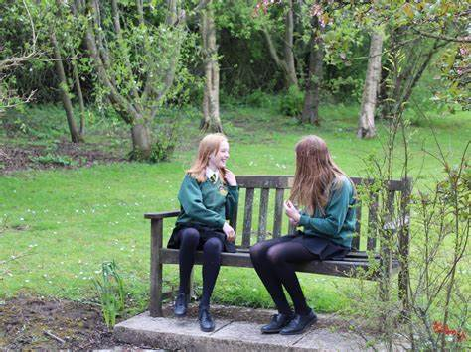

Application Process
The closing date for all applications is Monday 23rd May 2022, 12 Noon

Interviews will be held as soon as possible after the closing date.

Completed applications must be returned to Garry Morrison at garry.morrison@northyorks.gov.uk

If you think you’re the person for the job, please complete the enclosed application form and send to the email address above by the closing date.

An email will be sent to shortlisted candidates with details of the interview process. If you have not heard from us within a week of the closing date please assume your application has been unsuccessful.

Queries
Please contact Garry Morrison at garry.morrison@northyorks.gov.uk or on 07814935700

Lady Lumley’s

JOB DESCRIPTION

POST: Caretaker
GRADE: Grade C
RESPONSIBLE TO: Site Manager
STAFF MANAGED: None
JOB PURPOSE: | To provide high quality effective caretaking services to ensure a secure, safe and hygienic environment for all building users.
JOB CONTEXT: | The caretaker and cleaning team as a whole are responsible for maintaining high standards of cleanliness and maintenance of equipment and buildings throughout the school.  The post is required to work with tools, cleaning equipment and products which contain chemicals, but the necessary protective clothing will be provided. Also required to work outdoors in all weathers to ensure the school premises is safe.  Enhanced DBS check is required for this post due to working within a school environment
ACCOUNTABILITIES / MAIN RESPONSIBILITIES
Operational Issues |  | - To ensure the safety and security of the building and site, undertaking daily safety and security checks.  - Act as a designated key holder, providing response to emergency calls.  - Locking and unlocking of buildings at pre-determined times.  - To monitor the heating system and report any faults to their Manager.  - To ensure outside areas are safe / clean, kept free from litter, debris, leaves and that there is safe access to the building during adverse weather conditions e.g. Snow.  - To undertake general portering duties whilst on site to include moving furniture & equipment on site.  - Receive deliveries to the site.  - To support the maintenance of the building, undertaking minor repairs (not requiring a contractor) of a range of equipment and buildings.  - To assist with cleaning duties as directed.  - Collect and assemble waste for collection.
Communications |  | - Communicate effectively with other members of staff and pupils within the school.  - Welcome contractors onto the site and check clearances.
Resource management |  | - To participate in the training and development and performance management processes within the school.  - Store equipment and products safely and securely.  - Ability to carry out informal risk assessments on buildings to identify faults/hazards.  - Order, stock control and store cleaning and caretaking equipment and products safely and securely.
Safeguarding |  | - To be committed to safeguarding and promote the welfare of children, young people and adults, raising concerns as appropriate.
Systems and Information |  | - To fulfil the necessary administrative tasks associated with the responsibilities of the post.
Data Protection |  | - To comply with the Trust’s policies and supporting documentation in relation to Information Governance this includes Data Protection, Information Security and Confidentiality.
Health and Safety |  | - Be aware of and implement your health and safety responsibilities as an employee and where appropriate any additional specialist or managerial health and safety responsibilities as defined in the Health and Safety policy and procedure.  - To work with colleagues and others to maintain health, safety and welfare within the working environment.  - Perform duties in line with health & safety regulations (COSHH) and take action where hazards are identified, reporting serious hazards to line manager immediately.
Equalities |  | - We aim to make sure that services are provided fairly to all sections of our community, and that all our existing and future employees have equal opportunities.  - Within own area of responsibility work in accordance with the aims of the Equality Policy Statement.
Flexibility |  | - The Trust provides front line services, which recognises the need to respond flexibly to changing demands and circumstances. Whilst this job outline provides a summary of the post, this may need to be adapted or adjusted to meet changing circumstances. Such changes would be commensurate with the grading of the post and would be subject to consultation. All staff are required to comply with the Trust Policies and Procedures.
Customer Service |  | - The Trust requires a commitment to equity of access and outcomes, this will include due regard to equality, diversity, dignity, respect and human rights and working with others to keep vulnerable people safe from abuse and mistreatment.  - The Trust requires that staff offer the best level of service to their customers and behave in a way that gives them confidence. Customers will be treated as individuals, with respect for their diversity, culture and values.

PERSON SPECIFICATION

Caretaker

Essential upon appointment | Desirable on appointment (if not attained, development may be provided for successful candidate)
Knowledge
- Awareness of Health & Safety  - Ability to read and write | - Ability to use tools for making minor repairs
Experience
- Experience of undertaking general cleaning duties  - Experience of carrying out minor repairs | - Experience of working as part of a team
Occupational Skills
- Able to work with minimum supervision.
- Self-motivated
- Punctuality
- Flexible approach
- Attention to detail
- Ability to manage time effectively to complete tasks to a high level.
- Ability to work both alone and within a team to achieve specified standards
- Good verbal communication skills

Other Requirements
- Ability to carry out general caretaking and cleaning duties as detailed in the Job Description.
- Enhanced DBS clearance

