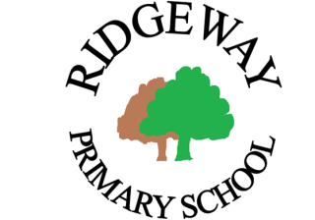
Ridgeway Primary School and Nursery
Southcote Road, South Croydon, CR2 0EQ
www.ridgewayprimaryschool.org.uk

RIDGEWAY PRIMARY SCHOOL
JOB DESCRIPTION - CLASS TEACHER

General duties:

To be responsible for the education and well-being of a designated class/group of pupils in accordance with the requirements of the Conditions of Employment of School Teachers having due regard to the requirements of
- The National Curriculum programmes of study and the school’s curriculum plans and schemes of work (Contexts for Learning)
- The school’s ethos, core values and School Development Plan
- School policies

Specific Responsibilities:

- To work closely with a range of professionals – external agencies alongside teachers, teaching assistants, SLT and the wider staff to ensure continuity and progression in children’s learning across the whole school, in accordance with the Teaching and Learning Policy / Early Years Policy in the Foundation Stage
- To produce medium and short term plans in collaboration with year group partners, to ensure continuity of teaching across a year group, and in accordance with the school’s policies
- To effectively use assessment (in line with school policy) to identify misconceptions, to track children’s understanding and to effectively plan for next steps in learning
- To create an inspiring learning environment where children are motivated, are actively involved in learning and where lifelong learning skills are introduced, practiced and mastered
- To be a team member within a curriculum team or teams. These roles will be subject to negotiation as part of the Annual Review and Development Cycle, set out in the Performance Management Policy
- To act as a member of a task team from time to time, developing new curriculum initiatives, implementing and monitoring aspects of the Teaching and Learning Policy, and working on aspects of curriculum development within the School Development Plan
- To share in the corporate responsibility for the well-being and discipline of all the children in the school, working closely with teacher colleagues, teaching assistants and other support staff
- To commit to and promote the home-school partnership in order to ensure that all those involved in children’s learning and development work closely together within agreed policies
- Have proper and professional regard for the ethos, policies and practices of the school, in particular: Health and Safety Policy, GDPR policy and Safeguarding and Child Protection policy

