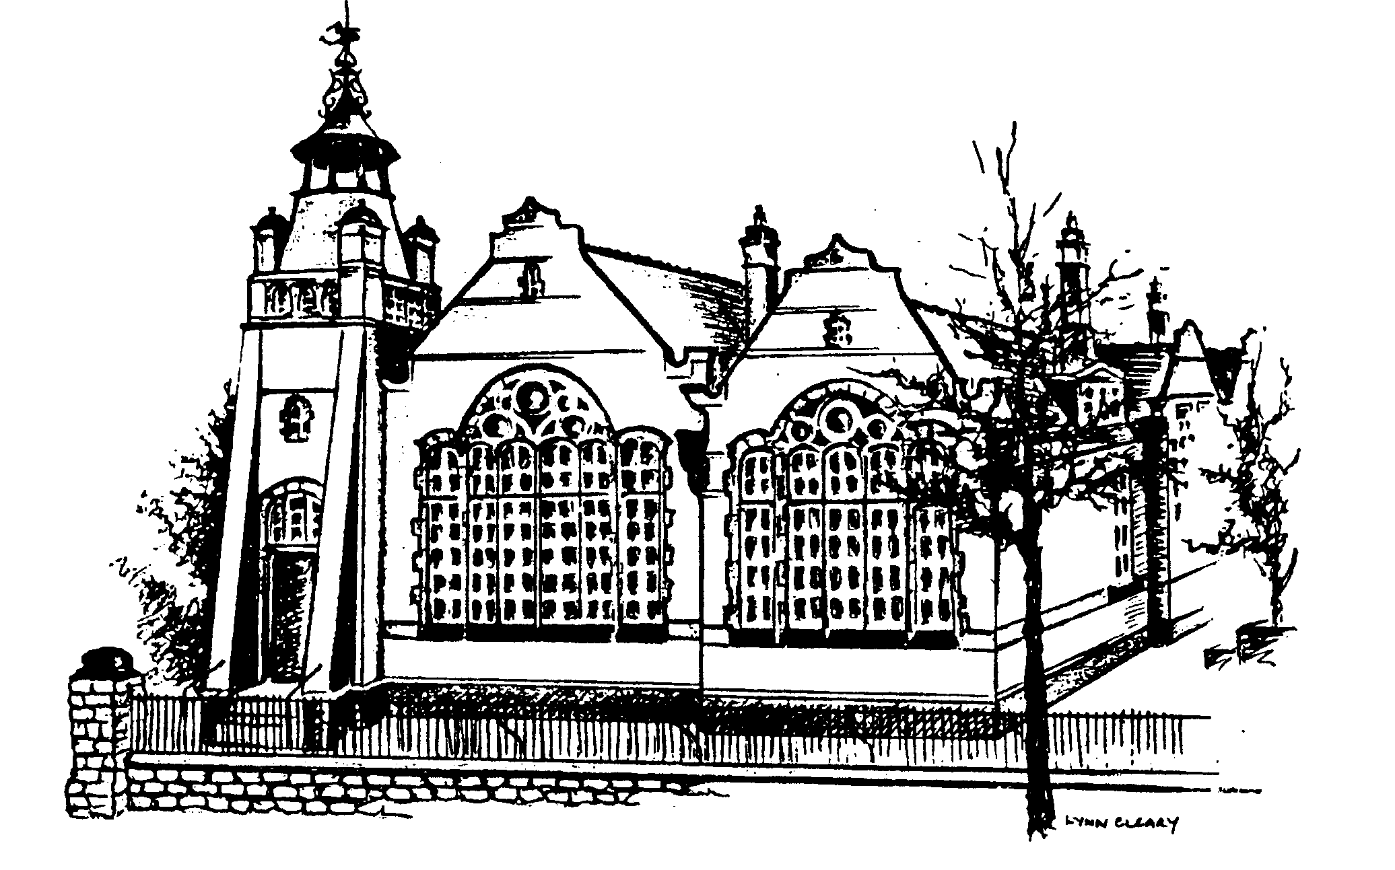
Headteacher: Mr Steve Border Lady Bay Primary School
Trent Boulevard
Deputy Head: Mrs Tracey Keane West Bridgford
Business Manager: Mrs Marj Masters Nottingham NG2 5BD

office@ladybay.notts.sch.uk
head@ladybay.notts.sch.uk Tel: 0115 9747 001
www.ladybay.notts.sch.uk April 2026

Appointment of Part Time Class Teacher – from September 2026 – Maternity Cover

Thank you for your interest in teaching at our school. Please find enclosed:
- Job description and person specification
- Details about the school
- Governors equal opportunities statement

We have a part-time Year 1 class teacher post available from September 2026 covering maternity leave. We welcome applications from teachers on the main pay scale. The post is for 3 days a week, working Wednesday to Friday. This is an opportunity to work alongside experienced members of staff; the school has recently been inspected by Ofsted and was rated as Good. We invite all candidates to read the Ofsted report as it gives a really good insight into the school – our values and how central they are to everything we do in school.

Applications
If you decide to apply you will need to complete the application form as fully as possible and write a supporting letter which should not exceed two sides of A4. Then choose one of the options below to apply.

- Apply via email, using the NCC application form (available to download from our website or NCC job vacancy website) to office@ladybay.notts.sch.uk. Attachments must be clearly labelled with your name. All applications will be acknowledged by email. Shortlisted applicants will be required to sign a hard copy of their application when they attend for interview.
- Return by post to the address above. Postal applications will only be acknowledged if you enclose a stamped addressed envelope or postcard. Please note that the school does not have a letter box for hand delivered applications out of usual school hours.

Closing date: Thursday 14^{h} May 2026 @ 12.00 noon.
Provisional Interview date: Tuesday 19th May 2026

Visits
We warmly welcome visits: please contact the school office if you wish to arrange a tour of the school office@ladybay.notts.sch.uk or tel. 0115 9747001and speak to Mrs Masters, our Business Manager. Tours are available on:
Thursday 7th May 9.15am
Thursday 7th May 4.30pm
Wednesday 13th May 2.00pm
Other times may be accommodated – please ring to request.

Please note that in line with the safeguarding requirements, if you are shortlisted,

- references will be requested prior to interview from your current or last employer. Referees may also be contacted by telephone.
- you will need to bring with you to the interview original documentation to prove your identity and that you have a right to work in the UK, and original qualification certificates essential to the post

Please see the information below about the school.
Yours sincerely,

Steve Border
Head Teacher

Lady Bay Primary School

INFORMATION ABOUT THE SCHOOL

Lady Bay Primary School is situated in the residential suburb of West Bridgford on the southern outskirts of the City of Nottingham. West Bridgford forms part of the Borough of Rushcliffe and is within the Nottinghamshire Local Authority. West Bridgford is almost entirely residential in character with a thriving town centre and mainly open country to the south and east. The Lady Bay area itself is distinct from the rest of West Bridgford and has a real community life of its own. Most of the housing is owner-occupied and a high proportion of parents of children at the school are in professional and managerial occupations. They take a close interest in their children’s education.

The school consists of three buildings on a single site, the first having been opened in 1899, the second in 1912 and the third in 2007. There are 2 playgrounds – one for the infants and one for the juniors – both of which have trim trails incorporated. Both playgrounds have 2 permanent multi-sport units. The school also has a playing field (“Ten Acre Field”) situated approximately a quarter of a mile from the school along Adbolton Lane.

The pupil roll is currently 378. Each year group has 2 parallel classes, making 14 classes in total.

Lady Bay Primary School is proud of its academic achievement, the rich curriculum offered and its caring ethos. The school’s approach to the curriculum is through whole school and year group planning. We are an OPAL school, and children enjoy a diverse range of play opportunities at lunchtimes.


At the heart of our school are our core values and our school motto is ‘Growing together: Caring for ourselves, each other and the environment’. Coupled with a broad and balanced curriculum, these aim to ensure our pupils leave Lady Bay Primary School as happy, secure, caring and responsible citizens.

The school was inspected by Ofsted in November 2022 and was confirmed as continuing as a Good school.

Each classroom is equipped with an interactive “Clevertouch” screen and every teacher is provided with a laptop.

Curriculum enrichment is offered through a number of after school clubs, educational day visits, residential visits for Key Stage 1 and 2 pupils and visitors into school such as theatre groups. The school has a number of partnerships and links with external bodies

The school seeks to develop positive relationships with our parent stakeholder group and is keen to work in partnership with parents who are normally actively encouraged to visit at any time – not only for consultation purposes but to involve themselves with their children’s learning by helping in classrooms and across the school in a variety of ways. The school has an active parents association (LBSA) which regularly organises social, educational and fund raising activities. They aim to promote good relationships between staff and parents and to provide additional funds to benefit the children in a variety of ways. Recently, the LBSA contributed towards the conversion of a storeroom into a base for our wraparound care.

The school is a Local Authority school maintained by Nottinghamshire County Council, not an Academy and is a member of the Rushcliffe Family of Schools. This comprises Rushcliffe School (an Academy) and 6 “feeder” primary schools. At the age of 11 the vast majority of our pupils transfer to Rushcliffe School. Relationships and links within the Family of Schools are excellent.

Members of the Governing Body show a keen interest in the school and are closely involved with its development. They visit on a regular basis.

Lady Bay Primary School is committed to safeguarding and promoting the welfare of children and expects all staff and volunteers to share this commitment.
Applicants are reminded that safeguarding is everyone’s responsibility and that they will be expected to place the welfare and safety of children at the forefront.

This post will require an enhanced DBS disclosure.

Further details will be given if you are invited to an interview. Please also note that if you are successful for a teaching post in the school you will also be subject to a prohibition from teaching check and for certain posts in schools a disqualification under the childcare act 2006 check will also be required if you work in certain settings.

The School, together with the recognised trade unions, is committed to the development of positive policies to promote equal opportunities in employment and in the delivery of our services, regardless of age, disability, gender reassignment, race, religion or belief, sex, sexual orientation, marriage and civil partnership, pregnancy and maternity or trade union membership status. This commitment will apply to recruitment and selection practices, training and development, promotion and in the application of national and local agreements in respect of pay and conditions of service.

The School is committed to safeguarding and promoting the welfare of children, young people and vulnerable adults and we expect all staff and volunteers to share this commitment.

