Shipton Bellinger Primary School
Some more details about our school…

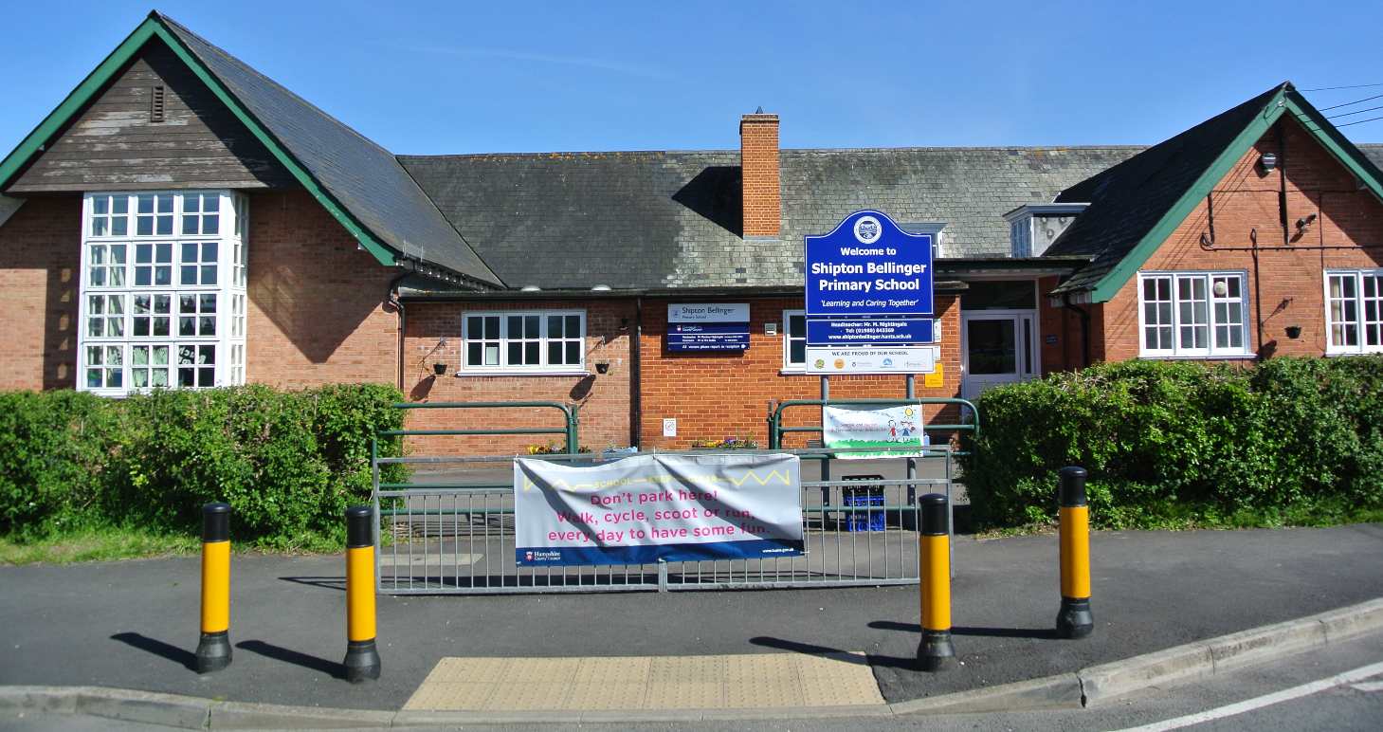

Shipton Bellinger Primary is a rural school situated in the heart of the village of Shipton Bellinger, on the Hampshire/Wiltshire border. We are very close to main trunk roads on the junction of the A338 and the A303. This makes us easily accessible from many local towns and cities, including Andover, Salisbury, Winchester and Hungerford. Two miles north is the garrison town of Tidworth. Our location gives us some unique features including a mixture of military and civilian families. We are a one-form entry school with 7 classes and currently 190 pupils on roll.
The school building itself (which is a mix of the older Edwardian building and more recent additions) includes seven classrooms, a hall, kitchen, library and a well-equipped community room - all retaining a friendly village atmosphere. The community room offers its own entrance, is well equipped and used for a variety of purposes, including a before and after school club. The school also houses an on-site kitchen to provide the children with school meals. The dedicated staff team work hard to make the classrooms both stimulating and engaging for children.
The grounds have been extensively re-developed for both recreational and academic pursuits, with an adventure play area and a wonderful, large playing field.
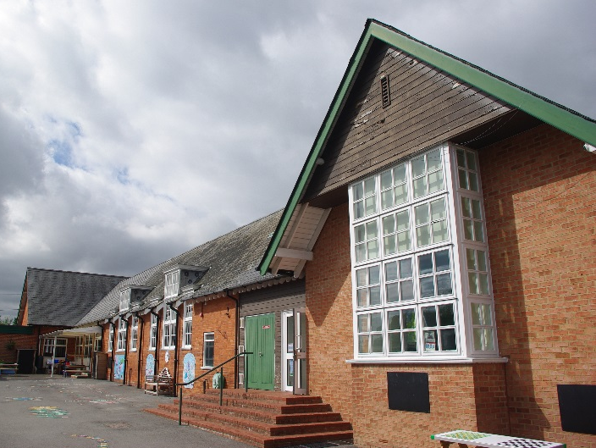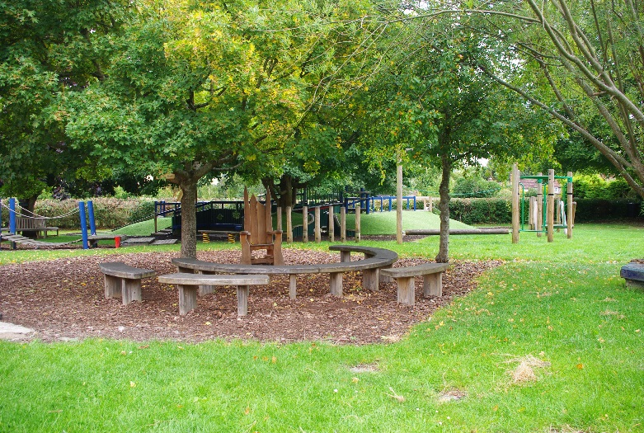
There is a free-flow outside learning area for our younger children. The local pre-school, although not run by the school, is also situated within the school grounds and we work in partnership with them.
We belong to the Rural Schools Group and have links with schools at Kimpton, Appleshaw, Amport, Grateley and Abbots Ann. We feed and liaise with different secondary schools including John Hanson in Andover, Hampshire, and The Wellington Academy in Tidworth, Wiltshire.
Shipton Bellinger Primary School is a maintained community school and therefore enjoys the support of the Local Education Authority, Hampshire County Council.

