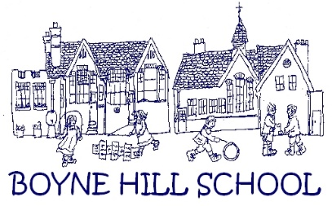

JOB DESCRIPTION FOR A KS1 TEACHER

ROLE: Class teacher

REPORTS TO: The Head Teacher

GRADE: Main Pay Scale

As a Church of England school, the role of Class Teachers is significant in realising the vision and ethos of the school. Teachers will work within the expectations of the School Teachers’ Pay and Conditions document and in line with the Teachers’ Standards document and our Appraisal and Career Progression documents.

Purpose of Job
To ensure the very highest expectations for all children with a positive proactive attitude to finding ways through for every child. To model the ethos and vision of the school within a framework inspired by our values and ethics.
- To assist the school leadership in ensuring the very best learning experience for children in our school
- To carry out the duties of a school teacher as set out in the Pay and Conditions Document and subject to any amendments due to Government legislation. This includes any duties as may be reasonably directed by the Head Teacher and the accountabilities expected of class teachers at Boyne Hill Infant & Nursery School.
- To demonstrate a passion for learning and education, striving to develop yourself and others and teach to a high standard, meeting the relevant Teachers’ Standards.

Professional Duties
General
- Alongside the Head Teacher and Senior Leadership Team, promote the school within the local community.
- Liaise with, when necessary, and/or provide relevant information when requested for meetings by or with other agencies and professionals such as Social Care, Educational Psychology, Children and Young Persons’ Disability Services etc.
- Share supervisory duties such as playtime duty as requested.
- Participate in the school’s Appraisal procedures.
- Take responsibility for your ongoing personal and professional development.
- Engage with professional learning opportunities within the school.
- Attend appropriate training and meetings.
- Develop supportive relationships with pupils and staff.
- Strive to develop positive relationships with families by communicating and consulting with parents of pupils.
- Liaise with school staff, parents and other professionals to support pupils’ learning
- Lead assemblies as necessary and prepare class contributions to open assemblies or performances to families.
- Promote the safeguarding of and the health and safety of the whole school community when on school premises or when engaged in school activities elsewhere.
- Inform the Head Teacher of any concerns about any of the children in your care.
- Participate in the community life of the school (School Fairs, Christmas Events, other celebrations etc).
- Keep up to date with the latest thinking and developments.
- Support the review of relevant policies and guidelines.

Teaching and Learning
- Plan for, resource and teach exciting, challenging and engaging lesson, in line with the requirements of the school curriculum and National Curriculum as well as any other national and local legislation and guidance.
- Work within our values framework so that every child’s voice is heard and valued and show respect for all pupils to ensure they feel welcomed and included.
- Assess the achievements of the children to inform planning, teaching and monitoring, including ongoing tracking data.
- Evaluate attainment and progression of pupils
- Monitor and celebrate the children’s successes.
- Maintain relevant records, including a record of achievement for each child.
- Report verbally and in writing to the parents/carers, in line with the school’s policy on Assessment, Recording and Reporting.
- Take account of the individual needs and learning styles of the children in the class, including any with Special Educational Needs or outstanding ability.
- Maintain a well organised, happy and stimulating learning environment.
- Work with other members of the school team, including attending training and planning meetings, to make the best possible provision for the children in your care.

