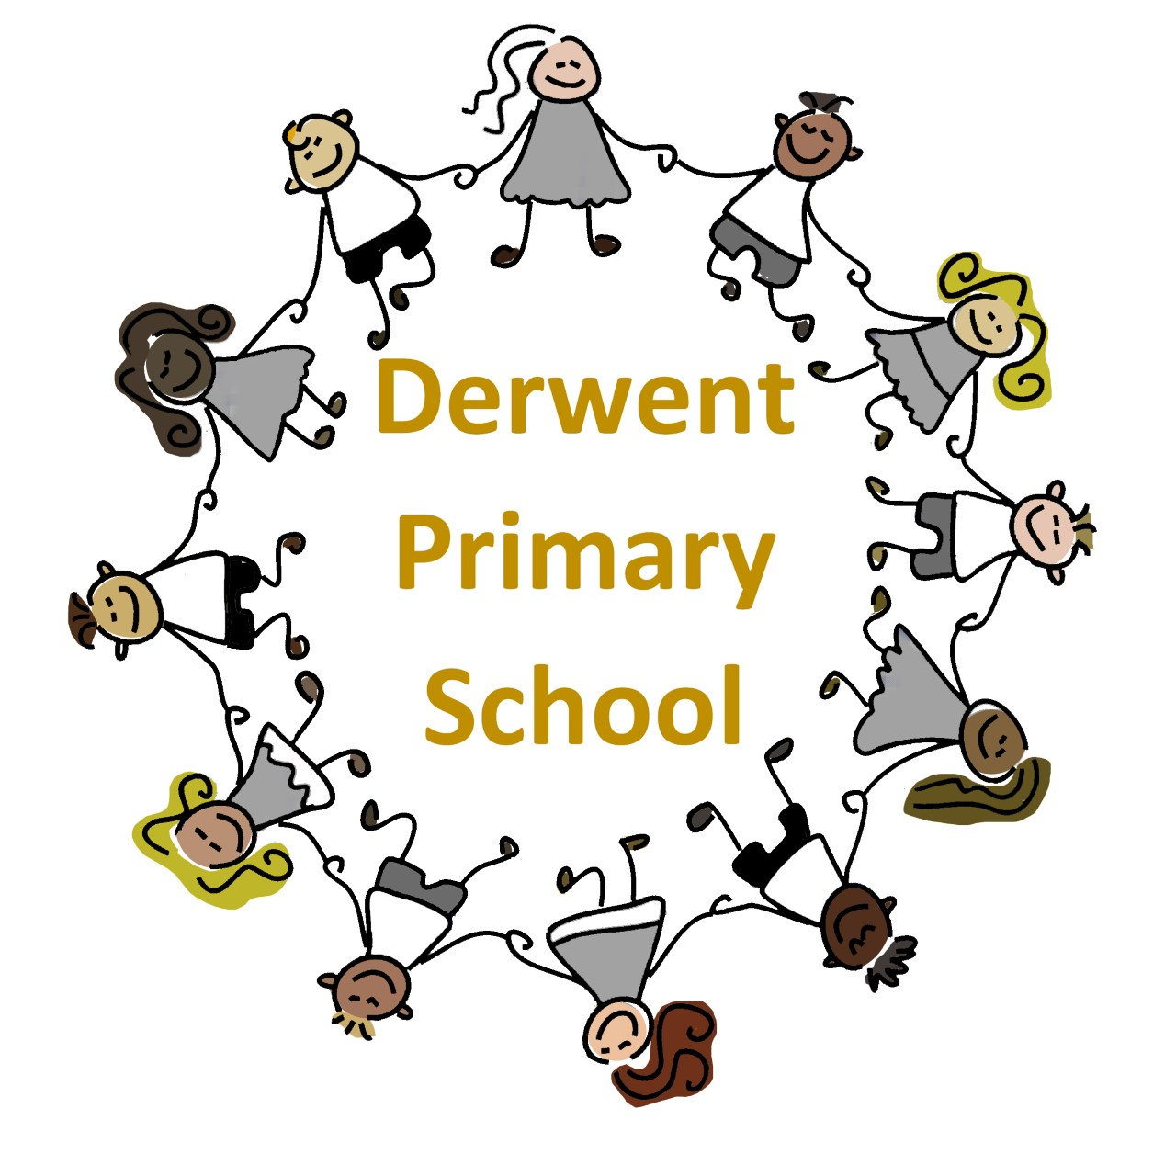
Derwent Primary School
St Mark’s Road, Derby, DE21 6AL
Tel: 01332 346222
Email: admin@derwentprimary.net
JOB DESCRIPTION
Job Role: Higher Level Teaching Assistant
RESPONSIBLE TO: The Headteacher

JOB PURPOSE: To work under the instruction/guidance of teaching/senior staff to undertake teaching, intervention and support programs to pupils.

MAIN DUTIES & RESPONSIBILITIES
- Teach and provide support for pupils on an individual/group or class basis.
- Undertake structured and agreed learning activities/teaching programs, adjusting activities according to pupil responses.
- Undertake programs linked to local and national learning strategies, recording achievement and progress and feeding back to the teacher.
- Establish productive working relationships with pupils, acting as a role model and setting high expectations.
- Promote the inclusion and acceptance of all pupils within the classroom.
- Support pupils consistently whilst recognising and responding to their individual needs.
- Encourage pupils to interact and work co-operatively with others and engage all pupils in activities.
- Provide feedback to pupils in relation to progress and achievement.
- Provide support for the teacher in assessing pupils’ responses to learning activities and, where necessary, modifying the activities to achieve progression towards intended learning outcomes.
- Liaise with teachers in designing and delivering appropriate learning opportunities to meet specific learning needs.
- Adapt and modify planned activities for pupils who are making extremely slow progress.
- Effectively communicate the work set by the class teacher to the pupils and ensure that pupils are aware of the teacher’s expectations.
SUPPORT FOR TEACHERS
- Provide adequate feedback to the teacher on the progress pupils have made in groups under your supervision.
- Use strategies, in liaison with the teacher, to support pupils to achieve learning goals.
- Assist with the planning of learning activities.
- Monitor pupils’ responses to learning activities and accurately record achievement/progress as directed.
- Undertake marking of pupils’ work and accurately record achievement/progress.
- Work closely with the class teacher in preparing resources e.g. setting up activity tables for lessons.
- Prepare and maintain equipment/resources as directed by the teacher and assist pupils in their use.
- Undertake pupil record keeping as requested.
- Work closely with the class teacher to contribute to the management of pupil behaviour, maintain order and an appropriate working environment, including implementation of the school’s behaviour policies.
- Report to teachers on the behaviour of pupils during lessons and any issues arising.
- Establish constructive relationships and communicate with other relevant professionals, in liaison with the teacher, to support pupils’ learning and progress.
- Respond knowledgeably to any questions from pupils about process and procedures.
- Ensure the health, safety and welfare of pupils is maintained at all times.
- Promote social and emotional development of pupils.
- Support the use of ICT.

HIGHER LEVEL TEACHING ASSISTANT
Able to meet the professional standards for higher level teaching assistants including but not limited to;
- Understand the objectives, content and intended outcomes for the learning activities in which they are involved
- Deliver and contribute to the planning and preparation of learning activities
- Contribute to the selection and preparation of resources suitable for children and young people’s interests and abilities.
- Support the evaluation of learners' progress using a range of assessment techniques
- Recognise and respond appropriately to situations that challenge equality of opportunity
- Undertake any other duties and responsibilities and deemed by the schools leadership team.
IN ADDITION:-
- Contribute to the overall ethos, aims and work of the school.
- Be aware of, uphold and contribute towards the development of the school’s policies and procedures.
- Be aware of, uphold and contribute towards the development of the school’s policies and procedures.
- Be aware of and comply with policies and procedures relating to child protection, health, safety and security, confidentiality and data protection, reporting all concerns to an appropriate person.
- Participate in appropriate school-based meetings. (paid)
- Undertake any administrative duties relevant and appropriate to this post.
- Participate in training and other learning activities and performance development as required.
- Accompany teaching staff and pupils on visits, trips and out of school activities as required.
- Embrace any other duties that may reasonably be regarded as within the nature of the duties, responsibilities and grade of this post.

Experience | - Working with or caring for children of relevant age
Qualifications | Necessary  - Secure numeracy/literacy skills  - Secure IT skills  - NVQ 2 for Teaching Assistants or equivalent qualifications or experience  - HLTA qualification or equivalent  Desirable  - Training in the relevant learning strategies used by the school Read, Write, Inc, Mastery Maths  - First aid training/training as appropriate
Knowledge/Skills | - Effective use of IT to support learning and systems  - Use of other equipment technology – video, photocopier  - Understanding of relevant polices/codes of practice and awareness of relevant legislation  - General understanding of national/foundation stage curriculum and other basic learning programmes/strategies  - Basic understanding of child development and learning  - Ability to self-evaluate learning needs and actively seek learning opportunities  - Ability to relate well to children and adults  - Work constructively as part of a team, understanding classroom roles and responsibilities and your own position within these  - Experience delivering whole class teaching in the primary phase.

