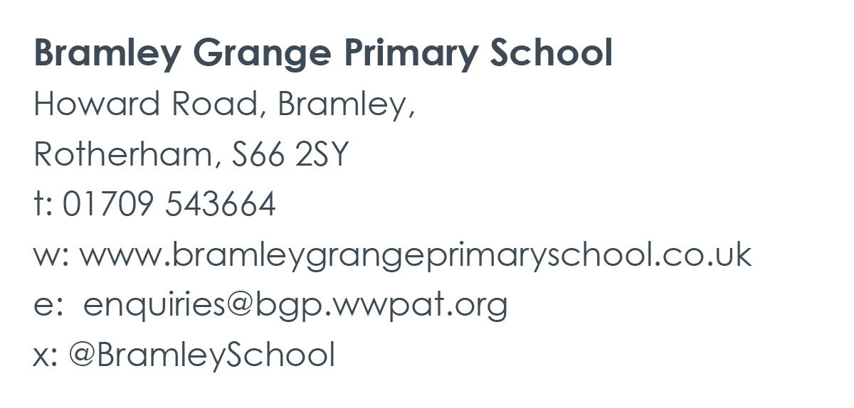

**Bramley Grange Primary School**

**Job Title: Part Time School Administrator/Receptionist Salary: Band D (Scale Point 5 FTE £23,500 - 6 FTE £23,893)**

**Pro-rated salary: £11,045 - £23,893.**

**Hours: 20 hours per week School Term Time (38 weeks + 2 INSET)**

**Please note that the role is not suitable for remote working.**

At an exciting time in the school’s development, we are seeking to appoint an exceptional School Administrator to be part of our new administration team at Bramley Grange Primary School.

**We are looking for someone to join our hardworking and dedicated team who:**

* Has relevant experience in a school or other office/reception environment.
* Is flexible with excellent interpersonal and communication skills.
* Has good organisational and data input skills.
* Works well as part of an administration team.
* Is committed to continual professional development.
* Shares in the Vision, Mission and Values of our Trust and School.

**We can offer:**

* Employed by White Woods Primary Academy Trust offering a commitment to encouraging and providing opportunities for personal and professional development.
* The opportunity to work within a highly motivated and supportive team within our school and across our Trust.
* Access to the South Yorkshire Pension Fund and a range of other employer benefits.

**For an informal discussion, or to arrange a visit to the School please contact:**

Nikki O’Loughlin (Headteacher) on 01709 543664 or email enquiries@bgp.wwpat.org

**Closing date:** Monday 15th July at 12 Noon.

**Interviews will be held on:** Friday 19th July at Bramley Grange Primary School.

**How to apply? Please complete our online application form below:**

<https://zfrmz.eu/mLPASrDOkBprZa4gBNgU>

You must complete our application form to be considered for this post.

This post involves working with children and therefore if successful you will be required to apply for a disclosure of criminal records check at an enhanced level. Further information about the Disclosure Scheme can be found at: www.gov.uk/disclosure-barring-service-check.

White Woods Primary Academy Trust is committed to safeguarding and promoting the welfare of children, young people and vulnerable adults.

Our Recruitment Privacy Notice can be viewed [**here**.](https://whitewoodsprimaryacademytrust.co.uk/resources/recruitment-privacy-notice/)