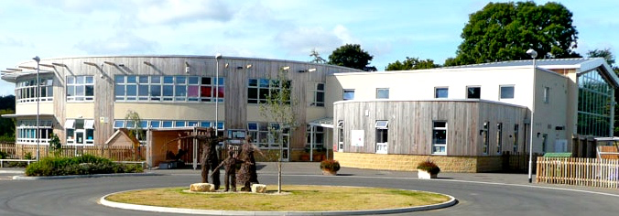

|  |  |
| --- | --- |
| **Job title** | **Part Time Teacher KS2** |
| **Hours** | 0.6 FTE |
| **Salary** | M1 – M6 |
| **Contract Type** | Part Time |
| **Commencement date** | 1st September 2025 |
| **Advertisement closing date** | Tuesday 18th June at 4.00pm |
| **Interview date** | Wednesday 25th June |

**Join Our Vibrant Team at Malmesbury C of E Primary School**

Malmesbury C of E Primary School is a thriving, two-form entry primary school, rated 'Good' by OFSTED in June 2024. With a dedicated and enthusiastic team, we aim to make learning both challenging and fun, ensuring that every child experiences an exciting, infectious, and rewarding educational journey.

**We are seeking a part-time (0.6) teacher (M1 – M6) to work 3 days in our KS2 team.**

The ideal candidate will be energetic, innovative, and passionate about creating an engaging learning environment. You will build strong relationships with our pupils and contribute to the dynamic, nurturing atmosphere that defines our school. We share a collective vision of “Growing together in wisdom and love; discovering life in all its fullness”, and our pupils embrace every challenge with curiosity and enthusiasm. You will join a supportive, child-centred team that is committed to creating inspiring and dynamic lessons. Our aim is to foster an environment where every child is motivated to excel, and you’ll play an integral part in making this vision a reality.

At Malmesbury, we pride ourselves on fostering creativity, incorporating ICT across the curriculum, and excelling in sport. Our school has a strong reputation for developing well-rounded learners who are encouraged to think critically and creatively. We are currently engaged in a collaboration with the James Dyson Foundation to extend the school, adding seven new classrooms, a second hall and building two rooms equipped for teaching Science, Technology, Engineering, the Arts and Maths, where children will learn alongside engineers from Dyson’s Malmesbury-based research division.

We have a longstanding tradition of supporting and developing talent. Our dedicated team of governors and staff is deeply committed to providing professional development for all. Additionally, a skilled team of teaching assistants offers vital support to every class.

**The successful candidate will:**

* Have a passion for learning.
* Be able to inspire children to achieve their best.
* Understand how to engage pupils in retrieving and applying knowledge to solve problems.
* Have high expectations for all pupils to ensure they reach their potential.
* Be creative and innovative in their approach to learning.
* Have good classroom management and behaviour management skills.
* Demonstrate high levels of emotional literacy and the ability to connect with students.
* Be committed to working as an active team player.
* Support our values of respect, kindness, courage, creativity and love and be sympathetic to our Christian foundation.

**In return we can offer:**

* The opportunity to work with wonderful children who love learning.
* A collaborative approach to planning and teaching in a two-form entry school.
* A friendly and inclusive team of teachers, teaching assistants and support staff.
* A committed and supportive SEN team.
* Support from engaged parents and governors.
* A school that actively encourages a home work life balance.
* Opportunities to be involved in whole school training and developing teaching practise.
* Experienced mentoring for all staff including ECTs.
* A comprehensive well-being support package.

Visits to the school are encouraged. Please contact the school office to arrange a visit (01666 823514 or [admin@malmesbury-pri.wilts.sch.uk](mailto:admin@malmesbury-pri.wilts.sch.uk)). An application pack is available from the school’s website ([www.malmesburyprimaryschool.co.uk](http://www.malmesburyprimaryschool.co.uk)) or by contacting [hr@malmesbury-pri.wilts.sch.uk](mailto:hr@malmesbury-pri.wilts.sch.uk).

**Malmesbury C of E Primary School is committed to safeguarding and promoting the welfare of children and young people and expects all staff and volunteers to share this commitment. All applicants will be subject to a full Disclosure And Barring Service check before appointment is confirmed. In accordance with the latest guidance, the school will research the internet profile of shortlisted candidates.**