KING JAMES’S SCHOOL

**A SPECIALIST SCIENCE COLLEGE**

Equality, Diversity and Inclusion Policy – Staff

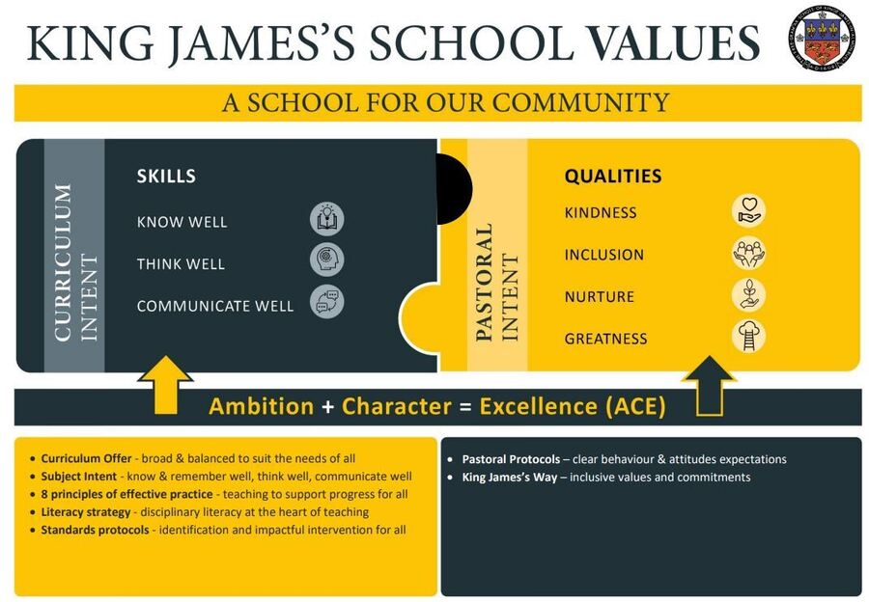

**Statement of intent**

King James’s School is committed to promoting equality of opportunity for all staff and job applicants. We are proud to have a working environment in which all individuals are able to make best use of their skills, free from discrimination or harassment, and in which all decisions are based on merit. We are committed to supporting our staff and applicants to be their authentic selves in the workplace without judgement and ensuring that diverse communities are celebrated.

We do not discriminate against staff on the basis of age, disability, gender identity and/or reassignment, marital or civil partner status, pregnancy or maternity, race, colour, nationality, ethnic or national origin, religion or belief, sex, or sexual orientation (the protected characteristics), amended in line with the Equality Act 2010. More detail on each of the protected characteristics can be found in Appendix A.

All staff have a duty to act in accordance with this policy and treat colleagues with dignity at all times, and not to discriminate against or harass other members of staff, regardless of their status. The principles of non-discrimination and equality of opportunity also apply to the way in which staff treat students, parents/carers, governors, third party organisations and former staff members.

This policy does not form part of any employee's contract of employment and may be amended at any time.

This policy covers all employees, casual workers, and agency staff (collectively referred to as ‘staff’ in this policy).

**Public Sector Equality Duty (PSED)**

PSED requires public bodies to have due regard to the need to:

* eliminate unlawful discrimination, harassment and victimisation and other conduct prohibited by the Equality Act
* advance equality of opportunity between people who share a protected characteristic and people who do not share it
* foster good relations between people who share a protected characteristic and people who do not

For more information on this, please refer to the Equality Objectives document.

# **Principles underlying this policy**

In accordance with this policy, the school commits to:

* having a working environment free of bullying, harassment, victimisation and unlawful discrimination, where individual differences and the contributions of all staff are recognised and valued
* promoting dignity and respect for all
* training managers and all other employees about their rights and responsibilities under this policy

This policy applies to all aspects of the school’s relationship with staff and to relations between staff members at all levels. This includes job advertisements, recruitment and selection, training and development, opportunities for promotion, conditions of service, pay and benefits, conduct at work, disciplinary and grievance procedures, and termination of employment.

Instances of bullying, harassment, victimisation and unlawful discrimination will be dealt with as misconduct, in line with the school’s Grievance Policy and/or Disciplinary Policy and Procedure, and appropriate action will be taken. Particularly serious complaints could amount to gross misconduct and lead to dismissal without notice.

Sexual harassment may amount to both an employment rights matter and a criminal matter, such as in sexual assault allegations. Harassment under the Protection from Harassment Act 1997 – which is not limited to circumstances where harassment relates to a protected characteristic – is a criminal offence.

# **Roles and responsibilities**

The Governing Body will be responsible for:

* ensuring the effective operation of this policy
* ensuring compliance with discrimination law
* assessing how this policy, and any supporting action plans, are working in practice, reviewing them annually, and considering and taking action to address any issues

The Senior Leadership Group will be responsible for:

* setting an appropriate standard of behaviour and leading by example
* ensuring that those they manage adhere to this policy and promote the school’s aims and objectives with regard to equal opportunities
* taking appropriate steps to accommodate the requirements of different religions, cultures, and domestic responsibilities, in line with the school’s Flexible Working Policy and Paid Leave Guidance
* making opportunities for training, development and progress available to all staff
* ensuring staff are helped and encouraged to develop their full potential, so their talents and resources can be fully utilised to maximise the efficiency of the organisation
* making staff progression decisions based on merit (apart from in any necessary and limited exemptions and exceptions allowed under the Equality Act 2010)
* reviewing employment practices and procedures where necessary to ensure fairness

The HR Manager will be responsible for:

* the day-to-day operational responsibility of this policy
* reviewing and updating this policy at appropriate intervals
* organising equal opportunities training, including for those involved in management and recruitment
* answering questions about the content or application of this policy

Line managers will be responsible for:

* participating in appropriate training on equal opportunities awareness and equal opportunities recruitment and selection good practice

All staff will be responsible for:

* conducting themselves to help the school provide equal opportunities in employment, and prevent bullying, harassment, victimisation and unlawful discrimination
* understanding that they, as well as their employer, can be held liable for acts of bullying, harassment, victimisation and unlawful discrimination, in the course of their employment, against their colleagues, customers, suppliers, visitors and the public
* taking seriously complaints of bullying, harassment, victimisation and unlawful discrimination by their colleagues, customers, suppliers, visitors, the public and any others in the course of the school’s work activities

# **Forms of discrimination**

Discrimination by or against an employee is generally prohibited unless there is a specific legal exemption. Discrimination may be direct or indirect and it may occur intentionally or unintentionally.

**Direct discrimination** occurs where someone is treated less favourably because of one or more of the protected characteristics outlined in Appendix A. For example, rejecting an applicant on the grounds of their race because they would not “fit in” would be direct discrimination.

**Indirect discrimination** occurs where someone is disadvantaged by an unjustified provision, criterion or practice that also puts other people with the same protected characteristic at a particular disadvantage. For example, a requirement to work full time puts women at a particular disadvantage because they generally have greater childcare commitments than men. Such a requirement will need to be objectively justified.

**Harassment** related to any of the protected characteristics is prohibited. Harassment is unwanted conduct that has the purpose or effect of violating someone's dignity, or creating an intimidating, hostile, degrading, humiliating or offensive environment for them.

**Victimisation** is also prohibited. This is less favourable treatment of someone who has complained or given information about discrimination or harassment, or supported someone else's complaint.

# 

# **Recruitment and selection**

The school will aim to ensure that no job applicant suffers discrimination because of any of the protected characteristics. The school’s recruitment procedures will be reviewed regularly to ensure that individuals are treated on the basis of their relevant merits and abilities. Job selection criteria will be regularly reviewed to ensure that it is relevant to the job and not disproportionate. The shortlisting of applicants will be done by more than one person wherever possible.

Job advertisements will avoid stereotyping or using wording that may discourage groups with a particular protected characteristic from applying. The school will take steps to ensure that vacancies are advertised to a diverse labour market.

Applicants will not be asked about health or disability before a job offer is made. There are limited exceptions which will only be used following discussion with the HR Manager, such as:

* questions necessary to establish if an applicant can perform an intrinsic part of the job (subject to any reasonable adjustments)
* questions to establish if an applicant is fit to attend an assessment or any reasonable adjustments that may be needed at interview or assessment
* positive action to recruit disabled persons
* equal opportunities monitoring (which will not form part of the decision-making process)

The school is required by law to ensure that all staff are entitled to work in the UK. Assumptions about immigration status will not be made based on appearance or apparent nationality. All prospective employees, regardless of nationality, will be expected to produce original documents, e.g. a passport, before employment starts, to satisfy current immigration legislation. The list of acceptable documents is available from the UK Border Agency.

# **Staff continuous professional development (CPD), promotion, and conditions of service**

Staff training needs and associated development opportunities will be identified through regular staff meetings, in line with the Performance Policy. All staff will be given appropriate access to CPD to enable them to progress within the organisation and all promotion decisions will be made based on merit. The school will adopt good practice in terms of data collection and use this data to monitor and measure the attraction, recruitment, retention and progression of staff.

The school’s conditions of service, benefits and facilities are reviewed regularly to ensure that they equal opportunities for all.

# **Termination of employment**

The school will ensure that redundancy criteria and procedures are fair and objective and are not directly or indirectly discriminatory.

The school will also ensure that disciplinary procedures and penalties are applied without discrimination, whether they result in disciplinary warnings, dismissal or other disciplinary action, in line with the school’s Disciplinary Policy and Procedure.

# **Disability discrimination**

The school will encourage staff who are disabled or become disabled to inform the HR Manager or their line manager about their condition so that the school can support them as appropriate.

Staff experiencing difficulties at work because of their disability (physical or otherwise) may wish to contact their line manager or the HR Manager to discuss any reasonable adjustments that would help overcome or minimise the difficulty. Their line manager or the HR Manager may wish to consult with the staff member and a medical adviser about possible adjustments.

The Governing Body will monitor the physical environment of the school premises to consider whether certain features place physically disabled staff, job applicants, service users, or other stakeholders at a substantial disadvantage compared to others. Where reasonable, the school will take steps to improve access for disabled staff and service users.

# **Part-time, casual workers, fixed-term employees and agency workers**

The school will monitor the conditions of service of part-time employees and their progression to ensure that they are being offered appropriate access to benefits and training and promotion opportunities. The school will ensure requests to alter working hours are dealt with appropriately under the Flexible Working Policy.

The school will monitor its use of casual work agreements, fixed-term employees and agency workers, and their conditions of service, to ensure that they are being offered appropriate access to benefits, training, promotion and permanent employment opportunities. The school will, where relevant, monitor their progress to ensure that they are accessing permanent vacancies.

# **Breaches of this policy**

If a member of staff believes that they may have been discriminated against, they will be encouraged to raise the matter through the school’s Grievance Policy. If they believe that they may have been subject to harassment, they will be encouraged to raise the matter with their line manager and HR Manager.

Allegations regarding potential breaches of this policy will be treated in confidence and investigated in accordance with the relevant procedure. Staff who make such allegations in good faith will not be victimised or treated less favourably as a result. False allegations which are found to have been made in bad faith will, however, be dealt with under our Disciplinary Policy.

Any member of staff who is found to have committed an act of discrimination or harassment will be subject to disciplinary action. Such behaviour may constitute gross misconduct and, as such, may result in summary dismissal. The school takes a strict approach to serious breaches of this policy.