PART TIME TEACHER OF MUSIC (0.4)
Ability to teach Drama or Media desirable

ECT/MPS/UPS and open to Unqualified Teachers

Candidate Pack

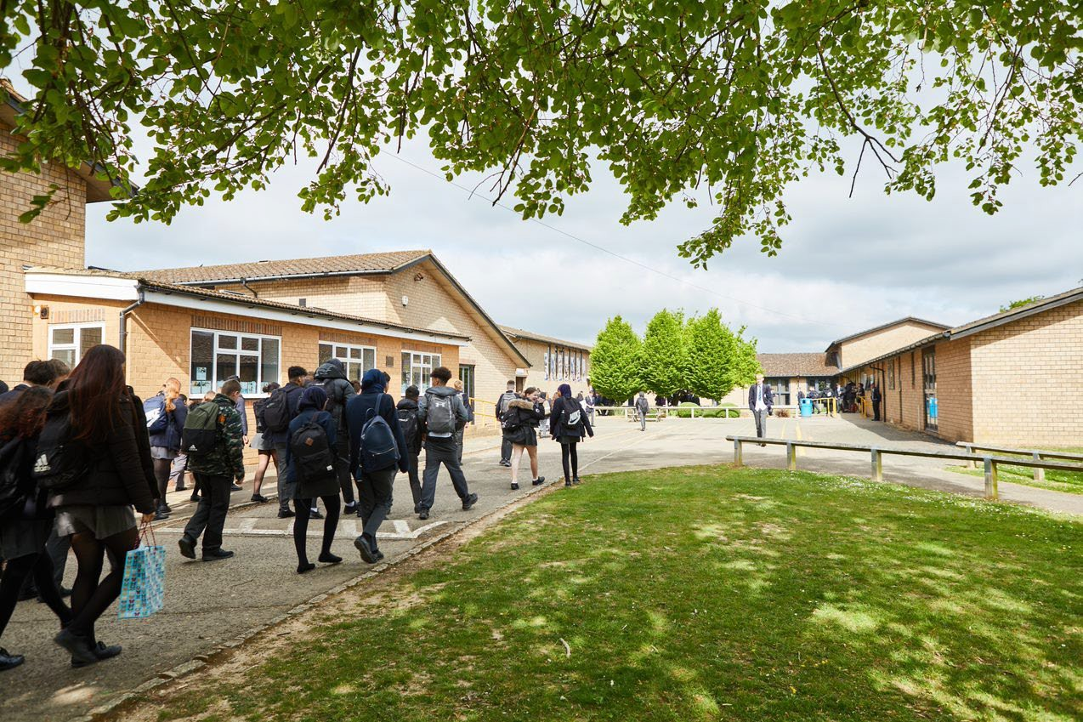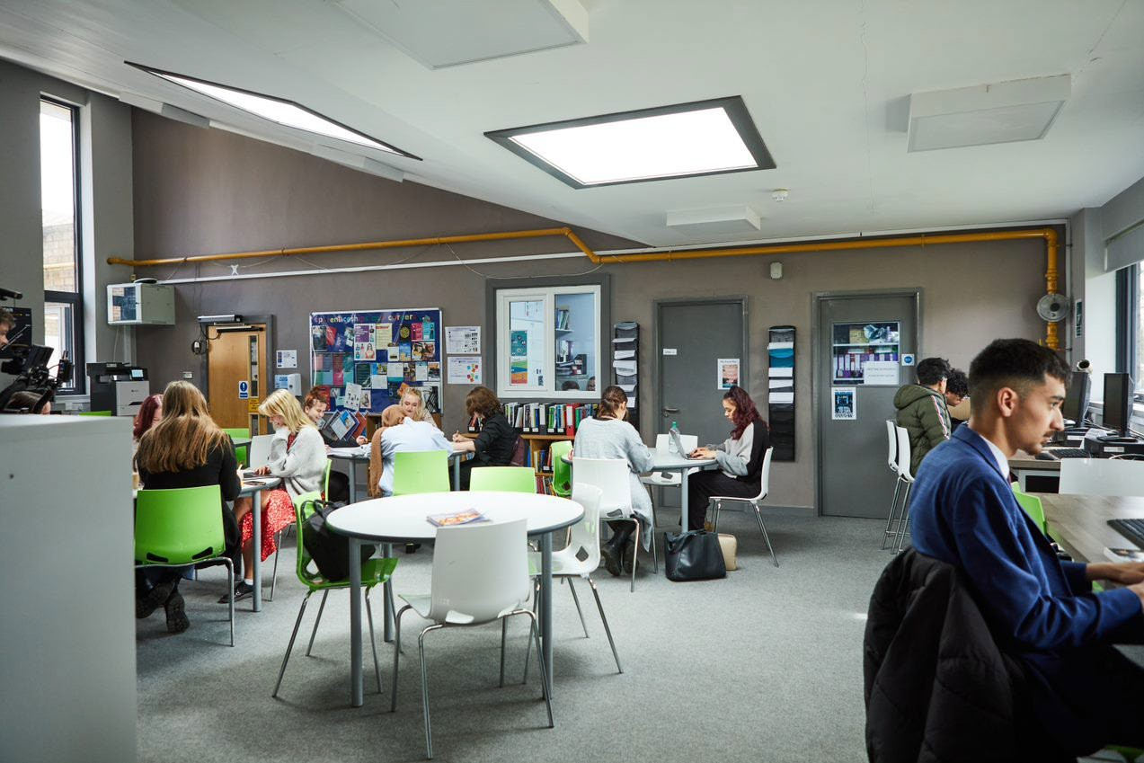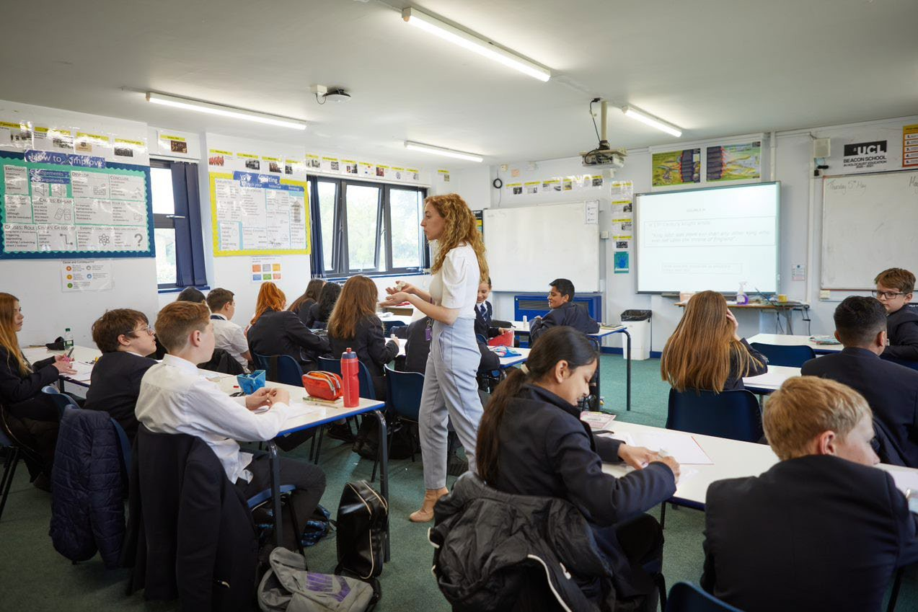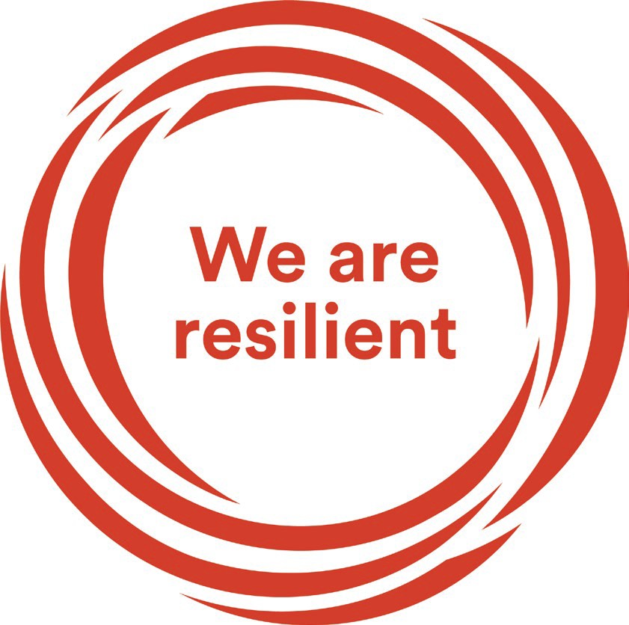
Welcome Letter from the Headteacher

Dear Prospective Candidate

Thank you for your interest in the position of Part Time Teacher of Music at Sir William Ramsay School.

I joined Sir William Ramsay School as the new Headteacher in May last year and am committed to getting the school back to ‘Good’ as quickly as possible. Clarity, consistency and rigour are central to our plans to ensure that all students enjoy learning and make good progress. Our plans include significant developments in high quality teaching and learning, the introduction of ambitious targets, a focus on developing excellent teaching, meaningful homework and improvements in behaviour for learning. We are also rolling out a digital learning 'One to One Device' strategy across the school to ensure that students can receive innovative teaching and access state of the art resources at both home and school.

We are looking to appoint a dynamic Part Time Teacher of Music to contribute to the development of this successful area. The ability to teach Drama or Media will be advantageous. The ideal candidate will have a belief in the ability of all students to achieve and a passion for raising student achievement. You will have a desire to strive for continuous school improvement and a commitment to team work as well as a sense of fun.

If you would like to find out more about the role or to arrange a conversation with the Head of Faculty, Mr Maxwell, please contact AMaxwell@swr.school.

I will hope to meet you in the near future.

Yours faithfully
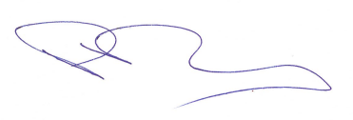
Paul Ramsey
Headteacher

Vision and Values at Sir William Ramsay School

Empowering Everyone to Achieve

Vision
A community where every voice counts, where talent and creativity are brought to life, where students grow in confidence, build resilience and are prepared for the rest of their lives.

Values
- We are respectful – we always treat people, property and the environment with kindness and consideration
- We are ambitious – we ask for help when we need it and strive to be the best we can be
- We are reliable – we do what is asked of us and deliver on our commitments
- We are resilient – we prepare for the future and adapt and grow from challenges

Mission
We aim to achieve our vision by:
- Raising students above the ordinary by developing and delivering lifelong learning which transforms lives
- Ensuring every person feels valued, safe and happy
- Enabling students to feel proud of themselves, and to take pride in the success of others
- Promoting a culture of mutual respect where everyone is treated as a valued member of the school community
- Encouraging positive communication so that words and actions are thoughtful, supportive and motivational
- Placing parents and carers at the heart of the life of the school
- Having highly dedicated and well-qualified staff who are committed to continuous professional development
- Adopting an ethos of continuous improvement within all aspects of school life

Equality
Sir William Ramsay is an inclusive and diverse community. We work to eliminate all forms of discrimination on the grounds of ethnic origin, religion, sexual orientation, gender, disability or ability. This is achieved via the following principles:
- Ensure that students have the opportunity to reach their potential in all areas of school life
- Ensure that parents/carers and students can make choices free from prejudice and stereotyping
- Oppose any form of racism, sexism, disability discrimination, homophobia or any other form of discrimination
- Value every student’s language and cultural background
Job Description

Job Title: | Part Time Teacher of Music (ability to teach Drama or Media advantageous)
Aim and Main Job Purpose: | To teach, enthuse and inspire students about Music

Teaching and Managing Student Learning
Teacher of Music will:
- Be able to teach effectively across the full range of age and abilities.
- Possess high expectations of students in relation to standards of achievement and behaviour.
- Have an active input in the creation, consistent implementation and improvement of schemes of work which encapsulate key school learning strategies.
- Monitor the progress of students including those requiring additional support and challenge them to ensure students are engaged in their learning and achieve success.

Assessment and Self-Evaluation
Teacher of Music will:
- Implement policies and practices for assessing, recording and reporting on student achievement and to assist in setting targets for further improvement.
- In conjunction with the Head of Performing Arts use data effectively to identify students who are underachieving and, where necessary, create and implement an effective intervention plan.

Relationships with Parents/Carers
Teacher of Music will:
- Establish a partnership with parents/carers to involve them in their child’s learning of the subject, as well as providing information about targets and attainment.
- Communicate effectively, both orally and in writing, with parents/carers.

Managing Own Performance
Teacher of Music will:
- Prioritise and manage their own time effectively.
- Take responsibility for their own professional development.
- Share good practice resulting in a tangible impact on student learning.
- Form constructive relationships with staff including team working and mutual support.
- Actively implement the key aspects of the school’s behaviour management policies.
- Be a form tutor.
- Make a contribution to the wider school life including specialist Drama & Music enrichment activities.
- Contribute to faculty planning and developments.

Strategic Leadership
Teacher of Music will:
- Contribute fully to the Faculty Development Plan which contributes positively to the achievements of the School Development Plan.

Other Responsibilities
- To promote the School’s vision, values and aims.
- To be aware of and comply with the codes of conduct, regulations, policies, procedures.
- To work as part of a team.
- To be generally responsible for safeguarding and promoting the welfare of students.
- To be responsible for own and team health and safety including well-being.
- To actively participate in the School’s appraisal system.
- To do Continued Professional Learning as agreed with the Line Manager.

This job description is current at the date indicated below but, in consultation with the postholder, it may be changed by the Headteacher to reflect or anticipate changes in the post commensurate with the grade or job title.
The Performing Arts Department

Team members share a commitment to raising standards of student achievement. We are keen to inspire students with a passion and love for the subject. If you are enthusiastic, passionate, enjoy challenges and are committed to help us offer excellence within the Performing Arts Faculty, then you are the person to join our progressive, supportive and forward-thinking team.

The Music Curriculum
Music is part of the Performing Arts department and is taught throughout the school from Key Stage 3 to Key Stage 5. The Key Stage 3 curriculum offers all students an opportunity to improve and develop their performance and composition skills whilst focusing on a broad range of musical genres. We offer the Level 2 BTEC First Award in Music. This progresses to Level 3 BTEC Subsidiary Diploma in Key Stage 5.

The department is well equipped with instruments including a set of Samba and African drums., electronic and acoustic drum kits, a keyboard suite, an Apple Mac suite and good number of ukuleles, acoustic and electric guitars and amps. The department focuses on increasing performance opportunities for students both in school and within the wider community. During the school year students are involved in a number of performances including the Christmas Concert, The Senior Citizens Party, Bi-Annual School Production, The Ramsay Summer Festival, Ramsay Music Week at Easter and also Mic Nights where student bands highlight their talents.

Department Facilities
The Music Department is situated in the Performing Arts centre and consists of two classrooms (one with a networked suite of Apple Macs running MuseScore 2 and Garageband software) and two practice rooms. Peripatetic lessons are popular with the department currently offering piano, singing, guitar, woodwind and drum lessons.

Extra-Curricular Activities
The Music department offer extensive extracurricular activities including a jazz band, ukulele club, choir and keyboard club.
The Drama department offers extra-curricular activities by itself and also as part of the larger Performing Arts Faculty. One of the department activities is the Shakespeare Schools Festival. This is an annual event which the department has participated in for over 10 years. Working within the wider Performing Arts Faculty we offer an annual school production which students can audition for.

How to Apply

If you wish to discover more about this exciting opportunity, need any further information or you wish to have an informal discussion, please contact Head of Faculty: amaxwell@swr.school 01494 815211.

Please email your completed application form to: jointheteam@swr.school

Closing Date: Noon – Thursday 22nd June 2023
Interviews: Week commencing Monday 26th June 2023

Sir William Ramsay School is committed to safeguarding and promoting the welfare of children and young people and expects all staff and volunteers to share this commitment. We will ensure that all our recruitment and selection practices reflect this commitment.

All successful candidates will be subject to DBS checks along with other relevant pre-employment checks.

